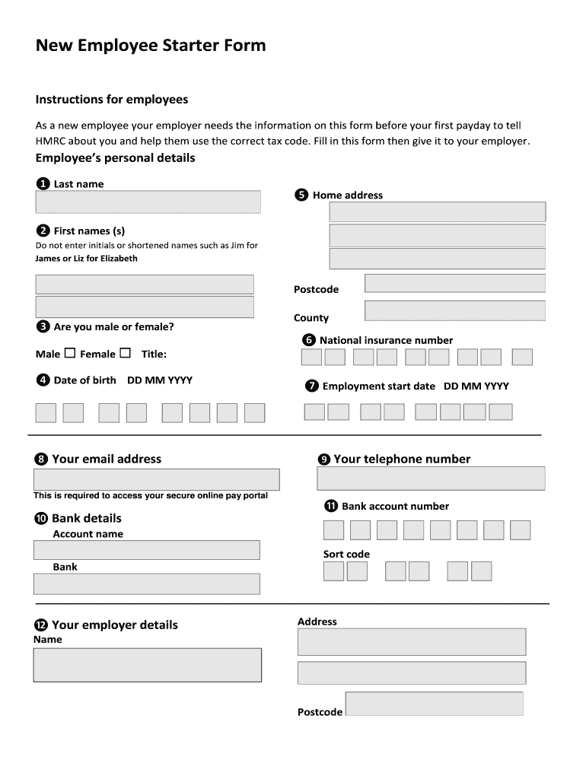

Draft a form as shown above in html/php language.

2 pages to be designed. -

1. LoginForm for new signup.

You can do this in Php/html language. Your job is to make this page appealing to the user, does form validation, uses appropriate validation controls and processs the result/ouput with confirmation to the other page.

Attribute no. 1-12

Fieldset 1-7

Attribute 1 : Max lenght of 25 characters only.

Attribute 2: Max lenght of 25 characters only. (just have one text box both for middle and first name).

Attribute 3: Radio button or Check box with 1 option only.

Attribute 4: input type as date

Attribute 5: Text Area or you choose your own too..

skip the county part..

Attribute 6: Input type as password and limit to 9 characters

Attribute 7: Date type - try for ensuring going onwards date can only be selected by the user..

Fieldset 8-11

Attribute 8: Input type as Email only

Attribute 9: input type as tel and limit to 10 digits only.

Attribute 10: Bank Name: DropDown or choose your own..

Attribute 11: Account No: to be 8 digits and remaining the last 2 of those to be shown as password field.

Skip the sort code field---

Attribute 12: Textbox that shows value only in uppercase..

Two Buttons- > Submit and Another to Clear.

On the click of Submit -> Request goes to another page- Confimationpage.php

ConfirmationPage.php shows:

"Successfully Registred or Form Completed followed by your LastName"

Shows todays date/time the form was completed.

Validation Logo of Html/css on the lower center page

css- use external css script with only form tag selectors.