Data Center Design
How data centers and AI factories are designed, powered, cooled, connected and run
Prepared for Nathan Hale
October 2026
Table of Contents

Executive summary
A data center is a building whose only job is to keep computer chips powered, cool, connected and safe. The concrete, chillers, switchgear, fibre and fences all serve that job. Every design decision is a trade-off between four things: how much useful computing you get, how much it costs, how much electricity it uses, and how often it fails.
In the last three years AI has changed the numbers more than the previous twenty did. A typical cloud server rack draws 10–20 kW. An AI training rack such as NVIDIA’s GB200 NVL72 draws about 130 kW and weighs about 1.4 tonnes, and vendors have announced racks of 600 kW and more. Air cannot carry that much heat away, so the chips are now cooled by warm water flowing through metal plates bolted directly onto them. The largest new campuses are planned at one to five gigawatts, as much as a mid-sized city, and some bring their own gas turbines or contract with nuclear plants because the grid cannot connect them fast enough.
This guide explains every layer of these buildings. It is written so a curious non-engineer can follow it, with enough precise numbers that an engineer or investor can use them. Each technical term is explained the first time it appears and again in the glossary.

Key findings
- Power is the bottleneck. Land, money and chips are easier to get than a large grid connection. In several US markets the wait for hundreds of megawatts is several years.
- AI racks draw 10× more than cloud racks and the gap is still widening. Above roughly 30–45 kW per rack, air cooling stops being practical, so every serious AI build now uses liquid cooling at the chip.
- New buildings are very efficient already. The best new facilities spend only 10–20% extra energy on top of the computers themselves (a PUE of 1.1–1.2). The next big gain is using the waste heat, for example for district heating.
- AI clusters behave like one machine. Tens of thousands of GPUs work in lockstep. That demands extremely fast networks and creates large, synchronised swings in power draw that the grid has never seen from a building before.
- Energy supply is the next frontier. On-site gas generation, large batteries, restarted and uprated nuclear plants, and in time small modular reactors are being contracted directly for data center campuses.

Figures at a glance
Measure | Enterprise data center | Cloud hyperscale | AI factory
Typical size (IT load) | 1–10 MW | 30–300 MW per campus | 100 MW – 5 GW per campus
Power per rack | 5–10 kW | 10–30 kW | 60–150 kW, heading to 600 kW+
Main cooling method | room air | air with containment, some liquid | direct-to-chip liquid plus air
Network | general-purpose Ethernet | leaf-spine Ethernet | NVLink inside racks plus a dedicated InfiniBand or Ethernet GPU fabric
Power profile | steady | steady, many small jobs | large synchronised swings
Floor load | ~12 kPa (250 lb/ft²) | ~12–15 kPa | up to ~25–35 kPa (500–750 lb/ft²)
Typical PUE | 1.5–1.8 | 1.1–1.2 | 1.1–1.3
Build time to first power | 18–30 months | 15–24 months | as little as 4–12 months for record builds

How to read this guide
The guide has nine parts. Parts I and II give you the overall picture and the campus. Parts III and IV cover the electrical and cooling systems; every other part uses their vocabulary. Parts V to VII cover the inside of the building, the network and what makes AI facilities different. Parts VIII and IX cover operations, money and what comes next. The final chapter works through the numbers for a 100 MW AI hall from start to finish.
The figures are 3-D renderings and engineering schematics made for this guide. The HTML edition lets you rotate the 3-D models. Numbers are typical for new builds in 2025–2026. Where a range is given, the low end is a good conventional data center and the high end is a leading AI facility.

Part I — Foundations

What a data center is
A data center is an industrial building designed to house, power, cool, connect and protect computers. A modern one is usually a large windowless box of one or two storeys, close to a high-voltage substation and a fibre route, and usually far from homes.
Its spaces fall into four groups:
- White space: the rooms where the computers stand in rows of racks.
- Grey space: the electrical, mechanical and telecom rooms that keep the white space running. It often takes up as much floor area as the white space.
- Support space: offices, the security desk, loading docks, storage and workshops.
- Yard: generators, transformers, cooling equipment, water tanks, batteries and sometimes solar panels.
Three requirements drive nearly every design decision:
- Electricity must arrive reliably, within tight voltage and frequency limits, to every rack, 8,760 hours a year.
- Heat must leave as fast as it is made. Essentially every watt of electricity that goes in comes out as heat. A 100 MW data center gives off as much heat as about 50,000 electric space heaters running flat out.
- Data must flow in and out at hundreds of terabits per second over at least two separate fibre routes.

From mainframes to AI factories
Data centers have gone through five overlapping generations.
- Mainframe rooms (1960s–1980s). One large computer in a raised-floor room, cooled by room air conditioners. 1–3 kW per machine.
- Server rooms and early colocation (1990s). Racks of small servers. The internet boom created colocation buildings, where companies rent space, power and cooling for their own equipment. 2–5 kW per rack. UPS systems, dual power feeds and the Uptime Institute’s tier ratings appeared in this era.
- Enterprise data centers (2000s). Multi-megawatt sites run by banks, telecom companies and large corporations. Hot-aisle/cold-aisle layouts and the PUE efficiency metric became standard. 3–6 kW per rack.
- Hyperscale (2010s–present). Google, Amazon, Microsoft, Meta, Alibaba and others built 30–300 MW campuses with custom hardware, outside-air cooling and PUEs near 1.1. 8–30 kW per rack.
- AI factories (2023–present). Buildings designed around one job: training and running large AI models on GPUs or other accelerators. Racks of 60–150 kW are normal and much larger ones are coming. Liquid cooling is required. Tens of thousands of chips act as one computer. Power draw can swing by tens of megawatts in under a second.
The move from generation 4 to 5 is a change in kind, not just in size. Power distribution, cooling and networking are all being redesigned at once.

The anatomy at a glance
Figure 1 shows a typical AI campus: a 230 kV substation, three data halls, a generator yard beside each hall, a central utility plant, battery storage, an office and security building, and solar panels. The rest of this guide zooms into these pieces.
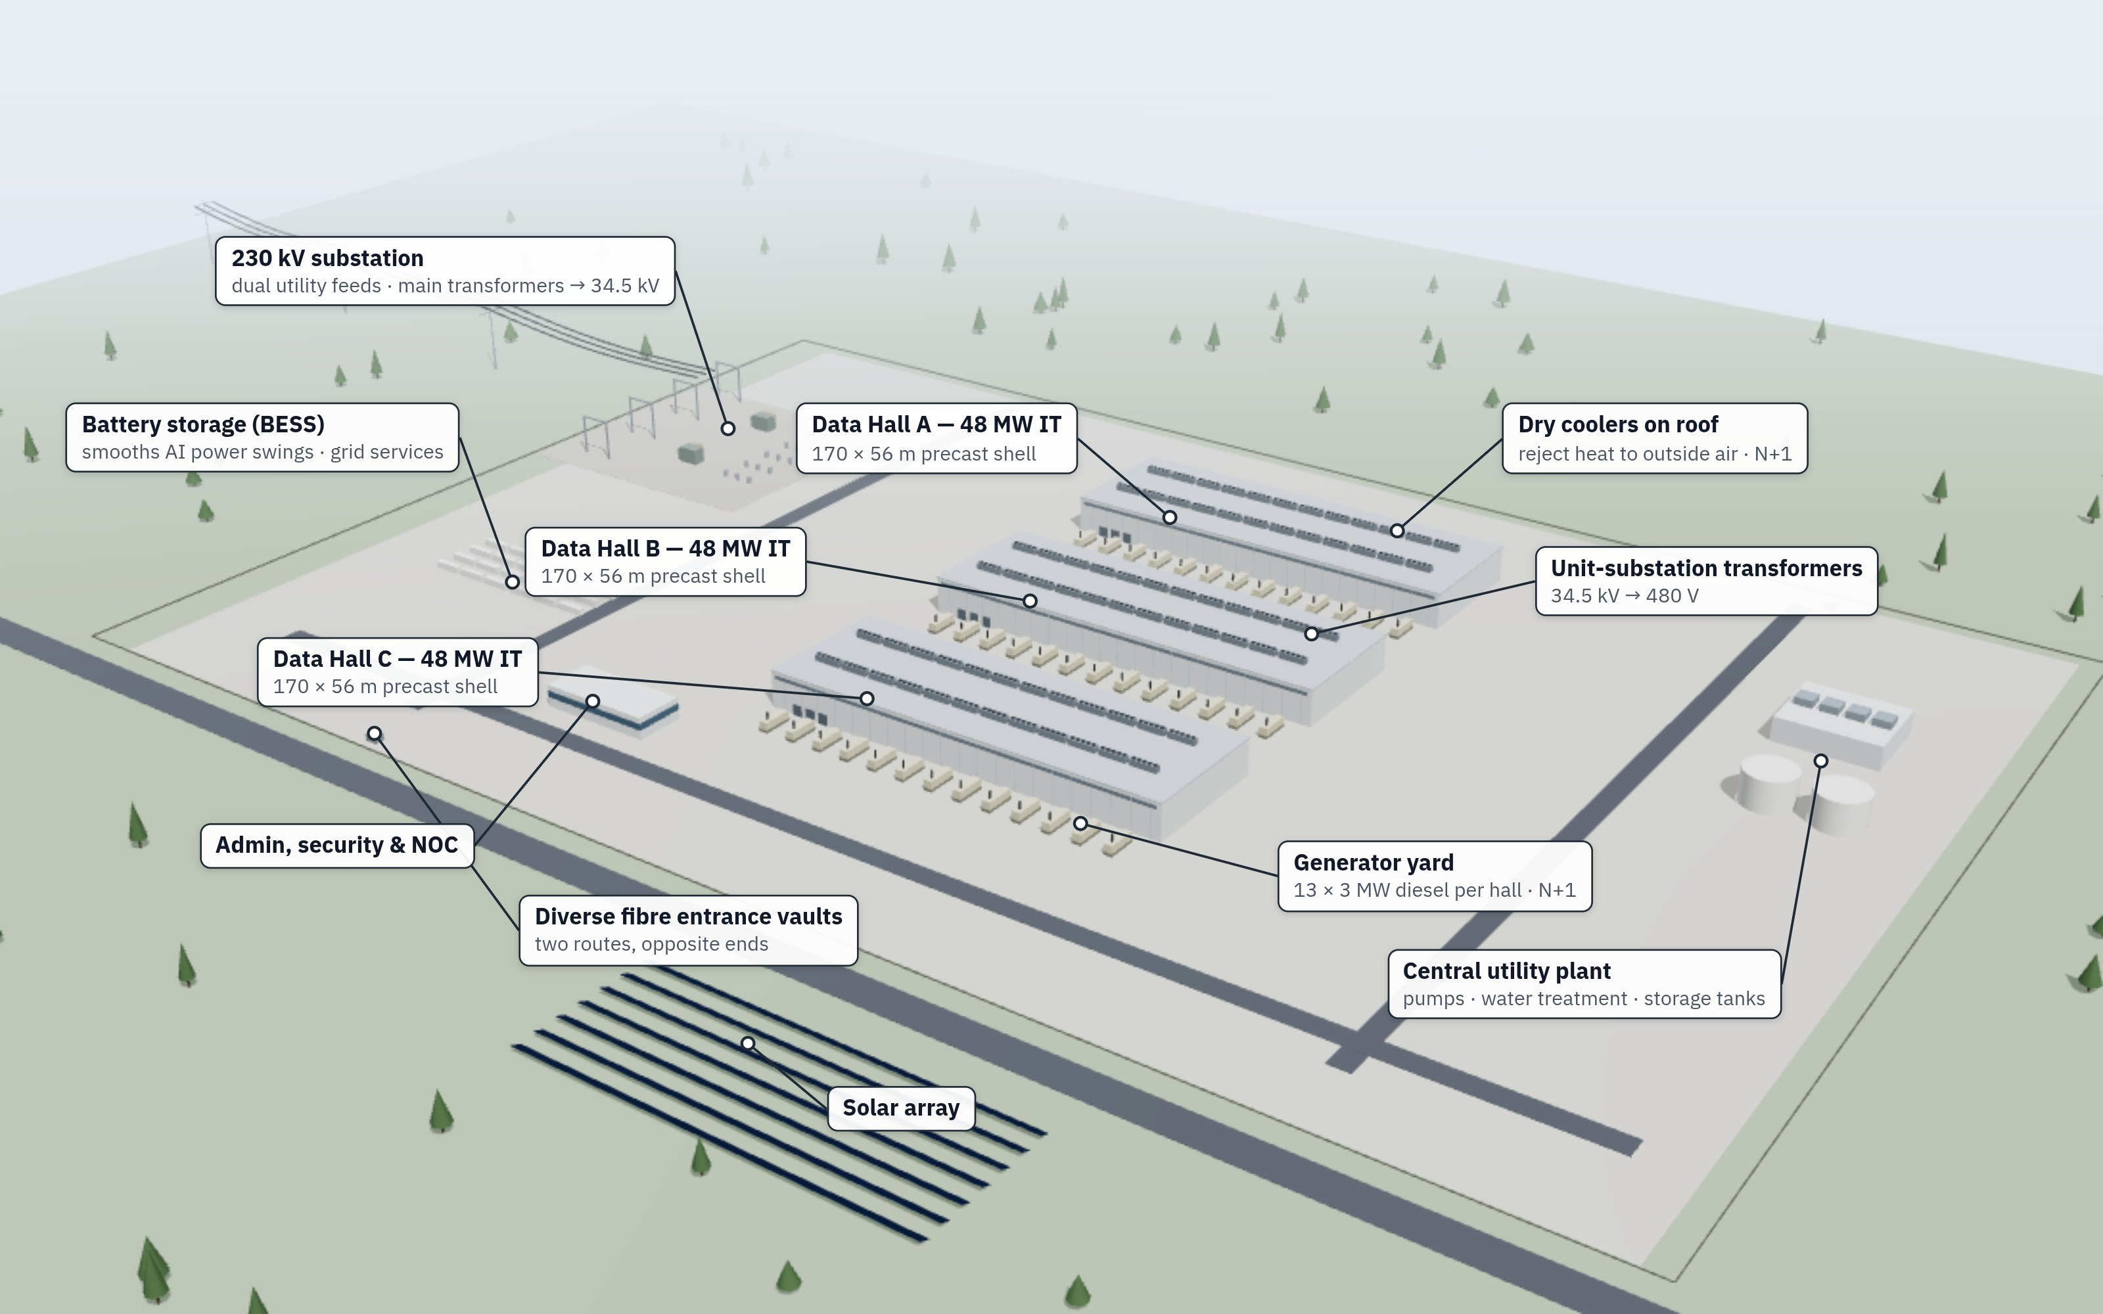
Figure 1 — A 144 MW AI campus seen from the air. Each hall has its own generator row and unit-substation transformers; dry coolers on the roofs reject the heat.
The campus in Figure 1 holds about 144 MW of computing load on roughly 60 hectares (150 acres). Campuses now under construction range from about 100 MW to several gigawatts on hundreds of hectares, but the layout pattern is the same everywhere: buildings for the computers, and an industrial yard of utilities to feed them.
Figure 2 opens up one hall. The roof is lifted so you can see the inside. Electrical rooms sit at one end. A mechanical gallery of pumps and coolant distribution units runs along one wall. Rows of racks fill the middle, with overhead power and fibre. The roof carries the heat-rejection equipment.
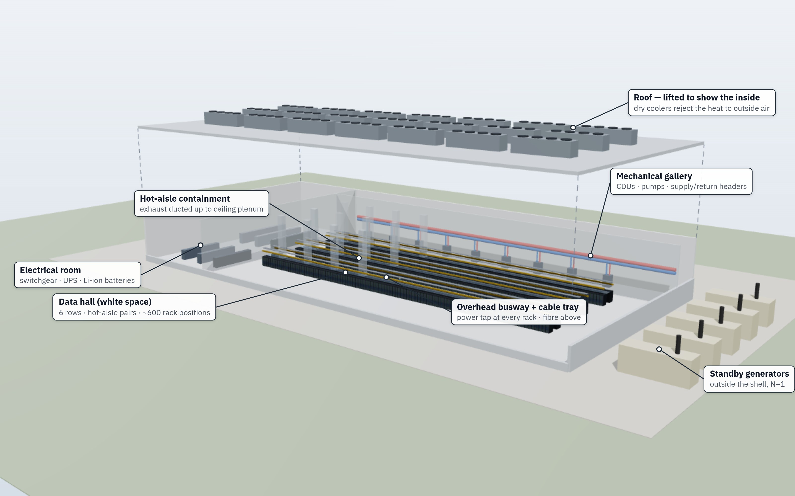
Figure 2 — Exploded cutaway of one data hall: electrical room (left), contained rows of liquid-cooled racks (centre), mechanical gallery (back wall), generators (right) and the roof with dry coolers lifted off.

Part II — Siting and the building

Choosing a site
Developers score candidate sites against dozens of weighted factors, often over 6–24 months. The most important factors have changed.
Ten years ago the top three were fibre (several long-distance routes nearby), latency to users, and the cost of land and power. For AI campuses today they are:
- Time to power. How soon can the utility deliver 100–1,000 MW of firm capacity? This includes new transmission lines and substation transformers, which can take years to manufacture.
- Water. Is there enough for cooling, and a permit to use it and discharge it? This matters less for designs that use little water (see Efficiency).
- Local acceptance. Will the county grant zoning, noise and air permits?
Other factors still count:
- Climate. Cool, dry places allow more hours of cooling with outside air (the Nordics, the Pacific Northwest, Iowa, Ireland). Hot or humid places need more mechanical cooling or evaporative assistance.
- Natural hazards. A 100-year floodplain is usually ruled out. Earthquake, tornado and wildfire risk raise construction and insurance costs.
- Taxes and incentives. Sales-tax exemptions on equipment, property-tax abatements and industrial power rates.
- Fibre. Training campuses need big links between their own buildings more than to cities. Inference sites, which answer user requests, want to be closer to users.
- Workforce. Electricians, pipe-fitters and data center technicians for construction and for 24/7 operation.
- Zoning and setbacks. Industrial zoning, distance from homes, and noise limits at the property line, which shape generator enclosures and fan choices.
- Environmental review. Wetlands, protected species and air-quality modelling can add 6–18 months.
In practice the site team rules out most candidates in the first week using mapping data, then spends a year on the few that remain. The usual deal-breakers are: the utility can offer 30 MW now but 300 MW only years later; the county says no; or the water supplier cannot guarantee volumes in a drought.

The campus and the building shell
Modern campuses use a few standard building forms.
- Single-block hall. Roughly 150–200 m long and 50–80 m wide, one or two storeys, 30–80 MW of IT load. Precast concrete or steel. Generators along one long side, transformers along the other, loading dock at one end.
- Multi-hall campus. Three to eight identical halls sharing a substation and a central utility plant, as in Figure 1.
- Multi-storey. In dense markets such as Northern Virginia, Frankfurt, Singapore and Tokyo, halls are stacked three to eight storeys high. Microsoft’s Fairwater AI site in Wisconsin uses two storeys of racks to shorten cable runs between GPUs.
- Modular and prefabricated. Electrical rooms, cooling skids and even whole data halls are built in factories and delivered on trucks. Prefabrication now drives much of the schedule compression.
Structural norms:
- Floors are reinforced concrete slabs. A loaded NVL72 rack weighs about 1.4 tonnes on a 0.6 × 1.2 m footprint, roughly 20 kPa (about 400 lb/ft²) directly under the rack. AI floors are designed for 25–35 kPa.
- Clear height is 6–10 m to fit overhead busway, cable trays, pipes and a hot-air return space.
- Fire compartments of a few thousand square metres are separated by two-hour fire walls.
- No windows in data halls.
- Two of everything that enters: two fibre vaults at opposite ends and two power routes that never share a trench.
Record builds have gone from bare site to running GPUs in about four months. xAI’s first Colossus cluster in Memphis took 122 days, by reusing an existing factory building and bringing in temporary gas turbines. Typical schedules are 15–24 months to first power. The grid connection, not construction, is usually what sets the date.

Part III — The power chain

From the grid to the chip
Electricity reaches a large campus at transmission voltage, usually 115–345 kV. Inside the fence it is stepped down in stages until it reaches the chip at under one volt. Figure 3 shows the chain.
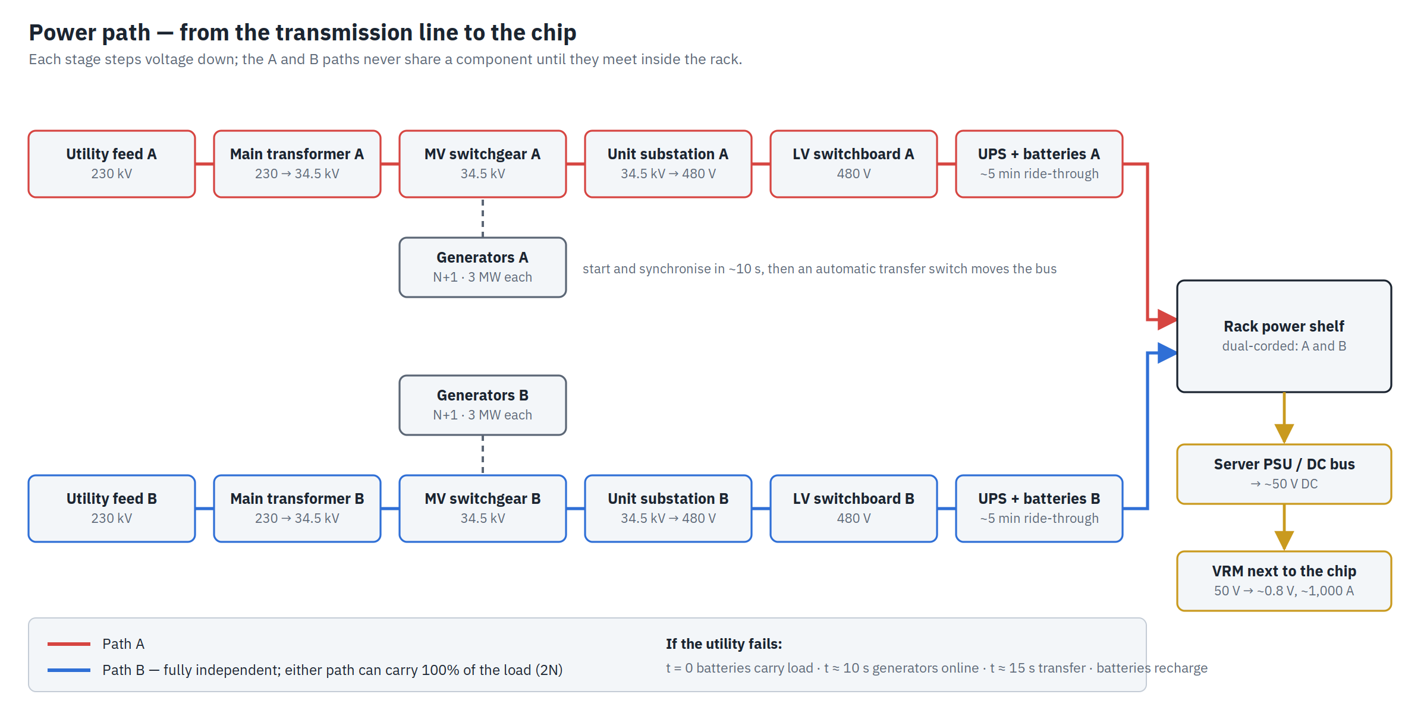
Figure 3 — The power path from the transmission line to the chip, with two fully independent paths (A and B) that meet only inside the rack.
The stages, in order:
- Utility feeds. One or, ideally, two lines from different substations.
- On-site substation. A gravel yard with steel gantries, circuit breakers and large main transformers that step down to medium voltage (MV), usually 34.5 kV in North America or 11–33 kV elsewhere.
- MV switchgear. Breakers that distribute MV around the campus. Ring or “main-tie-main” layouts let any breaker be serviced without cutting power.
- Unit substations. Transformers at each building step MV down to low voltage (LV): 480 V in North America, 400–415 V in most other places.
- LV switchboards. The main distribution boards for UPS systems, cooling plant and building services.
- Uninterruptible power supply (UPS). Batteries (now mostly lithium-ion) and power electronics that carry the load through any utility disturbance until generators start. Typical ride-through is about five minutes.
- Distribution to the rows. Power distribution units (PDUs) or remote power panels feed overhead busway: a metal bar running above each row with a plug-in tap box for every rack.
- Rack power shelves. Inside AI racks, power shelves convert AC to roughly 50 V DC and feed a copper busbar running up the back of the rack.
- Voltage regulators (VRMs). On each board, next to the chip, these step 50 V (or 12 V) down to about 0.7–1.0 V at hundreds to more than a thousand amperes per chip.
Every stage loses a little energy: about 0.5–1% per transformer, 2–4% in a double-conversion UPS (less in “eco” modes), 2–5% in power supplies and 5–10% in on-board regulators. Together, roughly 10–15% of the electricity entering the building becomes heat before it reaches a transistor.
Higher voltages mean less current, thinner copper and lower losses. That is why rack power moved from 12 V to 48–50 V, and why NVIDIA has announced an 800 V DC rack architecture for its next generation of very large racks. That design moves AC-to-DC conversion out of the rack and into the building.

Redundancy and the Uptime tiers
Not every facility needs the same reliability. The common framework is the Uptime Institute Tier classification. It uses this vocabulary:
- N: exactly enough equipment to carry the load, no spare.
- N+1: one spare unit, such as nine generators where eight are needed.
- 2N: two complete, independent systems, each able to carry the whole load (the A and B paths in Figure 3).
- 2(N+1): two independent systems, each with its own spare.
Uptime Institute tiers. The availability percentages are long-standing industry rules of thumb; Uptime’s certification is based on design topology, not on a promised percentage.
 | Tier I | Tier II | Tier III | Tier IV
Power and cooling paths | one | one, with spare components | several, one active | several, all active
Can be serviced without shutdown | no | no | yes | yes
Survives any single failure | no | no | not always | yes
Commonly quoted availability | 99.671% | 99.741% | 99.982% | 99.995%
Equivalent downtime per year | ~29 h | ~23 h | ~1.6 h | ~26 min
Typical users | labs, small offices | small businesses | enterprise, colocation, cloud | finance, government, critical services
Relative build cost | 1× | ~1.3× | ~1.8–2.2× | ~2.4–3×
Three points matter in practice:
- People cause most outages. Uptime’s surveys consistently find that a large share of serious outages involve human error or procedure failures, not just equipment.
- Cloud providers often build to Tier III. Their software already shifts work between buildings and regions, so paying for Tier IV inside every building buys little.
- AI training is different again. A training job saves its progress (a checkpoint) regularly and can restart from it. Losing power to a training hall wastes hours of work but does not lose customer data. Some AI training halls therefore use less redundancy, for example single-path power to the GPUs, and spend the savings on more compute. Inference halls, which serve users directly, keep cloud-style redundancy.

Backup power
When the utility fails, the data center runs first on batteries and then on generators.

Batteries (UPS)
- Valve-regulated lead-acid (VRLA): the old standard; heavy, bulky, replaced every 4–6 years.
- Lithium-ion, mostly lithium iron phosphate (LFP): now standard in new builds. It takes about a third of the space, lasts 10–15 years, and can also earn money by helping the grid with frequency regulation.
- Flywheels: a spinning mass that gives 15–30 seconds of ride-through. Sometimes used instead of batteries where the generators start fast.
Generators. The standard is diesel: 2–3.5 MW engines in sound-proofed enclosures, arranged N+1 or better. They reach full load in about 10 seconds, and an automatic transfer switch (ATS) moves the load onto them. A large campus can have more than a hundred. Diesel is reliable and stores well, but faces growing limits:
- Air permits often cap running hours, typically 50–500 hours a year including testing, and require modern emission controls.
- Fuel. Running a 300 MW campus on generators for three days takes on the order of 5–6 million litres (1.5 million US gallons) of diesel.
- Neighbours notice the smoke and the noise of monthly tests.
Alternatives in use or being deployed:
- Natural-gas engines and turbines. Cleaner and fed by pipeline rather than tank. At AI campuses they are increasingly installed behind the meter as the primary power source, with the grid as backup, because the grid connection would take too long.
- Fuel cells. Solid-oxide fuel cells running on natural gas, used as on-site primary power at several US sites.
- Large battery systems (BESS). Container-sized lithium batteries that provide minutes to hours of backup, smooth AI power swings and earn grid-service revenue.
- Nuclear. Data center operators have signed long-term contracts with existing and restarting nuclear plants (for example Microsoft with Constellation for the former Three Mile Island Unit 1, and Amazon at Talen’s Susquehanna plant). They have also backed small modular reactor developers (Amazon with X-energy, Google with Kairos Power) for the 2030s.

Part IV — Cooling

Why cooling is the hardest problem
Essentially all the electricity a data center uses becomes heat. A 100 MW building must reject 100 MW of heat continuously, in any weather, while holding the chips within a few degrees of their target.
That is manageable when racks draw 5 kW and are spread out. It becomes very hard at 130 kW per rack packed shoulder to shoulder. Heat density matters more than the total. An AI rack gives off about as much heat as 60–70 household space heaters crammed into a wardrobe-sized box.
Cooling is also the largest energy overhead after the computers. In an older facility with a PUE of 1.6, the cooling plant can use almost half as much energy as the IT equipment. Each 0.1 improvement in PUE on a 100 MW site saves roughly 8–9 GWh a year, worth about $5 million at industrial power prices.

Air cooling and containment
Early data centers simply filled the room with cold air. The problem was recirculation: hot air leaving the back of one rack was pulled into the front of the next, so the air conditioners were cooling their own exhaust.
The fix, standard since the mid-2000s, is the hot aisle / cold aisle layout. Rows of racks face each other in pairs, so fronts draw cool air from a shared cold aisle and backs blow hot air into a shared hot aisle. Containment then puts a physical barrier around one of the aisles:
- Cold-aisle containment encloses the cold aisle with doors and a roof. It is easy to add to older raised-floor rooms.
- Hot-aisle containment encloses the hot aisle and ducts the hot air to a return space above the ceiling (Figure 4). The rest of the room becomes a large pool of cool air. This is preferred in new builds because the return air is hotter, which makes the cooling coils more efficient.
The air is cooled by:
- CRAC units (computer room air conditioners), each with its own refrigerant compressor. Older design.
- CRAH units (computer room air handlers): fans blowing over coils filled with chilled water. Most common today.
- Fan walls: a wall of large, efficient fans with coils, serving a whole room or hall.
ASHRAE’s thermal guidelines recommend 18–27 °C (64–81 °F) at the server inlet and allow higher temperatures for short periods. Every degree warmer means more hours a year when outside air alone can do the cooling.
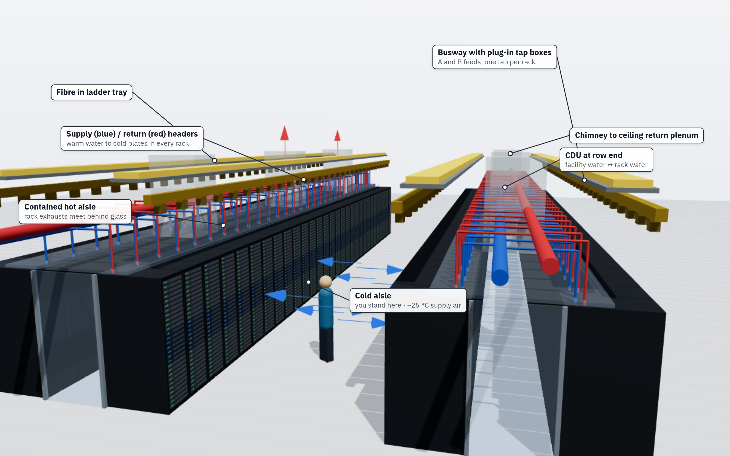
Figure 4 — Inside a liquid-cooled AI hall. Blue (supply) and red (return) water headers run above the contained hot aisles and drop into every rack. Busway with a plug-in tap per rack and yellow fibre in ladder trays run overhead. The CDU sits at the end of each row.

Liquid cooling
Above roughly 30–45 kW per rack, air stops working well. Fan power rises steeply as airflow increases, and the air gets too loud and fast to move through the servers. Water carries about 3,500 times more heat than the same volume of air, so the industry has moved to liquid.
Liquid-cooling methods.
Method | How it works | Typical rack power | Where it is used
Rear-door heat exchanger | a water-cooled coil replaces the rack’s back door and cools the exhaust air | 20–50 kW (up to ~80 with active fans) | retrofits, mixed halls
Direct-to-chip (DLC) | metal cold plates sit on each GPU and CPU; water flows through micro-channels inside them | 60–200 kW today | today’s standard for AI (NVIDIA GB200/GB300, AMD MI300/MI350 series, Google TPU)
Single-phase immersion | whole servers sit in a tank of non-conducting oil; pumps move the fluid | 100 kW+ per tank | crypto mining, some HPC, pilots
Two-phase immersion or two-phase cold plates | the fluid boils at the chip and condenses elsewhere, absorbing a lot of heat per litre | highest | emerging; limited by fluid cost and environmental rules
With direct-to-chip cooling, about 80–85% of a rack’s heat leaves in the water. The rest, from memory, network cards and power supplies, is still removed by fans and room air. Figure 5 shows an NVL72-class rack with one compute tray pulled out, its copper cold plates visible.
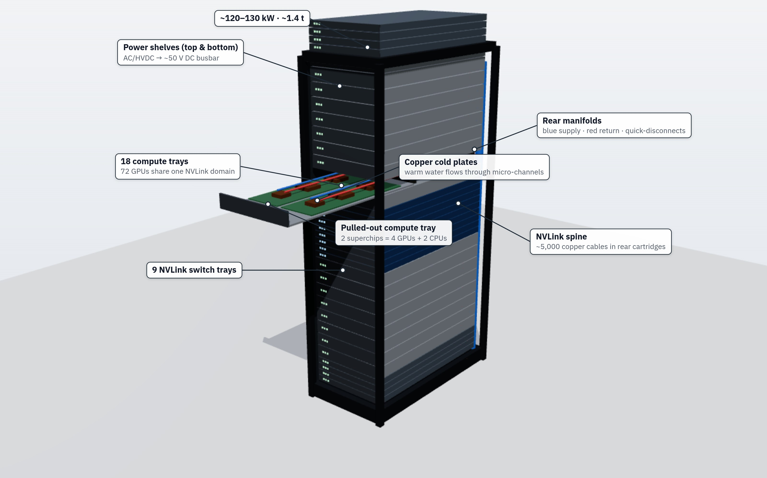
Figure 5 — A liquid-cooled NVL72-class rack. One compute tray is pulled out to show the cold plates on the GPUs and CPUs. Supply and return manifolds and the copper DC busbar run up the back; the NVLink “spine” of copper cables joins all 72 GPUs.
The key design choice is warm water. Cold plates accept coolant at 25–45 °C. Water that warm can be cooled by outside air in most climates for most of the year, with no refrigeration compressor running. That is how AI halls reach PUEs near 1.1 despite their density.

The cooling loops
Most liquid-cooled facilities have two or three connected loops (Figure 6).
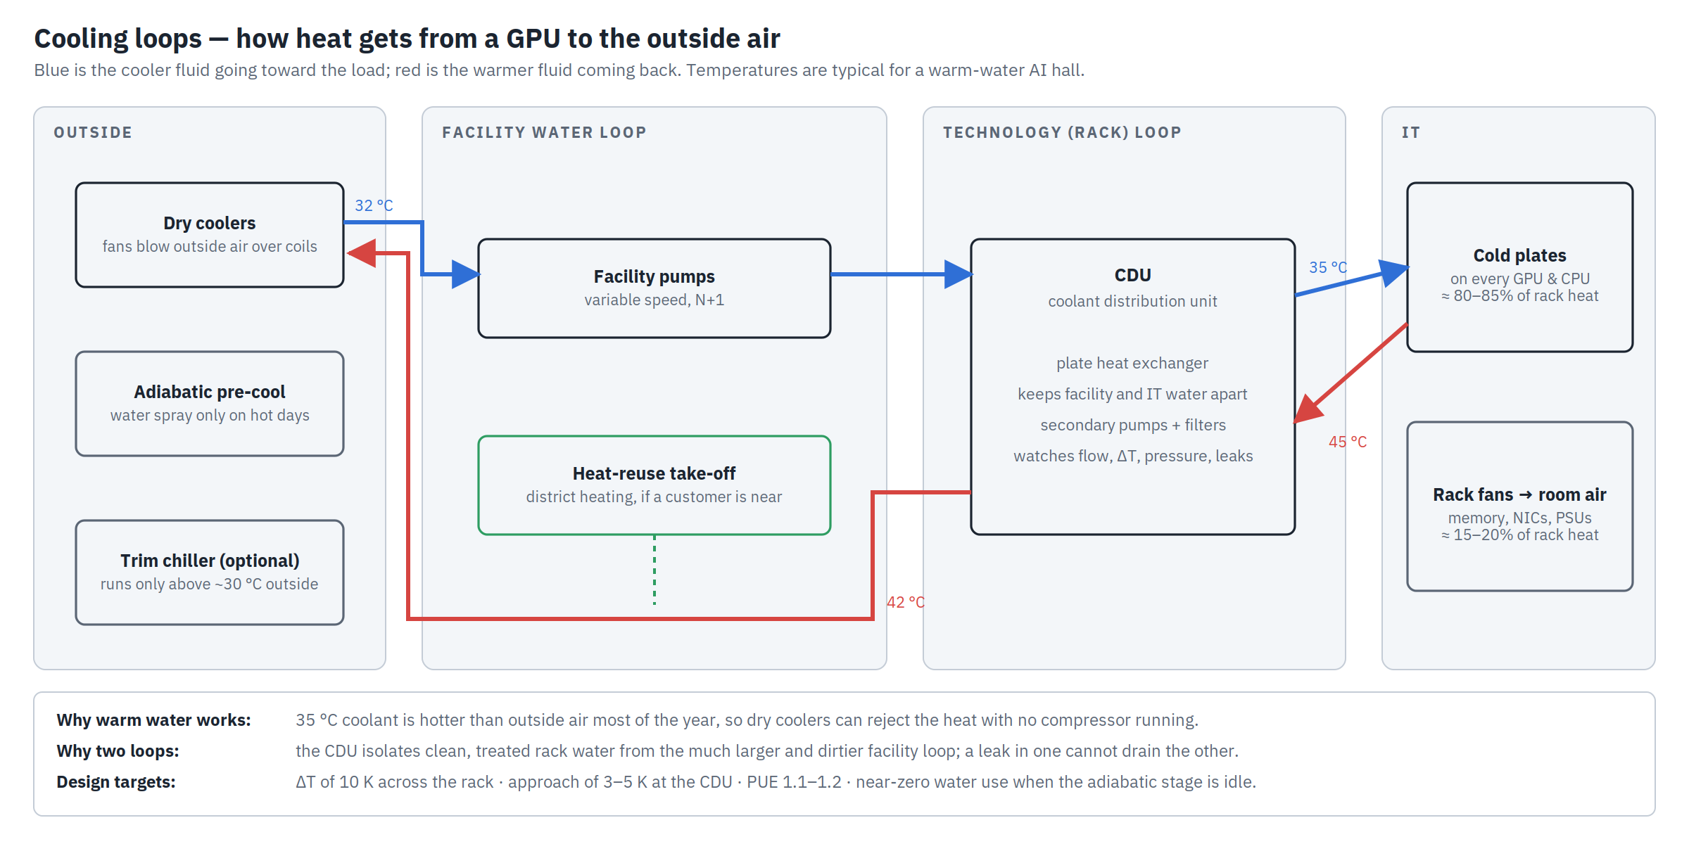
Figure 6 — Cooling loops. The facility loop moves heat from the CDU to the outside; the technology loop moves heat from the cold plates to the CDU; residual heat goes to room air.
- Facility water loop. Carries heat from the building to the outside. It includes pumps, large pipes and heat-rejection equipment: dry coolers (big radiators with fans), cooling towers (which evaporate water and are more efficient but use water), or adiabatic dry coolers that spray water only on the hottest days. Some sites add a small trim chiller for heat waves.
- Technology (rack) loop. Carries very clean, treated water or a water-glycol mix through the rack manifolds and cold plates.
- Coolant distribution unit (CDU). A heat exchanger with pumps, filters and sensors that separates the two loops. A leak or contamination in one loop cannot drain or foul the other. CDUs can sit in a gallery (Figure 2), at the end of a row (Figure 4) or inside the rack.
- Air loop. Fans and coils (CRAHs or fan walls) remove the heat the liquid does not capture.
Design goals:
- A large temperature rise (ΔT). A 10 K rise across the rack needs half the flow of a 5 K rise, so pipes and pumps can be smaller.
- Warm supply temperatures, to maximise hours without compressors.
- N+1 redundancy on pumps, CDUs and heat-rejection units, with valves that let any one be isolated for repair.
- Leak detection at every rack and under every pipe joint, with automatic shut-off valves.
- Low water use. Closed-loop dry cooling uses almost no water. Evaporative cooling saves electricity but can use 1–2 litres of water per kWh of IT energy.

Efficiency: PUE, WUE and CUE
Three ratios dominate efficiency reporting.
- PUE (power usage effectiveness) = total facility energy ÷ IT equipment energy. A PUE of 1.0 would mean no overhead at all. The best new facilities report 1.08–1.2. The global average reported by Uptime’s surveys has hovered around 1.5–1.6 for years, pulled up by older sites.
- WUE (water usage effectiveness) = litres of water consumed ÷ kWh of IT energy. It ranges from near zero for closed-loop dry cooling to about 2 L/kWh for heavily evaporative sites. Communities and regulators increasingly ask for it.
- CUE (carbon usage effectiveness) = kg of CO₂ ÷ kWh of IT energy. It depends mostly on the local grid and on clean-energy contracts.
PUE is a blunt tool. It ignores what the computers achieve, it gives no credit for reusing heat, and moving equipment such as server fans into or out of the “IT” side can change it. It remains the industry’s common language anyway.
Heat reuse is the next step. Water coming back from cold plates at 40–45 °C is warm enough, with a heat pump, to feed district heating networks. Meta’s data center in Odense, Denmark, Microsoft’s partnership with Fortum in Finland and the Stockholm Data Parks programme all do this. Heat reuse only works where there is a heat customer within a few kilometres, which rules out most remote AI campuses.

Part V — The white space

Data hall layout
The white space is where the racks stand. Its layout balances power, cooling, cabling, weight and access.
- Raised floor or slab. For decades, cold air came up through perforated tiles in a raised floor about 0.6 m high, with cables underneath. New AI halls almost always use a concrete slab with everything overhead (Figure 4). Slabs carry heavy liquid-cooled racks better, perform better in earthquakes, and keep leaks and cables apart.
- Aisle widths. Cold aisles are about 1.2 m wide, enough for a person and a server lift. Hot aisles are often about 0.9–1.2 m.
- Row length is limited by fire compartments, busway ratings and cable reach. Rows of 15–30 m are typical.
- Containment is standard in all new builds.
- Clear height of 6–10 m leaves room for busway, trays, pipes and the hot-air return space.
- Access. Wide doors, ramps and a clear route from the loading dock so a 1.4-tonne rack on a pallet jack can reach any position.

Racks
The 19-inch rack, standardised in the 1960s, is still the basic unit. It is 19 inches (482.6 mm) between mounting rails, typically 42–52 U tall (1U = 1.75 in, 44.45 mm), 600–800 mm wide and 1,000–1,200 mm deep.
Variants in high-density facilities:
- Open Compute Project (OCP) Open Rack. A 21-inch-wide equipment space with a shared DC busbar at the back and hot-swappable power shelves. Used widely by Meta and Microsoft.
- NVIDIA MGX and NVL72-class racks (Figure 5). Built around GPU trays, liquid manifolds and a DC busbar. An NVL72 holds 18 compute trays (72 Blackwell GPUs and 36 Grace CPUs) and 9 NVLink switch trays.
- Next-generation AI racks, designed for 600 kW to 1 MW per rack, with power conversion moved to a separate sidecar or to the building.
Cable management is a craft of its own. Pre-terminated fibre trunks with multi-fibre MPO connectors, labelled patch panels and overhead trays keep airflow clear and make changes quick.

Cabling and fibre
A data center is a fibre plant as much as a power plant. One AI training cluster can need hundreds of thousands of optical links.
- Fibre types. Multimode fibre is cheaper for short runs (under about 100 m). Singlemode fibre is used for everything longer and increasingly for everything, because the fastest optics (400G, 800G, 1.6T) use it.
- Connectors. LC for single links; MPO/MTP for 8–24 fibres at once; very small form-factor connectors (MDC, SN) where panel space is tight.
- Standards. ANSI/TIA-942, ISO/IEC 11801-5 and BICSI 002 cover cabling layout, labelling and grounding.
- Meet-me room (MMR). A secure telecom room where outside carriers and cloud connections meet the building’s network.
Optical transceivers, the small modules that turn electrical signals into light, are now a large share of network cost and power. An 800G transceiver uses roughly 15 W, and a large cluster needs hundreds of thousands of them. Co-packaged optics, which put the lasers next to the switch chip, cut that power substantially. NVIDIA and Broadcom began shipping co-packaged-optics switches in 2025–2026.

Part VI — The network

Fabric topologies
Old data center networks were built like a tree: access switches fed aggregation switches, which fed a core. That suited traffic going in and out of the building (“north-south”). Modern workloads send most traffic between servers (“east-west”), and a tree chokes on that.
The answer is the leaf-spine design (Figure 7), a form of the Clos network invented for telephone exchanges in the 1950s.
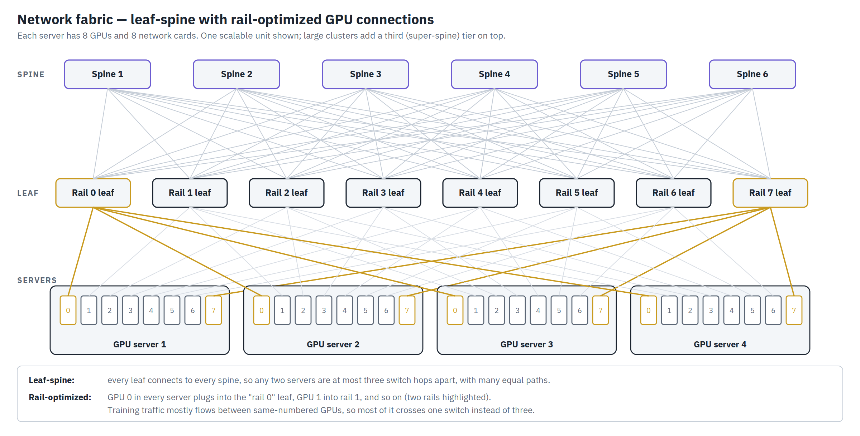
Figure 7 — Leaf-spine fabric with rail-optimized GPU connections. Every leaf connects to every spine; GPU number 0 in every server connects to the rail-0 leaf, and so on.
- Leaf switches connect to servers.
- Spine switches connect to every leaf.
- Any two servers are at most three switch hops apart (leaf, spine, leaf), and there are many equal paths between them.
A non-blocking fabric has as much spine capacity as the leaves can send. Very large networks add a third tier, the super-spine. Google’s Jupiter network goes further and uses optical circuit switches (mirrors that redirect light) in place of the spine.

Ethernet, InfiniBand and NVLink
Three kinds of network sit inside an AI factory.
Network technologies in an AI cluster.
 | NVLink (and similar) | InfiniBand | Ethernet (RoCE / Ultra Ethernet)
Role | scale-up: makes the GPUs in one rack act as one large GPU | scale-out: connects racks in a training cluster | scale-out GPU fabric, storage, management and connection to the outside
Reach | inside a rack (copper), or a few racks | the whole cluster | anywhere
Speed | 1.8 TB/s per GPU (NVLink 5) | 400 Gb/s (NDR) or 800 Gb/s (XDR) per port | 400–800 Gb/s per port, 1.6 Tb/s arriving
Who makes it | NVIDIA; open alternatives (UALink) in development | NVIDIA (from its Mellanox acquisition) | many vendors
- NVLink links 72 GPUs in an NVL72 rack into one domain through the NVLink switch trays and about 5,000 copper cables in the rack’s spine. Any GPU can read another’s memory directly.
- InfiniBand was built for supercomputers. It does not drop packets and steers traffic around congestion, giving very consistent latency. It has dominated large training clusters.
- Ethernet is everywhere and has many suppliers. With RDMA over Converged Ethernet (RoCE) and newer congestion control, it now runs many of the largest training clusters, including Meta’s and xAI’s. The Ultra Ethernet Consortium published its 1.0 specification in 2025 to tune Ethernet further for AI.

Rail-optimized GPU networks
During training, GPUs constantly exchange results. In a common pattern, GPU 0 in every server talks mostly with GPU 0 in other servers, GPU 1 with GPU 1, and so on.
A rail-optimized network takes advantage of this. Each 8-GPU server has 8 network cards. Card 0 in every server connects to the “rail 0” leaf switch, card 1 to rail 1, and so on (Figure 7). Most training traffic then crosses one switch instead of three, which lowers latency and frees spine capacity. Nearly every large GPU cluster is now built this way.

Connecting buildings
A large operator runs a region: several buildings or campuses within a few tens of kilometres, linked by data center interconnect (DCI). This is fibre carrying many wavelengths of light (DWDM) at 400 Gb/s to 1.6 Tb/s each, with round-trip times well under a millisecond. Across continents, private backbones (Google’s B4, Microsoft’s WAN, Meta’s Express Backbone) carry petabits per second.
AI is pushing these links harder. Google has described training Gemini models across multiple data centers, and Microsoft links its Fairwater AI sites over a dedicated high-speed network. When no single site can get enough power, splitting training across sites becomes necessary.

Part VII — The AI factory

Why AI data centers are different
A cloud data center serves many small, independent jobs. Each rack mostly works alone, failures are local, and the total power draw is smooth because thousands of unrelated jobs average out.
An AI training data center runs a few enormous jobs. Every GPU is part of one calculation, so a slow or failed GPU can hold up thousands of others. Five properties set these buildings apart:
- Rack density of 60–150 kW today, heading to 600 kW and more (Figure 8).
- Liquid cooling everywhere (see Liquid cooling).
- Very large scale-up domains. A whole rack, and soon several racks, behaves as one machine.
- Dedicated GPU networks, rail-optimized and usually non-blocking.
- Synchronised power swings (see Power swings).
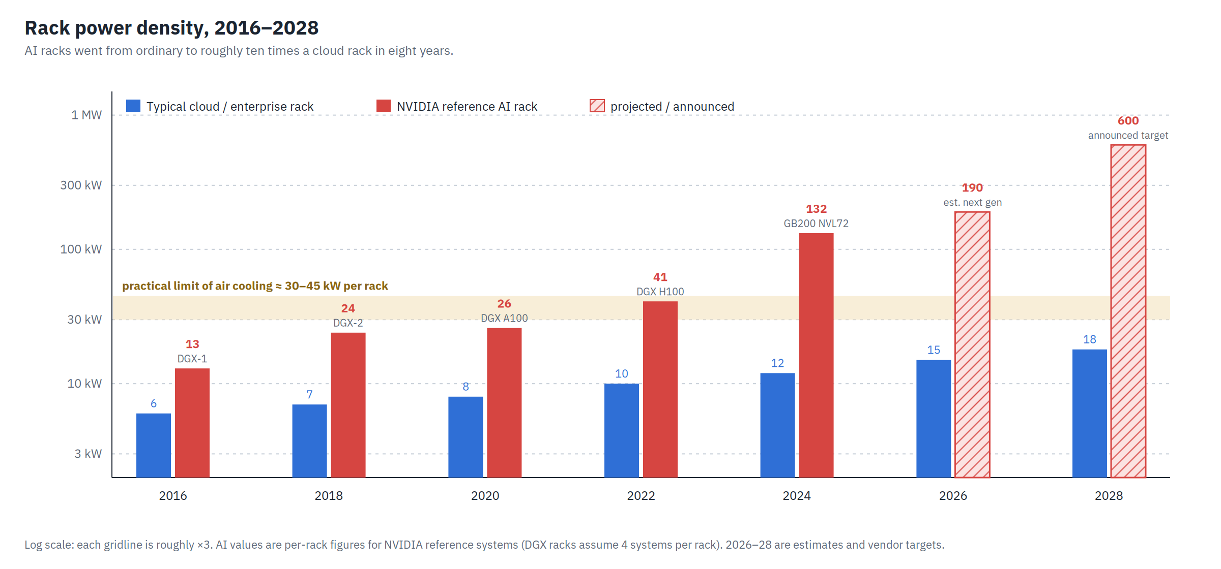
Figure 8 — Rack power density, 2016–2028, on a log scale. Cloud racks have roughly tripled; AI racks have grown about tenfold, past the practical limit of air cooling.
The building changes to match:
- Heavier floors and stronger slabs.
- More mechanical space per megawatt: CDUs, pumps and bigger pipes.
- Fewer, larger electrical feeds per row: busway rated 800–1,600 A or more.
- Warmer white space (25–30 °C), because liquid does most of the work.
- Room to grow: power and cooling designed for the next GPU generation, not just this one.

GPU pods
The building block of an AI factory is the pod or scalable unit: a group of racks that are installed, cabled, tested and scheduled together. Figure 9 shows one.
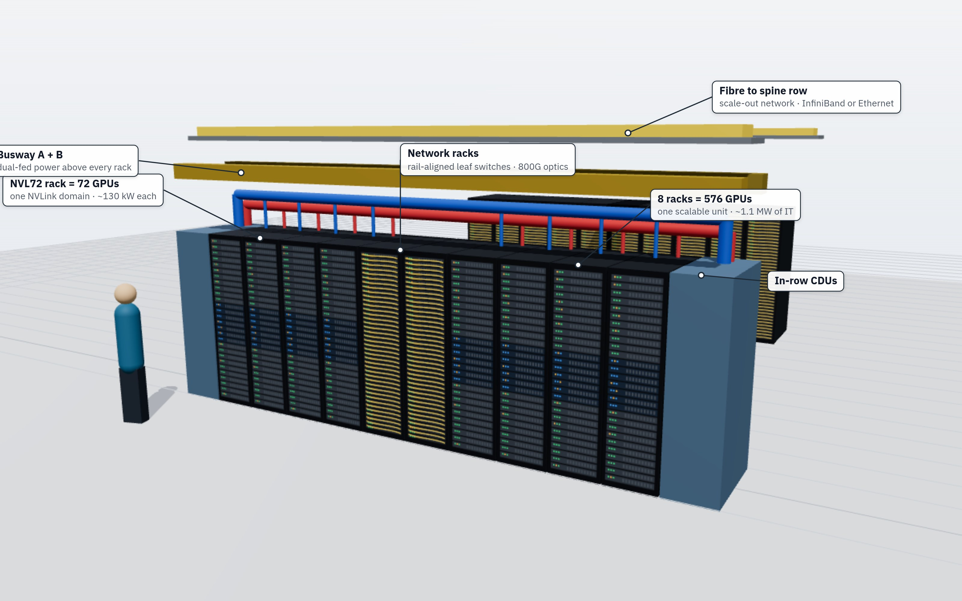
Figure 9 — A GPU pod row. Eight NVL72 racks (576 GPUs) with network racks in the middle, in-row CDUs at each end, dual overhead busway, liquid headers and fibre running to the spine row.
A typical NVIDIA GB200 scalable unit has:
- 8 NVL72 racks = 576 GPUs, about 1–1.1 MW of IT load.
- Network racks holding the rail leaf switches for the scale-out fabric.
- Liquid distribution: in-row CDUs or connections to a facility CDU gallery.
- Dual busway (A and B) above the row.
Clusters are built by repeating this unit: 16 units make about 9,000 GPUs, and 100 units make about 57,000. Job schedulers such as Slurm or Kubernetes place training jobs in whole units so traffic stays local.
Other vendors use similar ideas: Google’s TPU v5p pods link 8,960 chips and its Ironwood (v7) pods 9,216 chips with optical circuit switches; Amazon’s Trainium2 UltraServers link 64 chips; AMD’s MI350-series racks link 8-GPU nodes over Ethernet.

Power swings
The power draw of an AI training cluster is unusual.
A cloud building’s power curve is smooth, because many independent jobs average out. A training cluster’s curve is jagged and synchronised. All GPUs compute together at full power, then pause together while they exchange results over the network, then compute again. They repeat this cycle many times a second.
At 100,000 GPUs of about 1.2–1.4 kW each (including their share of CPU, memory and network), that is a load of well over 100 MW that can drop and recover by a large fraction in a fraction of a second. A job that crashes or finishes can drop it all at once. To the grid, this looks like a very large, very fast industrial load. Grid operators, including ERCOT in Texas and NERC, now study large AI loads specifically after several incidents in which groups of data centers dropped off the grid together during voltage dips.
Engineering responses include:
- Batteries on the building bus to absorb and supply the swings.
- Software power smoothing. GPU firmware and training frameworks keep power near a steady floor, for example by running filler work during network phases. NVIDIA added power-smoothing features for this purpose.
- Grid-forming inverters and fast reactive-power control at the substation.
- Ride-through settings agreed with the utility, so the campus does not disconnect during brief voltage dips.

Training halls and inference halls
Training halls build new models. They run long, tightly coupled jobs and are optimised for maximum computation per watt and the largest possible coherent clusters. They can be far from users and are often in rural areas with cheap power.
Inference halls run trained models to answer user requests. They are optimised for cost per answer and fast response, so they sit closer to population centres and need cloud-style reliability. Their racks may be just as dense, since the same GPUs are used, but their networks look more like a normal cloud than a supercomputer.
The boundary is blurring. Inference now uses a growing share of AI compute, and many operators design halls that can switch between the two. The overall pattern is gigawatt training campuses where power is available, and smaller inference sites near users.

Notable AI campuses
As publicly reported through mid-2026:
- xAI Colossus, Memphis, Tennessee. About 100,000 H100 GPUs installed in 122 days in 2024, expanded beyond 200,000. A second, larger site (Colossus 2) targets around a gigawatt, using on-site gas turbines and Tesla Megapack batteries.
- OpenAI Stargate, with Oracle and SoftBank. A multi-site US programme, the first in Abilene, Texas (built by Crusoe and operated with Oracle), and further sites announced in Texas, New Mexico, Ohio and the Midwest, plus partner projects abroad.
- Meta Prometheus (New Albany, Ohio, ~1 GW) and Hyperion (Richland Parish, Louisiana), planned to grow to several gigawatts.
- Microsoft Fairwater (Mount Pleasant, Wisconsin, and Atlanta). Two-storey halls with closed-loop liquid cooling, linked into one distributed AI system.
- Amazon Project Rainier (New Carlisle, Indiana). Hundreds of thousands of Trainium2 chips, built for Anthropic.
- Google TPU campuses in Iowa, Oklahoma, Ohio and elsewhere, built around TPU pods and optical circuit switching.
- Neoclouds such as CoreWeave, Nebius, Crusoe and Lambda, which build or lease GPU-specific facilities, often in secondary markets with available power.
Common features: hundreds of megawatts to several gigawatts of contracted power; on-site generation or dedicated substations; warm-water liquid cooling; rail-optimized networks at 400–800 Gb/s per GPU; and build schedules far faster than the industry managed before.

Part VIII — Safety, security and operations

Physical security
Large data centers are protected in layers, each harder to pass than the last:
- Perimeter: fences, crash-rated barriers and gates, cameras, and intrusion sensors such as radar or buried cable.
- Site entry: a staffed guardhouse, vehicle inspection and number-plate recognition.
- Building: no windows in halls, hardened walls, badge-controlled doors, and mantraps (two-door booths that let one person through at a time, often with biometric checks).
- Inside: separate access zones; data halls typically need a badge plus fingerprint or face recognition.
- Customer cages in colocation sites, with locked cabinets and their own cameras.
- Security operations centre: 24/7 monitoring and guards.
Insider risk is taken seriously: background checks, two-person rules for sensitive rooms, and strict control of anything that stores data leaving the building. Used drives are typically shredded on site.

Fire detection and suppression
Fire in a data center is dangerous because of the high-value equipment, the electrical energy and the fast air movement.

Detection
- Aspirating smoke detection (VESDA is a common brand) continuously samples air through small pipes and can detect an overheating component long before flames. Alarms escalate in stages: alert, action, fire 1, fire 2.
- Spot smoke and heat detectors as backup.
- Linear heat detection along cable trays.
- Gas detection in battery rooms.

Suppression
- Pre-action sprinklers. The pipes stay dry until a detector alarms. Water is released only if a sprinkler head is also opened by heat, so two things must go wrong before water reaches the equipment.
- Clean-agent gas (inert gases or chemical agents) in small high-value rooms such as telecom rooms. Some agents are being phased out over environmental concerns.
- Water mist systems, which use less water than sprinklers.
Compartments. Fire walls divide the building, and every cable or pipe passing through them is sealed with fire-stopping.
Battery rooms get special treatment. Lithium-ion batteries can enter thermal runaway, a self-sustaining fire. Standards such as NFPA 855 and UL 9540A set the rules for spacing, ventilation, explosion control and testing.

Operations
A data center is only as reliable as the people running it.
- Network operations centre (NOC). Watches the network and services 24/7.
- Building management system (BMS). Controls and monitors the cooling plant, electrical system and alarms.
- Electrical power monitoring system (EPMS). Records every breaker and meter at high speed, so faults can be traced afterwards.
- DCIM software (data center infrastructure management). Tracks every asset, its power, temperature and location, and plans capacity.
- Maintenance management. Generators are run under load monthly; batteries, breakers and cooling units are tested on fixed schedules.
- Change control. Every change follows a written method, peer review and a rollback plan. Most avoidable outages trace to skipped or unclear procedures.
- Staffing. A 100 MW site might have 30–80 staff across security, electrical, mechanical, IT and management, working in shifts around the clock.

Commissioning
Before a data center goes live, it is tested in five levels:
- Level 1, factory testing. Major equipment is tested at the manufacturer.
- Level 2, delivery inspection. Equipment is checked on arrival for damage and conformity.
- Level 3, installation and start-up. Each item is installed and started by its vendor.
- Level 4, system testing. Each system (UPS, generators, cooling plant) is tested on its own under load.
- Level 5, integrated systems testing. The whole facility is tested together under simulated full load using load banks, with real failures staged: pull the utility, fail a generator, fail a pump, trip a breaker. Only after Level 5 is the hall handed over for IT equipment.
For liquid-cooled halls, commissioning also includes flushing and filling the technology loop, checking water quality, and leak-testing every connection. An independent commissioning agent documents the results for the owner, insurers and tenants.

Part IX — Money and the future

Costs
Data center costs are usually quoted per megawatt of IT capacity. Approximate 2025–2026 US ranges for the building and its infrastructure:
Approximate construction cost per megawatt, excluding IT equipment.
Facility type | Build cost per MW of IT
Enterprise, Tier III | $8–12 million
Hyperscale, air-cooled | $9–12 million
AI-ready, liquid-cooled | $11–15 million
Highly redundant AI or Tier IV | $15–25 million
The building is the smaller part of the bill for AI. The IT equipment usually costs two to four times as much as the building. An NVL72 rack sells for roughly $3–4 million, so 100 MW of them costs on the order of $2.5–3 billion, compared with about $1.1–1.5 billion for the facility.
Annual operating costs for a 100 MW site:
- Electricity: the largest cost. At $0.06/kWh and a PUE of 1.2, about $55–65 million a year.
- Staff and maintenance: about $10–20 million.
- Property tax and insurance: highly variable, $2–15 million.
- Water and treatment: $0.5–3 million.
Revenue models. Wholesale colocation is priced per kW per month (roughly $120–200 for large hyperscale leases in major US markets). Retail colocation is priced per cabinet. GPU clouds charge per GPU-hour, roughly $2–6 for current-generation GPUs depending on model and contract length.

Regulation and communities
Data centers used to be welcomed as quiet taxpayers. They are now examined as heavy users of power, water and land.
- Grid rules. Utilities and regulators are creating special tariffs for very large loads, often requiring long contracts, minimum payments or customer-funded grid upgrades so other customers do not carry the cost. Texas, Ohio, Virginia and Georgia have all acted.
- Pauses and limits. Ireland’s grid operator restricted new connections around Dublin; Amsterdam and Frankfurt have zoning limits.
- Community agreements: local hiring, road improvements and payments to schools and services.
- Noise rules, which affect generator testing schedules and cooling fan choices.
- Water permits with drought conditions attached.
- Air permits limiting generator hours.
- Disclosure. The EU’s Energy Efficiency Directive requires large data centers to report energy, water and heat-reuse figures each year.

Sustainability
The IEA estimates that data centers used about 415 TWh in 2024, roughly 1.5% of global electricity, and projects about 945 TWh by 2030, driven mostly by AI. Lawrence Berkeley National Laboratory estimated US data centers used 4.4% of US electricity in 2023, rising to between 6.7% and 12% by 2028.
The industry’s responses:
- Efficiency. New builds at PUE 1.1–1.2, warm-water cooling, more efficient chips per unit of computation.
- Clean-energy contracts. Long-term power purchase agreements (PPAs) for wind, solar and storage.
- 24/7 carbon-free energy. Google and Microsoft aim to match their use with clean energy every hour, not just on an annual total. That pushes demand for always-available sources such as nuclear, geothermal and long-duration storage.
- Heat reuse where a heat customer is nearby.
- Water. Closed-loop and dry cooling, recycled or non-drinking water for evaporative systems, and published WUE figures.
- Embodied carbon. Lower-carbon concrete and steel, and longer equipment lifetimes.

What comes next
Five trends will shape the next five years:
- Bring-your-own power. On-site gas plants and large batteries are already common at AI campuses. Nuclear restarts and uprates are coming online, and small modular reactors are planned for the 2030s. This separates AI growth from grid connection queues, at a cost in emissions, money or time.
- Megawatt racks and 800 V DC. Rack power is heading toward 1 MW. Power will be converted outside the rack and distributed at 800 V DC to cut copper and losses.
- Light instead of copper. Co-packaged optics put lasers next to switch chips, and optical interconnects will extend scale-up domains beyond one rack.
- Optical circuit switching. Mirrors that redirect light, used by Google, may take over parts of the network from electronic switches.
- Flexible demand. Data centers that can briefly slow down or shift work when the grid is stressed can connect sooner. Several utilities now offer faster connections in exchange for this flexibility.
The data center, a plain industrial building in a field, has become one of the most strategically important kinds of infrastructure in the world.

Worked example: a 100 MW AI hall
This chapter puts the guide’s numbers together for one hypothetical 100 MW (IT) training hall built with NVL72-class racks. Every figure is rounded and meant to show the scale, not to serve as a design.

Compute
- 100 MW ÷ ~132 kW per rack ≈ 750 racks
- 750 racks × 72 GPUs ≈ 54,000 GPUs
- ≈ 94 scalable units of 8 racks

Electricity
- PUE of 1.2 → 120 MW at the meter
- At an average 85% load: 120 MW × 0.85 × 8,760 h ≈ 0.9 TWh a year, about as much as 85,000 US homes
- At $0.06/kWh ≈ $54 million a year

Cooling
- About 85 MW leaves in liquid. With a 10 K temperature rise: flow = 85,000 kW ÷ (4.19 kJ/kg·K × 10 K) ≈ 2,000 litres per second (about 32,000 US gallons per minute), or roughly 2.7 L/s per rack
- About 15 MW leaves in air. With a 12 K air temperature rise: 15,000 kW ÷ (1.2 kg/m³ × 1.005 kJ/kg·K × 12 K) ≈ 1,000 m³/s of air (about 2.2 million cubic feet per minute)
- With dry coolers, water use is close to zero except during adiabatic hours in heat waves

Electrical plant
- Batteries: 5 minutes at 100 MW ≈ 8.3 MWh usable, per path
- Generators: about 120 MW ÷ 3 MW ≈ 40, plus spares → 45–50 units, or none if the site relies on on-site gas generation instead
- Unit-substation transformers: about 40 × 3 MVA per path

Space
- About 750 racks at 2.5–3.5 m² of white space each (including aisles and in-row CDUs) ≈ 2,000–2,600 m² of white space
- Electrical and mechanical rooms usually need two to three times that again

Money
- Building and infrastructure: about $1.1–1.5 billion
- IT equipment: about $2.5–3 billion for racks plus roughly 10–15% more for the network and storage
- Total: on the order of $4–5 billion, with power costs of about $50–60 million a year

Weight
- 750 racks × ~1.4 t ≈ 1,050 tonnes of IT equipment, about as much as 700 cars, plus several hundred tonnes of water in the pipes

Glossary
2N
Two complete, independent systems, each able to carry the whole load.
Adiabatic cooling
Spraying water onto air or coils so evaporation lowers the temperature; used only on the hottest days in “adiabatic dry coolers”.
All-reduce
A step in distributed training where every GPU combines its results with every other GPU’s.
ATS
Automatic transfer switch: moves a load from one power source to another, for example from the utility to generators.
BESS
Battery energy storage system; container-sized batteries used for backup, smoothing and grid services.
BMS
Building management system: software that controls and monitors cooling, electrical and building equipment.
Busbar / busway
A rigid metal conductor; busway runs above rows with plug-in tap boxes, and a busbar runs up the back of a rack.
CDU
Coolant distribution unit: a heat exchanger with pumps and filters that separates facility water from rack water.
Checkpoint
A saved copy of a training job’s progress, so it can restart after a failure.
Clos / leaf-spine
A network where every leaf switch connects to every spine switch, giving many equal paths.
Cold plate
A metal block with internal channels, fixed to a chip, through which coolant flows.
Colocation
A data center that rents space, power and cooling to customers who bring their own equipment.
Containment
Doors and panels that separate hot and cold air in a data hall.
Co-packaged optics
Optical engines mounted in the same package as a switch or network chip.
CRAC / CRAH
Computer room air conditioner (with its own compressor) / air handler (using chilled water).
CUE
Carbon usage effectiveness: kg of CO₂ per kWh of IT energy.
DCI
Data center interconnect: high-capacity fibre links between buildings or campuses.
DCIM
Data center infrastructure management software: asset, power, cooling and capacity tracking.
Dry cooler
A large radiator with fans that rejects heat to outside air without using water.
DWDM
Dense wavelength-division multiplexing: many colours of light on one fibre.
GPU
Graphics processing unit; the main chip used for AI training and inference.
Hot aisle / cold aisle
The layout where racks face each other in pairs so all intakes share one aisle and all exhausts share another.
Hyperscaler
A company running cloud infrastructure at very large scale (Amazon, Microsoft, Google, Meta, Oracle, Alibaba and others).
InfiniBand
A low-latency, lossless network used in supercomputers and AI clusters; generations include HDR (200 Gb/s), NDR (400 Gb/s) and XDR (800 Gb/s).
Inference
Running a trained AI model to answer requests.
IT load
The power used by the computing equipment itself, excluding cooling and other overhead.
Kilowatt (kW), megawatt (MW), gigawatt (GW)
Units of power: 1 MW = 1,000 kW; 1 GW = 1,000 MW.
Mantrap
A small two-door security booth that admits one person at a time.
MV / LV
Medium voltage (roughly 1–35 kV) / low voltage (under 1 kV).
N+1
The number of units needed plus one spare.
Neocloud
A cloud provider specialising in GPU computing (CoreWeave, Nebius, Crusoe, Lambda and others).
NVLink
NVIDIA’s high-speed GPU-to-GPU link; an NVL72 rack joins 72 GPUs in one NVLink domain.
OCP
Open Compute Project: an industry group publishing open hardware designs, started by Facebook (now Meta).
Optical circuit switch
A switch that redirects light with tiny mirrors instead of processing packets electronically.
PDU
Power distribution unit: equipment that distributes power to rows or racks.
PPA
Power purchase agreement: a long-term contract to buy electricity, often from a new wind or solar farm.
Pre-action sprinkler
A sprinkler system whose pipes stay dry until a detector alarms.
PUE
Power usage effectiveness: total facility energy divided by IT energy.
Rail-optimized
A GPU network design where same-numbered GPUs in every server share a leaf switch.
RoCE
RDMA over Converged Ethernet: lets servers read each other’s memory directly across Ethernet.
Scalable unit (pod)
A standard group of racks installed and operated together, for example 8 NVL72 racks.
Scale-up / scale-out
Making one machine bigger (more GPUs in one NVLink domain) / connecting more machines over a network.
SMR
Small modular reactor: a factory-built nuclear reactor of up to about 300 MW.
Tier I–IV
Uptime Institute’s classification of data center redundancy.
ToR / leaf
Top-of-rack or leaf switch: the first switch a server connects to.
UPS
Uninterruptible power supply: batteries and electronics that carry the load through power disturbances.
VESDA
A brand of aspirating smoke detection, often used as a generic name.
VRM
Voltage regulator module: converts board power to the chip’s operating voltage, right next to the chip.
White space / grey space
Rooms holding IT equipment / rooms holding the electrical and mechanical equipment that supports it.
WUE
Water usage effectiveness: litres of water consumed per kWh of IT energy.

Further reading
- Uptime Institute, Tier Classification System and the annual Global Data Center Survey — uptimeinstitute.com
- ASHRAE TC 9.9, Thermal Guidelines for Data Processing Environments — ashrae.org
- Open Compute Project, Open Rack and advanced cooling specifications — opencompute.org
- NVIDIA, GB200 NVL72 product pages and DGX SuperPOD reference architectures — nvidia.com
- International Energy Agency, Energy and AI (2025) — iea.org
- Lawrence Berkeley National Laboratory, 2024 United States Data Center Energy Usage Report — eta.lbl.gov
- Google, papers on Jupiter networking, TPU pods and optical circuit switching — research.google
- Meta Engineering blog, posts on AI cluster networks and data center design — engineering.fb.com
- Microsoft, Fairwater AI datacenter announcements — blogs.microsoft.com
- NFPA 75 (IT equipment protection) and NFPA 855 (energy storage systems)
Figures: 3-D renderings and schematics created for this guide from generic, publicly documented design patterns. They are illustrative and do not depict any specific operator’s facility.

