Bar Chart - Total Sales per Category

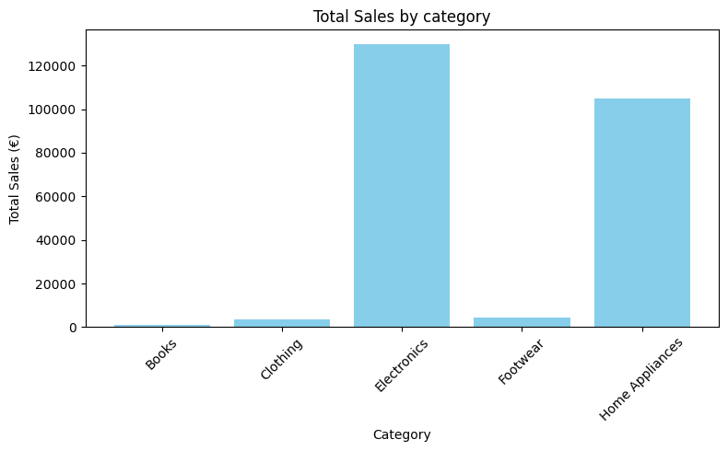

Line Chart - Monthly sales Trend
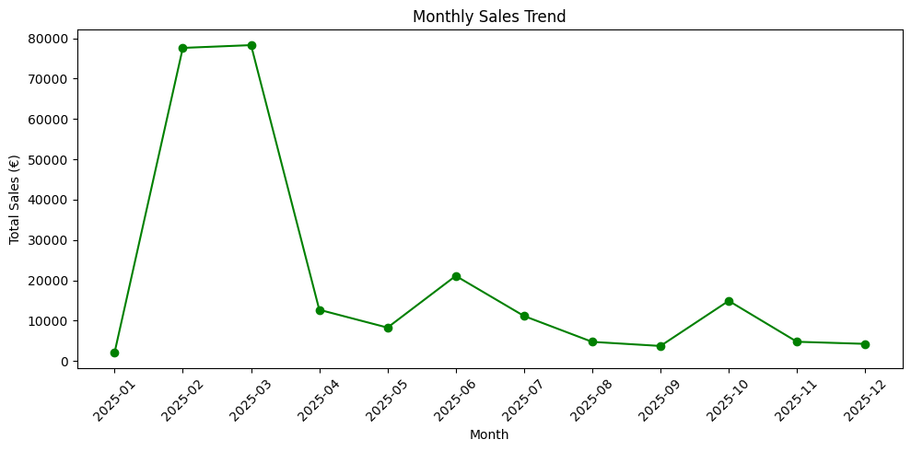

Pie Chart - Payment Method Distribution

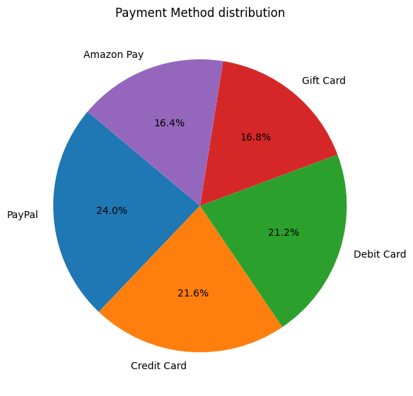

Horizonta Bar chart - Top 5 Products by Revenue

