2021-AT-03-eng Hey Taxi!
6yo–8yo:  – | 8yo–10yo:  – | 10yo–12yo:  hard | 12yo–14yo:  medium | 14yo–16yo:  easy | 16yo–19yo:  –
Answer Type: Multiple-Choice with Images (☐ keep order of multiple-choice/-select)
Categories (click to choose):  ☑ algorithms and programming  ☐ data structures and representations |  |  | ☐ computer processes and hardware  ☐ communication and networking  ☐ interactions, systems and society

Body
In the smart city of Bebrasopolis, the traffic signs know where the self-driving taxis should go and gives them directions using these symbols: . Each symbol has one of these meanings: move forward, turn left, turn right or turn back. The directions make the taxi move 1 block at a time and are always relative to the taxi’s orientation.
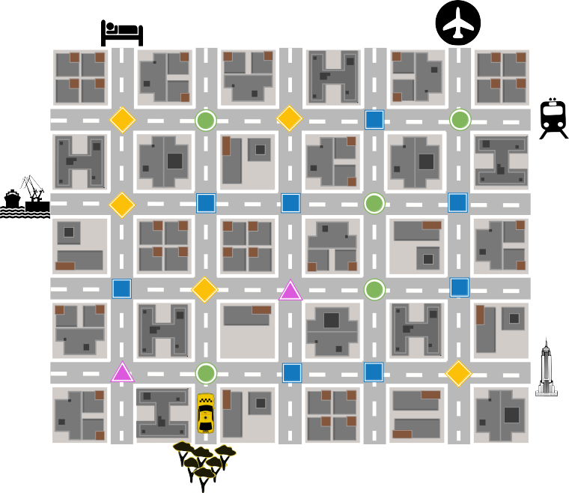
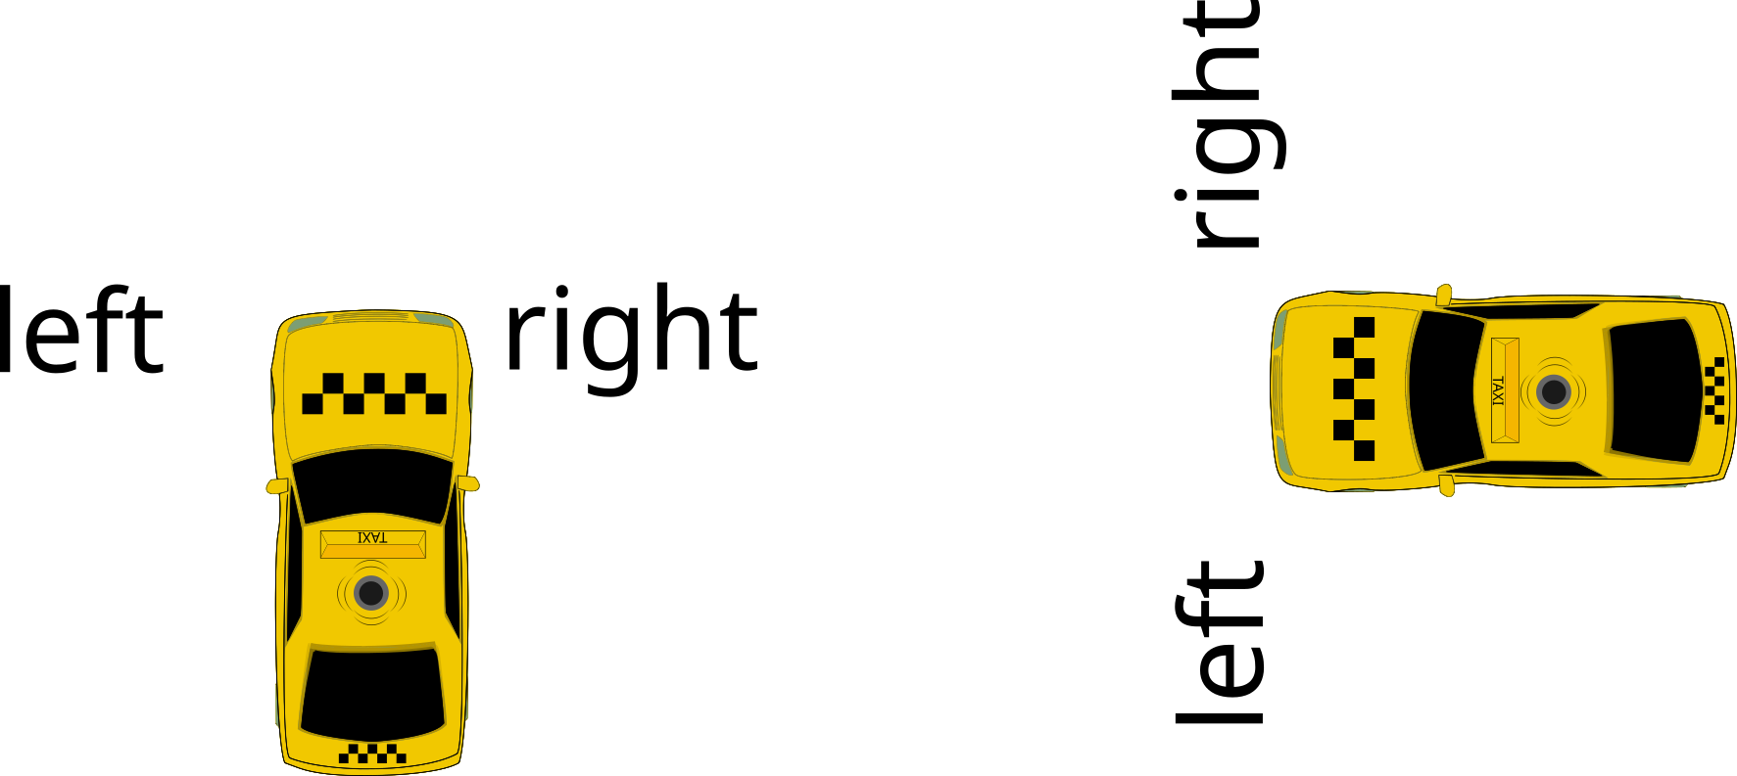

Question / Challenge
The traffic symbols in this picture direct the taxi from the park  to the airport  . What is the meaning of each traffic symbol?

Answer Options / Interactivity Description
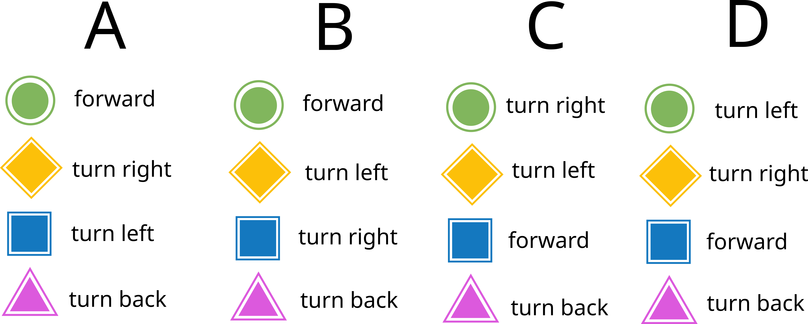

Answer Explanation
Correct answer A
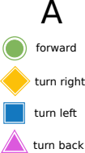
Explanation (the path from the starting point to the destination is shown):
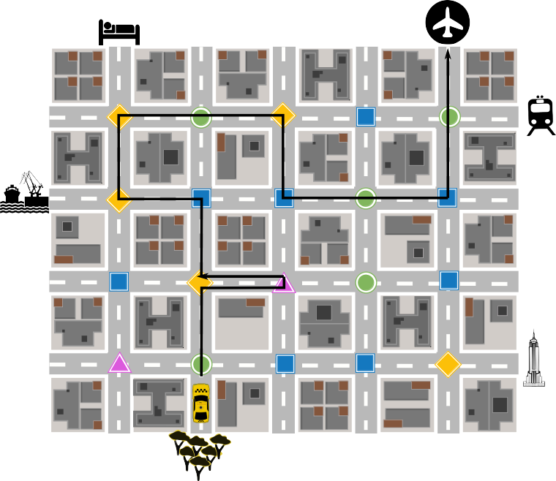

Incorrect answer B
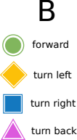

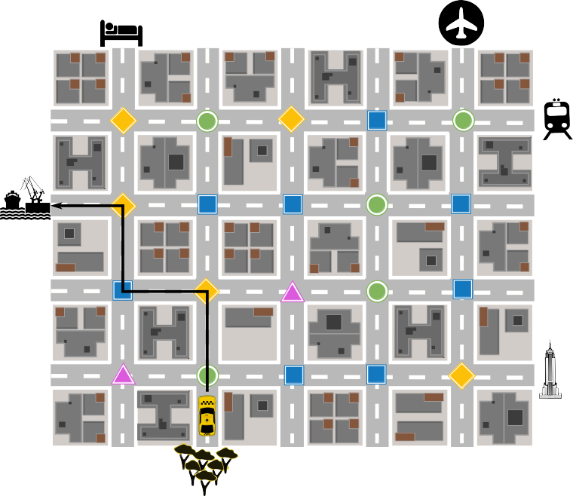

Incorrect answer C
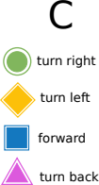

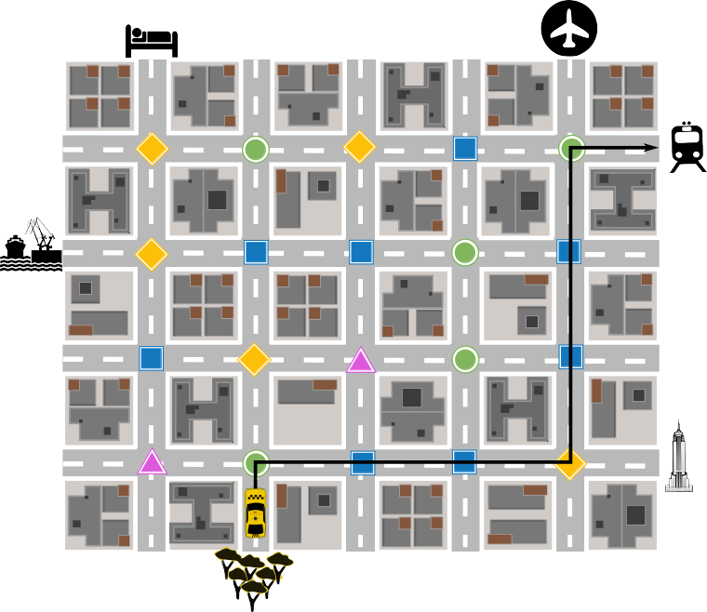

Incorrect answer D
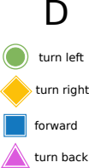

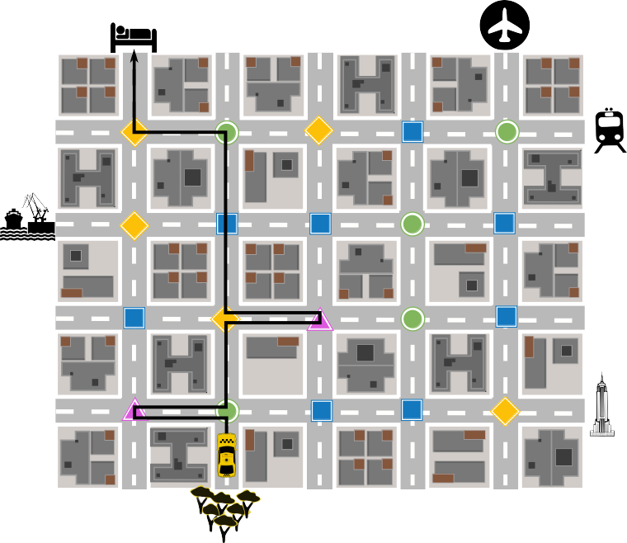

It’s Informatics
The computational thinking concept illustrated with this task is algorithms. A very simple computer program is written using four different types of instructions. Given the output of the program, you must figure out which symbol means which instruction.
Self-driving cars and other self-driving vehicles are examples of artificial intelligence that are slowly becoming an everyday part of life. The taxi in this task would need to be equipped with a broad range of sensors (like cameras, radar, ultrasonic) to understand its environment. Computer vision software would use these sensors to keep the taxi in lane, follow signs, and avoid pedestrians.
While the taxi in this task is self-driving, it is not fully autonomous, because it follows one sign after another to get to its destination. An autonomous vehicle would use artificial intelligence to decide its own route based on sensing of the environment, GPS and map data, traffic reports, and even information from other autonomous vehicles!

Keywords and Websites
Artificial intelligence: https://www.tutorialspoint.com/artificial_intelligence/index.htm
Self-driving cars / autonomous vehicles: https://en.wikipedia.org/wiki/Self-driving_car
Digital traffic signs: https://en.wikipedia.org/wiki/Variable-message_sign

Wording and Phrases
Self-driving car and autonomous car are usually synonymous, but we make a distinction in this task to illustrate that the taxi blindly follows signs whereas a truly autonomous vehicle would employ dynamic route planning.

Comments
========================================
Review by: Susanne Datzko (svn: sdatzko) on 2021-04-22 Non-assigned review Rating as is: 1/6 Potential: 3/6
It's informatics section: Can be improved
The task is very long: much to read and understand and much bookkeeping involved to find the correct solution. Is there a way to find it quickly without checking the whole way and all answer alternatives?
Graphics: No svg and source not clear enough.
========================================
By: Ungyeol Jung (svn: purnagi) on 2021-04-23 Assigned review Rating as is: 3/6 Potential: 5/6
It's informatics section: Can be improved
Combination of age group and difficulty level: The level is good
[IDEA] I like the idea. This task can help students understand AI and self-driving cars.
[TEXT] The text should be presented more clearly. Also, presenting the picture first is very awkward and less readable.
[IT'S INF] The AI concept applied to self-driving cars needs to be more clearly organized. In particular, the expression'a different AI conepts' is awkward.
[GRAPH] Graphics should be improved with SVG. Pixabay's icon needs to be recreated.
[OTHERS] This task is not accessible from the review site. It can only be accessed using the SVN repository. We need to discuss whether the title is appropriate.
========================================
By: Ruwan Devasurendra (svn: devasurendra) on 2021-04-23 Assigned review Rating as is: 4/6 Potential: 5/6
It's informatics section: Can be improve
Combination of age group and difficulty level: The task looks easier than indicated
• Perhaps change for clarity the last line of the question stem from “Which meaning the traffic symbols will have to reach the airport?” to “Which meaning should each traffic symbol have so that Bibi is able to travel from the park to the airport?”.
• It’s informatics section: could perhaps expand on the idea of algorithms and how they are used by machines/programs to make decisions. Doesn’t describe the applications of the CT skills, though has a great explanation of AI.
• Introduction could be more concise
• Good graphics and presentation of answer options and solutions
• Good question, but type of question is common.
========================================
By: Pieter Waker (svn: waker) on 2021-04-23 Non-assigned review Rating as is: 4/6 Potential: 5/6
It's informatics section: Great as it is now
Combination of age group and difficulty level: The level is good
Refreshingly different and difficult. Fortunately option1 was correct.
========================================
2021-05-19 Task Workshop Group D: The author did not make any modifications or responses to the reviews. We made changes to the text in order to simplify it and correct ambiguities (e.g. “back” could have been confused with reverse) . New graphics were created from scratch so they would be in SVG format, keeping the original ideas (also removing multiple taxis, making symbols easier to see, making city blocks more uniform). The It’s Informatics section was updated to be more straightforward, to make sensors more relevant to self-driving vehicles, to explain the main computational thinking concept for this task, and to clarify that this particular taxi is not autonomous. It is also suitable for 10-12 year olds. This task is a more sophisticated version of 2014-SI-02 Alien Language.
========================================

EDIT ABOVE (keep this template and add above this line): author, e-mail, date (YYYY-MM-DD): Comment.

Graphics and Other Files
2021-AT-03-eng.odt This file.
at-03.svg
at-03_correct.svg
at-03_b.svg
at-03_c.svg
at-03_d.svg
references.svg
The original graphical ideas are from original author Martin Kandlhofer. However, they were not in SVG format. These SVG graphics are self made by Víctor Koleszar, vkoleszar@ceibal.edu.uy; aurruticoechea@ceibal.edu.uy, Uruguay, and Alar Urruticoechea, aurruticoechea@ceibal.edu.uy, Uruguay; Licence the same as the task
These images use the following symbols and icons (Pixabay licence – free licence for commercial purposes):
https://pixabay.com/es/vectors/empire-state-building-rascacielos-33290/
https://pixabay.com/es/vectors/dormir-cama-dormitorio-resto-297724/
ttps://pixabay.com/es/vectors/tren-cercan%C3%ADas-silueta-frontal-309520/
https://pixabay.com/es/vectors/aeropuerto-se%C3%B1ales-s%C3%ADmbolos-plano-39335/

EDIT ABOVE (keep this template and add above this line): filename, author, source/self-made, license
Please indicate:
- Source of each image or of each other file to produce the task image(s):
(URL and/or author)
- License for each image.
Note: If the source of an image is unclear, it might be copyrighted and cannot be used in the task.

Authors, Contributors, and Editors (incl. Graphics)
Original author / original graphics idea: Martin Kandlhofer, kandlhofer@ocg.at, Austria
Contributor / graphics: Víctor Koleszar, vkoleszar@ceibal.edu.uy, Uruguay
Contributor / graphics: Alar Urruticoechea, aurruticoechea@ceibal.edu.uy, Uruguay
Contributor / editor, Tom Naughton, tomn@cs.nuim.ie, Ireland
Contributor / editor, Marvin G. Hall, mghall@hallsoflearning.com, Jamaica
EDIT ABOVE (keep this template and add above this line): author / contributor / editor, e-mail, country.

License

Copyright © 2021 Bebras – International Challenge on Informatics and Computational Thinking. This work is licensed under a Creative Commons Attribution-ShareAlike 4.0 International License. https://creativecommons.org/licenses/by-sa/4.0/.

