2022-FR-02c-bee-hive Bee hive
6yo–8yo:  – | 8yo–10yo:  – | 10yo–12yo:  hard | 12yo–14yo:  hard | 14yo–16yo:  medium | 16yo–19yo:  medium
Answer Type: Interactive (Drag & Drop) (☐ keep order of multiple-choice/-select)
Computational Thinking Skills:  ☑ abstraction  ☑ algorithmic thinking  ☐ decomposition  ☐ evaluation  ☑ pattern recognition |  |  | Computer Science Area:  ☑ algorithms and programming  ☐ communication and networking  ☐ computer processes and hardware  ☐ data structures and representations  ☐ interactions, systems and society

Body
Beaver needs some help to place the bees in the hive.
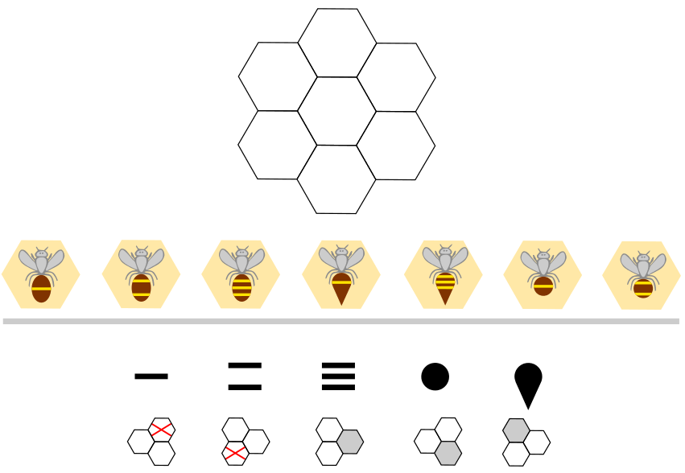
Rules are associated with the number of stripes and to the shape of the bees: below each feature is shown a part of the hive. Gray color means a bee with this feature must be placed in this way. A red cross means a bee with this feature can’t be placed here, considering the part of the hive.

Question / Challenge
Drag and drop the bees in the hive respecting the rules.

Answer Options / Interactivity Description
Interface during the resolution: so that users can check the rules they have already used, the backgrounds of the bees already placed change to gray. A bee can be removed from the hive. In this case the rule for this bee is automatically returned to its initial state.
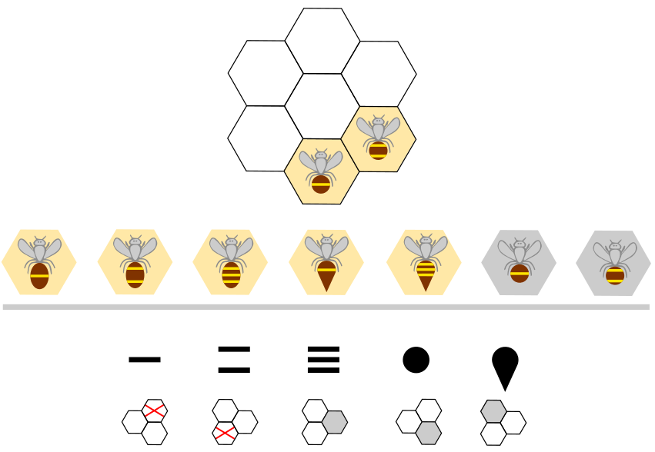
For full feedback, after all the bees have been placed, the background of one of the rules that is broken is changed to red. The corresponding cells in the grid are outlined in red.
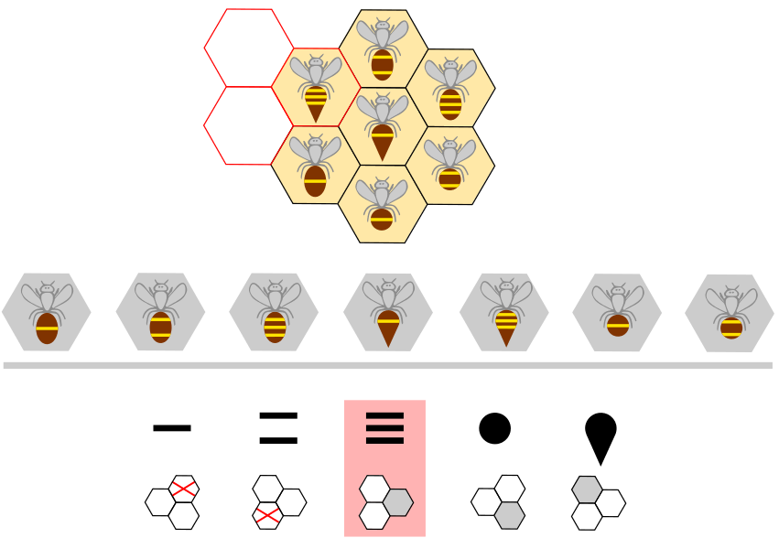

Answer Explanation
Here is the solution:
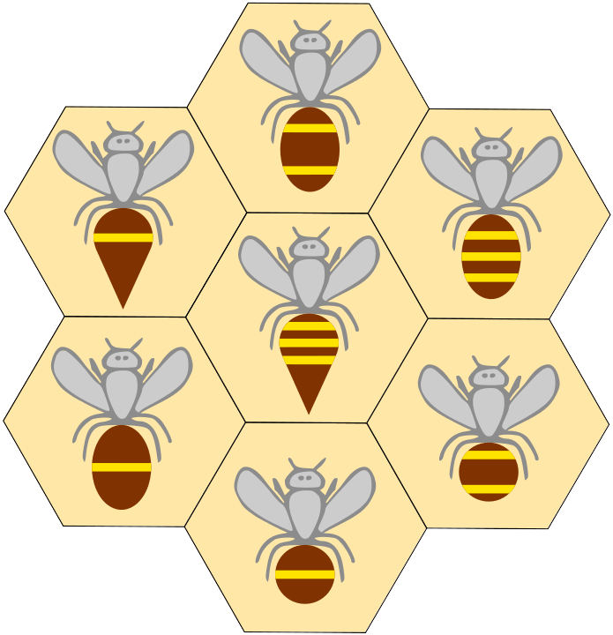
To solve the problem, we need to determine which rules apply to each bee. Then we need to mentally superimpose each piece of the hive that corresponds to a rule associated with the feature, unto the whole hive, in order to determine the possible placements for the bee. See below:
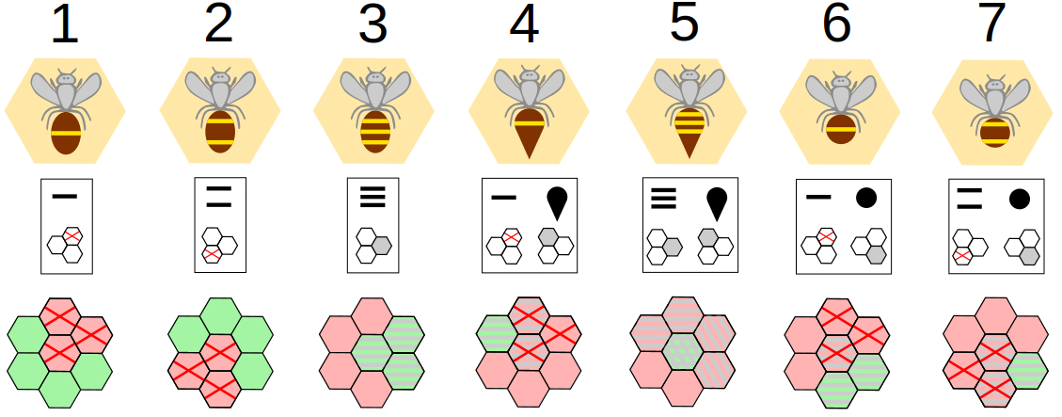
The strategy at each stage, consists of placing a bee for which only one placement is possible. There is no need for backtracking for this task.
First, bees 4, 5 and 7 can be placed. There is then only one possible place left for bee 3 and 6. In the same way we finish with placing the bees 1 and 2.

It’s Informatics
This task calls for logical skills. Reasoning induces the mobilization of the logical OR and AND connectors and the understanding of negatively formulated rules.
Logical reasoning is part of computational thinking. It is found for example when it is necessary to determine a condition for an if/else structure.
This task addresses problem solving by constraint satisfaction. The strategy for this type of problem is to start by dealing with the most constrained elements and to limit the number of cases to be explored. Constraint programming is a programming paradigm.

Keywords and Websites
Logical reasoning, OR, AND, constraint

Wording and Phrases
EDIT HERE (delete this): list of words and phrases used to name important things mentioned in the task body (actors, activities/processes, concepts, definitions, objects, names, etc.) This is to ensure the consequent use of terminology in the task body and to facilitate translation.

Comments
Marielle Léonard, marielleleonard59@gmail.com, 2022-04-01: There are two easier versions of this task.
EDIT ABOVE (keep this template and add above this line): author, e-mail, date (YYYY-MM-DD): Comment.

Graphics and Other Files
2022-FR-02c-bee-hive.odt This file.
2022-FR-02c_bee_hide.svg : Marielle Léonard, self-made
2022-FR-02c_bee_hide_being_resolved.svg : Marielle Léonard, self-made
2022-FR-02c_bee_hide_feedback.svg : Marielle Léonard, self-made
2022-FR-02c_bee_hide_right_wrong_places.svg : Marielle Léonard, self-made
2022-FR-02c_bee_hide_solution.svg : Marielle Léonard, self-made
EDIT ABOVE (keep this template and add above this line): filename, author, source/self-made, license
Please indicate:
- Source of each image or of each other file to produce the task image(s):
(URL and/or author)
- License for each image.
Note: If the source of an image is unclear, it might be copyrighted and cannot be used in the task.

Authors, Contributors, and Editors (incl. Graphics)
Author : Marielle Léonard, marielleleonard59@gmail.com, France
EDIT ABOVE (keep this template and add above this line): author / contributor / editor, e-mail, country.

License

Copyright © 2022 Bebras – International Challenge on Informatics and Computational Thinking. This work is licensed under a Creative Commons Attribution-ShareAlike 4.0 International License. https://creativecommons.org/licenses/by-sa/4.0/.

