INFOMCV Assignment 3
Authors (Group number)

Summary
(Briefly explain your implementation. How was the voxel space set, how did you create the color models, how did you do the matching. Approx. two thirds of a page.)

Everything from assignment 2 is reused as it is. The background subtraction was good enough for this assignment as well. To account for people going outside our voxel space, we increased its size. The color models are created via a color histogram. We take each cluster’s voxels that are between y:8 and y:30 which is roughly where only the t-shirt is. We disregard head and pants, since their pants’s colors and head/hair share similar colors. Then, using the remainig voxels we create a mask from their corresponding pixels. We then transform the current frame into (HSV) from (BGR). We then cut from the frame those pixels using that maks. From this new cut frame using the method calcHistogram() on the three channels H, S, V we create a histogram on each. If this is the first frame (i.e. we just started the application) we save these histograms to a global array which will act as the offline color models and we return a choice of colors for each cluster and stop here. For every other frame, instead after creating the histograms, we compare them to the offline histograms using compareHist() on each channel (H, S, V). In total every online color model is compared to the 16 offline models (4 cameras, 4 clusters each, 16 online models * 16 offline, in total 256 comparisons). The best match is decided to be the correct color model. Ghost voxels are the biggest culprit to our mislabeling. The sometimes occlude or completely change the online color model because of wrong labeling of clusters. I believe had we implemented the choice task to filter them, our solution would be quite accurate in almost every case. Finally, reducing the step size from 128 to 64 (i.e. increasing the voxels per person by double) significantly improved the color model creation as there was more color data to be used and compared with online and offline.

Link to video
(Link to a video (Youtube, Vimeo, Wetransfer, etc.) clearly showing the 3D reconstruction of the input videos. Several frames need to be shown and the scene needs to be visible from several angles. Make sure the link is accessible by r.w.poppe@uu.nl and m.doyran@uu.nl.)

YouTube link: https://youtu.be/h211x5JpoIM
NOTE: Video of 4 people is looped over every 5 frames, instead of every frame to reduce clip length.

Trajectory image
(Include an image with the colored 2D trajectories of each person for the duration of the video. Approx. half a page.)
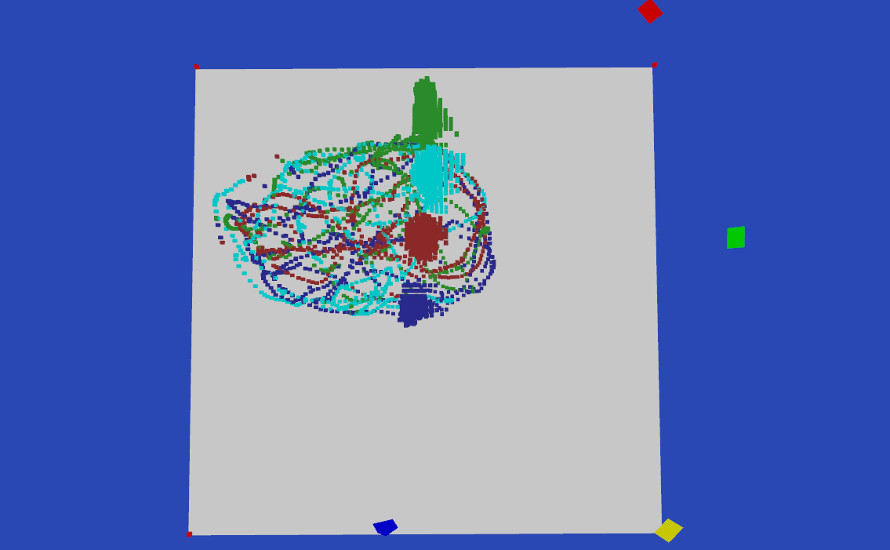
Choice tasks
(Indicate which ones you did, and how you did them; Approx. half a page.)

- CHOICE 1: Using multiple cameras to increase the robustness: 15
All 4 cameras are used. Per camera view 4 models are created. In total this makes 16 offline models and 16 online models.
- CHOICE 7: Dealing with occlusion in creating the color models: 20 (only take into account voxels that are actually visible from a view)
Per frame, we calculate for each camera view, the angles of every cluster center from the camera position in the voxel world, as well as the distance between each cluster and the camera position. Then we perform a pair check for every cluster if their angles are closer than 5 degrees to another cluster. If they are we then check which of the pair is closer tot he camera. The one thats closer is labeled visible, the further away is labeled notVisible. When doing the color models only the visible clusters are taken into account.

