INFOMCV Assignment 4
Authors (Assignment pair 1)

Description and motivation of your baseline model and four variants
(For your baseline model, add a description and motivation of the architecture and parameters (which layers, which dimensions, how connected, etc.). Also use model.summary(). For each of the four variants, add a description of which property differs from the baseline model, and why this choice was made. Make sure you name/number your models so you can refer to them. Approx. 0.5-1 page.)

Variants
We wanted to explore different options in reducing overfitting in our base model with our variants. All 4 of the variants try to do that using a different strategy.

tf.keras.layers.Dropout(.25)
Variant1-Dropout implements a dropout layer with 25% chance to drop the neuron weight. It is placed after the second convolution layer and before the max pooling. This is because the layer has 64 filters (the previous one has 32) and it is more likely to overfit the data. Dropout will reduce the correlation between neurons there.

tf.keras.layers.Dense(64, activation='relu',kernel_regularizer=tf.keras.regularizers.l1(0.001))
tf.keras.layers.Dense(10, activation='softmax' , kernel_regularizer=tf.keras.regularizers.l1(0.001))
Variant2-L1Regu implements a different regulirizer. L1 is placed on both the dense layers since they are responsible for transforming the input features and the output labels. L1 applies a penalty to the loss function which could potentially allow the model to generalise better.
tf.keras.layers.BatchNormalization()
Variant3-BatchNorm
Batch normalization is added after first Conv2D layer. It stabilize learning process, normalizes values to 0 or to 1 depending on whichever they are closer to using mean and std, solves internal covariate shift. That is also the best place to put the single batch norm layer since it normalizes the first input of the network.
tf.keras.layers.Dense(64, activation='relu', kernel_regularizer=tf.keras.regularizers.l2(0.001))
tf.keras.layers.Dense(10, activation='softmax', kernel_regularizer=tf.keras.regularizers.l2(0.001))
Variant4-L2Regu
Similarly, to L1 variant, adding L2 to both dense layers makes most sense. L2 prevents overfitting by slowly melting large weight values, encourages model to use lower weights.

Training and validation loss for all five models
(Put, on each row, the loss and accuracy graphs side-by-side. The x-axis should have the epochs, the y-axis loss/accuracy. Uses lines with a different color for training and validation. Approx. 1 page)
Base
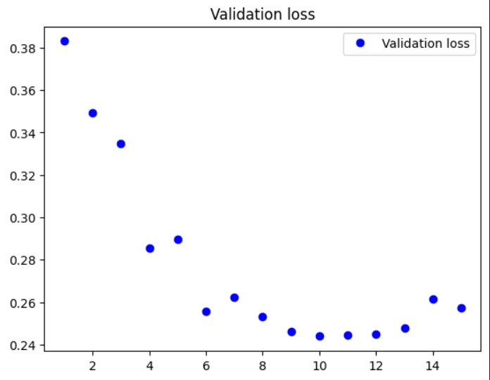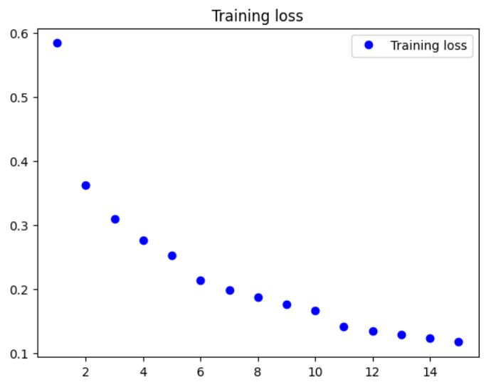
Variant1-Dropout
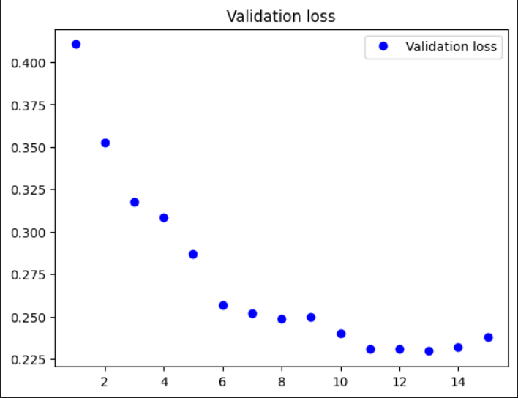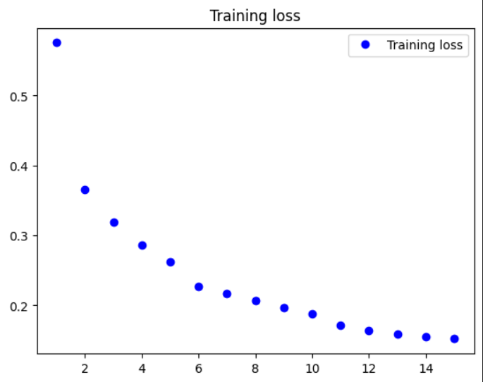
Variant2-L1Regu
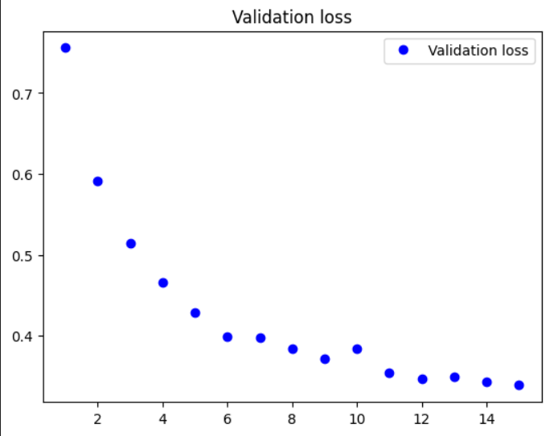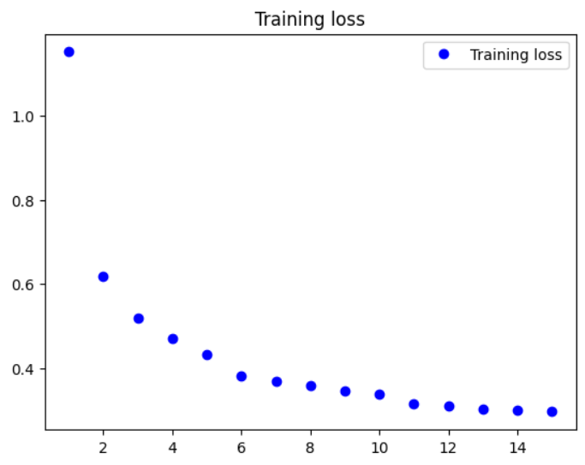

Variant3-BatchNorm
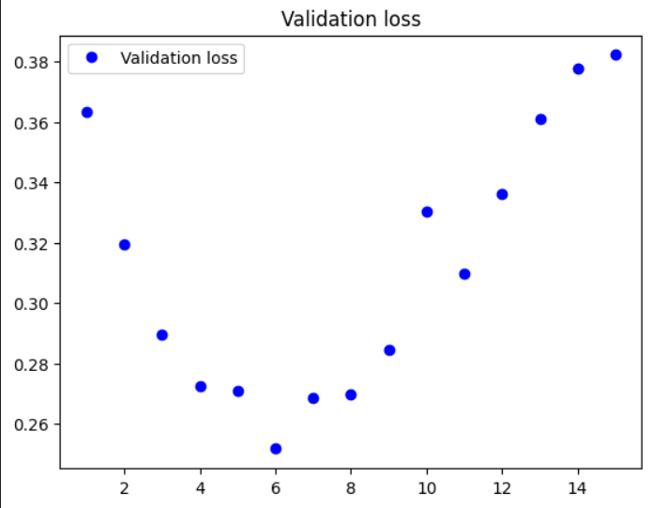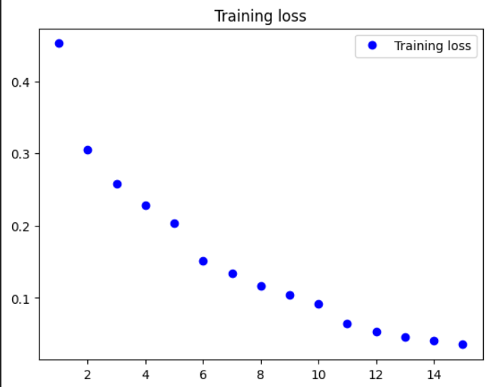
Variant4-L2Regu
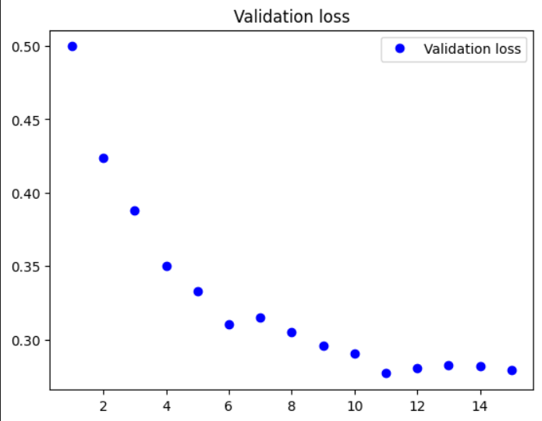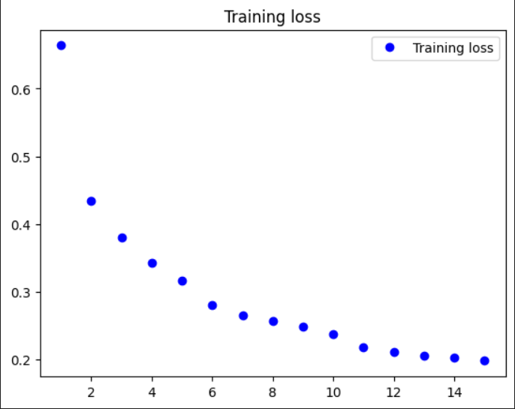

Link to your model weights
(Link should be accessible by Ronald Poppe and Metehan Doyran.)
Link:

Table with training and validation top-1 accuracy for all five models
(Fill the table below.)
Model name | Training top-1 accuracy (%) | Validation top-1 accuracy (%)
Base | 0.9581 | 0.9147
Variant1-Dropout | 0.9439 | 0.9164
Variant2-L1Regu | 0.9195 | 0.9043
Variant3-BatchNorm | 0.9879 | 0.9147
Variant4-L2Regu | 0.9415 | 0.9139

Discuss your results in terms of your model
(Discuss the results in terms of complexity, type of layers, overfitting measures, etc. Make pair-wise comparisons between the four variants and the baseline model. Approx. 0.5 page.)

Base

Base < - > Variant1-Dropout
Dropout variant is better than baseline on the validate data but worse on train data. This suggests that the base model is slightly overfit.

Base < - > Variant2-L1Regu
L1 performs slightly worse on the validate but a lot worse on the train data. Our assumption is that it can’t converge fast enough in 15 epochs or perhaps it underfits and reducing the strength could help. Perhaps further finetuning the strength of the regularizer could potentially improve the model within 15 epochs.

Base < - > Variant3-BatchNorm
Batch normalization trains excellently. It has the same validation accuracy but the loss is the highest of all models. This suggests overfitting. Adding a dropout layer and a regulirizer could benefit this model a lot. Also from documentation it is suggested that adding batch normalization to every layer that uses an activation function is going to perform better since it will regulate the full model.

Base < - > Variant2-L2Regu
L2 variant is a slightly worse than baseline on the validation and training set. Although this variant seems to converge faster than the L1 variant. Similarly to L1 further finetuning of its parameters could improve the results.

Discuss the differences between the two models evaluated on the test set
(Discuss the potential causes for (lack of) differences in terms of architecture. Also compare the results of each model to the training performance. Approx. 0.5 page.)
Model name | Test accuracy (%) | Test loss (%)
Variant1-Dropout | 0.9172 | 0.2305
Variant3-BatchNorm | 0.9128 | 0.4180

Dropout prevents overfitting, which improves generalization performance on the testing set.
Batch normalization can also help prevent overfitting. But it's possible that the use of batch normalization in variant3 is not having a significant impact on the model's performance, or is even slightly hurting performance in this particular case. In terms of structure, I believe the placement of dropout produces a bigger impact than batch normazaliation. Droppout is placed just after the 2nd convolution where 32 neuros meet 64 and the feature memorization is created, therefore it has higher impact on overfitting. Batch normalization, supposedly, requires the whole network to be normalized by placing it before every activation. In our case we’ve placed it only once, which does help in the training but appears to overfit on features and instead hurts the matching of the test set.

Choice tasks
(Indicate which ones you did, and how you did them; Approx. half a page.)

