INFOMCV Assignment 5 Report
Student 1 – Student 2

architecture choices
Explain briefly the architectural choices for your frame, optical flow and two-stream networks. Use model.summary(). Discuss layers and hyperparameters. Make sure you discuss the type of fusion in the two-stream network.(two pages)
In general we want to have a model that can have an optimal accuracy in just 15 epochs. More than that and we would not have enough resources on the colab project.
- Frame CNN architecture:
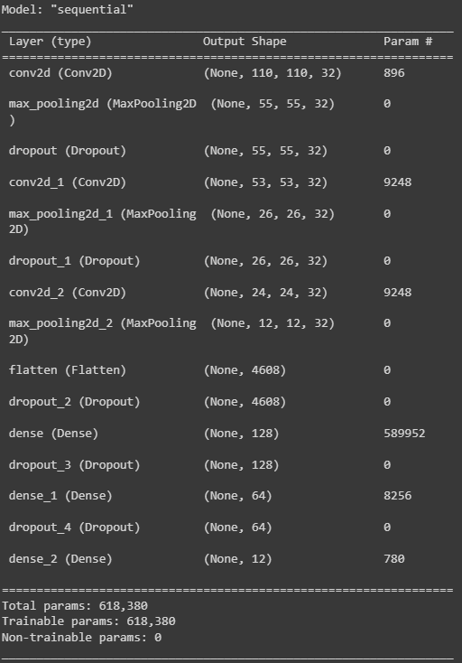We have implemented a custom model for the images. We started from a model that has only 3 dense layers and added on top based on performance. Making the model too complicated seemed to overfit it but making it too simple contributed to underfitting. For example, we’ve concluded that adding a 4rth convolution layer did add a very slight improvement but it was not worth the performance. This is why we believe 3 convo2D are most optimal. We have a learning rate of 0.001 and a sparse_categorical_crossentropy which infers that the output is a softmax activation, since we have 12 classes. To further battle overfitting we’ve added a lot of drop layers with a higher impact at the dense layers since they are usually making the important connections. We also care about concrete features which is why we’ve used MaxPooling(). We’ve experimented with a batch_normalization layer however it slowed down the learning too much for it to beat the model without batch_norm in 15 epochs, so we decided against it.
- Optical flow CNN architecture:
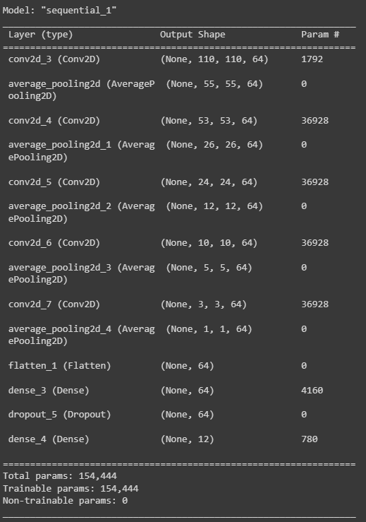
This model started similarly as the first one and is entirely custom. 3 Dense layers with 12 output classes. Here however our input data is so much different. Since we are only using 1 frame, we have much of the data as black pixels non-important data and very little of it as important flow data. Which is why we experimented with more convolutions to extract as much features as possible and at the same time keep parameters not too much as to not overfit. We also switched to average pooling to get a “blurring” effect from each convolution to establish a general flow in each per convolution.
- Combination into two-stream network:
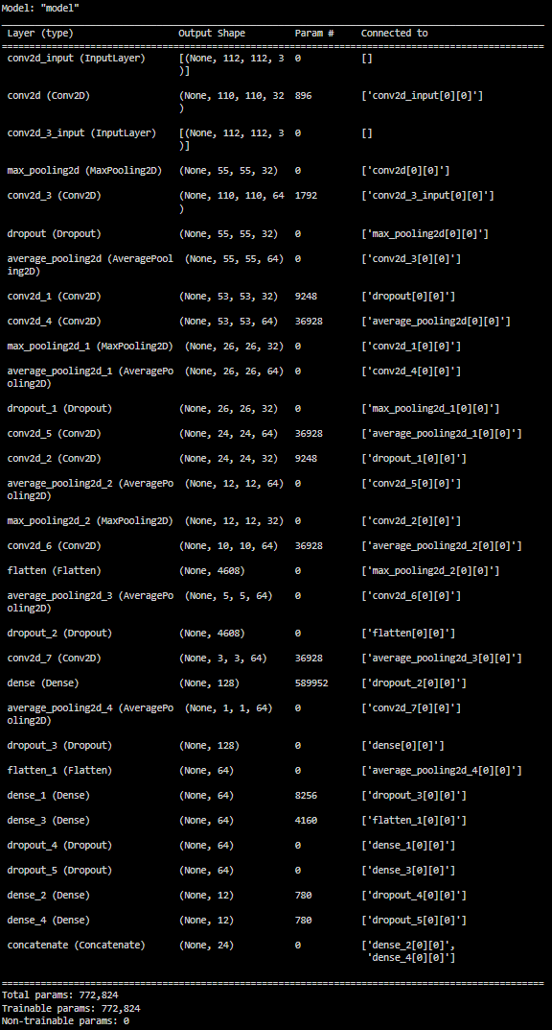
Our two stream network is fused at the output of both previous CNN’s and an additional Dense layer is added to determine the combined output of both.

Results

Include the (1) train-validation accuracy and (2) train-validation loss graphs for each of the four networks. Make sure train and validation lines have different colors in your graphs. The x-axis should cover the epochs, the y-axis should be accuracy (for (1)) or loss (for (2)). (two pages)

Stanford 40 Frames
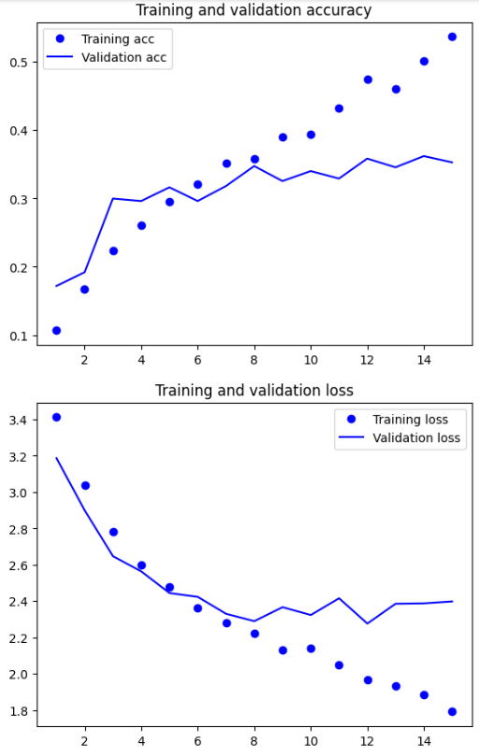

HMDB51 Frames
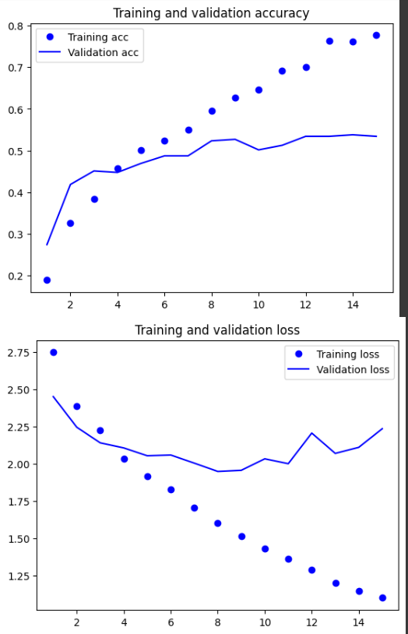

HMDB51 Optical flow
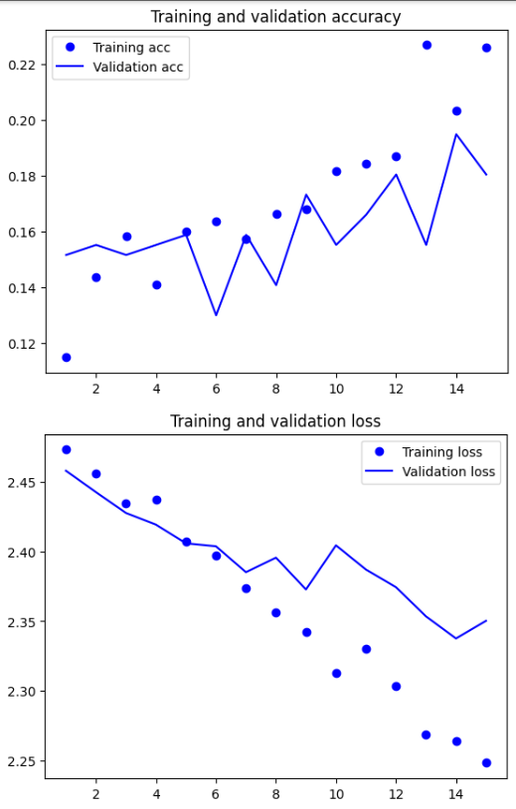

HMDB51 Two-stream
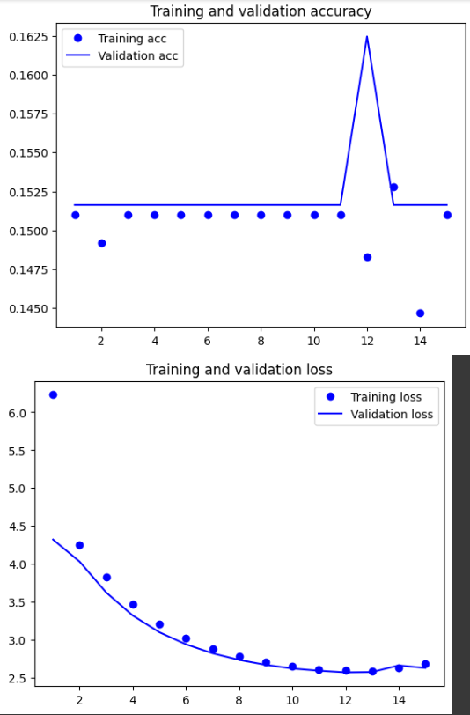

Result table
Fill in the following table. Use model.count_params() to obtain the number of parameters.
- Summary of your results per model
Dataset | Model specifications
Dataset | Model | Top-1 accuracy (train / test) | Top-1 loss train | Model parameters
Stanford 40 | Frames | 0.5366 / 0.4046 | 1.7906 | 618,380
HMDB51 | Frames | 0.7767/ 0.4870 | 1.0990 | 618,380
HMDB51 | Optical flow | 0.2269/ 0.1494 | 2.2484 | 154,444
HMDB51 | Two-stream | 0.1528/ 0.1494 | 2.6772 | 772824

Discussion of results
Discuss the performance of your models, and compare the results between models. Explicitly discuss the training procedure, and risk of overfitting. (one column)

The models that worked on the RGB frames performed the best especially after being fine-tuned on the HMDB51 dataset. During finetuning, we reduced the learning rate of the overall model so each weight gets updated but slower instead of freezing layers. The latter option significantly impacted the accuracy of our model, which is why we opted for lower learning rate instead. Our optical flow models suffered from having too little data to work with (only 1 frame per video), and because of that the overall performance of the two stream also suffered.

Link to Model Weights
Make sure your link is accessible for m.doyran@uu.nl and r.w.poppe@uu.nl

Choice Tasks
Mention choice tasks, and include the results (when applicable) or a motivation how you implemented the choice tasks. (one page)

