## Gesture + Noise Recording , 22.5.14, Lorenz Gruber, Final Year Project

### Gesture to be Recorded:

01 – double knock

02 – tick move

03 – ind move + 90 deg turn right

04 – right left right left

05 – z move

### File name structure in csvNoise_20Hz:

Each .csv file is named as g[XX]_[YY]_t[ZZ].mat:

[XX]: gesture index

[YY]: tester ID

[ZZ]: trial index

Each .csv file has 8 columns (the gyro data was recorded as well. )

t epoch time in ms

tRel relative time in s

x in g

y in g

z in g

alpha

beta

gamma

## Details

* All samples at 20Hz
* Use my I-Phone 4
* Phone is attached to right arm, use the fitness band and tissue pack to properly fix it to the arm.
* The handlebar used was a flat handle bar.
* During all g00, the right arm was constantly held at the handle bar. During all the g00 recordings, none of the gestures defined above was performed.
* For g012-5, Alex noted the stop time of each gesture.
* For the right left right left move, I moved the right arm slightly to the right and did it then.
* For the Z move, I move the are slightly up.
* Gesture one was omitted as it requires both hands and hence to dangerous on bike.

## Recordings

|  |  |  |  |
| --- | --- | --- | --- |
| Filename (.csv) | User name – on server | Duration (s) | Description |
| g00_A1_t01 | n-accel1 | 51 | Cycle down Burnthwaite Road and accelerate on bike, standing. |
| g00_A1_t02 | n-accel2 | 51 | s.a. (see above) |
| g00_L1_t01 | n-low1 | 64 | Cycle down Burnthwaite Road and try to make as little movement as possible. |
| g00_L1_t02 | n-low2 | 62 | s.a. |
| g00_T1_t02 | n-traffic2 | 141 | Cycle round Fulham in normal traffic. But keep right arm at handlebar constantly |
| g00_T1_t03 | n-traffic3 | 141 | s.a. |
| g00_T1_t04 | n-traffic4 | 149 | s.a. |
| g00_T1_t05 | n-traffic5 | 144 | s.a. |
| g00_T1_t06 | n-traffic6 | 159 | s.a. |
| g02_L1_t01 | g2-1 | 34 | Perform gesture 2, 5 times whilst cycling on bike |
| g02_L1_t02 | g2-2 | 32 | Perform gesture 2, 4 times whilst cycling on bike |
| g02_L1_t03 | 2-2 | 36 | Perform gesture 2, 5 times whilst cycling on bike, but stronger movement and tried to have are almost horizontal instead of bending down… |
| g02_L1_t04 | 2-1 | 33 | s.a. |
| g03_L1_t01 | g3-1 | 30 | Perform gesture 3, 5 times whilst cycling on bike |
| g03_L1_t02 | g3-2 | 32 | s.a. |
| g04_L1_t01 | g4-1 | 34 | Perform gesture 3, 5 times whilst cycling on bike |
| g04_L1_t02 | g4-2 | 30 | s.a. |
| g05_L1_t01 | g5-1 | 35 | Perform gesture 3, 5 times whilst cycling on bike |
| g05_L1_t02 | g5-2 | 31 | s.a. |
|  |  |  |  |

## End times of gestures

The time was stopped on a separate phone and the following are the approximate end times of the gestures:

This shows the raw table

|  |  |  |  |  |  |
| --- | --- | --- | --- | --- | --- |
| Filename | rep1 | rep2 | rep3 | rep4 | rep5 |
| g02_L1_t01 | 6.6 | 12.1 | 17.4 | 22.1 | 27.6 |
| g02_L1_t02 | 5.4 | 11.4 | 16 | 20.1 | 24.1 |
| g03_L1_t01 | 7.4 | 12.6 | 17.4 | 22.7 |  |
| g03_L1_t02 | 7.4 | 12.4 | 16.8 | 21.4 | 25.5 |
| g04_L1_t01 | 7.9 | 12.6 | 17.8 | 22.5 | 26.5 |
| g04_L1_t02 | 7.5 | 12.1 | 16.0 | 19.9 | 23.7 |
| g05_L1_t01 | 7.7 | 13.1 | 18.5 | 24.1 | 27.8 |
| g05_L1_t02 | 7.3 | 11.7 | 15.9 | 20.1 | 24.1 |

I changed some of the times afterwards, so this table was used in MATLAB:

|  |  |  |  |  |  |
| --- | --- | --- | --- | --- | --- |
| Filename | rep1 | rep2 | rep3 | rep4 | rep5 |
| g02_L1_t01 | 6.6 | 12.1 | 17.4 | 22.1 | 26.7 |
| g02_L1_t02 | 6 | 11.4 | 15.5 | 20.1 | 23.5 |
| g03_L1_t01 | 7 | 12.6 | 17.4 | 22 | 150 |
| g03_L1_t02 | 6.5 | 12.4 | 16.8 | 21.4 | 25.5 |
| g04_L1_t01 | 7 | 12 | 17 | 21.5 | 25.5 |
| g04_L1_t02 | 6.5 | 11.5 | 15.3 | 19.2 | 23 |
| g05_L1_t01 | 7.7 | 13.1 | 18.5 | 24.1 | 27.8 |
| g05_L1_t02 | 7.3 | 11.7 | 15.9 | 20.1 | 24.1 |

## Screenshot from http://www.acceldatacollect.appspot.com/listData

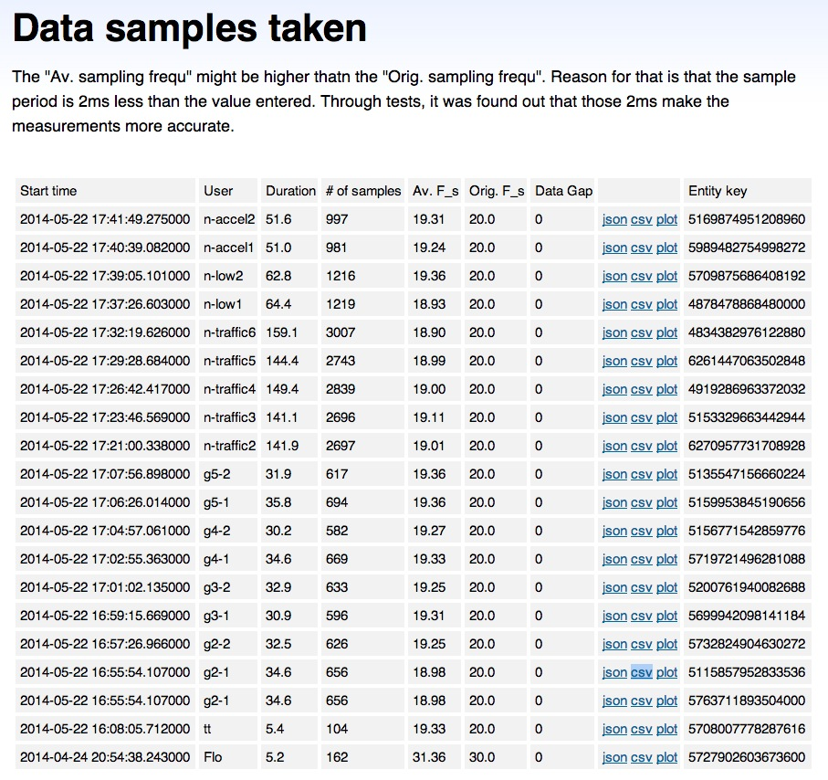

## Sheet with the end times of gestures

### 