## Gesture Recording , 8.4.14, Lorenz Gruber, Final Year Project

### Gesture to be Recorded:

01 – double knock

02 – tick move

03 – ind move + 90 deg turn right

04 – right left right left

05 – z move

### Test Persons

8 Persons, between 22 and 24, 6 male, 2 female. A list with the details is in the appendix.

All testers were standing during the recording.

Only right hands were used.

### Total samples

Each tester recorded 10 repetitions for each of the 5 gestures.

8 Persons * 5 Gestures * 10 Repetitions = 400 Samples

### Position of phone:

The phone is held in the users right hand. It is held with screen faces up. Homebutton towards user. An I-Phone 4 with iOS 6.1.3 was used to record. The recording was done using a web application running in the Safari browser.

### Start position of hand:

The hand should be in a calm position with right hand straight, as if one was cycling.

### Start and stop sound:

The phone makes a start and stop sound to indicate to the user when to start…

### Recording details:

Recording period: 2s

Pause: 2s

FSample: 60 Hz

Repetitions per Gesture: 10

The gestures were recorded in the same order. 1 through to 5.

The acell data from the I – Phone is at maximum +/- 2g. Not sure why that is.

### Recording Procedure:

The person conducting the test (me), explained the aim of the recording to the tester. Then a piece of paper (Scan is in the Appendix) with names and movements was shown to the tester. Then I performed each gesture to the tester to show them what it looks like.

The tester was also told how to hold the phone in his hand.

Then I started a trial recording to show how the start and stop sounds worked.

They were told to go back to the original position after the stop sound. However I did not stress the initial position to all testers in the same manner. I told most of them to hold the right arm straight down (as if the were cycling).

For gesture 2 and 3, the tester was told to stay in the final position until the stop sound occurs.

Extra care had to be taken to select the correct gesture and name in the web application before sending the data to the server.

### File name structure in csvData:

Each .csv file is named as g[XX]_[YY]_t[ZZ].mat:

[XX]: gesture index

[YY]: tester ID

[ZZ]: trial index

**IMPORTANT!! the acceleration values are in g, not m/s2.**

Each .csv file has 8 columns (the gyro data was recorded as well. )

t epoch time in ms

tRel relative time in s

x in g

y in g

z in g

alpha

beta

gamma

### Json structure in jsonData

IMPORANT: the acceleration data is the raw data from the phone. It needs to be devided by 10 for the correct acceleration in Gs. For the CSV files this has been done.

**UPDATE 5.6.14, this json structure was changed to allow more general inputs**

The json files contains all recordings from one person:

Top level: Array / List containing individual gesture Objects / Dict

[ g0, g1, g2, g3, g4, g5] 🡪 might not be in order

gx: Object/Dict containing info about recording

{

origSampleFrequ: 60,

startTime: 1396897906944,

repetitions: Array[10],

gesture: "1",

user: "XX",

periodGesture: 2000, // in ms

noOfRepetiontion: 10

}

repetitions: Array/ List containing containing individual repetition Objects / Dict

[ r0, r1, r2, r3, r4, r5, r6, r7, r8, r9] 🡪 might not be in order

rx: Object/ Dict containing raw data.

{

alpha: Array[121]

beta: Array[121]

gamma: Array[121]

rep: 0

t: Array[121]

x: Array[121]

y: Array[121]

z: Array[121]

}

## Appendix:

All recording were done on the 8.4.14.

|  |  |  |  |
| --- | --- | --- | --- |
| ID | Name | Age | Notes |
| L2 | Loek | 22 | “2s for G4 was too little” |
| V1 | Vicky | 22 | - got out of Rhythm for G1 once  - abrupt movements for G4  - carefule, G2 – G5 was recorded with wrong name (but that was fixed afterwards) |
| R1 | Richard | 23 | - suggested to bring a bike to the labs and do it with a bike  - suggested to do a survey which gestures users like |
| T1 | Thomas | 22 |  |
| O1 | Oskar | 23 | Knocked on the phone directly for G1 |
| J2 | Josh | 23 |  |
| N1 | Nina | 24 | - check for g04 whether she got out of rhythm  - held the phone slightly more horizontal than others. |

Picture that was shown to test persons:

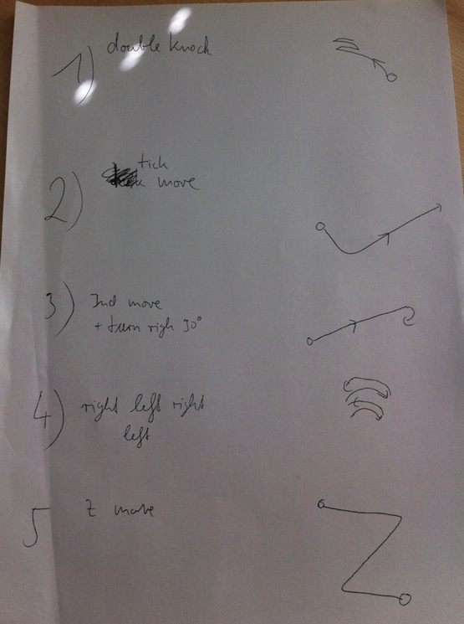

Position in which phone was held:

Ok, this is a mouse, but imagine the sticker that you see at the back of the mouse to be the screen of the phone.

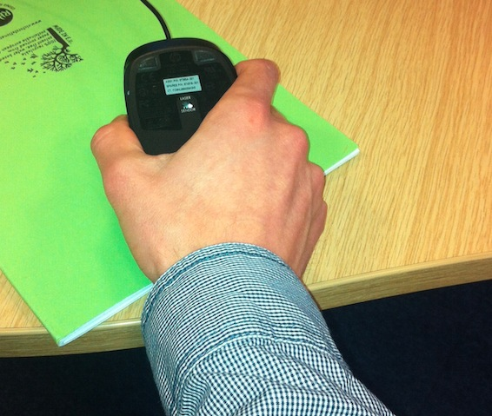

Picture from server for the noise data. However it was recorded on localhost only.

The second to last row is g11 and the top row is g19.

