WAZUH SOC LAB

Shellshock Attack Detection
Detection and investigation using Wazuh and Apache access logs
Test date: October 24, 2026

1. Executive Summary
This lab exercise tested Wazuh’s ability to identify a Shellshock-pattern HTTP request recorded by an Apache web server. A crafted request was sent from a Kali Linux machine to an Ubuntu endpoint running Apache. Wazuh generated a high-severity alert based on the request captured in the Apache access log.
Detection was successful. The available evidence confirms that the suspicious request was logged and matched by Wazuh rule 31168 at Level 15. The evidence does not, by itself, prove that the injected command executed or that the server was successfully exploited.

2. Lab Environment
Component | Role | IP address
Kali Linux | Attacker / test source | 192.168.1.104
Ubuntu Linux | Apache web server and Wazuh agent | 192.168.1.103
Wazuh manager/dashboard | Centralized log monitoring and alerting | 192.168.1.102

3. Preparation and Method
The test followed the Wazuh Shellshock proof-of-concept documentation. The Ubuntu endpoint was checked to confirm that the Apache default page was available. The Wazuh agent service was restarted and its status verified as active before the request was sent.
The request was issued from the Kali terminal using the following command:
sudo curl -H "User-Agent: () { :; }; /bin/cat /etc/passwd" http://192.168.1.103
The request places a Shellshock-like string in the HTTP User-Agent header. This is a detection test; the command string in the header should not be treated as proof that command execution occurred.

4. Evidence and Observations

4.1 Apache service and Wazuh agent readiness
The supplied screenshots show the Ubuntu Apache2 default page and the Wazuh agent service status returning “active” after restart.

4.2 Test request and server log
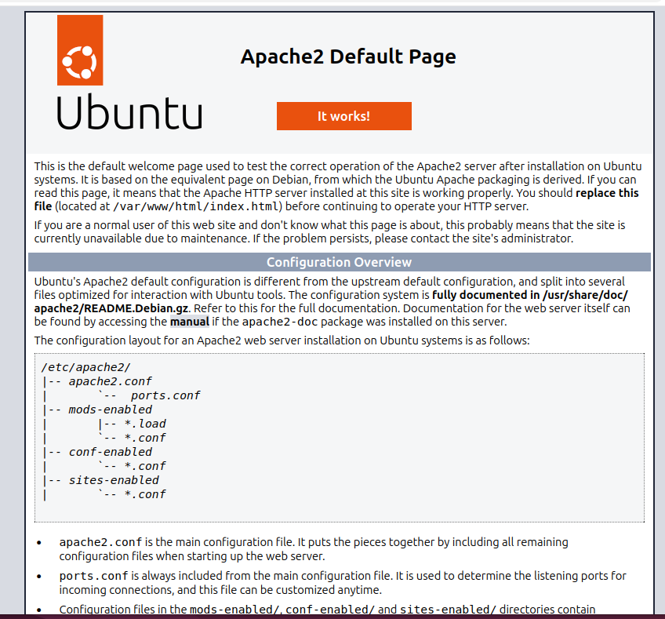
Evidence 1. Apache2 default page on the Ubuntu endpoint.
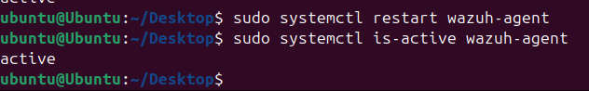
Evidence 2. Wazuh agent restarted and confirmed active.

4.3 Wazuh detection
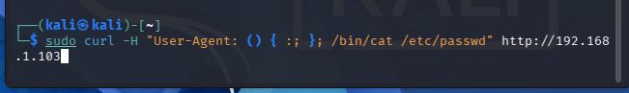
Evidence 3. Shellshock-pattern HTTP request sent from Kali Linux.
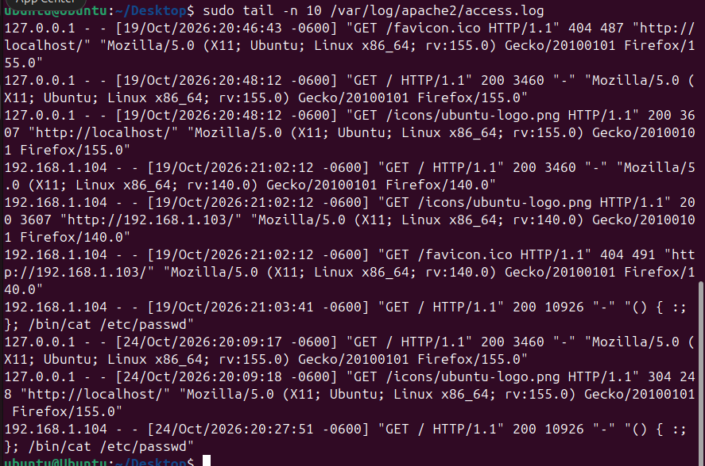
Evidence 4. Apache access log showing the request from 192.168.1.104.
Evidence 5. Wazuh alert list showing the Shellshock detection alert.
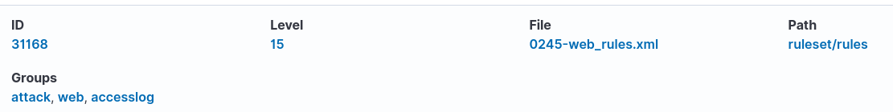
Evidence 6. Wazuh alert details, including rule metadata and event fields.

5. Alert Details
Alert description | Shellshock attack detected
Wazuh rule ID | 31168
Severity level | 15
Rule groups | web, accesslog, attack
Attacker/source IP | 192.168.1.104 (Kali Linux)
Victim/agent IP | 192.168.1.103 (Ubuntu)
Agent name / ID | ubuntu / 001
Apache access-log timestamp | October 24, 2026, 20:27:51 (-0600)
Wazuh alert timestamp | October 24, 2026, 20:27:59.667
HTTP method / path | GET /
HTTP response status | 200
Log source | /var/log/apache2/access.log
MITRE ATT&CK IDs shown in alert | T1068 — Exploitation for Privilege Escalation; T1190 — Exploit Public-Facing Application

6. Analysis
The Apache access log records a GET request from the Kali host containing the suspicious User-Agent value. Wazuh matched the logged request and produced rule 31168, “Shellshock attack detected,” at Level 15. The Wazuh event details identify the source IP as 192.168.1.104, the Ubuntu agent as 192.168.1.103, the request path as “/”, and the log location as /var/log/apache2/access.log.
The HTTP 200 status indicates that Apache returned a successful HTTP response for the request. It does not establish that the injected /bin/cat /etc/passwd command was executed. The evidence provided is sufficient to demonstrate log-based detection of a Shellshock-pattern request, but not successful exploitation.

7. Conclusion
The Shellshock detection test was successful from a monitoring perspective: Wazuh identified the suspicious HTTP request in the Apache access log and generated a Level 15 alert (Rule ID 31168). This demonstrates how centralized log monitoring can support web-attack detection and incident investigation.
No claim is made that the server was successfully exploited. Confirming command execution would require additional endpoint evidence, such as process-execution audit logs correlated with the request timestamp.

8. Recommended Follow-up
- Correlate the Apache request timestamp with endpoint process-execution telemetry, if available.
- Review surrounding Apache access and error logs for related requests or indicators.
- Keep the test isolated to the authorized lab environment and document any cleanup performed.

Reference
Wazuh documentation — Detecting a web attack: Shellshock: https://documentation.wazuh.com/current/proof-of-concept-guide/detect-web-attack-shellshock.html

