

Lab Manual- Create and Configure an Azure Virtual Machine with IIS

Prepared for:

Date: 18th Nov 2023

Prepared by:
Document Name: Lab Manual Document Number AZLab999
Contributor:

Contents
1. Lab Objective 3
2. Lab Scenario 3
3. Lab Create Azure Virtual Machine 3
4. Take Remote (RDP) to Virtual Machine 6
5. Install IIS (Web Server ) 10
6. Learning Objectives 16

Lab Objective

- Create an Azure Virtual Machine using the Azure Portal
- Understand core VM configuration components
- Configure compute, networking, and storage options
- Connect to the VM using Remote Desktop (RDP)
- Deploy a basic workload (IIS Web Server)

Lab Scenario

You are a Cloud Engineer responsible for deploying infrastructure in Microsoft Azure.
Your organization requires a Windows Server Virtual Machine to host a web application. You need to:
- Select the appropriate subscription and resource group
- Choose the correct OS image and VM size
- Configure networking (ports)
- Attach storage disks
- Deploy and test a web server
This simulates a real-world infrastructure provisioning task in cloud environments.

Lab Create Azure Virtual Machine

- In The Azure Search , Type Virtual Machine and select it

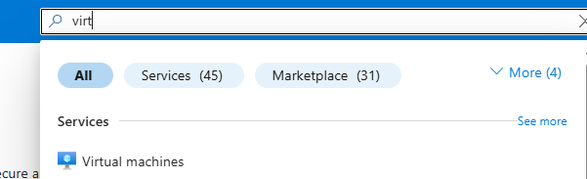

- In Computer Infrastructure Virtual Machine , Select Create Virtual Machine

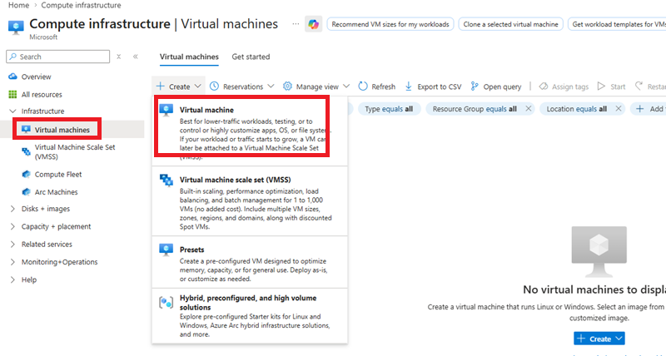

- In The Virtual Machine , Fill the Basic Details and Click Next

Subscription : ODL-AZ-XXXX
VMName : IN-VM-01
Region : WestUS2
Availability Option : No Infrastructure redundancy required
Security type : Standard
Image : Window Server 2025 Azure Edition
Size : IN-VM-01
Region : Standard_DS1_V2 – 1 CPU , 3.5 GiB Memory
UserName : Vmadmin
Password : Password@123

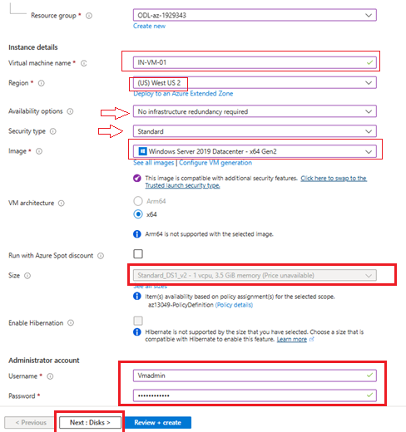

- In The Next Screen ( Disk ) Select Standard HDD and Click Next

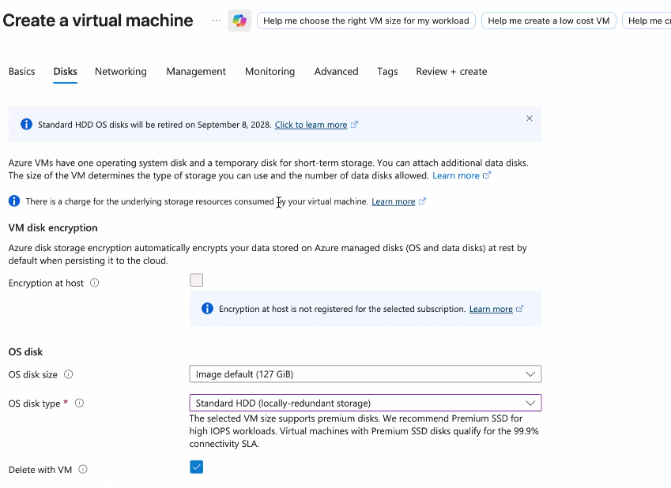

- Click Review + Create Create

- Once Machine Get Created, Click Go To Resource Button and you should be in VM Console

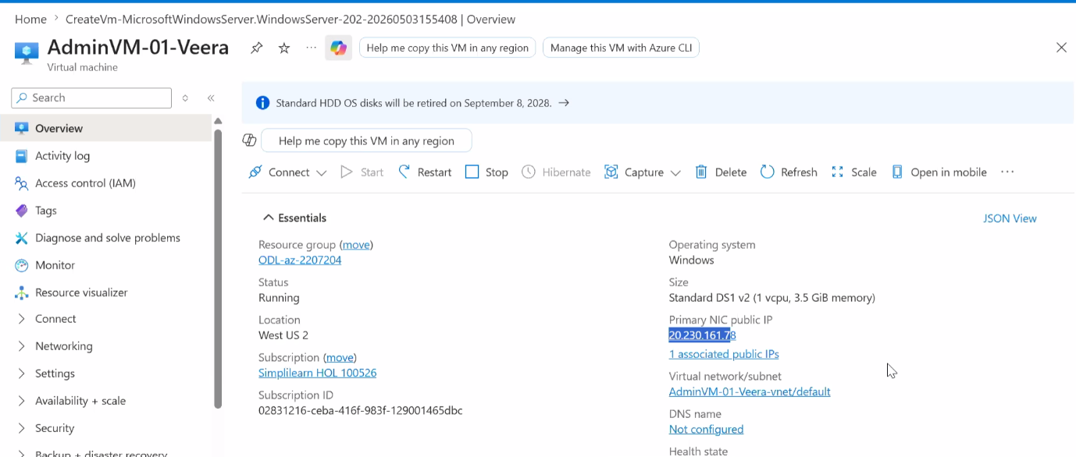

Take Remote (RDP) to Virtual Machine

  - Copy the public IP address from VM Console
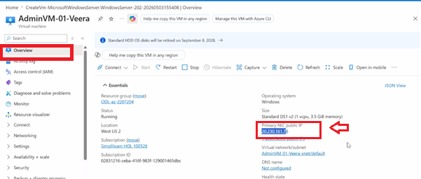

  - From your windows Laptop, Launch Remote desktop
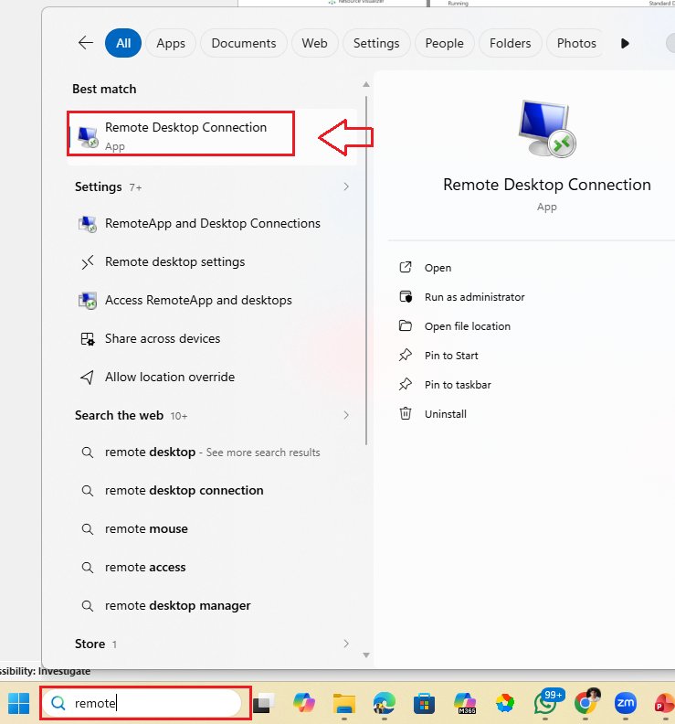

  - Paste the Public IP copied from VM console of Azure and click Connect
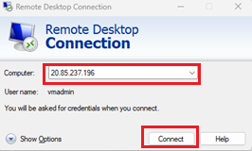

  - Enter following credentials which you enter while creating the VM

User Name : VMAdmin
Password : Password@123

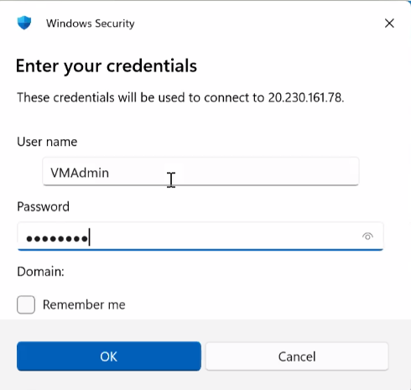
  - Wait for the connection to be established

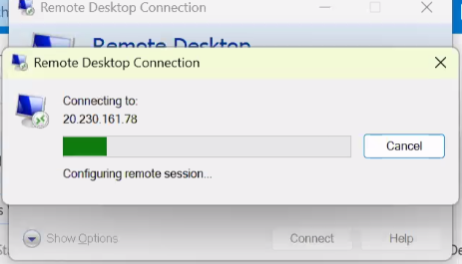

  - Once the connection get established , you may get the Popup , click Yes

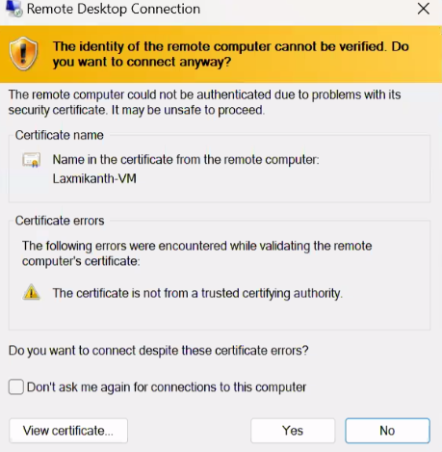

  - Click Accept in send diagnostic data to Microsoft screen

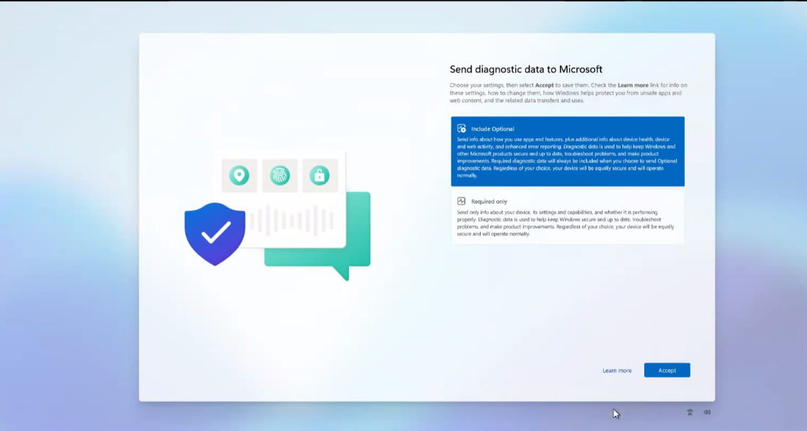

  - You should now see Server Manager

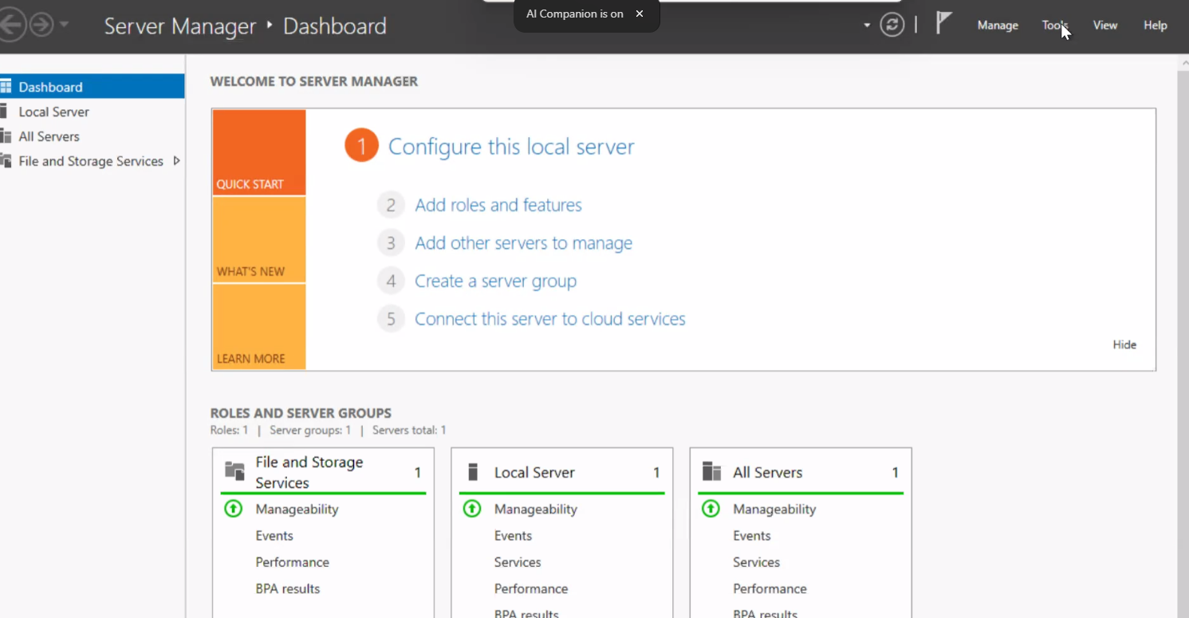

Install IIS (Web Server )

- Click the “Add roles and features” text. In Server Manager
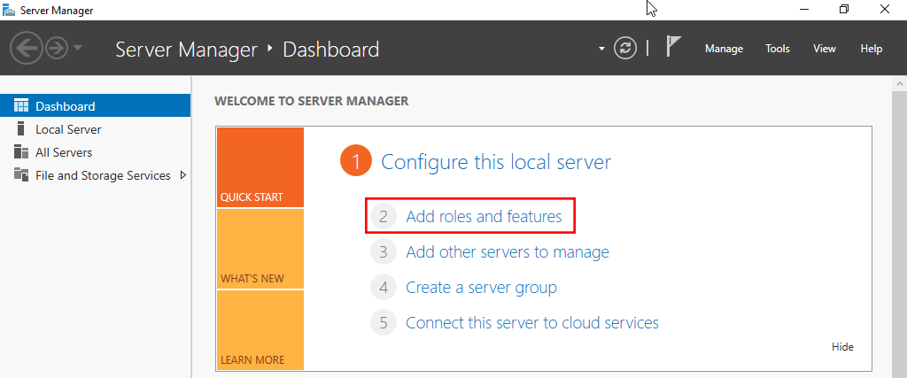
- On the “Before you begin” window, simply click the Next button.
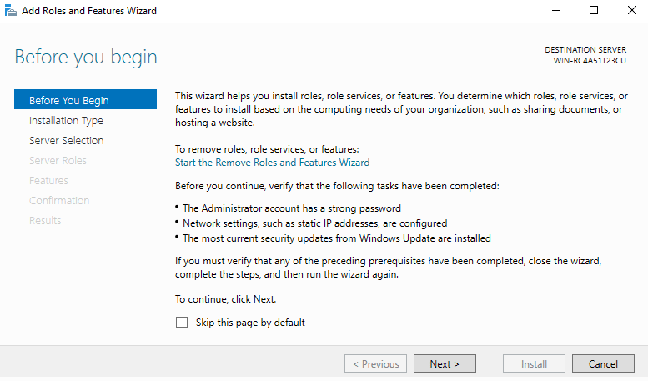
- On the “Select installation type” window, leave “Role-based or feature-based installation” selected and click Next.
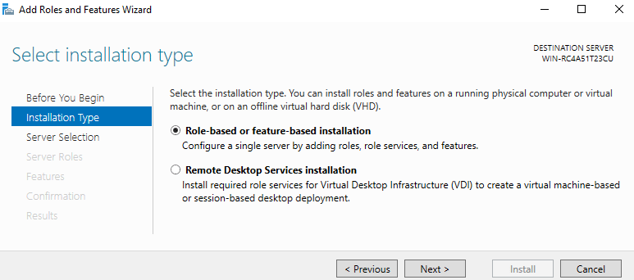
- Click Next
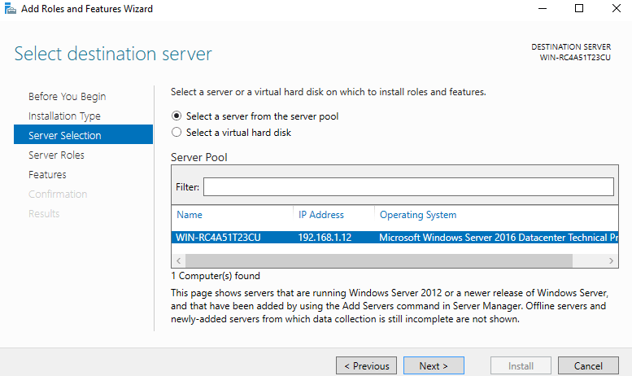
- From the “Select server roles” window, check the box next to “Web Server (IIS)”. Doing this may open up a new window advising that additional features are required, simply click the “Add Features” button to install these as well. Click Next back on the Select server roles menu once this is complete.
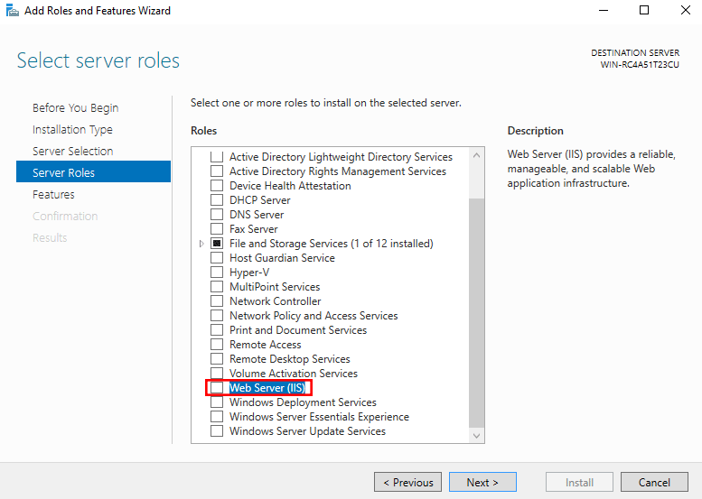
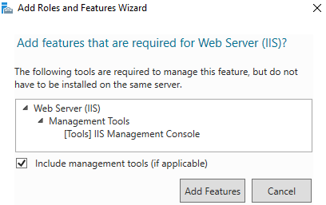
- We will not be installing any additional features at this stage, so simply click Next on the “Select features” window.
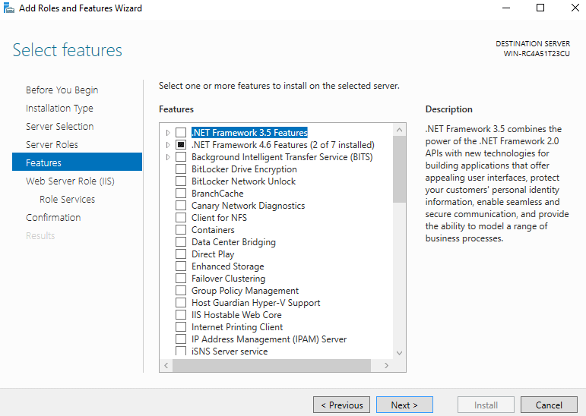
- Click Next on the “Web Server Role (IIS)” window after reading the information provided and click Next
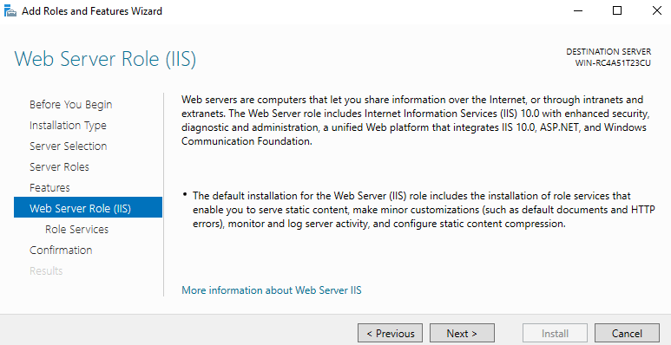
- At this point on the “Select role services” window you can install additional services for IIS if required. You don’t have to worry about this now as you can always come back and add more later, so just click Next for now to install the defaults.
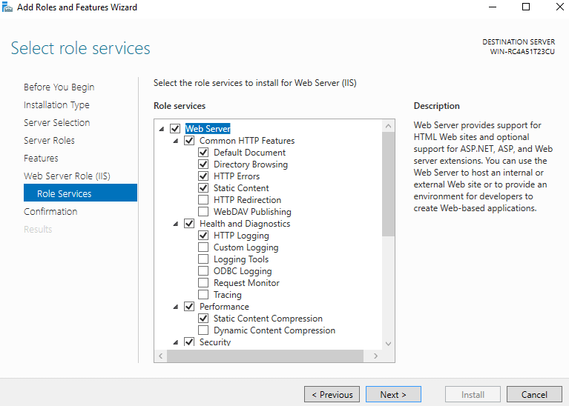
- Finally on the “Confirm installation selections” window , review the items that are to be installed and click Install when you’re ready to proceed with installing the IIS web server.
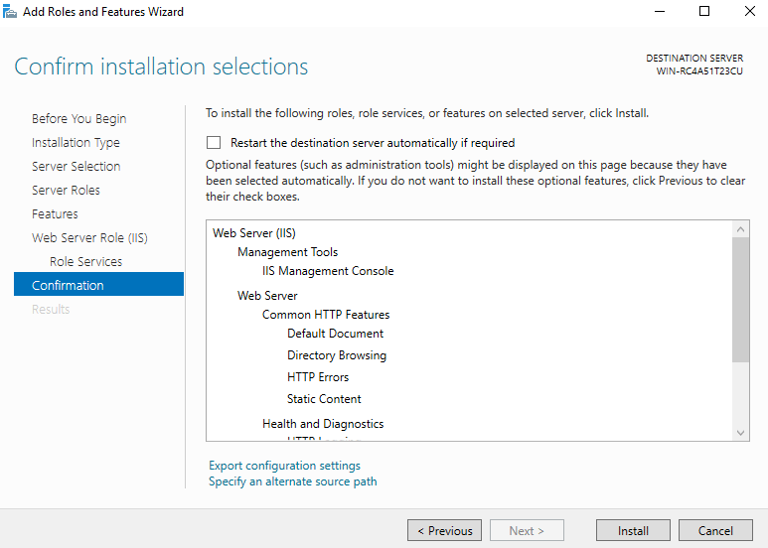
- Once the installation has succeeded, click the close button. At this point IIS should be running on port 80 by default with the firewall rule “World Wide Web Services (HTTP Traffic-In)” enabled in Windows firewall automatically.
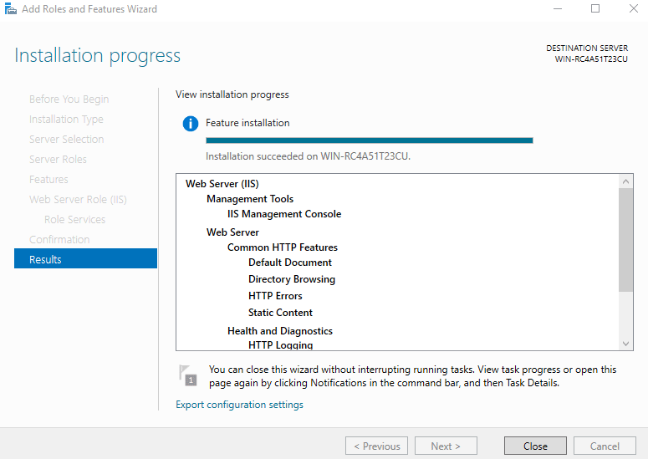
- We can perform a simple test by opening up a web browser and browsing to the server that we have installed IIS on. You should see the default IIS page.
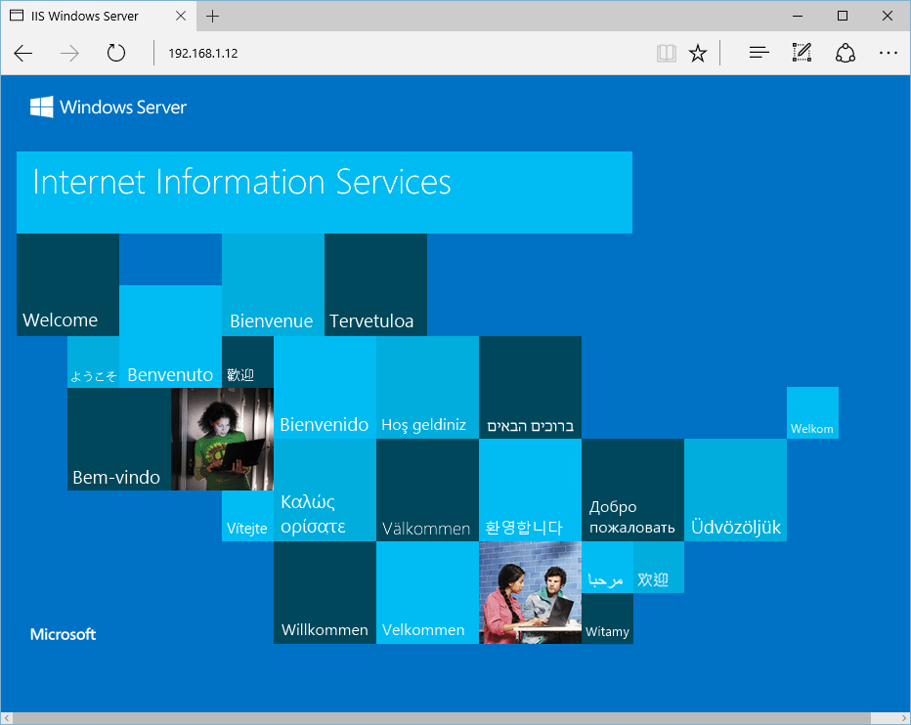

Learning Objectives
By the end of this lab, learners will be able to:
- Understand Azure VM architecture and components
- Explain the purpose of subscription and resource group
- Select appropriate VM image and size based on requirements
- Configure inbound ports for connectivity (RDP/HTTP)
- Understand disk options in Azure
- Deploy and access a VM using RDP
- Install and validate IIS web server

