Comparative Genomics 2018
Practical 1: Basic Genome Analysis
Group 11
Shuhan Xu, Fuqi Xu, Milda Valiukonyte

Exercise 1
1.
09.fa.txt: Escherichia coli
17.fa.txt: Streptomyces coelicolor
24.fa.txt: Saccharomyces cerevisiae
49.fa.txt: Rubrobacter xylanophilus
51.fa.txt: Spiribacter curvatus

2.
09.fa.txt: 5277676 bp
17.fa.txt: 8667507 bp
24.fa.txt: 1531933 bp
49.fa.txt: 3225748 bp
51.fa.txt: 1926631 bp

3.
09.fa.txt: 5358 genes
17.fa.txt: 7910 genes
24.fa.txt: 799 genes
49.fa.txt: 3257 genes
51.fa.txt: 1908 genes

4.
09.fa.txt: prokaryotic
17.fa.txt: prokaryotic
24.fa.txt: eukaryotic
49.fa.txt: prokaryotic
51.fa.txt: prokaryotic

Exercise 2
1.
blastp: searches amino acid sequence against protein sequence database
blastn: searches nucleotide sequence against nucleotide sequence database
blastx: translates nucleotide sequence in all 6 reading frames and searches against protein database
tblastn: searches protein sequence against nucleotide sequence database translated in all 6 reading frames
tblastx: translates nucleotide sequence in all 6 reading frames and searches against nucleotide sequence database translated in all 6 reading frames.

2.
run blastp against refseq

3.
A protein family is a group of closely related homologs which perform the same function.
Protein families are then grouped into superfamily in which all members are homologs but may have different functions from one another.

3.1.
There is a superfamily for this protein.

3.2.
It is HSP90 superfamily

4.1
Similarity is a measure of relationship between aligned sequences based on the degree of identity or similarity of amino acids at the matched positions.

Homology means that sequences are evolutionary related based on common ancestry.

4.2
Homology is different from similarity. Homology comes from evolutionary relationship which may not be entirely evident from sequences, e.g. sequences which are distantly related may have low identity or similarity or sequences may be similar due to convergent evolution. Similarity is a quantitative method used to measure relationship between sequences based on alignment. Highly similar sequences with Evalue below a threshold are inferred to be homologous.

4.3
When we are performing BLAST search, we are looking for highly similar sequences. We assume that highly similar sequences with Evalues below a threshold are homologous.

5.
Max target sequences: 20 000
Expect threshold: 1
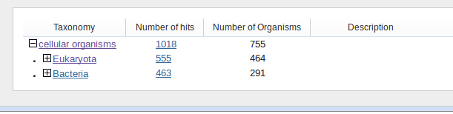

The taxonomic spread is extended to both eukaryote (464) and bacteria (291). However, this protein family is not represented in Archaea.

6.

