MACHINE LEARNING PROJECT-1

REPORT

1. Data Arrangement
The dataset is about used car sales. It has 3471 rows for training and 869 rows for testing. There are no missing values. Below is what the raw data looks like:

name | year | km_driven | fuel | seller_type | transmission | owner | selling_price
Maruti 800 AC | 2007 | 70000 | Petrol | Individual | Manual | First Owner | 60000
Maruti Wagon R LXI Minor | 2007 | 50000 | Petrol | Individual | Manual | First Owner | 135000
Hyundai Verna 1.6 SX | 2012 | 100000 | Diesel | Individual | Manual | First Owner | 600000

Each column was processed differently depending on its type:

Column | What we did | Why
name | Deleted | It's just a text label, can't be used in the model.
year | MinMaxScaler | Numbers like 2007, 2015 are too large and would make gradients unbalanced.
km_driven | MinMaxScaler | Range is 1 to 806599, very wide. Needed to normalize.
fuel | One-hot encoding (4 cols) | No order between Diesel, Petrol, CNG, LPG. Giving 0,1,2,3 would imply a false ranking.
seller_type | One-hot encoding (3 cols) | Same reason as fuel, no natural order.
transmission | Binary (0 or 1) | Only two values: Manual=0, Automatic=1.
owner | Ordinal (0 to 4) | There is a natural order: Test Drive < 1st < 2nd < 3rd < 4th+.
selling_price | MinMaxScaler | Target variable. Scaling makes gradient descent more stable.

2. Learning Rates
We tried 4 different learning rates to see how they affect training. The convergence rule we used is: stop when the difference between two consecutive cost values is less than 0.000001.
Here is the output we got:
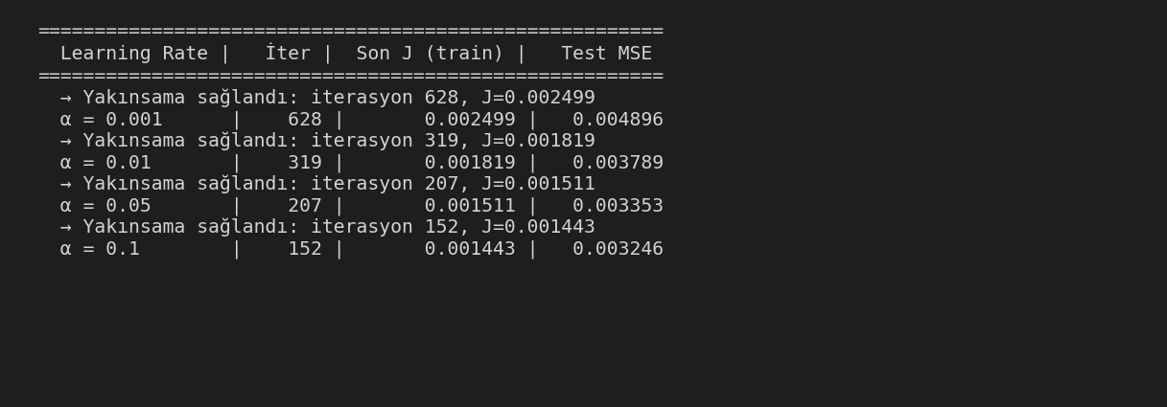
As we can see, higher learning rate means fewer iterations and lower cost. a=0.1 converged the fastest (152 iterations) and had the best test MSE so we used that as our final model.
With a=0.001 it was very slow and stopped at a higher cost value. With a=0.1 there was no divergence or oscillation, so it was safe to use.

3. Plots

Cost function and predictions
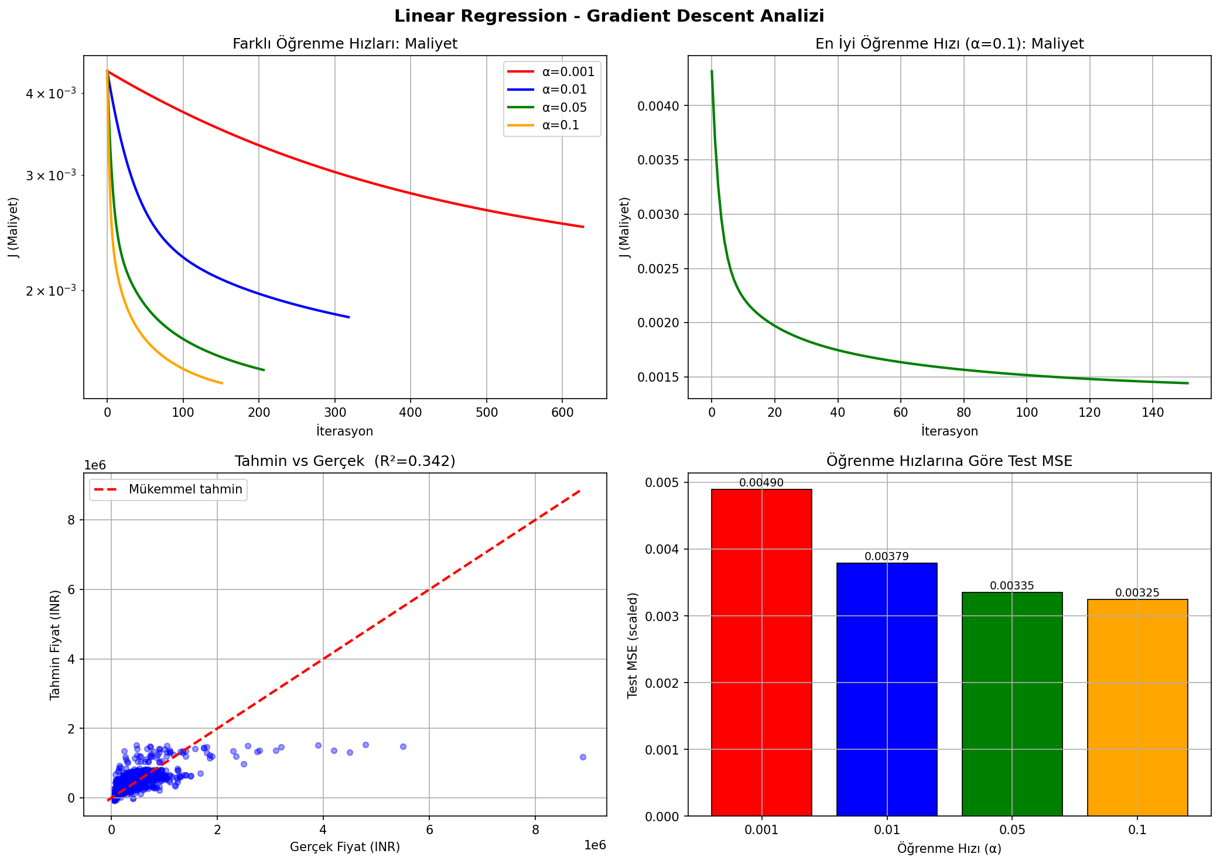
From the top-left plot we can clearly see that larger learning rates go down faster. The predicted vs actual scatter (bottom-left) shows the model is catching the general trend but there is still quite a bit of spread, which matches the R²=0.34 score.

Theta values over iterations
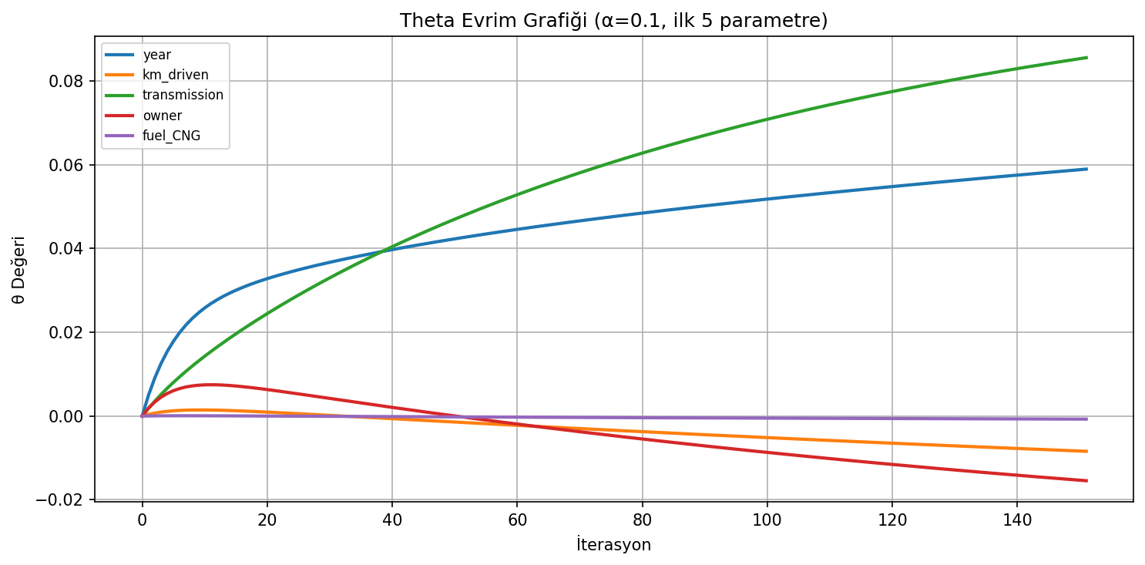
Figure 2: The first 5 theta values across iterations for a=0.1. They stabilize quickly which confirms the model converged.

4. Evaluation Metrics
We evaluated the best model (a=0.1) on the test set. The output:

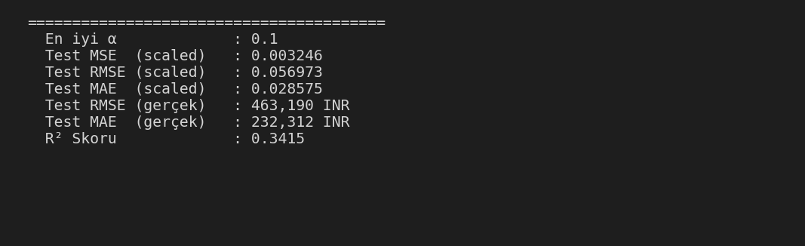

The R² score is 0.34 which means our model explains about 34% of the variance in car prices. The MAE is around 233,000 INR. This is not perfect but it makes sense for a linear model because:
- Car prices are not really linear, especially for luxury cars.
- We dropped the 'name' column (brand and model), which is actually a big factor in price.
- Linear regression can't capture interaction effects (like fuel type × year).

5. Convergence
We decided convergence when:

| J(t-1) - J(t) | < 0.000001
This means if the cost barely changes between two iterations we stop. We chose this because when cost stops improving, training more doesn't help.

Convergence results:

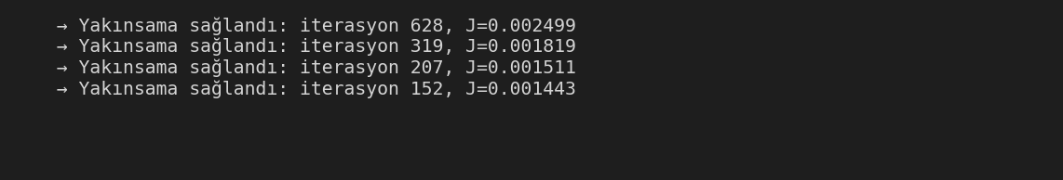

All learning rates converged successfully. None of them diverged. This is expected because linear regression has a convex cost function so there is always one global minimum.

6. Learned Parameters (Theta)
These are the final theta values for a=0.1:

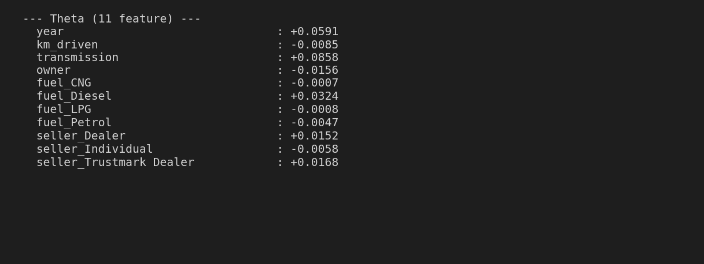

The signs all make sense. For example year is positive (newer = more expensive), km_driven is negative (more km = cheaper), transmission is the largest positive value (automatic cars are more expensive), owner is negative (more previous owners = cheaper). This shows our model learned the correct relationships.

7. Conclusion
We implemented linear regression with gradient descent from scratch using only numpy and pandas. We tested four learning rates and α=0.1 gave the best result, converging in 152 iterations with a test MSE of 0.003246.
The final model achieved R²=0.34 and MAE of around 232,000 INR. This is expected for a linear model because car prices are not linear, we dropped the name column which is a big factor in price, and linear regression cannot capture interactions between features.
Performance could be improved by encoding the brand name, adding polynomial features, or using a non-linear model like decision trees.

