**I.CLASS DIAGRAM**

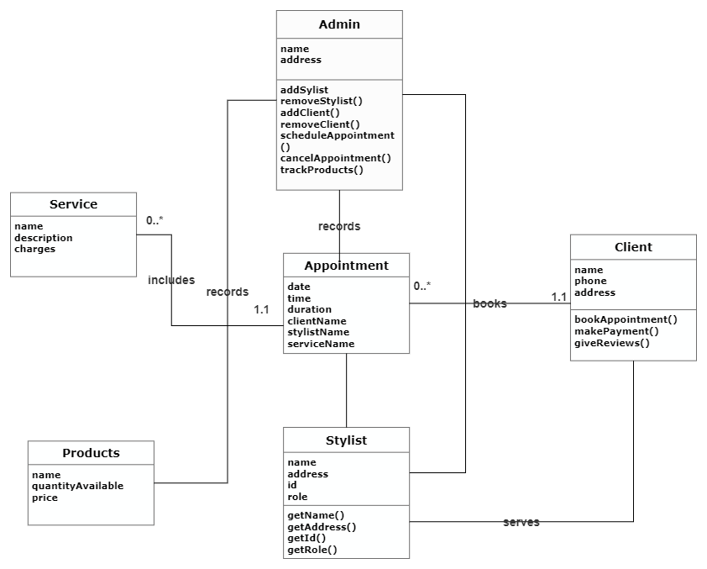

**II.USE CASE DIAGRAM**

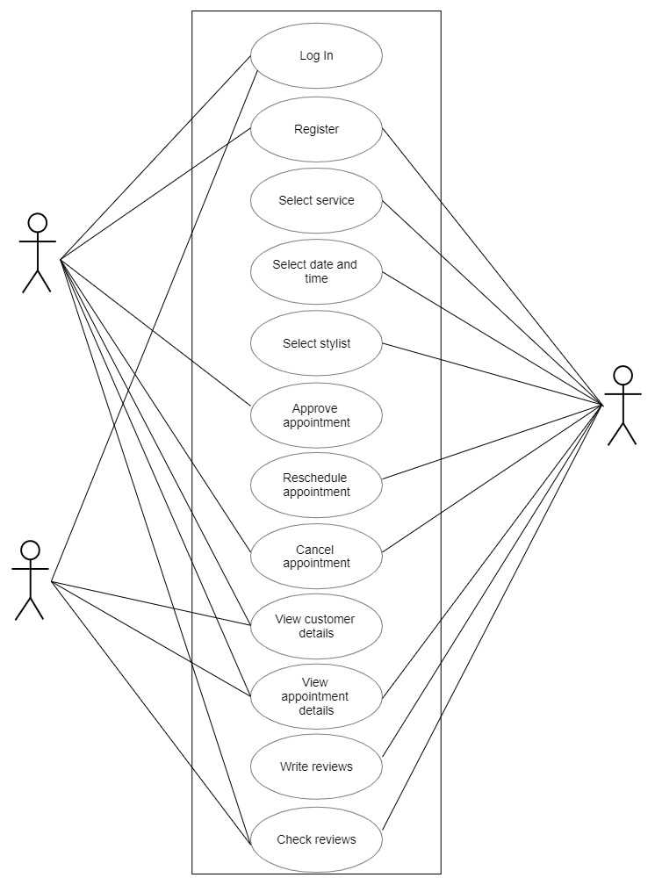

**III.FLOWCHART**

