AERO1005 MATLAB Coursework 2

Author: Bofan ZOU
Student ID: 20717834
Date of report: 4/21/2026

a )
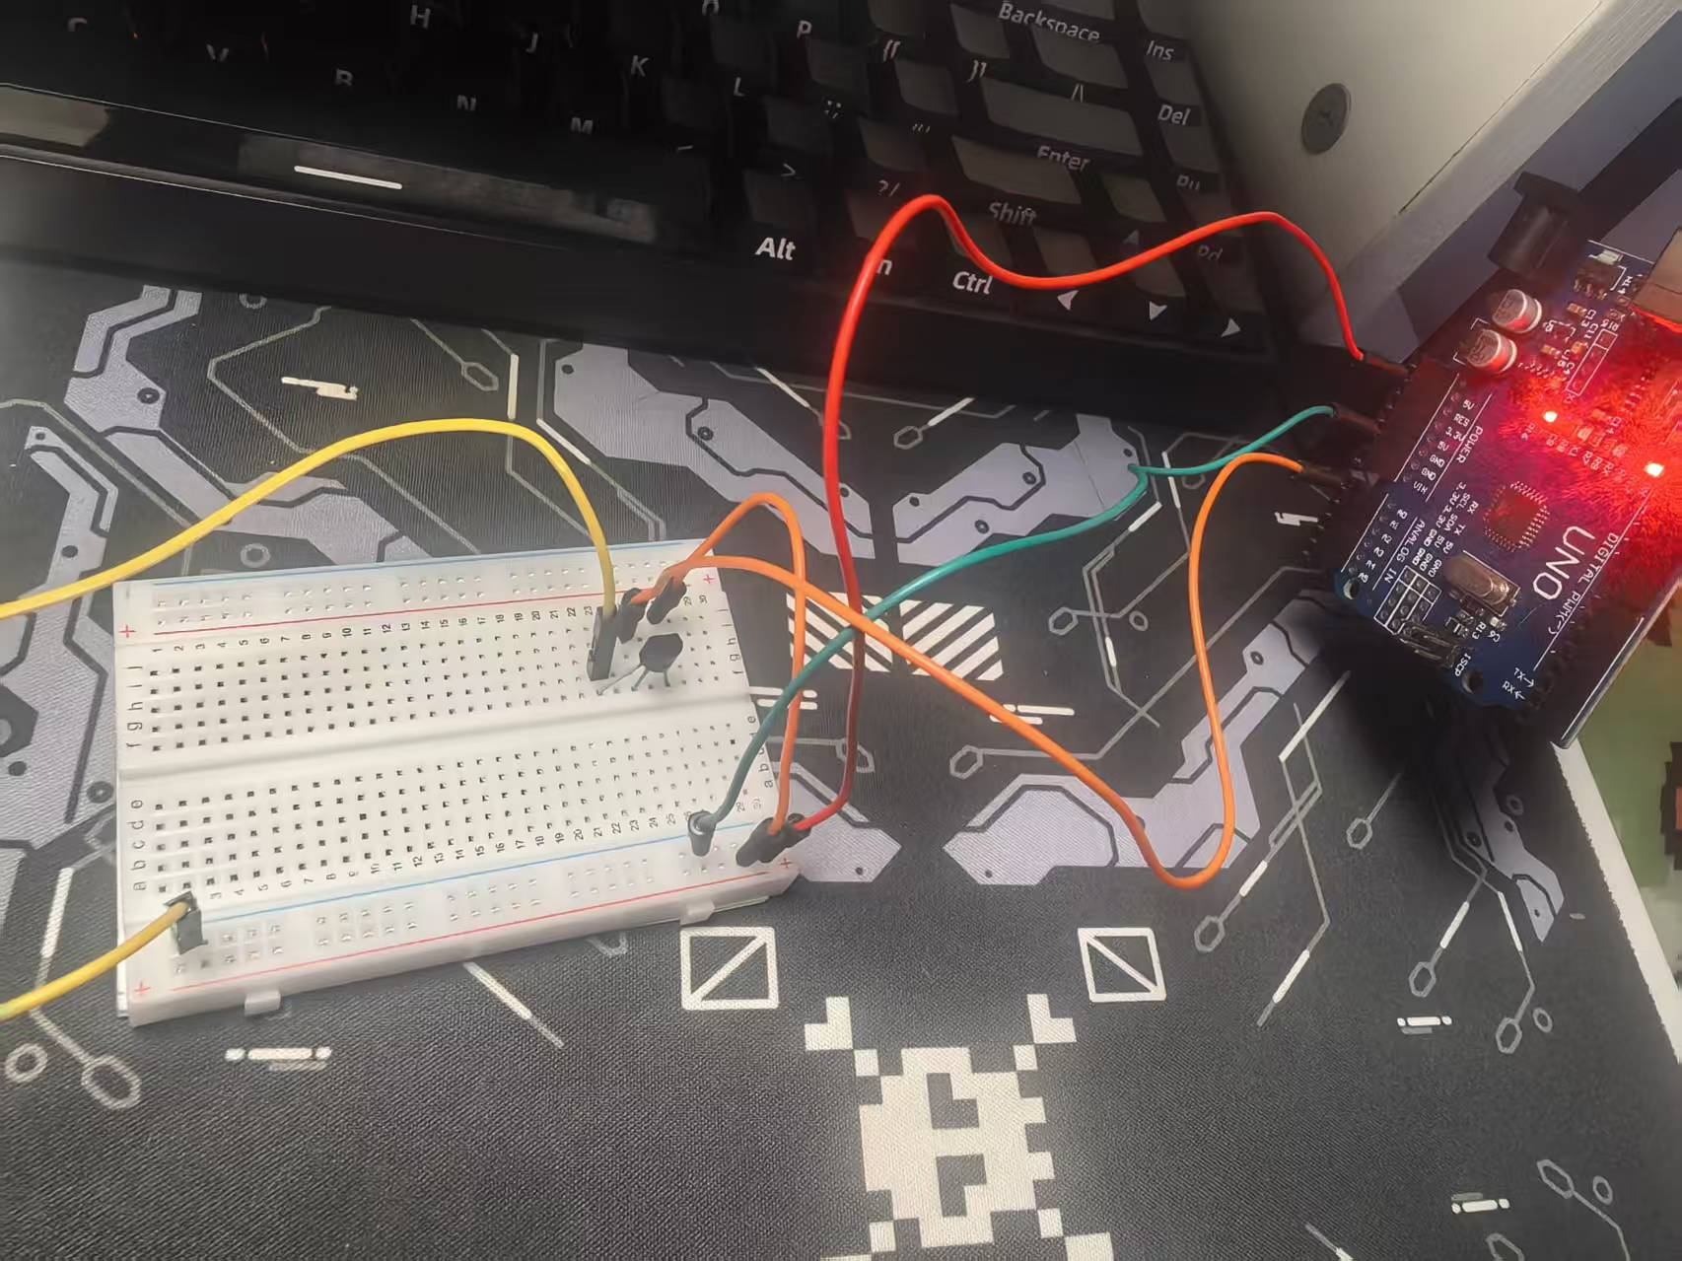
c ) To make the changes in the curve more noticeable, the temperature sensor was heated repeatedly with a hair dryer
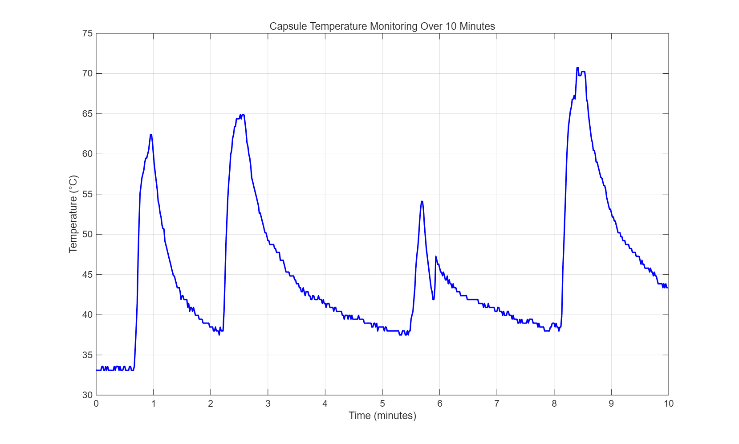

f )
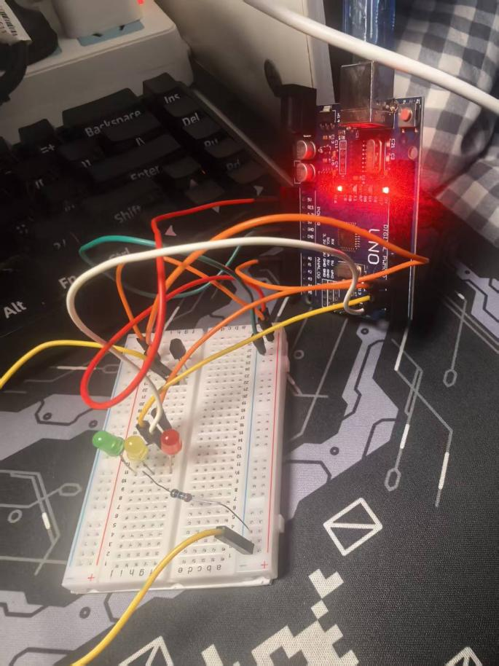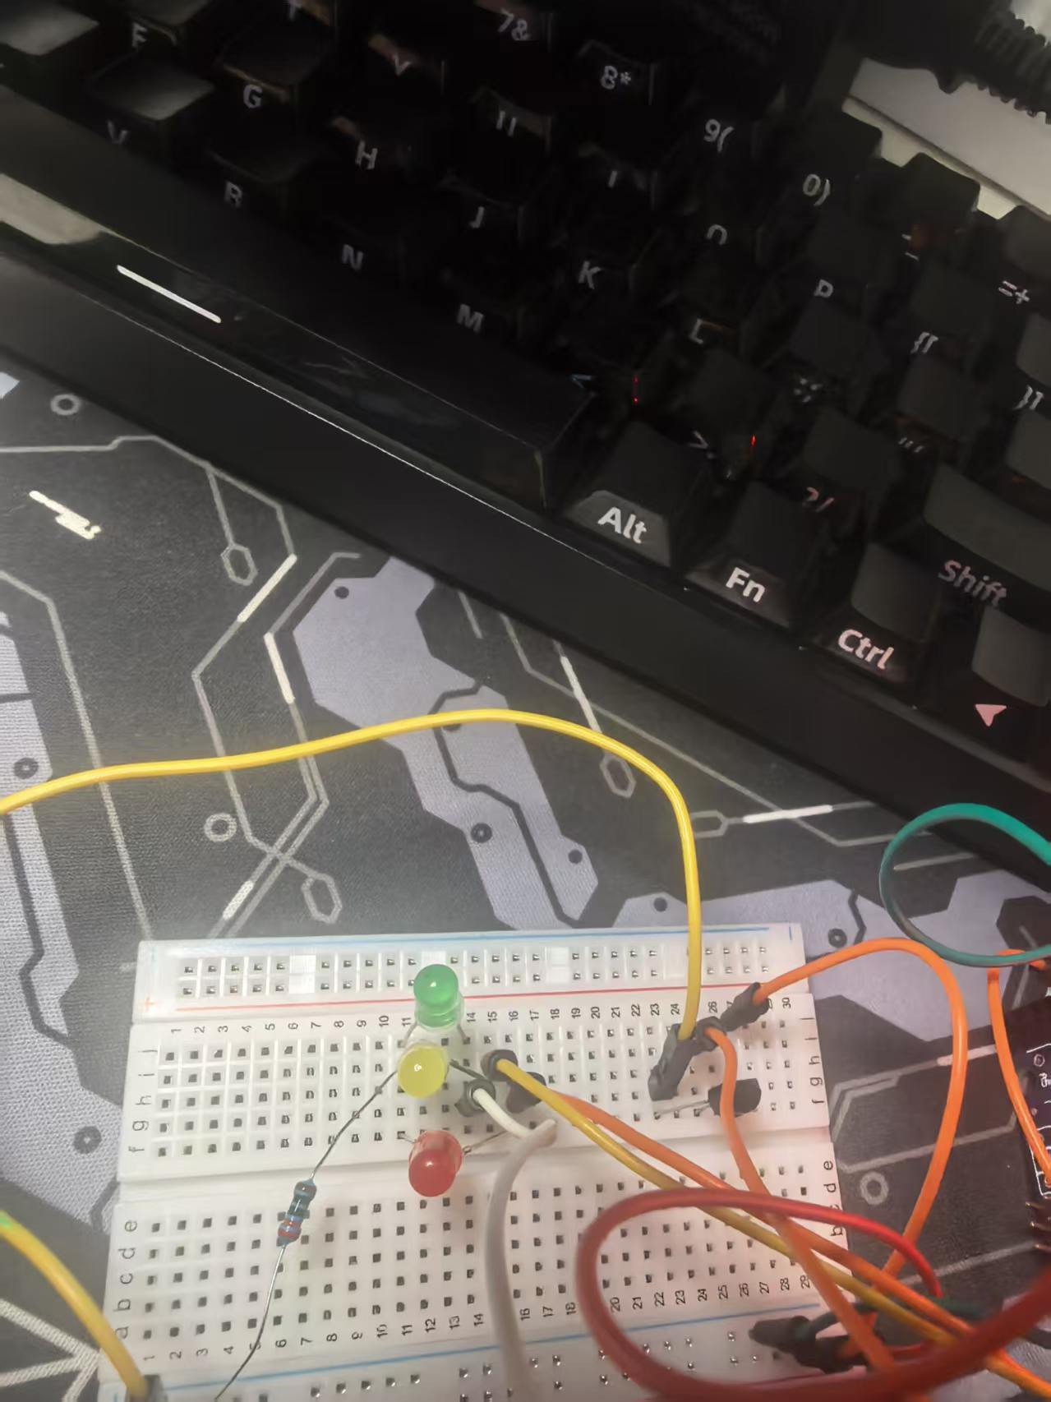
g )
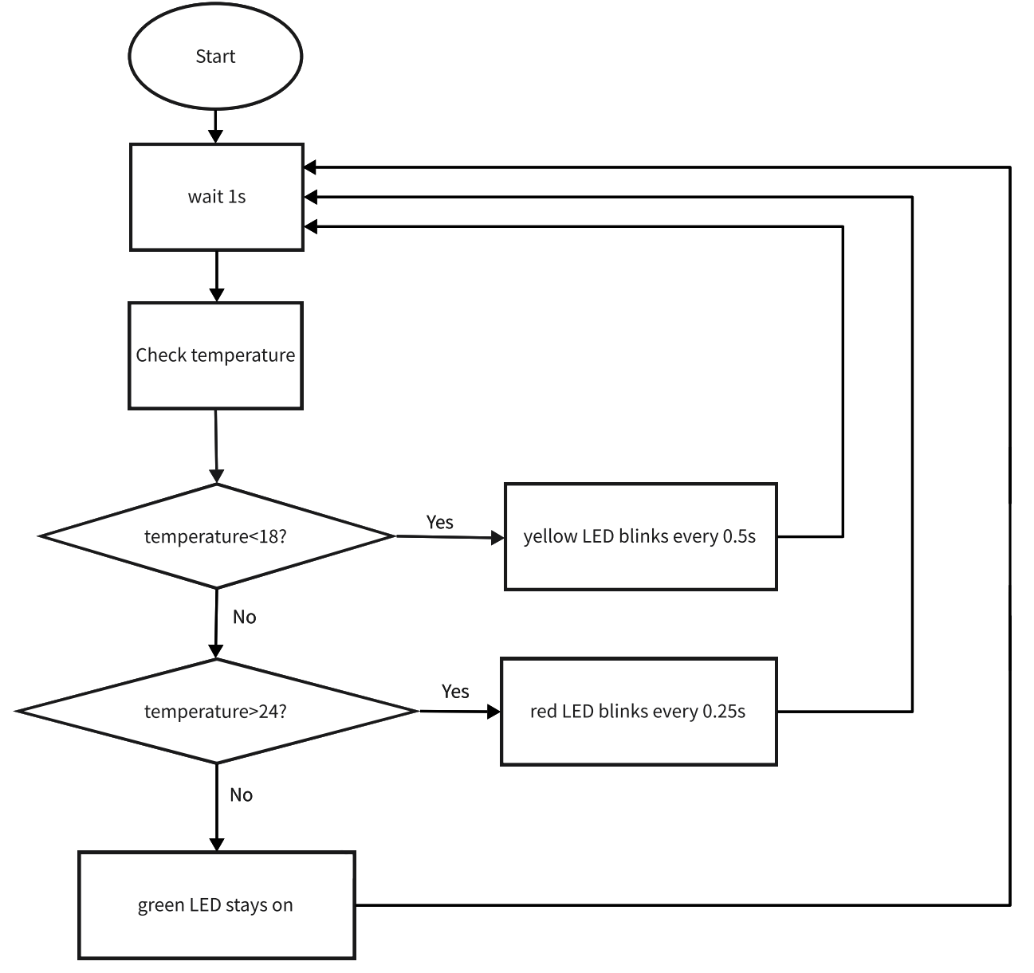
i )
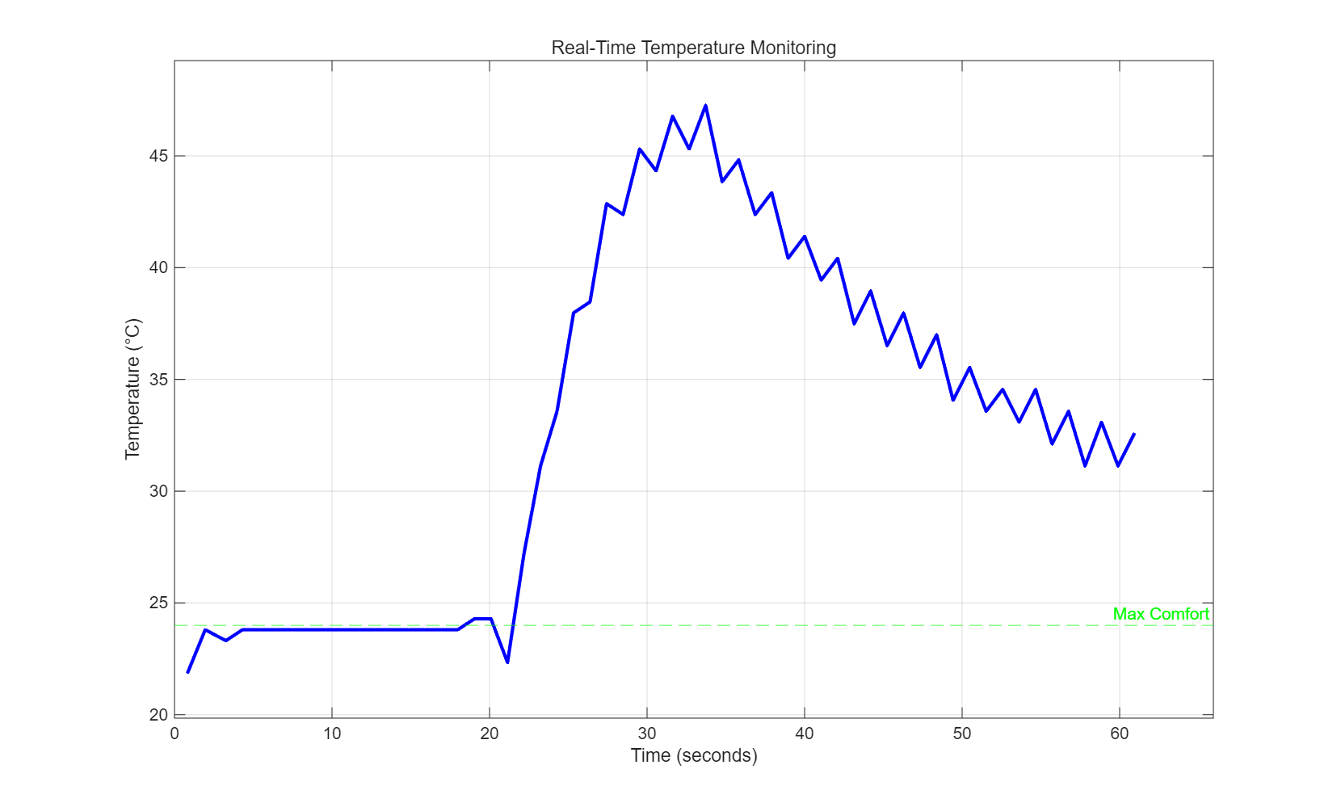
m )
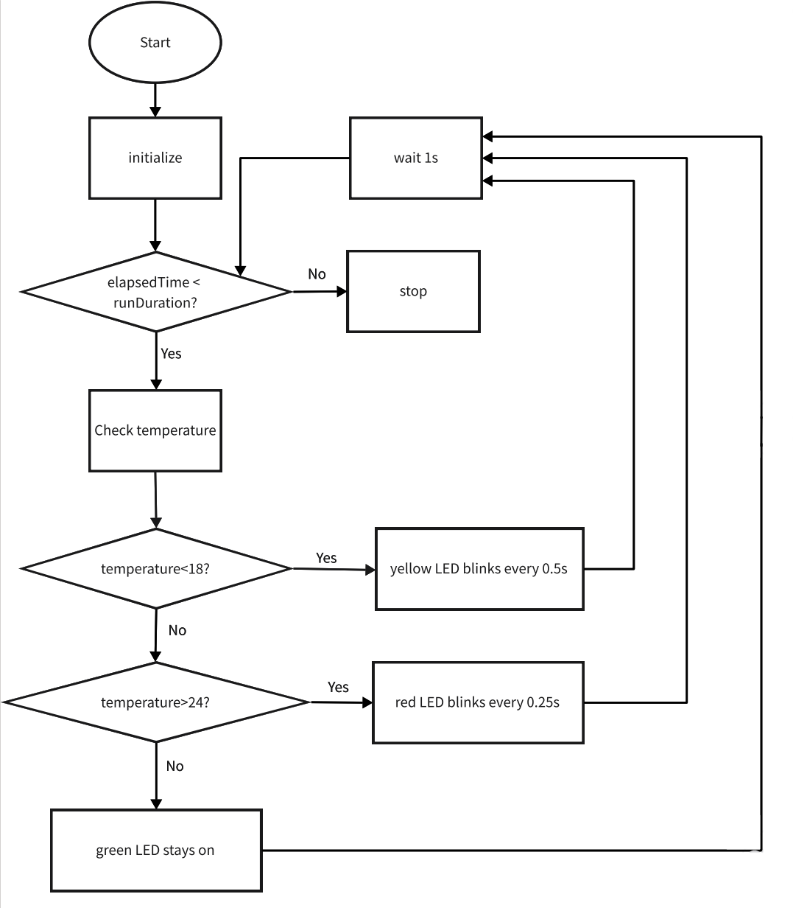
Task 3
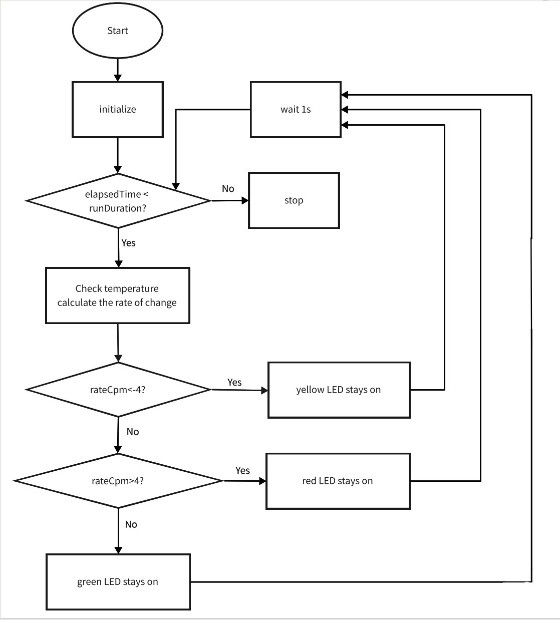
Task 4
This project involved developing a MATLAB-based temperature monitoring system for a crew capsule using an Arduino interface, which presented several challenges throughout the implementation process. One major challenge was establishing reliable communication between MATLAB and the Arduino hardware. Initial attempts resulted in connection errors and buffer overflow issues when reading voltage data, requiring careful debugging of serial port configurations and sampling intervals. Additionally, implementing the LED blinking logic while maintaining accurate timing proved difficult, as the pause() command and loop execution delays affected the intended blink frequencies. Calibrating the MCP9700A temperature sensor also required attention, as electrical noise from the Arduino power supply occasionally caused fluctuating readings.
Despite these challenges, the project demonstrated notable strengths. The modular design using separate functions (temp_monitor.m, temp_prediction.m) improved code organisation and reusability. Real-time data visualisation with live plotting provided immediate feedback on system performance, while file logging capabilities ensured data persistence for post-flight analysis. The implementation of version control through Git facilitated systematic tracking of code changes, proving essential when reverting to previous working versions after unsuccessful modifications.
However, several limitations were identified. The system relies on a simple derivative calculation for temperature prediction, which is sensitive to sensor noise and may produce inaccurate short-term rate estimates. The LED indicators provide only basic visual feedback without auditory alerts for critical temperature excursions. Furthermore, the current implementation requires continuous MATLAB-Arduino connection, limiting portability for standalone operation.
Future improvements could include implementing a moving average or Kalman filter to smooth sensor data and improve prediction accuracy. Adding wireless connectivity (e.g., Wi-Fi module) would enable remote monitoring capabilities. Incorporating a data dashboard with historical trend analysis and automated email alerts when thresholds are approached would enhance the system's practical utility for aerospace applications. Finally, deploying the algorithm directly onto the Arduino microcontroller would eliminate the need for constant MATLAB connection, creating a more robust embedded solution.

