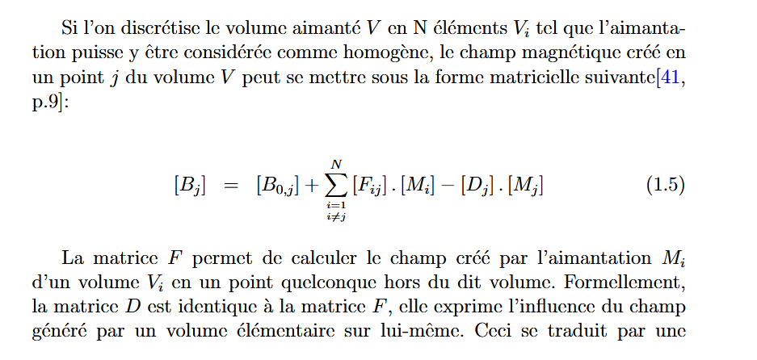

<https://theses.hal.science/tel-00723886v3/file/ellip.pdf> p.8