Birla Institute of Technology and Science, Pilani
Dubai Campus

AYU: Reliable Remaining Useful Life Prediction for Predictive Maintenance
Project by
V Sivaraman 2023A7PS0166U
Course: BITSF464 Machine Learning
Concept Integration Assessment 1

Abstract
Predictive maintenance involves using operational data to assess the condition of equipment prior to failure. In this project, the concept is approached as a Remaining Useful Life (RUL) prediction problem, the objective being to estimate the number of operating cycles that remain before a specified failure occurs. AYU makes use of the NASA C-MAPSS turbofan dataset and primarily concentrates on two issues that have been repeatedly mentioned in the literature review: changes in sensor behaviour under different operating conditions, and the fact that a simple point prediction does not indicate how reliable that prediction really is. The proposed work compares standard preprocessing with preprocessing that takes operating conditions into account for the FD001-FD004 datasets, and then introduces a simple post-hoc calibration procedure in order to generate prediction intervals. The modelling process begins with a naive baseline and then moves on to XGBoost, before later incorporating temporal models such as GRU, LSTM, or TCN. Engine-disjoint validation is applied throughout. Performance is evaluated using MAE, RMSE, R², and NASA's asymmetric prognostic score, and later experiments will also examine interval coverage and interval width. For CIA1, the initial FD001 pipeline was completed by employing exact uncapped RUL targets, removing the near-constant sensors, and calculating causal rolling means and standard deviations over 5-, 10-, and 20-cycle windows. Both versions of XGBoost—those with and without cycle information—performed significantly better than the naive mean-RUL baseline. The version that included the cycle information was chosen since it achieved a validation RMSE of 32.02 and an R² of 0.7621, and, more importantly, a substantially lower NASA score than the version without cycle information. On the 100 official FD001 test endpoints, the model attained an MAE of 19.08, an RMSE of 25.45, and an R² of 0.6249. One reason FD001 was used first is that it provides the simplest of the four C-MAPSS settings, with one operating regime and one fault mode. This made it possible to check whether the data preparation, feature construction, validation split, and evaluation procedure were working correctly before introducing the additional difficulty of FD002-FD004. CIA1 is therefore treated mainly as a baseline-building stage, after which the same general pipeline can be extended to the remaining subsets. Keeping the evaluation setup consistent should also make the later comparisons easier to interpret. These results represent only an initial baseline and are not presented as state-of-the-art performance. The primary goal of AYU is to investigate how preprocessing, temporal modelling, and calibration influence RUL prediction in a controlled manner rather than simply attempting a more complex architecture.
Introduction
Predictive Maintenance
Industrial equipment generally does not suddenly shift from a perfectly sound state to failure; instead, its condition deteriorates gradually as a result of wear, heat, vibration, variations in load, and other factors associated with operation. Unlike corrective maintenance, which only takes place after a failure has occurred, scheduled preventive maintenance may replace a component even if some of the component's useful life still remains. Predictive maintenance aims at using the measurements taken during operation so that maintenance can be carried out according to the actual condition of the machine rather than merely on the basis of a fixed timetable. Despite this, merely having a basic warning about whether the system is healthy or not is still not sufficient for a number of maintenance decisions. A better question to ask is how much of the operating life remains. An estimate of the remaining useful life provides this information and can thus aid in planning maintenance, arranging for spare parts, and managing operating risk. Recent research into the C-MAPSS programme also illustrates this change, since a great many of the newer studies now focus on robustness, uncertainty, and the usefulness of maintenance rather than just aiming to reduce the average prediction error. [3], [9]
Remaining Useful Life Prediction
The remaining useful life is the amount of operating time that still remains until a particular failure condition is met. In the case of C-MAPSS, it is given as the number of cycles that the engine has left at a specific point on its degradation path. That is why the task is regarded as a regression problem and makes use of several sensor readings and a history of operating conditions rather than being viewed simply as a classification problem concerning whether the system is healthy or faulty. [3], [16] A single sensor reading by itself does not necessarily give a full picture of the degradation. Information about the engine's condition can be obtained from the current values, the way they have changed recently, their variation over time, and the operating conditions. This is the reason why both engineered time-based features and sequence models are appropriate options for RUL prediction. [4], [8] In practical maintenance, the time at which a prediction is made is almost as important as the accuracy of the number itself. An effective model should, in principle, be able to tell the difference between an engine that is still a long way from failure and one that is approaching a critical stage, even if both are currently working normally. This is one of the reasons why RUL prediction provides more useful information than a simple failure label. At the same time, it also presents a more difficult machine-learning problem since the model has to learn from the gradual degradation shown in the sensor histories rather than just distinguishing between two clear classes. For AYU, this means that the structure of the time-series and the way the data are prepared are especially important. [3], [4]
Machine Learning for Multivariate Sensor Time-Series
Classical supervised models are able to work with features that have been derived from a sensor's history, whereas recurrent or convolutional models can learn directly from ordered sequences. In AYU, XGBoost is used initially as a simple baseline for the tabular data. The GRU, LSTM, and TCN models are retained for the subsequent temporal comparison. This approach is also helpful in making the comparison easier to understand since it allows the effect of preprocessing to be separated from that of using a temporal model. [4], [5], [8] It is also evident from the literature that preprocessing goes beyond being a simple procedure carried out before modelling; the choice of sensors, the definition of the target, the application of smoothing, normalisation, and the manner in which operating conditions are managed can all affect the final RUL result. Furthermore, the domain-adaptation papers indicate that a model which performs well in one distribution might not behave in the same way when that distribution changes. [2], [5], [6], [11]-[13]
Challenges in RUL Prediction
The fact that operating conditions make it more difficult to predict the remaining useful life is because a sensor may degrade, or it may be due to the present operating regime, or it may be due to both factors at the same time. That is why some papers employ condition-aware normalization, operation-profile alignment, or domain adaptation. In other words, achieving good accuracy under one set of conditions does not automatically imply that the model will stay reliable when the distribution of operation changes. [2], [8], [11]-[13] Uncertainty is also a problem; two engines can have similar remaining useful life (RUL) estimates even if one of the predictions is considerably more reliable than the other. For a maintenance decision, this difference is important. In order to address this, some recent studies have made use of probabilistic models, Bayesian approaches, or calibration techniques so that the output consists of an interval or a distribution and not just a single RUL value. [3], [7], [10], [14], [15]
There is also the problem of determining where an improvement actually arises. When changes are made simultaneously to target labelling, filtering, sensor selection, normalization, and the model architecture, it becomes hard to tell which of these changes caused the improvement. Moreover, recent papers have employed more complicated combinations of attention mechanisms, graph models, Transformers, and ensembles, making it even more difficult to isolate the effects. Lastly, C-MAPSS remains a simulated benchmark; although good results on it are helpful, they do not imply that the same model is immediately suitable for use in a real airline fleet. [5], [11], [16]
Motivation and Scope of AYU
If the papers are arranged in chronological order, the course of the research becomes fairly clear: the earlier studies are more concerned with representing degradation and modelling time dependencies, whereas the later ones place greater emphasis on domain shift, probabilistic outputs, and calibrated reliability. Taking that progression into account, AYU then poses a simpler question—can operating-condition variation and uncertainty be adequately addressed without at once developing another highly complicated architecture? [1]-[15] Because of this, the project compares global preprocessing with preprocessing that is aware of operating conditions when looking at FD001 to FD004, compares classical and temporal models using engine-disjoint validation, and then incorporates a lightweight calibration layer onto the best deterministic model. The aim is to keep the evaluation setup as consistent as possible so that any changes in accuracy and reliability can be attributed to particular sections of the pipeline.
Dataset Selection
NASA C-MAPSS Dataset
The dataset used by AYU is NASA C-MAPSS. It includes simulated degradation trajectories of turbofan engines under various combinations of operating conditions and fault modes. Each row of the dataset has an engine ID, the cycle number, three operating settings, and 21 sensor variables. The training engines run on until they fail, which allows the remaining useful life (RUL) to be calculated for each cycle. The test engines, on the other hand, are stopped before failure and NASA gives the RUL value corresponding to the last test cycle observed. [16]
C-MAPSS Subsets
Table 1. C-MAPSS subset characteristics.
Subset | Train Engines | Test Engines | Operating Regimes | Fault Modes
FD001 | 100 | 100 | 1 | 1
FD002 | 260 | 259 | 6 | 1
FD003 | 100 | 100 | 1 | 2
FD004 | 249 | 248 | 6 | 2
The problem becomes more difficult with each of the four subsets. FD001 has only one operating regime and one fault mode, which is why it is suitable for use as the initial baseline. FD002 includes multiple operating regimes, FD003 includes multiple fault modes, and FD004 combines both of these features. It is therefore possible to raise the level of difficulty while still using the same general dataset format. [16]
Why C-MAPSS Was Selected
C-MAPSS was chosen primarily since it is used in a great deal of recent research into remaining useful life and because it allows for both engineered-feature models and temporal deep-learning models to be employed. The FD001-FD004 progression is also suitable for this project as the operating conditions and fault complexity can be raised without having to switch to a totally different dataset. Moreover, the dataset is small enough to make it suitable for a semester-long project. [3], [5], [6], [8], [11], [16]
Dataset Limitations
The key limitation is that C-MAPSS is based on simulation and not on actual telemetry data gathered from a real airline fleet. Genuine equipment may exhibit additional noise, undergo maintenance actions, operate under conditions that are not seen here, and have failure mechanisms which are not included in this study. Therefore the results obtained in AYU should be regarded as benchmark results alone and not as proof that the model is ready for use in safety-critical situations. [16]
Detailed Literature Review
Wen et al. (2021)
One of the earlier papers discussed in this review is that of Wen et al. They begin by combining various sensor measurements into a composite health indicator and then make use of this indicator for the purpose of estimating the remaining useful life. The main point I have drawn from this paper is that the quality of the degradation representation is important even before the final regressor is taken into account. This is pertinent to AYU since sensor selection and temporal summarization are also regarded as part of the experiment. A drawback is that the construction of the health indicator is still closely linked to the benchmark and it does not address the issues of cross-condition generalisation or calibrated uncertainty. [1]
Fu et al. (2021)
A paper that is also very useful is Fu et al., since it directly addresses distribution shift. The approach involves combining a residual LSTM with unsupervised domain adaptation in order that knowledge of RUL may be transferred when the training and target distributions differ. This supports the aspect of AYU relating to operating conditions. Yet, the fact that successful transfer has been achieved between benchmark domains is still not equivalent to proving that the method will generalize to any actual industrial environment. [2]
Vollert and Theissler (2021)
Vollert and Theissler do not suggest a new RUL model; rather, they examine machine-learning approaches using C-MAPSS. The paper is valuable since it clearly identifies problems such as interpretability, model uncertainty, domain adaptation, and transfer learning even though the average prediction error has improved. It thus provides a reason for AYU to go beyond merely considering RMSE. The fact, however, that it is a review article means that it does not prove one particular adaptation or uncertainty method to be the best. [3]
Zhang et al. (2022)
Zhang and others can be regarded as a reference among the temporal models; their approach involves the use of a bidirectional GRU together with temporal self-attention and also includes various kinds of preprocessing, such as removing variables, smoothing, and applying sliding windows. The model is intended for the purpose of capturing long-term degradation information, something that is relevant to the later temporal-model stage in AYU. Nevertheless, the final output remains essentially a deterministic RUL value, meaning that attention on its own does not address the issue of uncertainty. [4]
Asif et al. (2022)
When considering how the published C-MAPSS results are obtained, Asif et al. offer a useful approach; their pipeline involves making several changes at the same time, namely piecewise RUL labelling, sensor selection, moving-median filtering, dimensionality reduction, and the use of a deep LSTM, and it is applied to all four subsets. The paper demonstrates that preprocessing and the way the target is constructed can have a major impact on performance. The disadvantage is that since so many components are altered together, it is not easy to determine exactly how much of the improvement was due to the LSTM and how much was due to the data processing. [5]
Li et al. (2022)
Li et al. apply a Transformer combined with feature-level and semantic-level domain alignment in order to carry out cross-domain RUL prediction using C-MAPSS and N-CMAPSS. The present paper is another instance illustrating that a powerful temporal model by itself does not suffice to eliminate distribution shift. The idea is applicable to AYU, but the full framework is rather heavy for the scope of this project and would still require a separate method if calibrated uncertainty is needed. [6]
Xiong et al. (2022)
Unlike the previous deterministic studies, Xiong et al. treat the remaining useful life as a probabilistic issue by combining temporal convolution with several self-attention modules and thus provide more than just a single point estimate. This is beneficial for AYU since it aligns with the view that a maintenance prediction should indicate a range of possible remaining useful life values. Yet as replicating another specialised probabilistic network would make it more difficult to determine whether the improvements were due to the predictor or to the uncertainty method, AYU keeps its calibration stage simpler. [7]
Xu et al. (2023)
Xu and others directly investigate the problem of multiple operating conditions; their method involves clustering and normalisation before applying attention-based spatio-temporal modelling. The present paper is especially relevant to the FD002 and FD004 experiments since those subsets include multiple operating regimes. However, there is the problem that the preprocessing and the architecture are altered together, so the benefits cannot be clearly attributed to normalisation alone. [8]
Lee and Mitici (2023)
Lee and Mitici are useful since they go a step further than simply predicting the remaining useful life (RUL); they incorporate probabilistic RUL estimates into a deep reinforcement-learning maintenance policy, thereby showing that the value of a prediction lies not just in the RMSE but also in risk, timing, and uncertainty. While AYU uses this concept only to justify a reliability-aware evaluation, the reinforcement-learning maintenance policy itself is not included because that would introduce a further set of assumptions regarding costs and the maintenance environment. [9]
Wang et al. (2023)
A paper that also focuses on uncertainty is that of Wang et al., who have developed a Bayesian large-kernel attention network which generates estimates of the remaining useful life of bearings along with uncertainty information. The key takeaway for AYU is that confidence can be measured explicitly rather than having to remain an informal limitation. However, this method is not directly concerned with shifts in turbofan operating conditions and the use of Bayesian deep learning introduces greater computational complexity through additional sampling and modelling as compared to the post-hoc approach outlined here. [10]
Huang et al. (2023)
For Huang and his colleagues the aspect most pertinent to AYU is the comparison between unified normalization and clustering-based normalization; their full model also involves graph-based sensor relationships, temporal convolution, and attention. The results do support the view that normalization can have a noticeable effect in the case of multiple operating conditions, but since the entire pipeline is complicated it remains difficult to determine how much of the improvement was due solely to the normalization step. [11]
Nejjar et al. (2024)
Nejjar and others examine domain shift by means of operation profiles and align the source and target operating phases when transferring the remaining useful life. This approach is useful since it indicates that the mismatch could be due to the way the machine is operated rather than merely resulting from a general difference in the feature distributions. The idea of incorporating condition awareness is suitable for AYU. Nevertheless, full domain adaptation would introduce considerably more complexity than is actually required for the present project. [12]
Le Xuan et al. (2024)
Le Xuan and others make use of self-supervised domain adaptation in order that the representations of degradation may be transferred even in the case where the target domain lacks RUL labels. This is yet another study illustrating that distribution shift remains a problem even with more powerful deep models. The entire self-supervised pipeline would constitute a major project by itself, and it would still not deal with the issue of prediction calibration. [13]
Xu et al. (2024)
The study by Xu and others addresses uncertainty directly by applying Bayesian deep learning and ensembles to distinguish between epistemic and aleatoric uncertainty. The paper is useful since it regards uncertainty as something that can be measured and assessed rather than just referring to it as a limitation. It also explains why AYU employs a simpler post-hoc approach: although Bayesian ensembles are more expressive, they also require more computation and introduce more modelling choices. [14]
Zhou et al. (2025)
The latest article in the review is by Zhou et al., who produce calibrated RUL intervals by combining CNN, BiLSTM, and Transformer branches with ensemble uncertainty methods and conformal prediction. This demonstrates that recent research is now beginning to assess interval coverage and robustness as well as the usual point error. AYU is not asserting that these ideas are new; rather, the contribution of this work is to address similar reliability questions using a simpler and more controlled pipeline. [15]
Literature Synthesis
When put together, the papers do not all address the same aspect of the problem, but it is possible to see the overall progression. The earlier ones are more concerned with representing degradation and learning temporal patterns, while the later ones devote more attention to distribution shift, probabilistic outputs, and eventually to calibrated intervals. It is because of this that the two main questions used in AYU are: whether condition-aware preprocessing helps with generalization, and whether it is possible to obtain useful prediction intervals for a deterministic RUL model without having to replace it with a different large architecture. [1]-[15]

Table of Reviewed Papers
Table 2. Chronological summary of the 15 reviewed papers.
Title | Authors | Year | Venue | ML Technique | Short Summary
A generalized remaining useful life prediction method for complex systems based on composite health indicator | Wen, Zhao, Chen, Li | 2021 | Reliability Engineering & System Safety | Composite health indicator + RUL | Multi-sensor health indicator improves degradation representation; motivates preprocessing as part of the model.
Deep residual LSTM with domain-invariance for remaining useful life prediction across domains | Fu, Zhang, Lin, Zhao, Zhong | 2021 | Reliability Engineering & System Safety | Residual LSTM + domain adaptation | Improves RUL transfer under distribution shift; motivates explicit robustness testing.
Challenges of machine learning-based RUL prognosis: A review on NASA's C-MAPSS data set | Vollert, Theissler | 2021 | IEEE ETFA | Review of ML RUL methods | Identifies uncertainty, interpretability, and domain adaptation as open C-MAPSS challenges.
Prediction of remaining useful life based on bidirectional gated recurrent unit with temporal self-attention mechanism | Zhang, Jiang, Wu, Li, Luo, Yin | 2022 | Reliability Engineering & System Safety | BiGRU + temporal attention | Combines temporal attention with recurrent modelling and highlights the role of preprocessing/windowing.
A Deep Learning Model for Remaining Useful Life Prediction of Aircraft Turbofan Engine on C-MAPSS Dataset | Asif et al. | 2022 | IEEE Access | Deep LSTM + preprocessing | Uses target shaping, sensor selection, filtering, dimensionality reduction, and LSTM across FD001-FD004.
Domain Adaptive Remaining Useful Life Prediction With Transformer | Li et al. | 2022 | IEEE Transactions on Instrumentation and Measurement | Transformer + domain adaptation | Aligns source and target representations to address cross-domain RUL shift.
Non-parametric Multi Self-Attention Temporal Convolutional Network for Probabilistic Remaining Useful Life Prediction | Xiong, Tian, Zhou, Ma | 2022 | PHM-Yantai | TCN + self-attention + probabilistic RUL | Models a distribution of plausible RUL values rather than only a point estimate.
Spatio-temporal degradation modeling and remaining useful life prediction under multiple operating conditions based on attention mechanism and deep learning | Xu, Xiao, Liu, Sui | 2023 | Reliability Engineering & System Safety | Condition normalization + attention deep learning | Treats operating conditions explicitly through clustering/normalization and spatio-temporal modelling.
Deep reinforcement learning for predictive aircraft maintenance using probabilistic Remaining-Useful-Life prognostics | Lee, Mitici | 2023 | Reliability Engineering & System Safety | Probabilistic RUL + DRL | Shows maintenance usefulness depends on uncertainty, risk, and timing, not prediction error alone.
Bayesian large-kernel attention network for bearing remaining useful life prediction and uncertainty quantification | Wang, Cao, Ye, Xu | 2023 | Reliability Engineering & System Safety | Bayesian attention network | Produces RUL estimates with uncertainty information; motivates reliability-aware evaluation.
Spatio-Temporal Attention Graph Neural Network for Remaining Useful Life Prediction | Huang, He, Sick | 2023 | IEEE CSCI | GNN + temporal attention + cluster normalization | Shows clustering-based normalization can materially improve performance under multiple conditions.
Domain adaptation via alignment of operation profile for Remaining Useful Lifetime prediction | Nejjar et al. | 2024 | Reliability Engineering & System Safety | Operation-profile alignment | Aligns operating phases to improve cross-domain RUL transfer.
Self-supervised domain adaptation for machinery remaining useful life prediction | Le Xuan, Munderloh, Ostermann | 2024 | Reliability Engineering & System Safety | Self-supervised domain adaptation | Learns transferable degradation representations when target RUL labels are unavailable.
Remaining Useful Life Prediction Accounting for Epistemic and Aleatoric Uncertainties | Xu et al. | 2024 | SRSE | Bayesian deep learning + ensemble | Separates epistemic and aleatoric uncertainty and evaluates uncertainty-aware prediction.
Remaining Useful Life Prediction and Uncertainty Quantification with Multi-Branch Deep Networks and Probabilistic Calibration | Zhou, Wei, Ma | 2025 | IEEE SDPC | Multi-branch deep learning + MC dropout + conformal | Combines strong point prediction with uncertainty estimation and empirical interval calibration.

Problem Identification and Research Gaps
• Operating-Condition Distribution Shift
A sensor may change due to engine degradation, due to a change in the way it is operating, or as a result of both of these factors occurring together. Although some existing papers attempt to address this issue by means of domain adaptation, profile alignment, or condition-based normalization, the problem is not entirely eliminated. In AYU, the gap in question is examined more directly by comparing global preprocessing with operating-condition-aware preprocessing in the case of FD001 to FD004. [2], [8], [11]-[13]
• Limitations of Deterministic Point Predictions
Although RMSE and MAE are useful, they only provide an average error and do not indicate how reliable a specific RUL estimate is, which is particularly important when the model overestimates the remaining life. For this reason, AYU later includes a lightweight calibrated interval layer and evaluates empirical coverage and interval width together with the usual point-prediction metrics. [3], [7], [10], [14], [15]
• Influence of Preprocessing on Reported Performance
A further problem is that in published results the choices made during preprocessing and modelling are usually combined. When the target definition, the sensor selection, the filtering, the dimensionality reduction, the normalization, and the architecture are all changed at the same time, it becomes difficult to explain the final improvement. That is why AYU keeps both the predictor and the evaluation setup as fixed as possible when investigating the effect of preprocessing. [5], [8], [11]
• Increasing Model Complexity and Reduced Transparency
Many of the more recent RUL models also incorporate a number of high-capacity components, such as attention mechanisms, Transformers, graph networks, ensembles, and domain adaptation. Although these methods can achieve good results, they are more difficult to reproduce and it becomes less obvious which component actually made a difference. AYU investigates whether simpler XGBoost models together with selected temporal baselines, plus careful preprocessing and calibration, can still provide a useful balance between accuracy and complexity. [6], [11], [15]
• Benchmark Performance Versus Real-World Generalisation
Since C-MAPSS remains a simulated benchmark, achieving good results on it alone does not serve as proof of reliability when used on an actual aircraft; real engines may experience noise, require maintenance, operate under new conditions, and have failure modes that are not included in the simulator. That is why the transition from simulator to real world is maintained as a specific limitation and AYU makes no claims regarding deployment or certification. [16]
• Prediction Accuracy Versus Maintenance Usefulness
One further drawback is that a single overall error value doesn't always indicate whether the model is useful for the purpose of maintenance. It's possible for a model to have an acceptable RMSE yet still give optimistic predictions towards the end of its life or generate intervals that are too wide to be of any use. That is why AYU also examines NASA's asymmetric score as well as interval coverage and width, and later looks at the behaviour of the errors at different phases of the RUL. [9], [15]
Final Problem Statements
• Problem Statement 1 - Operating-Condition-Aware RUL Prediction
What effect does operating-condition-aware normalization have on the accuracy and robustness of Remaining Useful Life predictions when applied to different subsets of the C-MAPSS data that include either a single or multiple operating regimes? In the first problem statement preprocessing is the main element that is being altered, while XGBoost and the temporal sequence model remain almost unchanged so that the effect of operating-condition-aware normalization can be more clearly observed.
• Problem Statement 2 - Calibrated Uncertainty for RUL Prediction
Can the use of model-agnostic uncertainty calibration transform deterministic RUL regressors into reliable interval predictors without substantially reducing the accuracy of point predictions? The second statement considers only the reliability aspect of the issue and involves adding a lightweight post-hoc method after the deterministic model, the resulting intervals then being verified by means of empirical coverage and interval width.
• Problem Statement 3 - Reliable RUL Prediction Under Varying Operating Conditions
How much can the use of preprocessing that takes into account operating conditions together with calibrated uncertainty estimation improve the accuracy and reliability of remaining useful life predictions for the NASA C-MAPSS FD001-FD004 systems when compared with deterministic baseline approaches that are based on global preprocessing? This third statement combines the two main directions that came out of the literature review: handling operating-condition variation and adding calibrated reliability to the RUL prediction.
Selected Problem Statement
The third problem statement has been chosen since it brings together both of the main gaps yet remains something that can be dealt with within a semester. Classical and temporal models will make use of engine-disjoint validation, normal point-prediction metrics, NASA's asymmetric score, and then the calibration metrics. The objective is not to come up with a new architecture; rather it is to systematically examine how preprocessing, temporal modelling, and calibration affect the accuracy and reliability of RUL.
Project Objectives
• Objective 1 - Develop and benchmark RUL prediction models
Develop a reproducible C-MAPSS pipeline and compare classical engineered-feature models with temporal sequence models using engine-disjoint splits and RMSE, MAE, R², and NASA's asymmetric prognostic score.
• Objective 2 - Quantify the effect of operating-condition-aware preprocessing
Compare global preprocessing with operating-condition-aware normalization, with particular attention to FD002 and FD004 where multiple regimes increase distributional complexity.
• Objective 3 - Evaluate prediction reliability in addition to accuracy
Apply a lightweight calibration method to the strongest deterministic predictor and evaluate empirical interval coverage, interval width, and reliability across different stages of remaining life.
Methodology and Feasibility
• Data Preparation and RUL Target Construction
The data from FD001 to FD004 will be arranged first by engine and cycle, then checked for any missing or nearly constant signals, and the RUL targets will be determined by using each training engine's known run-to-failure point. In the case of CIA1, the target is exactly the uncapped RUL, which is equal to the final cycle minus the current cycle. Although some studies make use of capped or piecewise targets, these will only be examined later as a separate analysis and are not included in the CIA1 baseline.
• Feature Engineering and Operating-Condition Processing
The classical pipeline makes use of the current sensor readings in conjunction with causal moving averages and standard deviations, and any feature selection or preprocessing step that learns from the data is fitted using the training engines alone; later experiments will compare normal global preprocessing with preprocessing which is based on the operating conditions.
• Model Development and Evaluation
The order in which the models are considered is simple: start with the naive baseline, then move on to XGBoost, followed by the selected GRU/LSTM or TCN model, and finally carry out reliability enhancement. The engines are kept separate in the training, validation, and subsequent calibration datasets so that rows relating to the same engine do not appear on both the training and validation sides of any split. Deterministic models are assessed using the RMSE, MAE, R², and NASA's asymmetric prognostic score, while the reliability enhancement stage includes empirical interval coverage and the mean interval width.
• Calibration, Ablation, and Final System
A strong deterministic model will be chosen and, in order to build post-hoc RUL intervals, a separate calibration set that is disjoint from the engine data will be used. The primary ablation studies will examine global and condition-aware normalization, the different temporal-window options, and the various target assumptions individually. Although the final CIA3 interface might display the predicted RUL together with an uncertainty interval, the health trajectory, and the risk state, the ML experiments themselves are still the main component of the project.
Feasibility
The experiments can be carried out at the C-MAPSS scale. The EDA, the rolling features, and the XGBoost procedure can all be performed using ordinary CPU hardware, while the more recurrent or temporal models can be run on a consumer GPU. The post-hoc calibration stage is also relatively light in comparison to training the main models.
Original Contributions
• Controlled Operating-Condition Normalization Study
The study into the different operating conditions will use the same modelling and evaluation setup when looking at FD001 to FD004, comparing global preprocessing with condition-aware preprocessing; the key point is to alter the preprocessing at the same time without making unnecessary changes to the rest of the pipeline.
• Reliability Layer for Deterministic RUL Models
Once a deterministic model has been chosen, a simple post-hoc calibration layer will be used to turn the point predictions into intervals; the intervals will then be evaluated on the basis of empirical coverage and width so that reliability can be measured rather than merely being discussed.
• Reproducible Complexity-Stratified Benchmark
The identical RUL target definition, engine-disjoint split logic, feature construction, and metric implementation will be applied to all four subsets, which should make it easier to see what occurs as both the operating condition and the fault complexity increase.
• RUL-Phase Failure Analysis
The analysis carried out later will also divide the predictions into early-, middle-, and late-life periods rather than depending solely on the overall RMSE. This is primarily in order to reveal errors such as the overestimation of late-life RUL which might be concealed within the average score.
Initial Python Implementation and Results
• Data Preparation
CIA1 takes FD001 as its clean initial baseline, consisting of 100 training engines and 100 test engines, under one operating condition and one fault mode. The training data comprises 20,631 observations and the test data 13,096 observations. Exact uncapped RUL labels were created for each of the training rows. For development purposes, entire engines, not individual rows, were divided in an 80/20 ratio into 80 engines for training and 20 for validation, in order to avoid any leakage between the two sets.
• Exploratory Data Analysis
Out of the 21 sensors, 15 exhibited meaningful variation. Sensors numbered 1, 5, 10, 16, 18, and 19 were effectively constant and therefore were excluded. The highest absolute Pearson correlations with remaining useful life (RUL) were found for sensors 11, 4, 12, 7, and 15. These correlations were taken as merely descriptive associations and not as indication of causal importance.
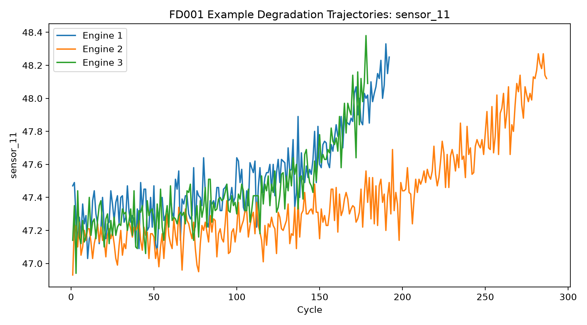
Figure 1. Representative sensor_11 degradation trajectories for three FD001 engines.
• Feature Engineering
The feature set kept the present values of the informative sensors and the three operating settings and also included, for each engine separately, the causal rolling means and standard deviations over 5, 10, and 20 cycles; no centred window or future observation was employed. The feature decisions were made on the basis of the training engines only. Two controlled configurations were examined, one involving cycles and the other not; the unit_id was not included as a predictor.
• Baseline Models
The naive approach was a mean-RUL predictor. XGBoost was trained under two different configurations—one including cycles and one without—in order to determine whether the performance was mainly dependent on the observable engine age or whether the degradation measurements and the engineered temporal features themselves contained a useful signal. Early stopping was based only on the engine-disjoint validation set and the official test RUL labels were not used for model selection or tuning.
Experimental Results
Table 3. FD001 validation results.
Model | MAE | RMSE | R² | NASA Score
Naive Mean RUL | 55.3633 | 65.7154 | -0.0019 | 19,351,068.7551
XGBoost with Cycle | 24.6777 | 32.0213 | 0.7621 | 411,193.2901
XGBoost without Cycle | 22.9424 | 32.1111 | 0.7608 | 1,428,466.0422
The two XGBoost models performed considerably better than the naive baseline. The model that included the cycle achieved the lowest validation RMSE (32.02) and the highest R² score (0.7621), whereas the model that did not include the cycle had a slightly lower MAE (22.94). The greater difference was seen in the NASA asymmetric score: it was 411,193 for the model with the cycle and about 1.43 million for the one without the cycle. Because the NASA score imposes a stronger penalty for dangerous overestimations of remaining useful life, the model with the cycle was chosen.
Once the choice had been made, the same feature configuration was trained once more with all 100 FD001 training engines for 84 boosting rounds, and the official test set was not evaluated until after this step, using the final observed cycle of each test engine.
Table 4. Official FD001 endpoint test results.
Metric | Result
MAE | 19.0819
RMSE | 25.4518
R² | 0.6249
NASA Score | 12,111.8971
In the official FD001 endpoint test, the model in question obtained an MAE of 19.08, an RMSE of 25.45, an R² value of 0.6249, and a NASA score of 12,111.90. This result provides an independent verification that the baseline pipeline is functioning properly beyond the development split.
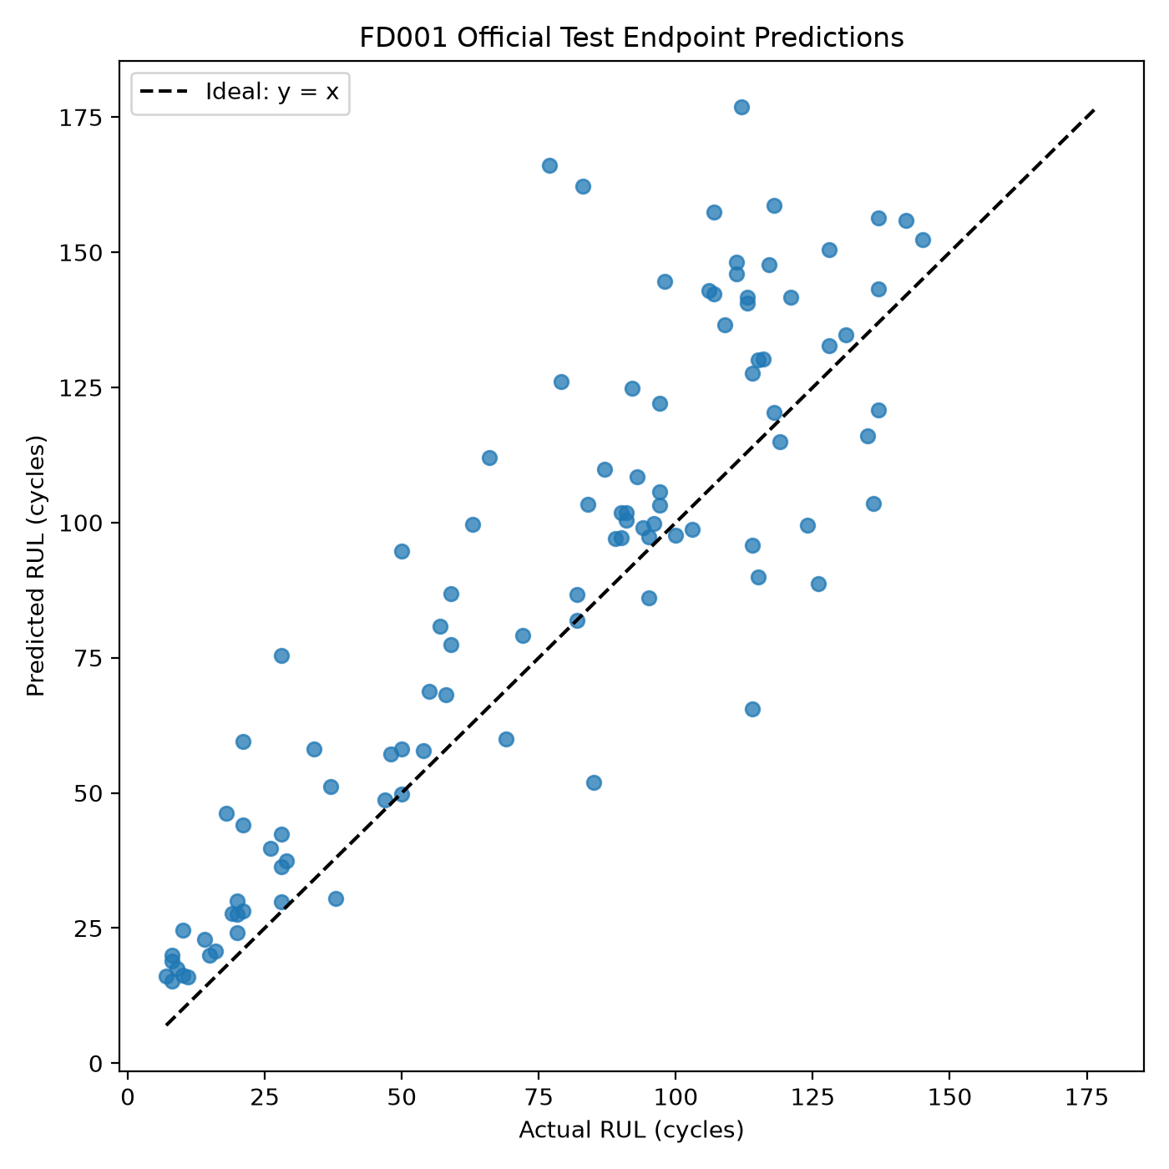
Figure 2. Predicted versus actual RUL for the official FD001 test endpoints.
Initial Findings and Limitations
The increase in validation RMSE after removing the cycle was only slight. This indicates that the engineered degradation features already contain useful information even without taking engine age into account. Yet the inclusion of the cycle led to a much greater improvement in NASA's asymmetric score, which shows that engine age helps to reduce the type of overestimation errors that the score penalizes most strongly.
The FD001 figures should not be directly compared to those based on capped or piecewise RUL targets, different preprocessing, or different evaluation points since the CIA1 target in this case is the exact, uncapped RUL. Moreover, the two NASA scores in this report are derived from different numbers of predictions: the validation score is based on 4,070 cycle-level predictions whereas the official test score uses 100 engine endpoints. Therefore, the absolute score values cannot be directly compared. At the present stage, the only aim is to set up a correct, leakage-aware baseline before carrying out the condition-aware and reliability experiments.
Conclusion
CIA1 sets out the existing literature and establishes the initial working baseline for AYU; the 15 papers examined in the report demonstrate a clear progression from methods of representing degradation and carrying out temporal modelling towards approaches focusing on operating-condition robustness, probabilistic prediction, and calibrated reliability. The project problem chosen on the basis of this review is to determine whether condition-aware preprocessing helps generalisation across FD001 to FD004 and whether a simple post-hoc calibration procedure can contribute useful uncertainty intervals to a deterministic RUL model.
So far only the FD001 baseline has been carried out, but the main evaluation procedure is already in place. It involves the exact construction of the uncapped RUL, eliminating the near-constant sensors, incorporating causal temporal features, carrying out engine-disjoint validation, training with XGBoost, and then evaluating the final endpoint. The model that was selected for the with-cycle scenario achieved an official test RMSE of 25.45 and a MAE of 19.08. The cycle ablation also demonstrated that the sensor-based features still contain useful degradation information even when the cycle is removed.
The further steps involve extending this baseline by moving on to the more difficult C-MAPSS subsets, comparing the different temporal models, testing condition-aware preprocessing, and then incorporating calibrated uncertainty. Since the split logic, the way the target is defined, and the evaluation protocol are to be kept as unchanged as possible, it should be easier to determine which of the changes actually improves the accuracy or reliability of the RUL.
References
[1] P. Wen, S. Zhao, S. Chen, and Y. Li, “A generalized remaining useful life prediction method for complex systems based on composite health indicator,” Reliability Engineering & System Safety, vol. 205, p. 107241, 2021, doi: 10.1016/j.ress.2020.107241.
[2] S. Fu, Y. Zhang, L. Lin, M. Zhao, and S.-S. Zhong, “Deep residual LSTM with domain-invariance for remaining useful life prediction across domains,” Reliability Engineering & System Safety, vol. 216, p. 108012, 2021, doi: 10.1016/j.ress.2021.108012.
[3] S. Vollert and A. Theissler, “Challenges of machine learning-based RUL prognosis: A review on NASA's C-MAPSS data set,” in 2021 26th IEEE International Conference on Emerging Technologies and Factory Automation (ETFA), pp. 1-8, 2021, doi: 10.1109/ETFA45728.2021.9613682.
[4] J. Zhang, Y. Jiang, S. Wu, X. Li, H. Luo, and S. Yin, “Prediction of remaining useful life based on bidirectional gated recurrent unit with temporal self-attention mechanism,” Reliability Engineering & System Safety, vol. 221, p. 108297, 2022, doi: 10.1016/j.ress.2021.108297.
[5] O. Asif, S. A. L. I. Haider, S. R. Naqvi, J. F. W. Zaki, K. S. Kwak, and S. M. R. Islam, “A Deep Learning Model for Remaining Useful Life Prediction of Aircraft Turbofan Engine on C-MAPSS Dataset,” IEEE Access, vol. 10, pp. 95425-95440, 2022, doi: 10.1109/ACCESS.2022.3203406.
[6] X. Li, J. Li, L. Zuo, L. Zhu, and H. T. Shen, “Domain Adaptive Remaining Useful Life Prediction With Transformer,” IEEE Transactions on Instrumentation and Measurement, vol. 71, pp. 1-13, 2022, doi: 10.1109/TIM.2022.3200667.
[7] J. Xiong, J. Tian, J. Zhou, and Y. Ma, “Non-parametric Multi Self-Attention Temporal Convolutional Network for Probabilistic Remaining Useful Life Prediction,” in 2022 Global Reliability and Prognostics and Health Management Conference (PHM-Yantai), pp. 1–8, 2022, doi: 10.1109/PHM-Yantai55411.2022.9941979.
[8] D. Xu, X. Xiao, J. Liu, and S. Sui, “Spatio-temporal degradation modeling and remaining useful life prediction under multiple operating conditions based on attention mechanism and deep learning,” Reliability Engineering & System Safety, vol. 229, p. 108886, 2023, doi: 10.1016/j.ress.2022.108886.
[9] J. Lee and M. Mitici, “Deep reinforcement learning for predictive aircraft maintenance using probabilistic Remaining-Useful-Life prognostics,” Reliability Engineering & System Safety, vol. 230, p. 108908, 2023, doi: 10.1016/j.ress.2022.108908.
[10] L. Wang, H. Cao, Z. Ye, and H. Xu, “Bayesian large-kernel attention network for bearing remaining useful life prediction and uncertainty quantification,” Reliability Engineering & System Safety, vol. 238, p. 109421, 2023, doi: 10.1016/j.ress.2023.109421.
[11] Z. Huang, Y. He, and B. Sick, “Spatio-Temporal Attention Graph Neural Network for Remaining Useful Life Prediction,” in 2023 International Conference on Computational Science and Computational Intelligence (CSCI), pp. 99-105, 2023, doi: 10.1109/CSCI62032.2023.00022.
[12] I. Nejjar, F. Geissmann, M. Zhao, C. Taal, and O. Fink, “Domain adaptation via alignment of operation profile for Remaining Useful Lifetime prediction,” Reliability Engineering & System Safety, vol. 242, p. 109718, 2024, doi: 10.1016/j.ress.2023.109718.
[13] Q. Le Xuan, M. Munderloh, and J. Ostermann, “Self-supervised domain adaptation for machinery remaining useful life prediction,” Reliability Engineering & System Safety, vol. 250, p. 110296, 2024, doi: 10.1016/j.ress.2024.110296.
[14] W. Xu, Y. Hao, J. Xu, Y. Liu, H. Liu, and E. Zio, “Remaining Useful Life Prediction Accounting for Epistemic and Aleatoric Uncertainties,” in 2024 6th International Conference on System Reliability and Safety Engineering (SRSE), 2024, doi: 10.1109/SRSE63568.2024.10772488.
[15] X. Zhou, F. Wei, and X. Ma, “Remaining Useful Life Prediction and Uncertainty Quantification with Multi-Branch Deep Networks and Probabilistic Calibration,” in 2025 IEEE International Conference on Sensing, Diagnostics, Prognostics, and Control (SDPC), pp. 187-192, 2025, doi: 10.1109/SDPC68151.2025.11347806.
[16] NASA Prognostics Center of Excellence, “Turbofan Engine Degradation Simulation Data Set,” PCoE Data Set Repository, NASA. [Online]. Available: https://www.nasa.gov/intelligent-systems-division/discovery-and-systems-health/pcoe/pcoe-data-set-repository/. Accessed: Sep. 25, 2026.

