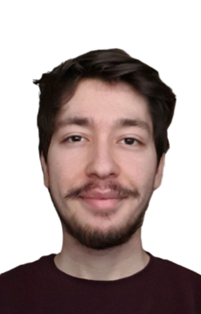
Furkan Özdemİr

PERSONAL INFORMATION
Website: furkan-ozdemir.github.io/personal-page/
Github: github.com/Furkan-Ozdemir
Linkedin: linkedin.com/in/furkan-o-demir/
Email: ozthefur@gmail.com
Address: İzmir, Karabağlar/Esenyalı
Date of Birth 03-05-1999
Mobile Phone: 05552831252

PROFILE
I am a student majoring in computer engineering looking for internships to get work experience. I am mainly focused on web development but interested in every part of software development and currently working on personal full-stack projects.I am very good at communicating with people and I am a fast learner.

EDUCATION

2020-Present Dokuz Eylül University
Computer Engineering

2018 –2020 Marmara University
Computer Engineering

2014-2017 Fen Bilimleri Sahilevleri High School

Experience
03/2020 – 04/2020 Cimri.com
Office Worker
Skills
- Javascript, Node.js | - CSS, Bootstrap
- HTML, EJS | - MongoDB
- Java • Python
- ReactJS • Jest
Projects
kaça çıkarım
- Designed with Bootstrap framework and implemented with Node.js and Express framework.
- Provides natural gas ,electricity bills and rent information for that selected district by using Istanbul Büyükşehir Belediyesi Open Data APIs and Istanbul Büyükşehir Belediyesi City Map API.
FullStack Calendar
- It is a fullstack web calendar for your business. Login with your account and create ,edit and see the tasks.
- Implemented with Node.js ,Express framework ,MongoDB and VanillaJS.
Zoom Link Generator
- This python script scrapes an email address from temproray-mail.net then connects to
zoom.us creates a new account with the scraped email and launches a meeting.
- Newly registered zoom accounts does not have a 40 minute time limit on their meetings.
That’s why I built this script for my classes.

Certificates
- APIs and Microservices | - Responsive Web Design
FreeCodeCamp | FreeCodeCamp

Languages
• Turkish: Native | • English: Fluent
• Spanish: Basic

