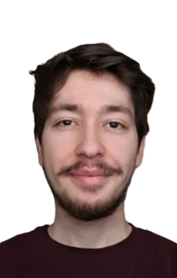Furkan Özdemİr

**PERSONAL INFORMATION**

Website: furkan-ozdemir.github.io/personal-page/

Github: github.com/Furkan-Ozdemir

Linkedin: linkedin.com/in/furkan-o-demir/

Email: [ozthefur@gmail.com](mailto:ozthefur@gmail.com)

Address: İzmir, Karabağlar/Esenyalı

Date of Birth 03-05-1999

Mobile Phone: 05552831252

**PROFILE**

I am a student majoring in computer engineering looking for internships to get work experience. I am mainly focused on web development but interested in every part of software development and currently working on personal full-stack projects.I am very good at communicating with people and I am a fast learner.

**EDUCATION**

2020-Present **Dokuz Eylül University**

Computer Engineering

2018 –2020 **Marmara University**

Computer Engineering

2014-2017 **Fen Bilimleri Sahilevleri High School**

**Experience**

03/2020 – 04/2020 **Cimri.com**

Office Worker

**Skills**

|  |  |
| --- | --- |
| * Javascript, Node.js | * CSS, Bootstrap |
| * HTML, EJS | * MongoDB |

* Java • Python
* ReactJS • Jest

**Projects**

**kaça çıkarım**

* Designed with Bootstrap framework and implemented with Node.js and Express framework.
* Provides natural gas ,electricity bills and rent information for that selected district by using Istanbul Büyükşehir Belediyesi Open Data APIs and Istanbul Büyükşehir Belediyesi City Map API.

**FullStack Calendar**

* It is a fullstack web calendar for your business. Login with your account and create ,edit and see the tasks.
* Implemented with Node.js ,Express framework ,MongoDB and VanillaJS.

**Zoom Link Generator**

* This python script scrapes an email address from temproray-mail.net then connects to

zoom.us creates a new account with the scraped email and launches a meeting.

* Newly registered zoom accounts does not have a 40 minute time limit on their meetings.

That’s why I built this script for my classes.

**Certificates**

|  |  |
| --- | --- |
| * **APIs and Microservices** | * **Responsive Web Design** |
| FreeCodeCamp | FreeCodeCamp |

**Languages**

|  |  |
| --- | --- |
| **• Turkish:** Native | **• English:** Fluent |
| **• Spanish:** Basic |  |