**Furkan Karacaer 1000174 INF1C**

**Patrick Sekimonyo 0994659 INF1C**

|  |  |  |
| --- | --- | --- |
| **Requirements specification Python’s Library system** | **Functional** | **Non-functional** |
| **Librarian** |  |  |
| 1. Login | **X** |  |
| * 1. Login should be fast |  | **X** |
| * 1. Login should be secure |  | **X** |
| * 1. Login should only work when username is found in the system |  | **X** |
| 1. Register | **X** |  |
| * 1. Register should take only a couple of seconds |  | **X** |
| 1. Import books | **X** |  |
| * 1. Importing books should be quick |  | **X** |
| * 1. Import books should be reliable |  | **X** |
| 1. Import customers | **X** |  |
| * 1. Importing customers should be quick |  | **X** |
| * 1. Import customers should be reliable |  | **X** |
| 1. Show loan administration | **X** |  |
| * 1. Should display all loans |  | **X** |
| * 1. Should work even when no items are loaned |  | **X** |
| 1. Create backup | **X** |  |
| * 1. Should not take long |  | **X** |
| 1. Restore backup | **X** |  |
| * 1. Should not take long |  | **X** |
| **Subscriber** |  |  |
| 1. Login | **X** |  |
| * 1. Login should be fast |  | **X** |
| * 1. Login should be secure |  | **X** |
| * 1. Login should only work when username is found in the system |  | **X** |
| 1. Register | **X** |  |
| * 1. Register should take only a couple of seconds |  | **X** |
| * 1. Register should ask for name, surname, address etc. |  | **X** |
| 1. Show catalogue | **X** |  |
| * 1. Catalogue should be easy to read |  | **X** |
| 1. Search book | **X** |  |
| * 1. Should display when a book is not available |  | **X** |
| * 1. Book search should be able to choose from title, ISBN, published etc. |  | **X** |
| 1. Loan book | **X** |  |
| * 1. Loan book should check the availability | **X** |  |
| * 1. Loan book should display the amount of copies. |  | **X** |
| 1. Return book | **X** |  |
| * 1. Should display all loaned books of your account |  | **X** |
| **Publishing Company** |  |  |
| 1. Login | **X** |  |
| * 1. Login should be fast |  | **X** |
| * 1. Login should be secure |  | **X** |
| * 1. Login should only work when username is found in the system |  | **X** |
| 1. Register | **X** |  |
| * 1. Register should take only a couple of seconds |  | **X** |
| * 1. Register should ask for name, surname, address etc. |  | **X** |
| 1. Show catalogue | **X** |  |
| * 1. Catalogue should be easy to read |  | **X** |
| 1. Search book | **X** |  |
| * 1. Should display when a book is not available |  | **X** |
| * 1. Book search should be able to choose from title, ISBN, published etc. |  | **X** |
| 1. Loan book | **X** |  |
| * 1. Loan book should check the availability | **X** |  |
| * 1. Loan book should display the amount of copies. |  | **X** |
| 1. Return book | **X** |  |
| * 1. Should display all loaned books of your account |  | **X** |

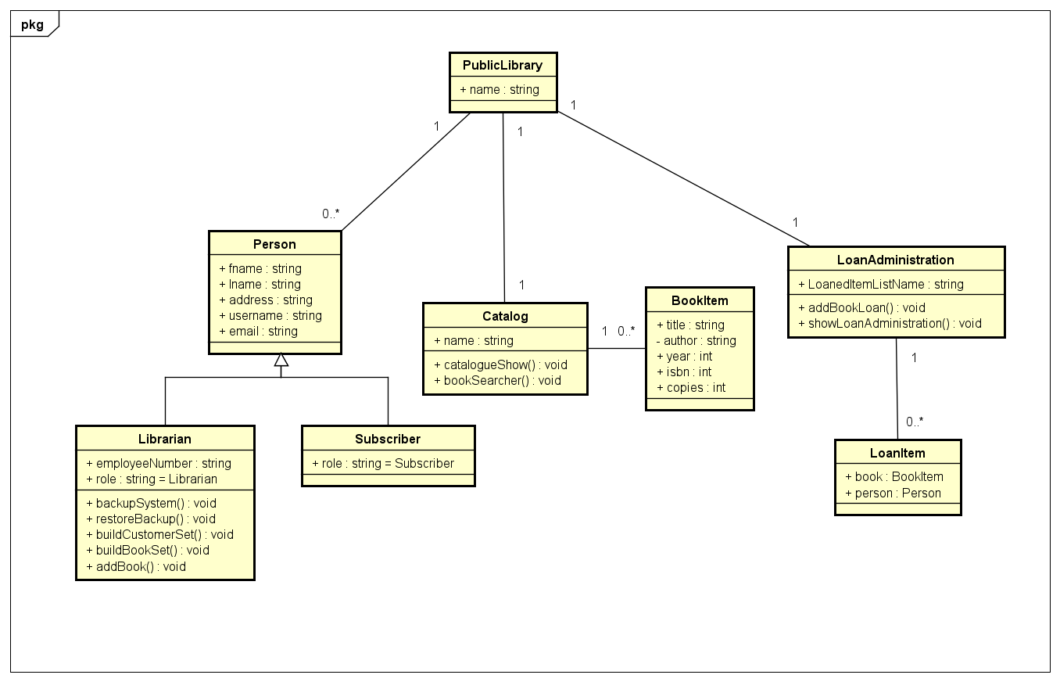

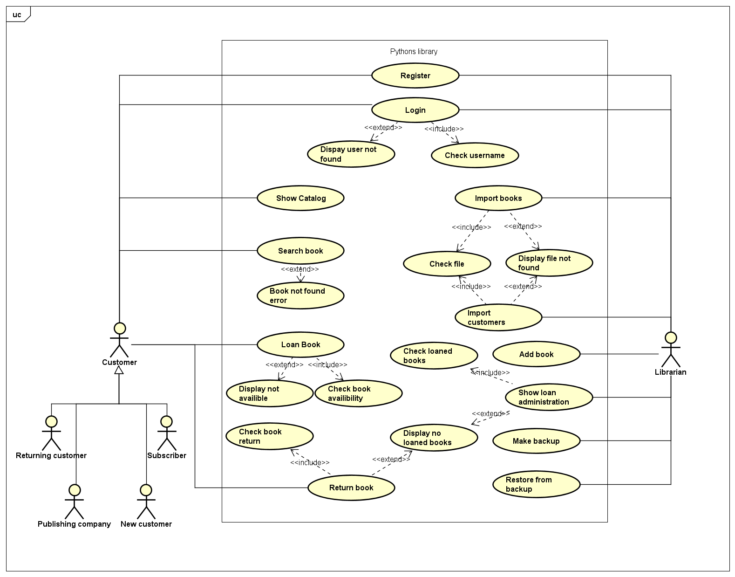

Pythons Library manual

Welcome to the library’s systems manual. In this manual all the different features and options for Pythons library will be explained.

# Getting started

When the application is started you will be greeted with this screen. Please remember that all navigation will be asked as a number that you can input.

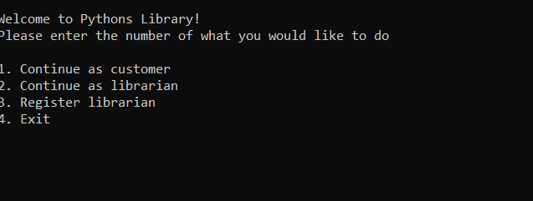

Figure 1Welcome screen

Pythons Library offers two main features sets. One as a customer browsing the app and one as a librarian in charge of maintaining the app. A librarian can also be added here. You can simply type the number “3”, answer the prompted questions and the librarian will be added to the system.

# Librarian features

Once you are registered as a librarian you can continue as a librarian fill in your name and if you are in the system you will be taken to this librarian screen.

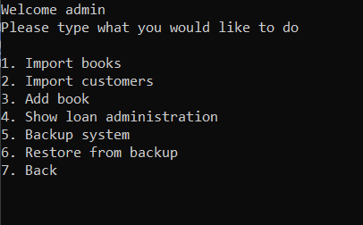

Figure 2 librarian screen

Alternatively, a default librarian is always added at the start-up. Simply enter the “admin” username into the login when continuing as librarian. From here the librarian can do the most essential tasks like importing books, importing customers, adding books, Showing the loan administration, backing up the system and restoring from this backup.

When importing books, you must enter the file name and you will receive a prompt which shows you whether it has successfully imported or if you may need to try again. Please remember the book data must be in a JSON file format and please note that importing a data set will overwrite the set currently in the system. Similarly, when importing customers, the same message will display when successful. When importing customers please remember that the file must be in a CSV file format.

The librarian can also add books. Simply type the number show and fill in the asked questions.

The librarian can also view the loan administration. Here the librarian can see who is loaning a book and which book(s) they are loaning.

Lastly the librarian can create a backup of the entire system. Simply select the backup number provide a file name. When restarting the system, you can restore all data by selecting the restore function and provide the file name.

# Customers

Welcome reader!  
when continuing as a customer you will be greeted by this screen.

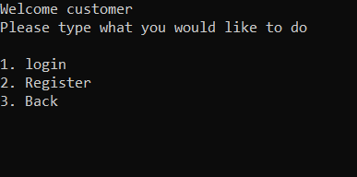

Figure 3 customer welcome

Here you can login, register or go back. If you would like to register, simply enter the displayed number, and fill in the forms. After registration you can login providing your username and you will be taken to the main menu.

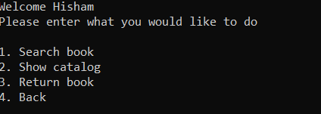

Figure 4 main menu

From here you can access the features. Would you like to search for a book, Browse the catalogue or return a book perhaps? They can all be done through this screen. When searching for a book you will be asked to provide the title, author, ISBN or published year of the book you are trying to find. If one book is found, you may proceed to loan this book or look for another. If multiple books are found they will be displayed, and you will be asked to search more specifically in order to get a book to loan. From here you can continue to the loan, confirm and the book will be stored under your account. If at any point you wish to stop you may do so by typing “exit” at the show inputs or use the menu to navigate backwards.

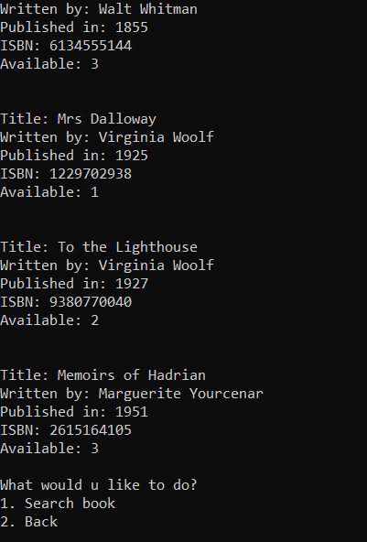

Figure 5 catalogue

You can also use the show catalogue option to browse through all the books that are in the system. From here you can search for the specific book you would like to you can navigate backwards.

Lastly you can use the return book function to display all the currently loaned books on your account and you can return the book you wish to return.

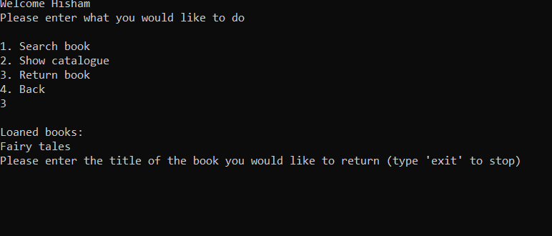

Figure 6 loaned books

Here you can also return by entering “exit”.

This concludes the user manual. I hope you will enjoy Python’s Library system and I wish you happy reading!