CS 423 HW1 Report
Name
Student ID
Date | 07/10/2026

0. Setup statement (Task 1)

Environment
Item | Your entry
Docker image and tag | s4lbot/cs423-gem5:v25.1.0.1
Host OS and architecture | Windows 11 (64-bit), x86_64
gem5 version | 25.1.0.1
Cross-gcc version | 13.3.0
Python version | 3.12.3
Environment block from scripts/smoke_test.sh | == [0/3] environment (quote this in your report's setup statement) ==  gem5: v25.1.0.1  cross-gcc: 13.3.0  python3: 3.12.3

Smoke test: hello on the baseline CPU
simInsts | system.cpu.numCycles | simSeconds | hostSeconds
114716 | 236454 | 0.000236 | 0.07

Answers to Q1.1–Q1.4
Question | Your answer
Q1.1 | simInsts: 114716
Q1.2 | system.cpu.numCycles: 236454
Q1.3 | simSeconds = numCycles × 1 ns (0.000236 s) is the simulated execution time of the target machine, i.e. how long hello would take on the modeled 1 GHz CPU. hostSeconds (0.07 s) is the wall-clock time the host computer spent running the simulator. gem5 executes many host instructions to model each target instruction, so host time is not tied to simulated time; here the host needed about 300× longer than the target.
Q1.4 | Since we linked the libraries statically, the glibc library was also included in the instruction count, resulting in a significantly higher number.

1. Baseline characterization (Task 2)
Workload | Instructions | Cycles | CPI | simSeconds
compute | 26,115,981 | 26,264,004 | 1.0057 | 0.026264s
memstream | 4,833,882 | 69,373,819 | 14.3516 | 0.069374s
branchy | 25,116,052 | 25,262,832 | 1.0058 | 0.025263s

Answers to Q2.1–Q2.3
Question | Your answer
Q2.1 | Ranking:  compute(1.0057) ≈ branchy(1.0058) << memstream(14.3516)  Explanation:  The compute and branchy workloads have a CPI close to 1 because most of their instructions can execute without significant stalls. The compute workload mainly performs ALU operations, while the branchy workload mostly uses simple control-flow operations. In contrast, memstream has a much higher CPI (14.3516) because it performs frequent memory accesses, causing the CPU to spend many cycles waiting for data from memory.
Q2.2 | A single-cycle CPU would complete each instruction in one cycle, but the clock period would have to be long enough for the slowest instruction, likely a memory access instruction, to complete all of its stages. This would make the clock significantly slower. Therefore, although compute and branchy instructions could still complete in one cycle, they would spend much of that cycle waiting for the longer datapath operations.
Q2.3 | The L1 data-cache statistics support the explanation from Q2.1. memstream has an overall cache miss rate of 98.10%, with 1,180,700 misses out of 1,203,605 accesses. In comparison, compute and branchy have miss rates of only 4.33% and 4.27%, respectively. This large difference shows that memstream frequently has to wait for data from lower levels of the memory hierarchy, explaining its much higher CPI of 14.3516.

2. Pipeline comparison (Task 3)

CPI and IPC of both CPUs
Workload | Baseline CPI | Baseline IPC | Pipeline CPI | Pipeline IPC
compute | 1.0057 | 0.9944 | 1.2342 | 0.8103
memstream | 14.3516 | 0.0697 | 13.2977 | 0.0752
branchy | 1.0058 | 0.9942 | 1.4826 | 0.6745

Pipeline CPI normalized to baseline CPI
Workload | Pipeline CPI / Baseline CPI
compute | 1.2272
memstream | 0.9266
branchy | 1.4741

Plots
plots/cpi.png
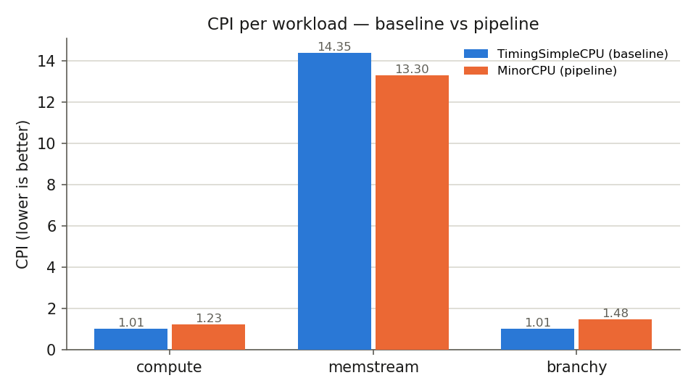
plots/cpi_normalized.png
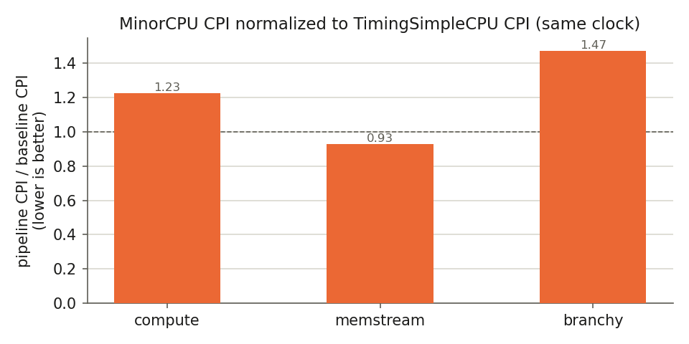

Task 3.1: mechanism-level explanation
Your explanation
The pipeline CPU has a higher CPI than the baseline CPU for all three workloads. For `compute`, CPI increases from 1.0057 to 1.2342 because pipelining introduces overhead from pipeline stalls and dependencies between instructions. For `memstream`, CPI decreases from 14.3516 to 13.2977, suggesting that pipelining slightly improves the handling of memory-related delays, although cache misses remain a major bottleneck. For `branchy`, CPI increases from 1.0058 to 1.4826 because branches can cause pipeline stalls or flushing when the correct next instruction is not yet available. Overall, pipelining does not necessarily reduce CPI for every workload, as its effectiveness depends on instruction dependencies, memory accesses, and control hazards.

Answers to Q3.1–Q3.4
Question | Your answer
Q3.1 | Assumption: Pipeline register overhead is assumed to be 0.  Single Cycle: sum of all steps, 200ps + 100ps +200ps + 200ps + 100ps = 800ps  Pipelined: the longest step should be the length of clock so max(200,100,200,200,100)ps = 200ps
Q3.2 | Using the execution-time formula, Execution Time = Instruction Count × CPI × Clock Period, the execution-time ratio is calculated as MinorCPU execution time divided by single-cycle CPU execution time. Since both CPUs execute the same number of instructions, the instruction count cancels out.  Assuming clock periods of 800 ps for the single-cycle CPU and 200 ps for MinorCPU:  - Compute: (1.2342 × 200) / (1 × 800) = 0.3086. MinorCPU is approximately 3.24 times faster.  - Memstream: (13.2977 × 200) / (1 × 800) = 3.3244. The single-cycle CPU is approximately 3.32 times faster.  - Branchy: (1.4826 × 200) / (1 × 800) = 0.3707. MinorCPU is approximately 2.70 times faster.  MinorCPU performs better on `compute` and `branchy` because its shorter clock period compensates for its higher CPI. However, `memstream` has a much higher CPI due to memory-related delays, which outweighs the benefit of the shorter clock period.
Q3.3 | The measured CPI is collected from MinorCPU running at 1 GHz with realistic memory latency, whereas the single-cycle CPU assumes a fixed clock period long enough for the slowest instruction to complete in one cycle. Therefore, using MinorCPU’s measured CPI in this comparison is only an approximation because the two designs model memory latency and instruction execution differently. For memstream, this likely biases the comparison in favor of the single-cycle CPU, since MinorCPU’s measured CPI includes the effects of memory delays, while the simplified single-cycle calculation does not fully account for them separately.
Q3.4 | TimingSimpleCPU is a non-pipelined processor model, but it is not equivalent to a true single-cycle CPU. TimingSimpleCPU executes instructions without overlapping them, yet instructions can still require multiple cycles, especially when waiting for memory. In contrast, the single-cycle design assumes every instruction completes in exactly one cycle, with a clock period long enough for the slowest instruction. This difference means TimingSimpleCPU's measured CPI is not necessarily 1. However, it does not change the main conclusion of Task 3: the comparison between the single-cycle and pipelined designs depends on both CPI and clock period, and memory-intensive workloads can behave differently from compute- or branch-heavy workloads.

Parameter probe
Item | Your entry
MinorCPU parameter(s) changed | executeBranchDelay
Values tried | First (1) => Modified (2)
CPI effect (before → after) | 1.4826 => 1.5025
Mechanism-level explanation | When we increased executeBranchDelay from 1 to 2, a 1-cycle penalty was added every time a branch target is resolved or flushed during execution, inflating the overall CPI from 1.4826 to 1.5025.

MinorTrace
Item | Your entry
Stall found | Memory Access / Data Hazard Stall (stalled Execute stage due to memory dependency and busy functional unit)
Trace lines (a few lines, not pages) | 18455000: system.cpu.execute: MinorInst: id=0/184.240/1184/4308.4311 addr=0x16596 inst="c_ldsp s0, 32(sp)" class=MemRead flags="IsInteger IsLoad"  18455000: global: MinorTrace: busy=(1,1/0/18457/4310),(8,1/0/18458/4311)  18455000: global: MinorTrace: insts=(0/184.240/1184/4305.4308) inputIndex=0 streamSeqNum=184 stalled=1,E,E,E,E,E,1,E drainState=NotDraining isInbetweenInsts=1
What the pipeline was waiting for | The Execute stage was stalled (stalled=1,...) waiting for the memory functional unit and destination register writeback. Multiple consecutive load instructions (c_ldsp reading stack memory into ra, s0, and s1) filled the execution/memory pipeline, forcing subsequent instructions to stall in the Execute stage until the L1 data cache memory requests were serviced.

3. Hazard microbenchmarks (Task 4)

4.1 Load-use
Item | Your entry
Predicted CPI/behavior (state BEFORE measuring) | TimingSimpleCPU (base):  - Prediction: Both dependent and independent kernels will have identical CPI (~1.46).  - Mechanism: As a non-pipelined CPU executing instructions strictly sequentially, data dependencies cannot cause pipeline stalls. Dependency structure will have zero impact on performance.  MinorCPU (pipe):  - Prediction: dependent CPI (~1.35–1.40) will be significantly higher than independent CPI (~1.20–1.25).  - Mechanism: In dependent, pointer chasing creates back-to-back RAW hazards where each load depends on the prior load's result, incurring a 1-cycle load-use stall per load (L1 hit latency = 2 cycles). In independent, static offsets remove load-to-load dependencies, allowing the in-order pipeline to overlap L1 accesses and hide the load-use latency.
Why can forwarding not remove the wait for a load’s data? | Forwarding bypasses register file writeback, but load data only arrives at the end of the Memory (MEM) stage. When a dependent instruction requires this data at the Execute (EX) stage, the value does not physically exist yet. Because forwarding cannot move data backward in time, a load-use pipeline stall is unavoidable.
From your measured extra cost per load, how much of the load-to-use latency does the in-order pipeline hide in the independent kernel? | Effective L1-hit load-to-use latency L = 2 cycles. baseline.py sets tag_latency = data_latency = response_latency = 1. In Cache.py, sequential_access defaults to False, so tags and data are read in parallel (max(1, 1) = 1 cycle), and response_latency adds 1 cycle, giving 2 cycles. Cross-check on TimingSimpleCPU: (10,669,761 − 7,319,405) / 3.2 M loads ≈ 1.05 extra cycles per load.  Without any hiding, a consumer right after a load would stall L − 1 = 1 cycle per load.  - Independent kernel: extra cost per load = (9,036,444 − 7,319,405) / 3.2 M ≈ 0.54 cycles. This is an upper bound for the exposed stall, because it also contains non-load overhead (compute shows a similar excess without any loads). So at least about 1 − 0.54 ≈ 46% of the 1-cycle stall is hidden: the first consumer of each load is four instructions later, so the data arrives before it is needed.

Variant / configuration | Instructions (simInsts) | Cycles (numCycles) | CPI (system.cpu.cpi)
base-loaduse-dep | 7,319,405 | 10,669,761 | 1.4577
base-loaduse-ind | 7,319,405 | 10,669,761 | 1.4577
pipe-loaduse-ind | 7,319,405 | 9,036,444 | 1.2346
pipe-loaduse-dep | 7,319,405 | 9,836,214 | 1.3439

Question | Your answer
How does the dependency structure affect each CPU, and why? | TimingSimpleCPU: Unaffected (CPI = 1.4577 for both). It executes instructions non-pipelined and sequentially, so data dependencies produce zero pipeline stalls.  MinorCPU: Heavily affected. The dependent kernel requires 799,770 extra cycles (CPI 1.3439 vs. 1.2346). Pointer chasing (ld p, 0(p)) creates a true Read-After-Write (RAW) hazard where every load must wait for the previous load's L1 response before calculating its target address. The independent kernel uses static offsets, allowing instruction-level parallelism to overlap memory accesses.

4.2 Branch pair
Item | Your entry
Predicted CPI/behavior (state BEFORE measuring) | I expect pipe-brpair-pred to have a lower CPI than pipe-brpair-rand. More predictable branch outcomes should result in fewer incorrect predictions, reducing pipeline flushes and control-hazard penalties.

Variant / configuration | Instructions | Cycles | CPI | condPredicted | condIncorrect | ratio
pipe-brpair-pred | 20,989,952 | 27,732,707 | 1.3212 | 20989952 | 27732707 | 0.065%
pipe-brpair-rand | 20,614,831 | 30,233,285 | 1.4666 | 20614831 | 30233285 | 50.0%
It also includes the predicted-taken path and the mispredicted branches; therefore, the ratio was calculated as condIncorrect / N (where N = 1M, with 1 conditional branch per iteration).

Question | Your answer
Number of branches | 2 per iteration
Misprediction penalty | Δcycles = 2,500,578, ΔcondIncorrect = 499,490, instruction difference = 375,121 (≈ 0.375 × N, since the 'true' path is 1 instruction longer). Adjusted penalty (c = 1) ≈ 5.76 cycles; with c = 1.2, ≈ 5.91.
What was it able to learn? | periodic pattern, 654 incorrect predictions, warm-up and cycle exit.
What it failed to learn: | The bits produced by xorshift are uncorrelated with the past, with a ~50% chance of being wrong (or, equivalently, a ~50% probability for each bit value).
Incorrect prediction mechanism | Until the branch is resolved in the Execute stage, instructions fetched along the incorrect path are discarded, and the Fetch1 stage is redirected.

4. Reproducibility statement
Item | Your entry
Exact commands, or "run `bash reproduce.sh` in the pinned container" | Run bash reproduce.sh inside the pinned Docker container s4lbot/cs423-gem5:v25.1.0.1.
Anything nonstandard about your environment | None. All experiments were conducted inside the official course Docker container.

GenAI disclosure
Item | Your entry
GenAI tool(s) used (or "none") | Claude Sonnet 5.5
Parts of the work it was used for | Report structure and drafting, review and correction of my draft answers, and help writing parts of the Task 4 code. I ran all simulations and verified all reported numbers myself.

