
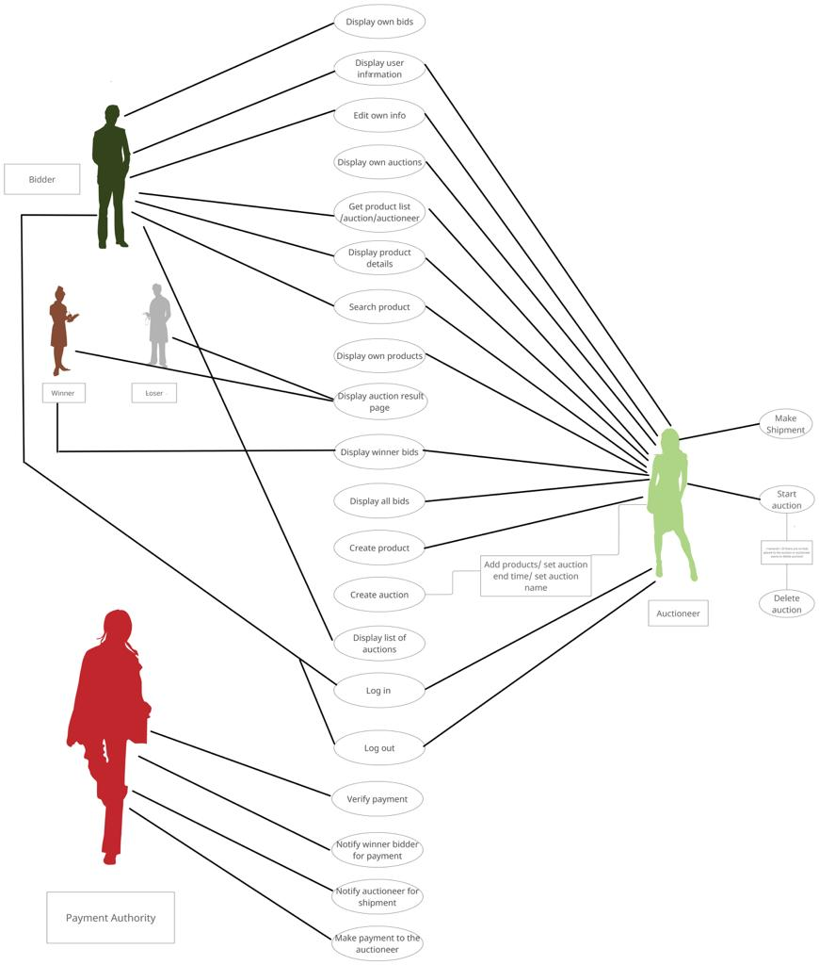
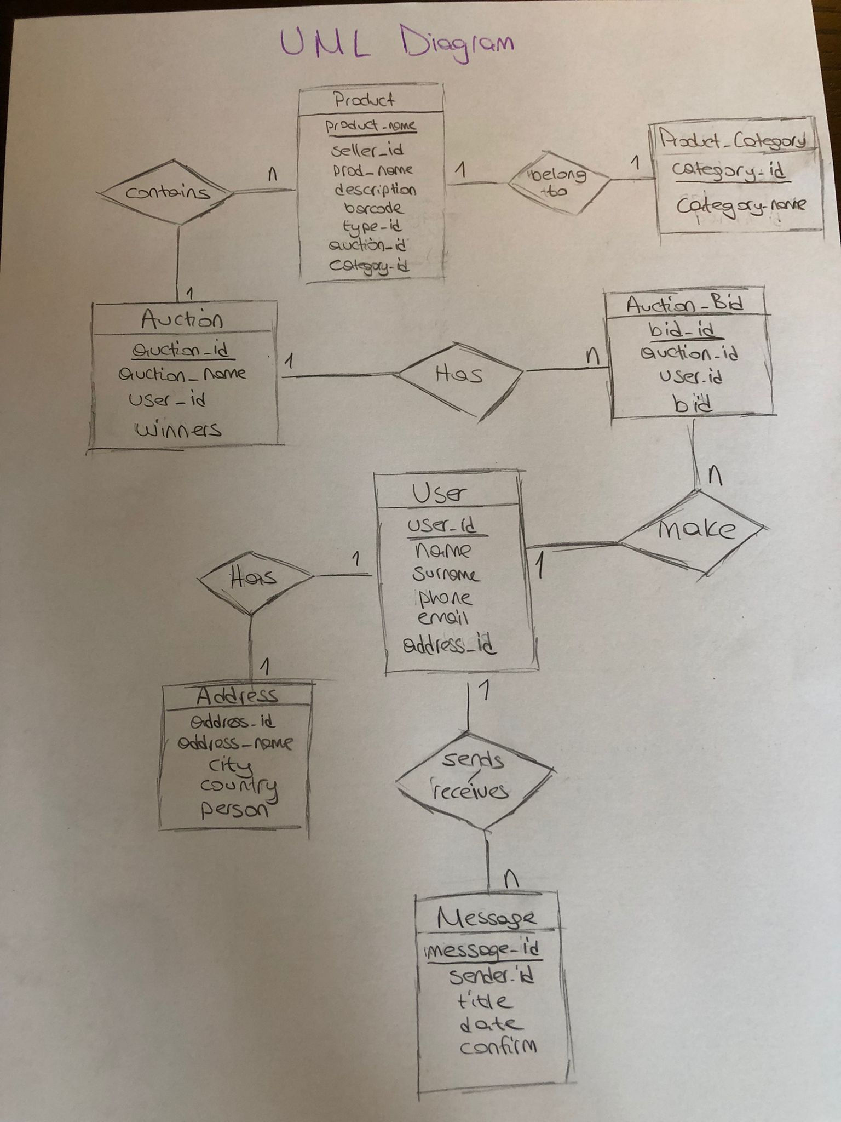
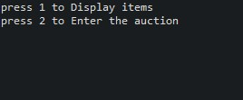
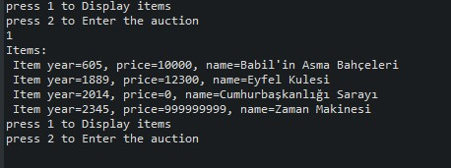
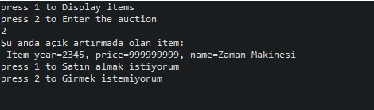
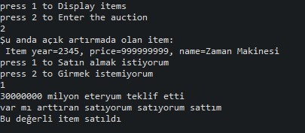
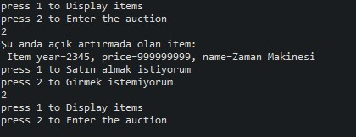
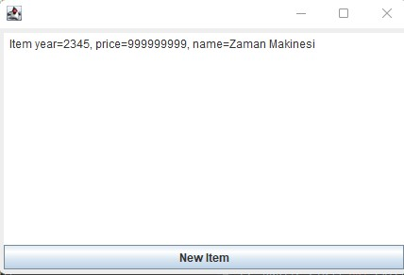
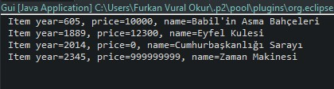
Furkan Vural Okur

Project Title: Online Auction System

- Introduction

  - Purpose/Project Proposal

Bringing technology together with the auction method and creating a more reliable and more effective system.

  - Software Language/ Project Environment

The programming language used to create this project is Java, and the project development environment is Eclipse IDE.

  - Data Structures

While creating this project, we used the Heap data structure in an agency task where the actors with the desired features are added by the manager, and the Linked List data structure to hold all the features of the actors to be selected for the agency. In conclusion, we used two data structures in total, Heap and Linked List.

- Architectural Representation

  - Use Case Diagram

2.2 Class Diagram

- Application

CONSOLE

GUI

- Conclusion / Summary

As a result, our project, called Online Auction System, is a console and gui application created using Heap and Linked List structures. This system, which will allow you to buy the valuable item you want with blockchain technology, will show everyone that you can participate in an auction from anywhere in the world.

- References

- Lecture pdfs of last year and this year related to our topic
- Some of the websites we have linked below
2.1 https://www.geeksforgeeks.org
https://stackoverflow.com/questions/17408769/how-do-i-resolve-classnotfoundexception
2.2 https://www.javatpoint.com/java-actionlistener
2.3 https://www.codegrepper.com/code-examples/javascript/frameworks/nodejs/java+script+while+loop

