**Datawise Case Study Questions:**

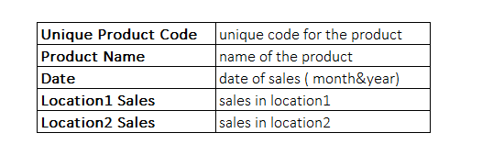You have given the sales data of a flowershop. (document name: datawise_case_study_data) The branch has 2 different locations and 3 products (productX, productY, productZ). Dataset includes following attributes with given descriptions:

Please apply the following steps to data for cleaning, structuring and analyzing:

1. Describe the data given, highlighting facts at first look.
2. Unify data & explain the assumptions for your steps in unification. Tip: Unify "Product Name" using the following format "productX".
3. 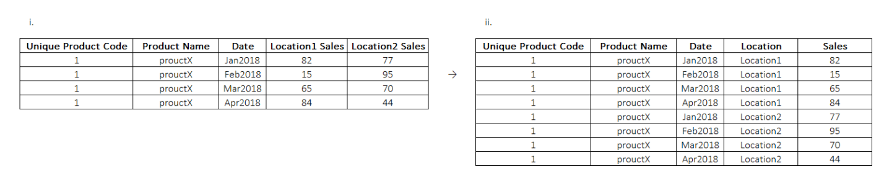Change table format from i to ii (New format should have locations in row instead of column)
4. a.) Extract month and year from "date" column; create new colmns for "month", "year".

b.) Create a "newdate" column from "date" column with the following date format: "1.01.2018".

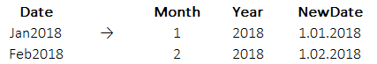

1. Load the second dataset where population data of locations in different years are given. (document name: datawise_case_study_additionaldata)
2. Merge the additional data of location population to the current data you were working on. Output should be in the following structure:



1. Calculate “Weighted Average” of product sales by using population as weight. In other words, we need average sales of each product regardless of date and location, but the average should be calculated with the weight for each location’s population.

Tip:Formula of weighted average is: 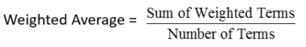

Output should be in the following structure:

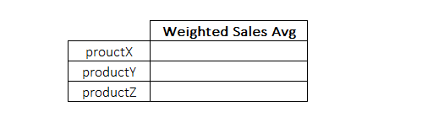

1. 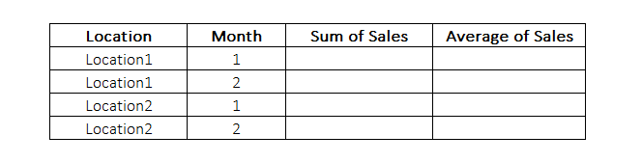Create a summary table in the following format:
2. Use the summary table to create a plot that has following features with ggplot/ggplot2 package.

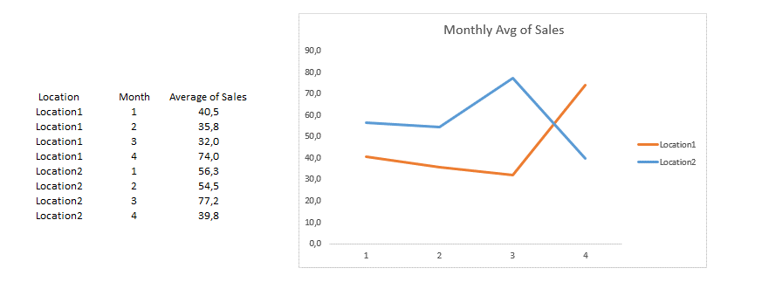

1. Create 3 different tables to visualize the data & analyze the data using visualization.

**Notes:**

You can choose any format you want for the solution: presentation slides, excel document or written document. Please share any code you have used to get to your solution as well.

If you have any questions feel free to contact.