POST : <http://localhost:8081/api/todo>

Request 1:

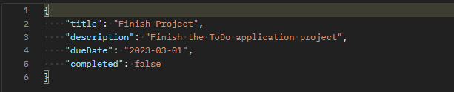

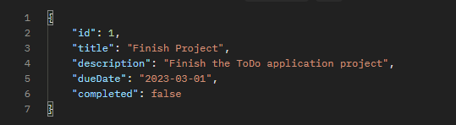Response 1:

Request 2:

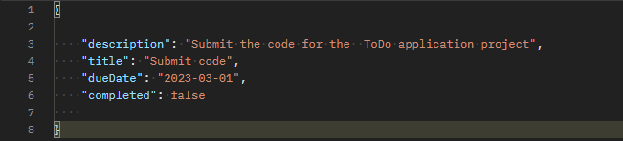

Response 2:

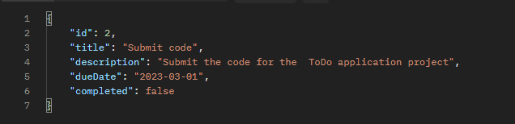

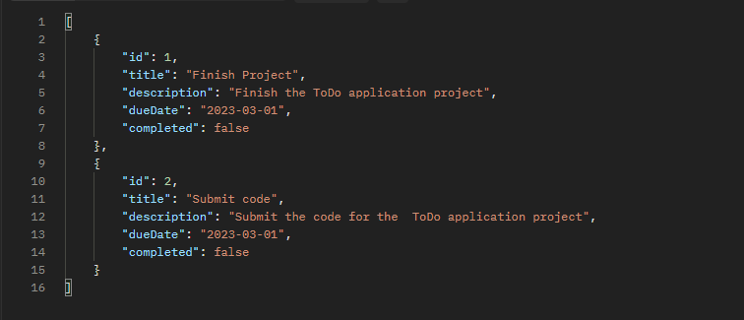GET : <http://localhost:8081/api/todo>

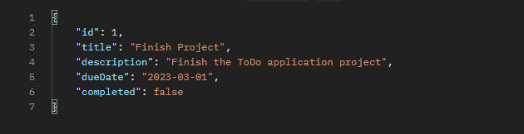GET : <http://localhost:8081/api/todo/1>

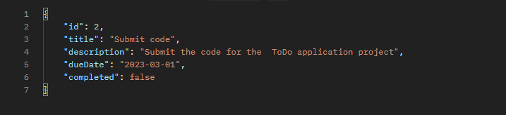GET : <http://localhost:8081/api/todo/2>

PUT : <http://localhost:8081/api/todo/1>

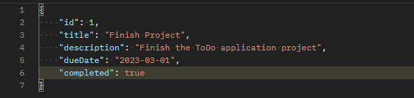Request :

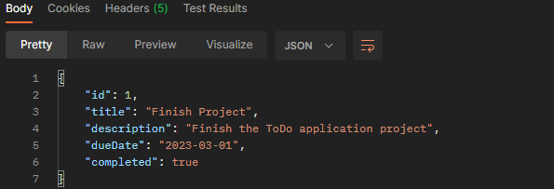Response :

DELETE : <http://localhost:8081/api/todo/1>

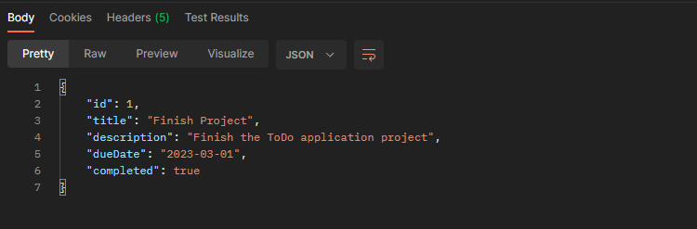Response :