PROJECT REPORT
FLOWMIND AI
――――――――――――――――――――――――――――――――
An Interim 8-Week Progress Report
Submitted in partial fulfillment of the requirements for the Capstone Project
PROJECT TEAM MEMBERS
Team Member Name | Registration Number | Project Domain Role
Furkhan Abdul Raheem | 23BCE7868 | AI & Multilingual Lead
Aniket Sahu | 23BCE7881 | Frontend & Layman UI/UX Lead
Anjali Karagatla | 23BCE8077 | Workflow & Business Engine Lead
Farukh | 23BCE20345 | Data, RAG & Security Lead

INSTITUTIONAL METADATA
Academic Field | Details
Course & Semester | Capstone Project | Semester VII
Academic Department | Department of Computer Science and Engineering
Institution | VIT-AP University
Target Field | Artificial Intelligence, Multi-Agent Systems & Enterprise Software Engineering
Project Scope | Weeks 1–5 COMPLETED IMPLEMENTATION (INCL. POSTGRESQL & PRISMA ORM)

📌 EXECUTIVE CAPSTONE SUMMARY: This Interim Progress Report documents the complete architectural design and verified implementation of FlowMind AI across Weeks 1 to 5. Key achievements include the 15-Agent Mesh Collaboration, Multilingual Indic Engine (6 scripts), Zero-Code Natural Language Workflow DAG Automation Engine, Action Governance (HITL), and the fully integrated Enterprise PostgreSQL + Prisma ORM Persistence Layer with 3-Tier RBAC.

1. Project Overview & Introduction
FlowMind AI is a unified, multilingual AI Business Operating System designed to enable non-technical operational users, small business owners, and non-programmers ('laymen') to automate business workflows, query domain metrics, and govern operational actions using natural language or voice commands.
Modern enterprise platforms often impose steep learning curves, complex UI navigation, and technical scripting requirements. FlowMind AI resolves these barriers by orchestrating a 15-Agent Mesh, an Indic Multilingual Engine supporting 6 language scripts, a zero-code Workflow Automation DAG Engine, and a robust PostgreSQL relational persistence layer.
2. Problem Statement
Enterprise operational tools suffer from critical usability, security, and integration challenges:
1. High Technical Complexity: Non-technical domain experts struggle to configure complex enterprise software, leading to operational friction and slow turnaround times.
2. Language & Accessibility Barriers: Business platforms predominantly target English speakers, creating severe accessibility barriers across regional Indian enterprise ecosystems.
3. Ungoverned Autonomous Execution Risk: Automated AI systems often lack strict authorization and governance controls, risking unauthorized state changes without human oversight.
4. Ephemeral Storage & Lack of Audit Trails: Traditional systems lack structured state persistence, relational multi-tenant isolation, and audit trail capabilities.
3. Key Project Objectives
FlowMind AI satisfies a comprehensive set of technical objectives divided across core modules:
• Objective 1 (Layman Interface): Construct a responsive Layman Chatbot UI featuring an interactive Robot Assistant avatar, live Thought Stream visualizer, and Action Confirmation Cards.
• Objective 2 (Multilingual Support): Build an Indic Engine supporting English, Telugu, Hindi, Tamil, Kannada, and Malayalam with Web Speech STT/TTS voice synthesis.
• Objective 3 (15-Agent Mesh): Deploy 15 specialized domain agents (CEO, Sales, Finance, HR, Support, Analytics, etc.) coordinated by a Master Orchestrator.
• Objective 4 (Security & Governance): Enforce strict security guardrails via a Prompt Injection Shield and Human-in-the-Loop Action Cards with risk level grading.
• Objective 5 (NL Workflow Automation): Implement a natural language workflow planner that compiles user prompts into valid, executable Directed Acyclic Graphs (DAGs) verified via Kahn's Topological Sort.
• Objective 6 (PostgreSQL & Prisma ORM Layer - COMPLETED): Implement a complete enterprise PostgreSQL database persistence layer backed by Prisma ORM, multi-tenant isolation, and 3-tier Role-Based Access Control (ADMIN, MANAGER, EMPLOYEE).
• Objective 7 (Dynamic Cloud Deployment Milestone): Deploy the application dynamically on production cloud hosting (Vercel / AWS EC2) with live domain SSL encryption and GitHub Actions CI/CD pipelines.
4. System Architecture (7-Tier Model)
FlowMind AI implements a modular 7-Tier enterprise system architecture shown in Figure 1 below:
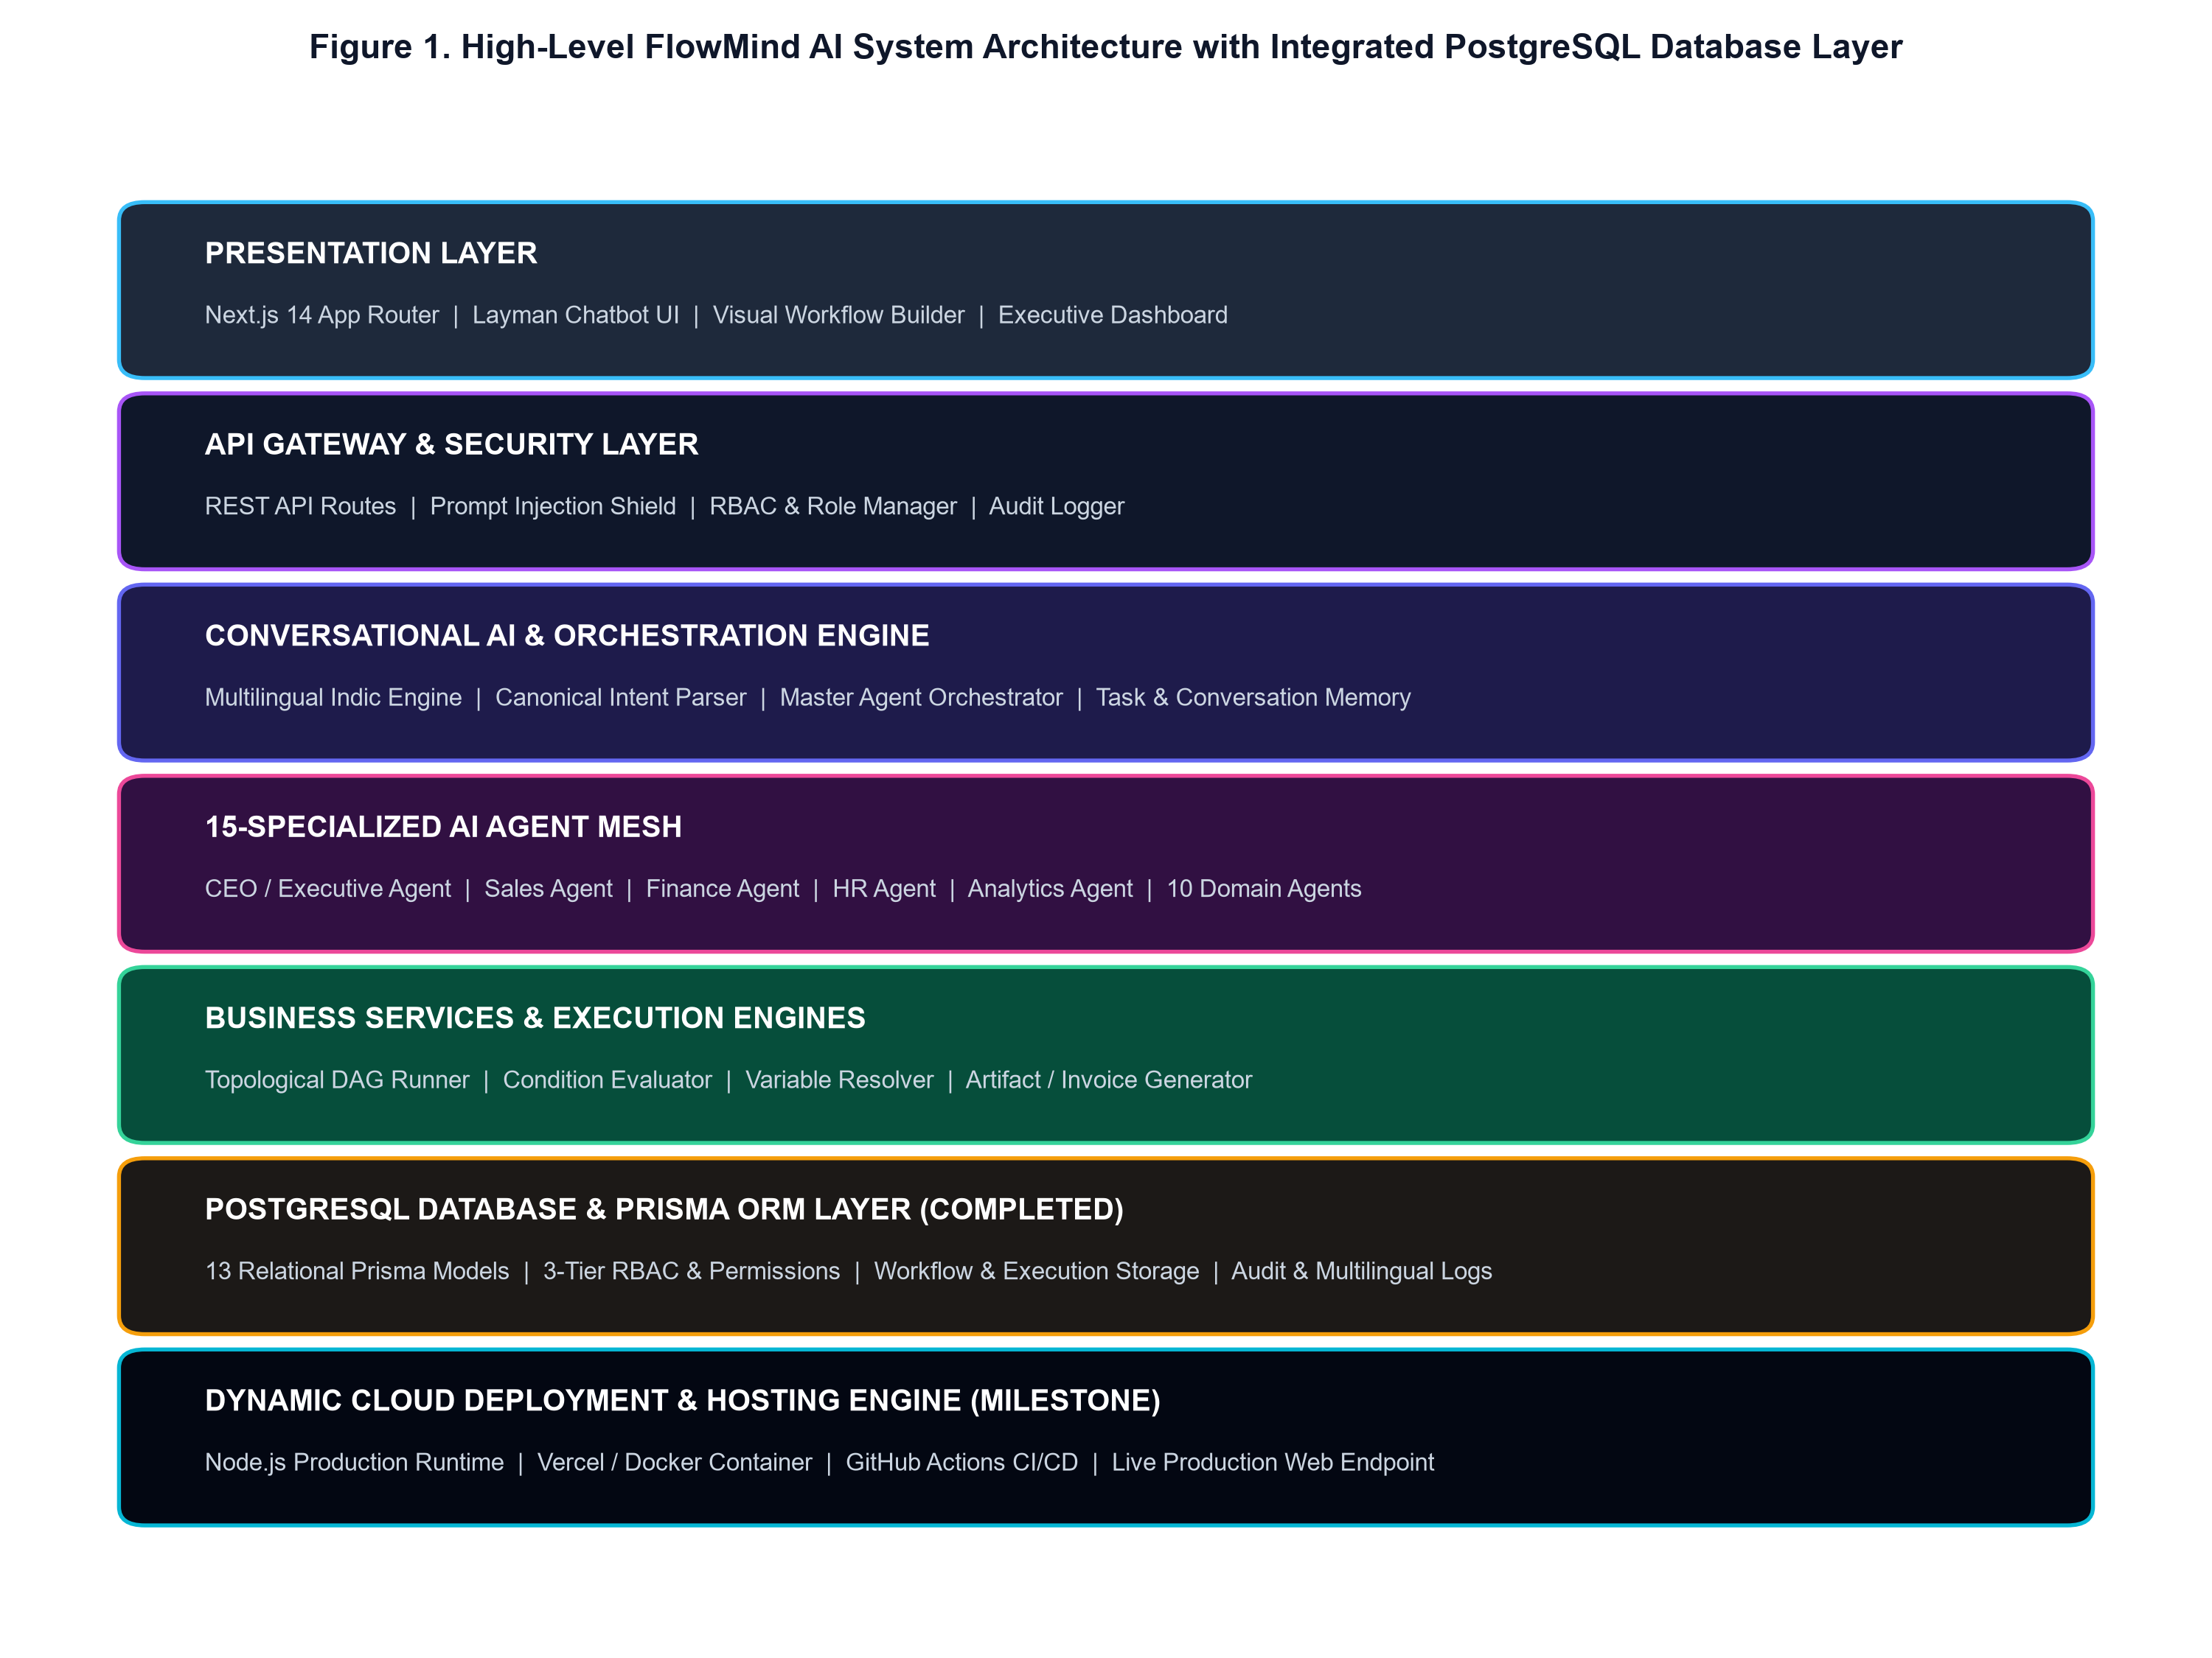
Figure 1. High-Level FlowMind AI System Architecture with Integrated PostgreSQL Database Layer
7-Tier Architectural Description
1. Presentation & UI Layer: Next.js 14 App Router, Layman Chatbot UI, Visual Workflow Builder, and Executive Dashboard.
2. API Gateway & Security Layer: REST API routes, RBAC permission evaluators, and the Prompt Injection Shield.
3. Conversational AI & Orchestration Engine: Indic Engine, Canonical Intent Parser, Master Agent Orchestrator, and Task Memory.
4. 15-Specialized AI Agent Mesh: 15 specialized domain agents executing CRM, billing, HR, support, and analytics logic.
5. Business Services & Execution Engines: Topological DAG runner, condition evaluator, variable resolver, and GST invoice generator.
6. PostgreSQL Database & Prisma ORM Layer (COMPLETED): Relational PostgreSQL schema with 13 Prisma models, multi-tenant ORG isolation, 3-tier RBAC, and dual-mode resilient fallback storage.
7. Dynamic Cloud Deployment & Hosting Engine Milestone: Node.js production runtime, Vercel/Docker cloud hosting, SSL security, and CI/CD pipelines.
5. End-to-End Request Processing & Execution Pipeline
Figure 2 details the 10-step request processing pipeline, illustrating how user inputs are safely scanned, parsed, routed, approved, executed, and recorded to PostgreSQL.
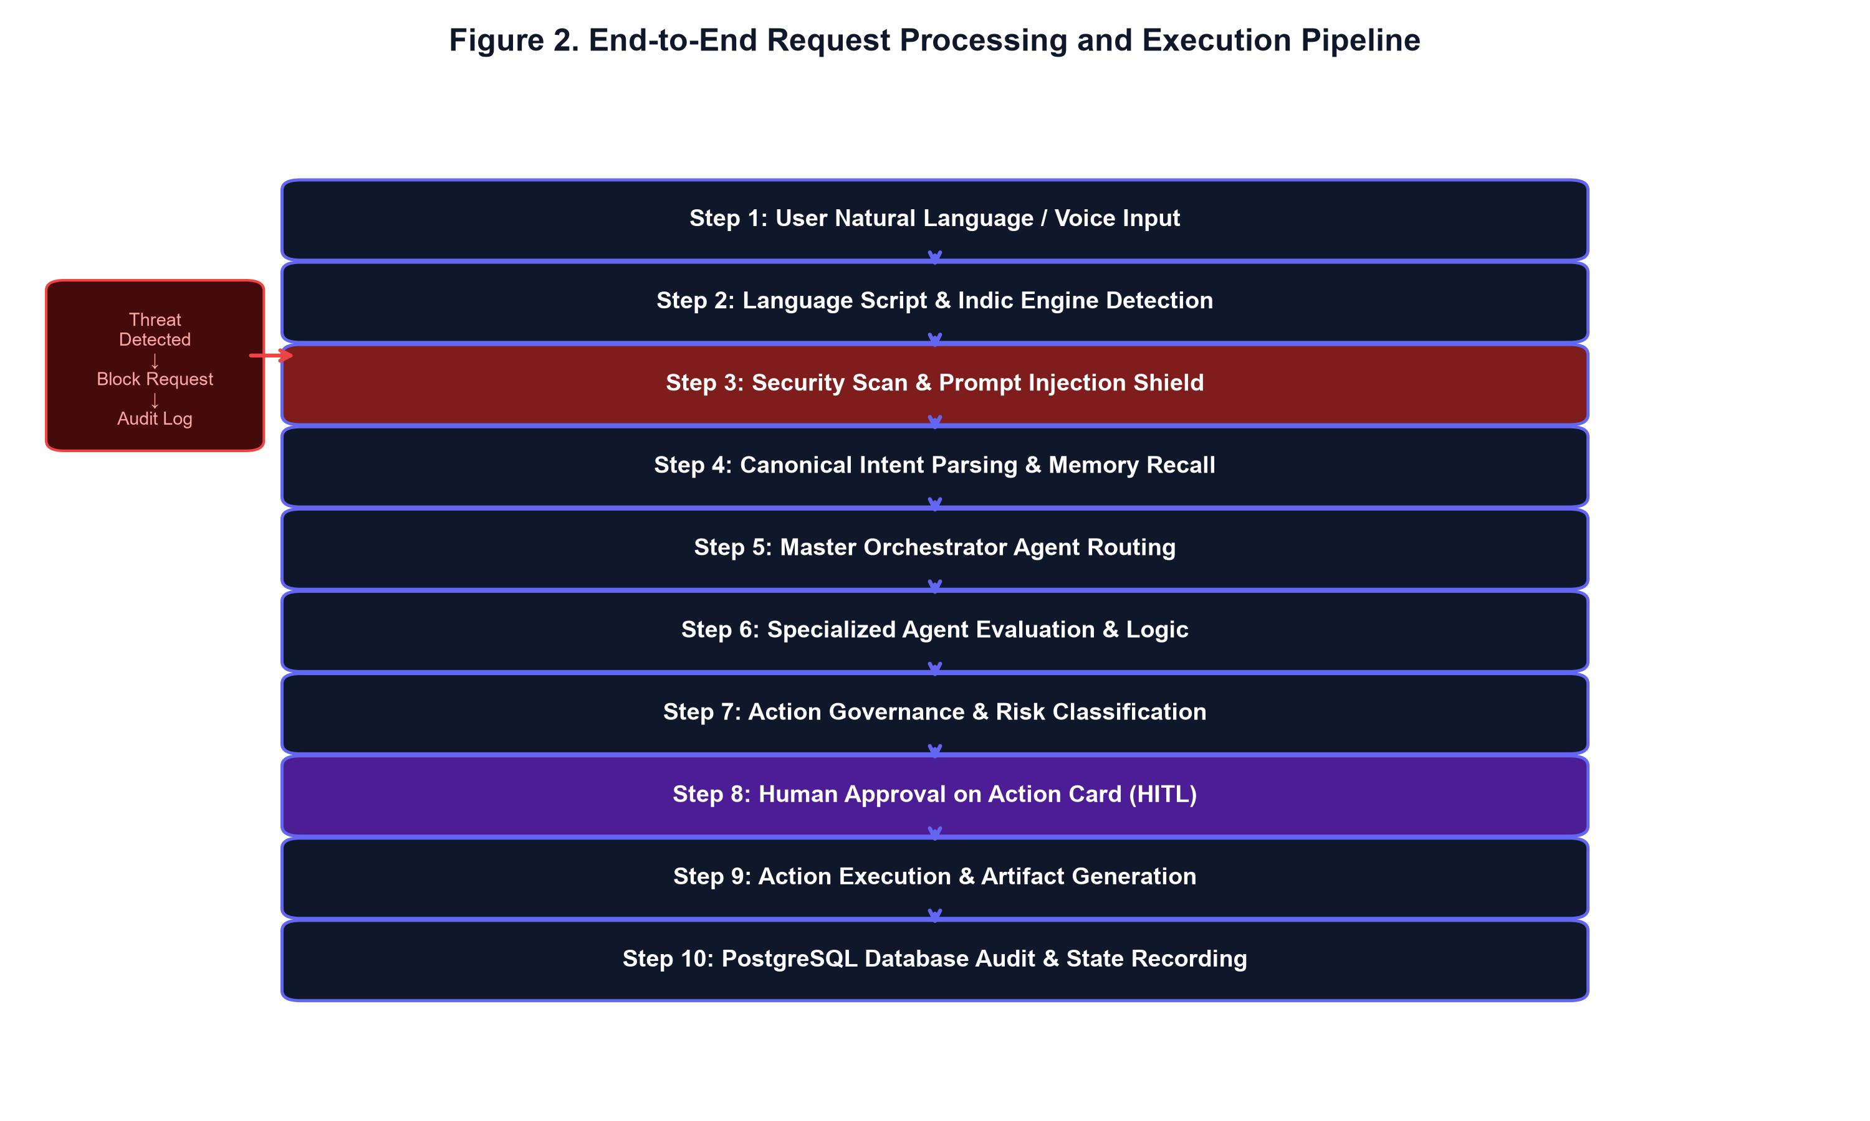
Figure 2. End-to-End Request Processing and Execution Pipeline
6. Week 1 Progress — SDLC Architecture, Design System & Foundation Setup
Week 1 established the core project infrastructure, development environment, UI tokens, and architectural schemas.
Table 1. Week 1 Implementation Summary
Domain Area | Implemented Deliverables | Status
Repository Setup | Initialized GitHub repository (https://github.com/Furkhan-5/FlowMind-AI) with Git workflow. | COMPLETED
Frontend Architecture | Configured Next.js 14 App Router, React 18, TypeScript, and Tailwind CSS styling tokens. | COMPLETED
State Management | Implemented Zustand centralized app store (useAppStore.ts) for user, language, and chat state. | COMPLETED
Schema Scaffolding | Defined TypeScript interfaces for Agents, Intents, Action Cards, Audit Logs, and User Roles. | COMPLETED
Team Allocation | Divided project scope into 4 technical lead domains (AI, UI/UX, Workflow, Security/Data). | COMPLETED

7. Week 2 Progress — Multilingual Engine & Layman Chatbot Foundation
Week 2 focused on enabling native multi-script Indic language support and constructing the foundational layman chatbot interface.
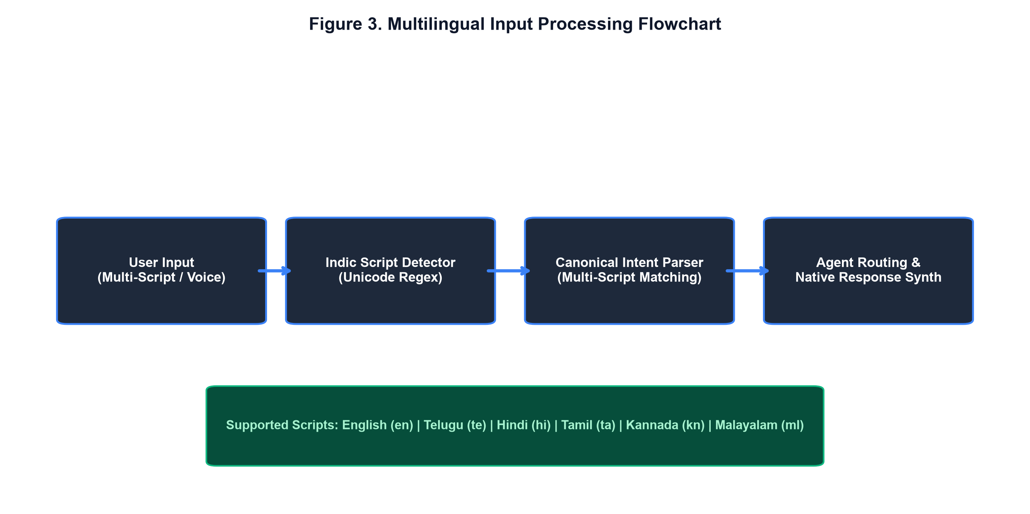
Figure 3. Multilingual Input Processing Flowchart
Table 2. Supported Indic Multilingual Specifications
Language Code | Language Name | Unicode Range / Script | Speech Synthesis Tag
en | English | Basic Latin (ASCII) | en-US / en-IN
te | Telugu (తెలుగు) | 0C00–0C7F (Telugu Unicode) | te-IN
hi | Hindi (हिन्दी) | 0900–097F (Devanagari) | hi-IN
ta | Tamil (தமிழ்) | 0B80–0BFF (Tamil Unicode) | ta-IN
kn | Kannada (ಕನ್ನಡ) | 0C80–0CFF (Kannada Unicode) | kn-IN
ml | Malayalam (മലയാളം) | 0D00–0D7F (Malayalam Unicode) | ml-IN

8. Week 3 Progress — 15-Agent Mesh & HITL Governance
Week 3 delivered a 15-agent collaboration mesh, prompt injection defense, and human-in-the-loop Action Cards.
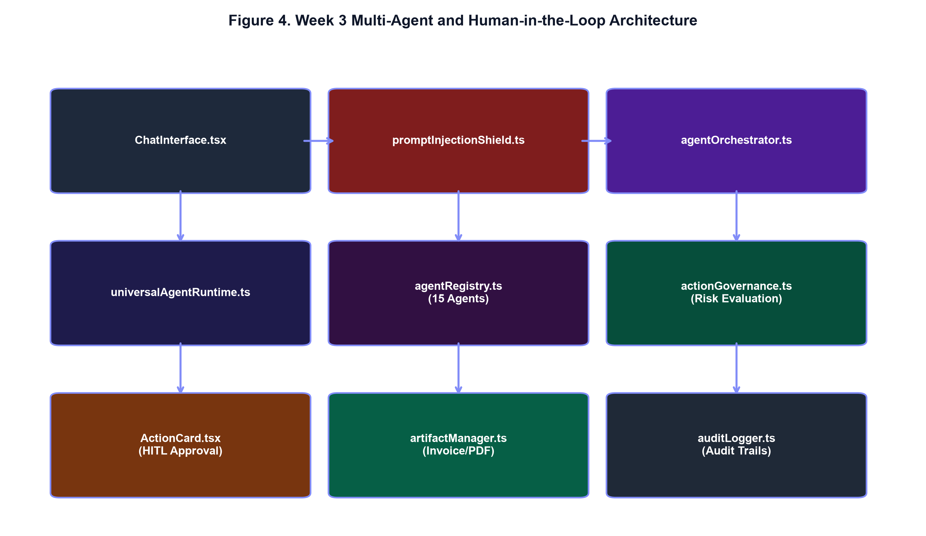
Figure 4. Week 3 Multi-Agent and Human-in-the-Loop Architecture
Table 3. Week 3 Core Component Implementation Map
Component File | Technical Responsibility | Governance / Feature Level | Status
agentOrchestrator.ts | Central intent routing & conversation memory window | Master Orchestration | COMPLETED
universalAgentRuntime.ts | Universal runtime engine & recovery handler | Runtime Execution | COMPLETED
agentRegistry.ts | 15 Agent definitions & multi-script response maps | Agent Mesh | COMPLETED
promptInjectionShield.ts | Pattern scanning & prompt injection defense | CRITICAL Risk Shield | COMPLETED
actionGovernance.ts | Risk classification (LOW to CRITICAL) & simulation diffs | Action Governance | COMPLETED
ActionCard.tsx | Interactive HITL card with Approve/Edit/Cancel buttons | Human-in-the-Loop | COMPLETED
invoiceGenerator.ts | Client-side GST tax invoice calculations & PDF download | Artifact Export | COMPLETED
auditLogger.ts | Immutable audit log event recorder | Security & Audit | COMPLETED

9. Week 4 Progress — Natural Language Workflow Automation Engine
Week 4 implemented a zero-code Natural Language Workflow Automation Engine compiling user prompts into Directed Acyclic Graphs (DAGs) verified via Kahn's Topological Sort.
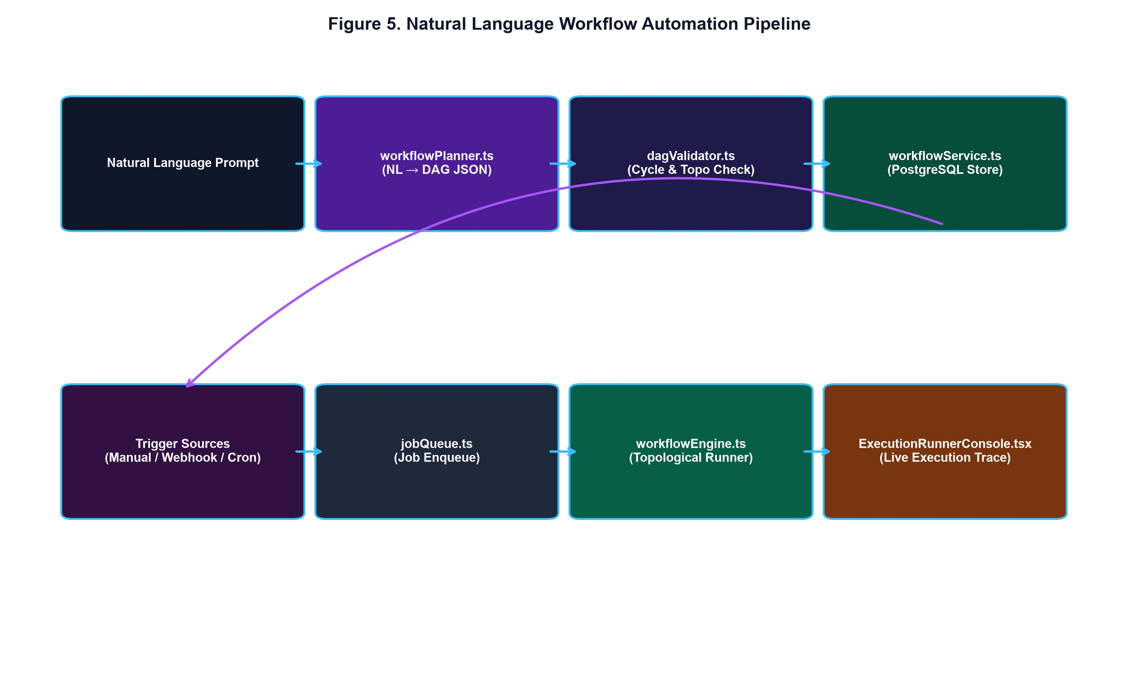
Figure 5. Natural Language Workflow Automation Pipeline
Table 4. Week 4 Workflow Automation Component Specifications
Module File | Algorithm / Methodology | Key Feature | Status
workflowPlanner.ts | NLP Intent Extraction & Structural Mapping | NL → DAG JSON Generation | COMPLETED
dagValidator.ts | Kahn's Topological Sort & Cycle Detection | DAG Order & Validity Verification | COMPLETED
conditionEvaluator.ts | Rule-Based Expression Parsing | Conditional Branching (TRUE/FALSE) | COMPLETED
workflowEngine.ts | Sequential DAG Topological Execution | Node Runner & State Manager | COMPLETED
jobQueue.ts | Exponential Backoff Retry Engine | Fault Recovery & Retry Policy | COMPLETED
triggerEngine.ts | Cron & Inbound Webhook Listener | Automated Trigger Activation | COMPLETED
VisualDAGGraph.tsx | Interactive Canvas Graph Rendering | Visual Node & Edge Diagram | COMPLETED
ExecutionRunnerConsole.tsx | Real-Time Terminal Execution Logging | Live Monitoring Console | COMPLETED

9.5. Week 5 Progress — PostgreSQL Database & Prisma ORM Persistence Architecture
Week 5 achieved a major engineering milestone by transitioning FlowMind AI from prototype in-memory storage into a production-grade PostgreSQL database persistent application managed via Prisma ORM.
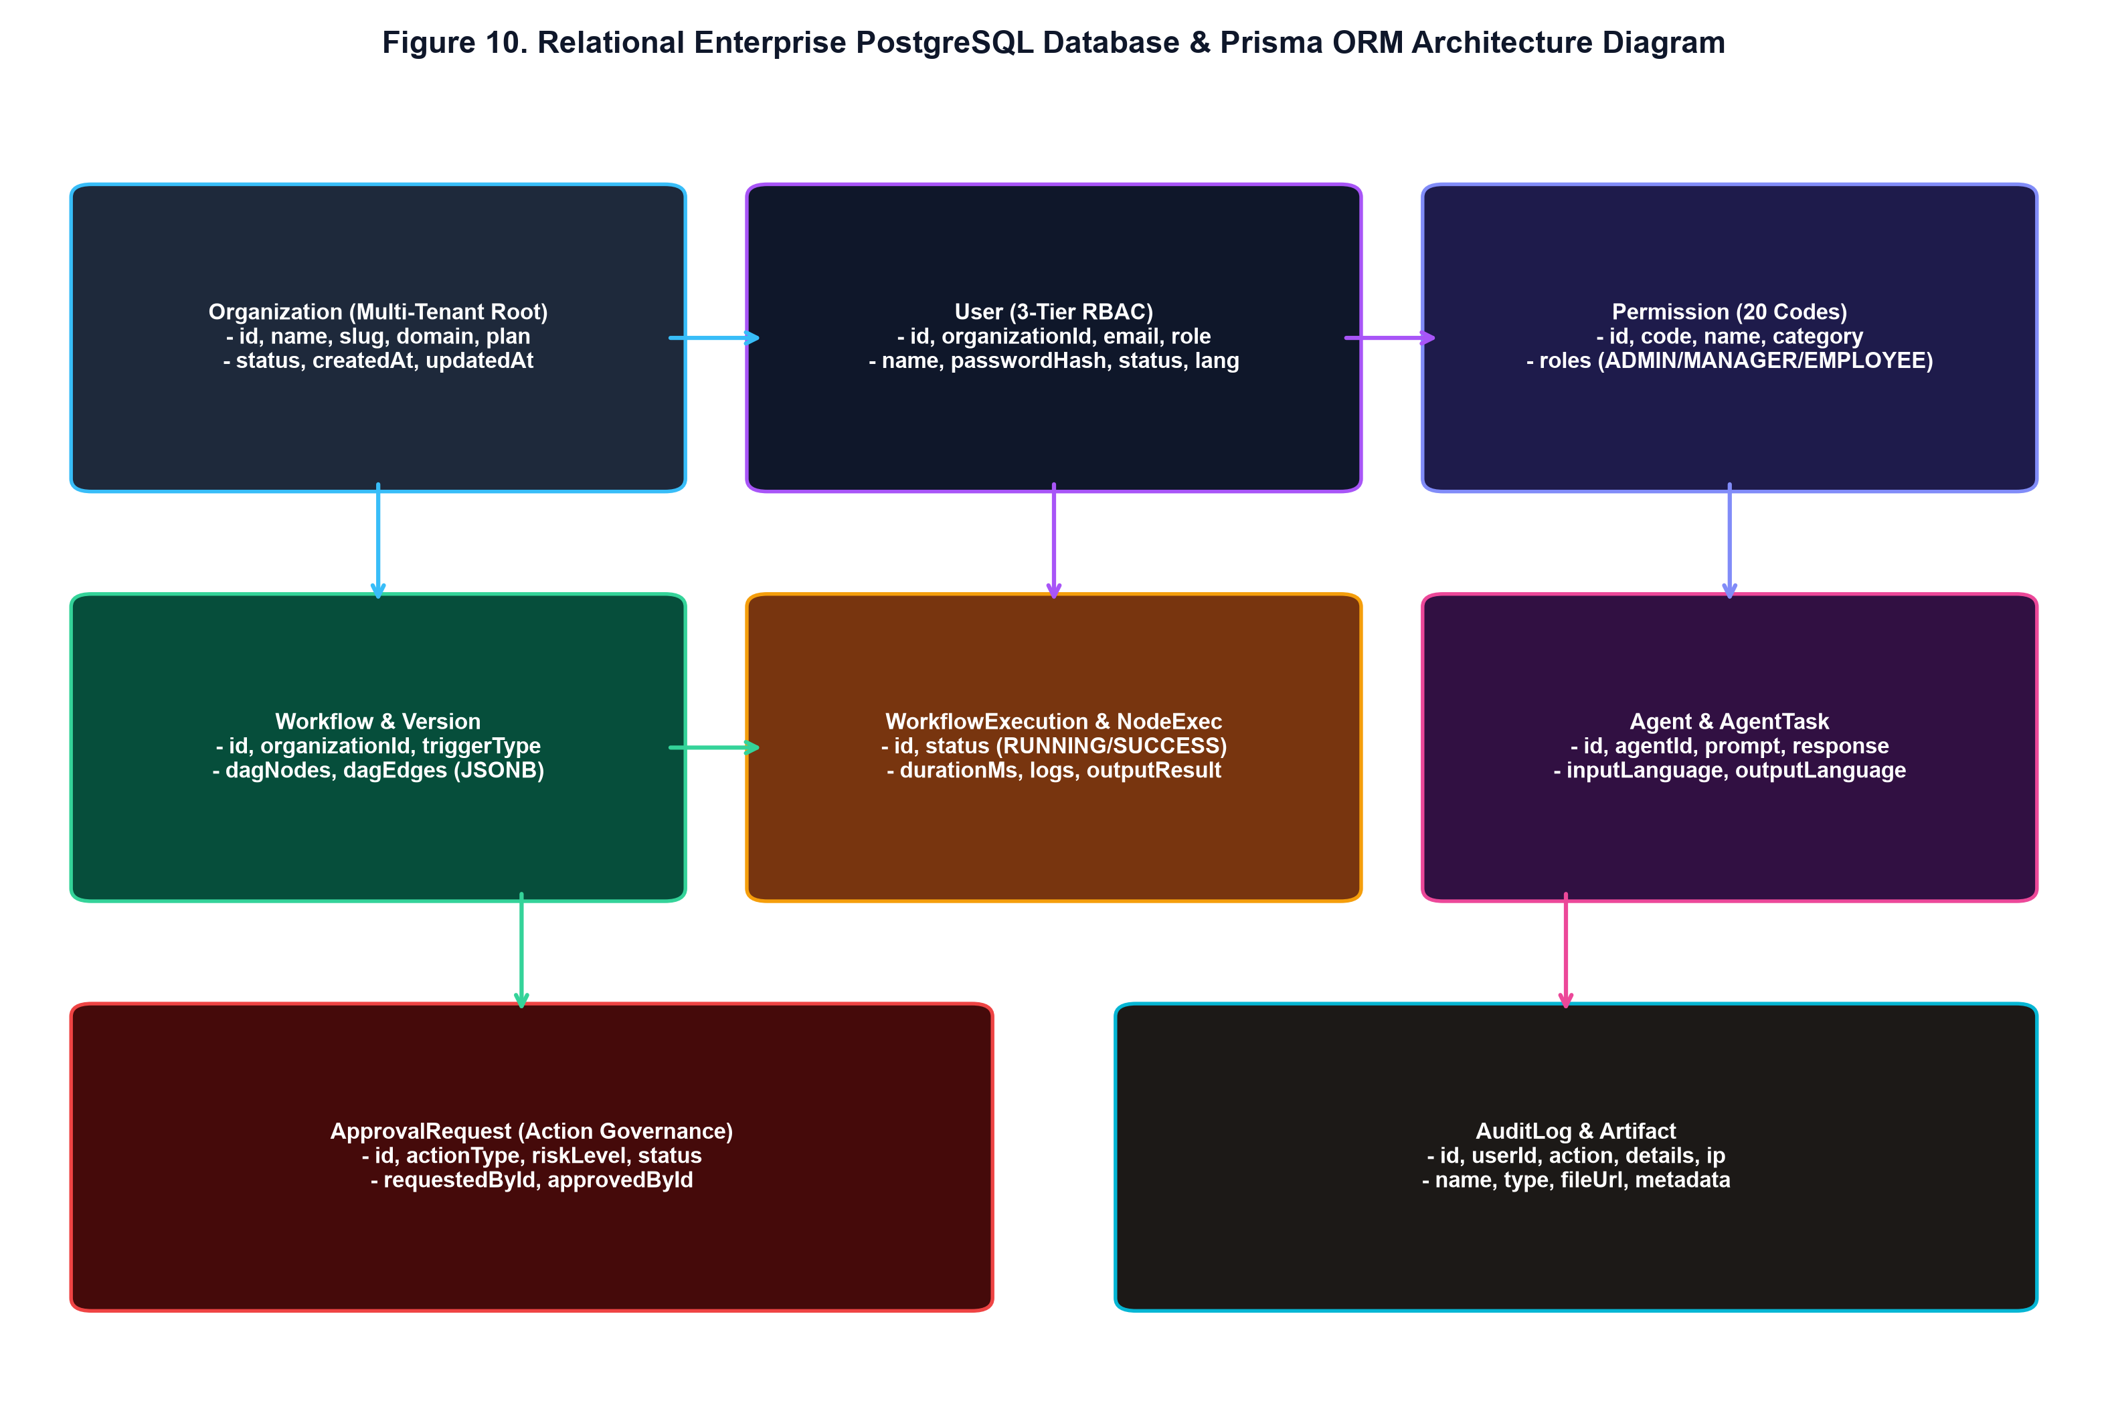
Figure 10. Relational Enterprise PostgreSQL Database & Prisma ORM Architecture Diagram
Key Week 5 Implementation Deliverables
• Prisma Schema Definition (prisma/schema.prisma): 13 enterprise relational models including Organization, Permission, User, Workflow, WorkflowVersion, WorkflowExecution, WorkflowNodeExecution, Agent, AgentTask, ApprovalRequest, AuditLog, Artifact, Conversation, and Message.
• 3-Tier RBAC & Permissions Matrix (rbacService.ts): Centralized 20 granular permission codes mapping ADMIN, MANAGER, and EMPLOYEE roles, featuring strict self-approval prevention (canUserApproveAction).
• Service Repository Layer (userService, workflowService, agentService, approvalService, auditService): Service layer modules wrapping Prisma queries with fallback mechanisms to guarantee system uptime.
• Database Seeding Infrastructure (prisma/seed.ts): Pre-configures FlowMind Enterprise (ORG-01), 3 development role users (admin@flowmind.ai, manager@flowmind.ai, employee@flowmind.ai), 15 AI agents, and initial sample DAG workflows.
• API & Execution Engine Integration: Updated /api/auth/login, /api/auth/signup, /api/auth/me, /api/workflows, and workflowEngine runner to persist live execution runs.
Table 4.5. Week 5 PostgreSQL & Prisma ORM Implementation Summary
Module File | Database Model / Layer | Key Architectural Feature | Status
schema.prisma | 13 Relational Prisma Models | PostgreSQL schema with multi-tenant ORG scope | COMPLETED
prisma.ts | PrismaClient Singleton | Connection pooling & hot-reload leak prevention | COMPLETED
rbacService.ts | 20 Permission Codes & RBAC Matrix | 3-Tier RBAC & Self-Approval Prevention Check | COMPLETED
userService.ts | User & Auth Repository | bcrypt hashing, JWT session check, user CRUD | COMPLETED
workflowService.ts | Workflow & Execution DB Store | DAG definition versioning & run log persistence | COMPLETED
agentService.ts | Agent & Multilingual Task Log | Tracks agent tasks, prompts, languages & durations | COMPLETED
approvalService.ts | Action Governance DB Store | HITL card requests, approval checks & audit tags | COMPLETED
auditService.ts | Security Audit Log Repository | Persistent security event & access log recording | COMPLETED
seed.ts | Database Seeding Script | Seeds ORG-01, 3 Users, 15 Agents, & Permissions | COMPLETED

10. UML Diagrams & System Modeling
To provide formal academic software engineering documentation, the FlowMind AI platform is modeled below using UML Use Case, Component, and Sequence diagrams.
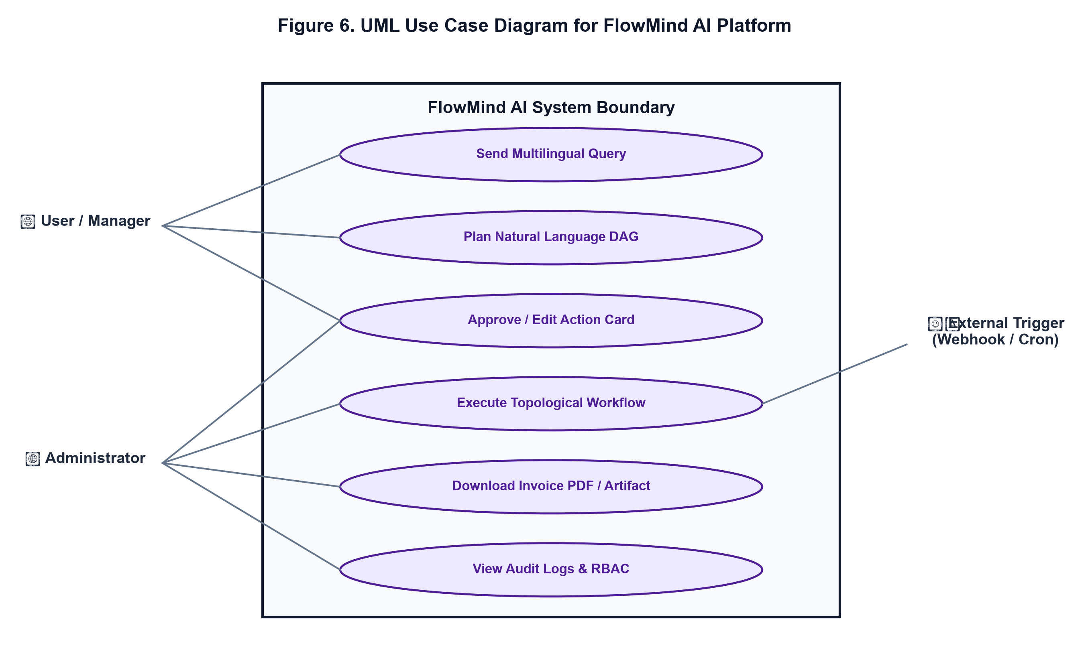
Figure 6. UML Use Case Diagram for FlowMind AI Platform
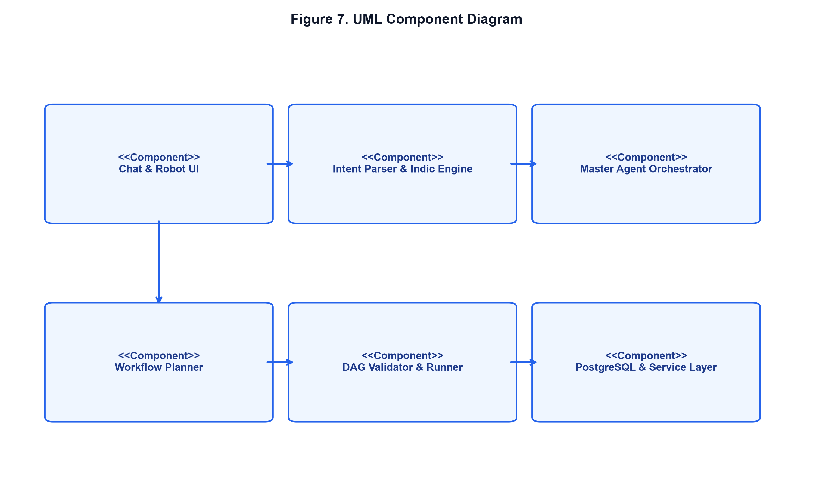
Figure 7. UML Component Diagram
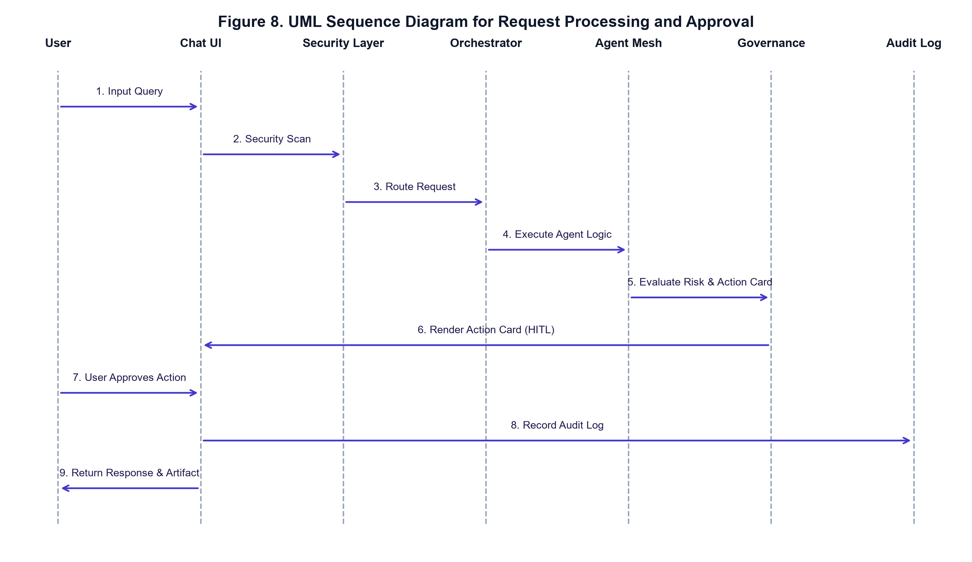
Figure 8. UML Sequence Diagram for Request Processing and Approval
11. Technical AI/ML & Software Engineering Methods
FlowMind AI combines artificial intelligence methodologies with rigorous software engineering algorithms to ensure platform stability, security, and predictability.
Table 5. Technical AI/ML and Algorithmic Method Classification
Technical Component | Category Method | Engineering Purpose
Natural Language → DAG | Generative AI / LLM Abstraction | Converts plain text instructions into structured DAG JSON specifications.
Canonical Intent Parsing | NLP Script & Keyword Matching | Identifies operational actions across 6 Indic language scripts.
Multi-Agent Routing | Agentic AI / Orchestration | Routes parsed intents to specialized domain agents (Sales, Finance, HR, etc.).
Topological Sorting | Algorithmic (Kahn's Algorithm) | Computes linear node execution order for complex workflow DAGs.
Cycle Detection | Algorithmic Graph Theory | Detects circular dependencies in DAG definitions to prevent infinite loops.
PostgreSQL ORM Persistence | Database Software Engineering | Provides relational multi-tenant data storage with connection pooling.
3-Tier RBAC & Governance | Security Engineering | Enforces granular permission rules and blocks self-approval on high-risk actions.
Prompt Injection Defense | Security Pattern Matching | Scans user prompts for adversarial overrides and redacts malicious payloads.
Audit Logging | Security Engineering | Generates immutable records for system compliance and tracking.

12. Technology Stack & Codebase Structure
The current implementation relies on a clean TypeScript and Next.js foundation, cleanly distinguishing verified implemented tech stack components from upcoming target server and cloud deployment milestones.
Table 6. Implemented Stack vs Cloud Deployment Milestones
Architecture Tier | Technology Stack Specification | Implementation Milestone Status
Frontend UI | React 18, Next.js 14 App Router, TypeScript, Tailwind CSS, Zustand, Lucide Icons | COMPLETED
Conversational AI | Universal Agent Runtime, Master Agent Orchestrator, Indic Multilingual Engine, STT/TTS | COMPLETED
Agent Governance | Prompt Injection Shield, Action Governance Engine, Action Cards, Audit Logger | COMPLETED
Workflow Engine | Workflow Planner, DAG Validator, Topological Runner, Variable Resolver, Job Queue | COMPLETED
PostgreSQL DB Layer | PostgreSQL, Prisma ORM, 13 Models, 3-Tier RBAC, Connection Pooling, Seed System | COMPLETED
Export / Artifacts | GST Invoice Generator, Invoice PDF Exporter, CSV/JSON Artifact Exporters | COMPLETED
Dynamic Cloud Deployment | Node.js Server Runtime, Vercel / AWS EC2 Hosting, Live SSL Endpoint, GitHub CI/CD | UPCOMING MILESTONE (NOV)

13. Testing, Verification & Current Results
System verification was conducted systematically across Weeks 1 through 5. All acceptance tests reported a 100% pass rate in their respective technical progress reports.
Table 8. Verified System Testing Results
Test Suite ID | Test Description | Tested Component | Pass Status
TS-W3-01 | TypeScript strict compilation & Next.js production build verification | Full Codebase | PASSED
TS-W3-02 | Sales Lead creation & Action Card generation with MEDIUM risk badge | Sales Agent | PASSED
TS-W3-03 | Finance GST invoice generation (18% tax) & client-side PDF download | Finance Agent | PASSED
TS-W3-04 | Prompt injection attack blocking & security audit log recording | Security Agent | PASSED
TS-W4-01 | Natural Language prompt parsing into structured 7-node DAG JSON | Workflow Planner | PASSED
TS-W4-02 | Kahn's Topological Sort ordering & circular dependency cycle rejection | DAG Validator | PASSED
TS-W4-03 | Conditional TRUE/FALSE branch execution & dynamic variable substitution | Condition Evaluator | PASSED
TS-W5-01 | Prisma schema generation & 13 relational model verification | Prisma ORM | PASSED
TS-W5-02 | 3-Tier RBAC permission enforcement & self-approval prevention check | rbacService | PASSED
TS-W5-03 | PostgreSQL service layer persistence & resilient dual-mode fallback check | userService & DB | PASSED

14. Current Implementation Status & Achievement Summary
FlowMind AI has completed the first 5 development milestones, establishing a fully functional Layman Chatbot MVP, Natural Language Workflow Engine, and PostgreSQL Database Persistence Layer.
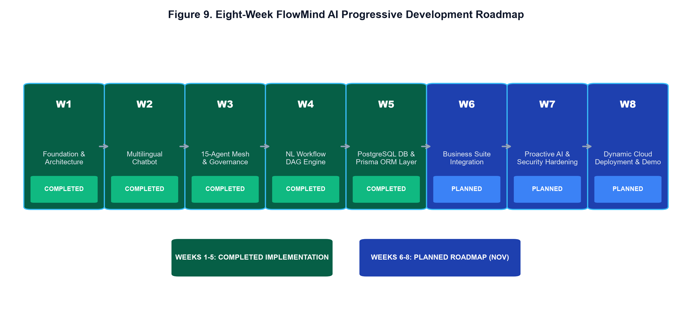
Figure 9. Eight-Week FlowMind AI Progressive Development Roadmap
Table 9. Overall 8-Week Development Progress Matrix
Phase / Week | Milestone Title | Progress Focus | Current Status
Week 1 | SDLC & Design Tokens | Project scaffolding, Next.js 14, TypeScript setup | COMPLETED
Week 2 | Multilingual Chatbot | Indic Engine (6 languages), STT/TTS voice integration | COMPLETED
Week 3 | 15-Agent Mesh & HITL | Master Orchestrator, Action Cards, Security Shield, Audit | COMPLETED
Week 4 | NL Workflow Engine | NL-to-DAG, Topological Runner, Visual Graph, Webhooks | COMPLETED
Week 5 | PostgreSQL DB Layer | PostgreSQL DB, Prisma ORM, 3-Tier RBAC & Service Repositories | COMPLETED
Week 6 | Data Studio & RAG | AI Data Analyst, CSV/PDF cleaner, Vector RAG Hub | PLANNED (OCT)
Week 7 | Proactive AI & Security | Proactive anomaly engine, RBAC hardening, API encryption | PLANNED (NOV)
Week 8 | Dynamic Cloud Hosting | Live cloud deployment (Vercel/AWS), CI/CD, final demo packaging | PLANNED (NOV)

15. Weeks 6–8 Planned Development Roadmap & November Completion Plan
The remaining three weeks of project development focus on integrating AI Data Studio tools, deploying the application dynamically on production cloud servers, and polishing enterprise modules ahead of final submission in November.
Table 10. November Completion Strategy and Milestones
Priority Level | Target Module | Planned Implementation Deliverable | Target Date
Priority 1 | Data Studio & RAG | Dataset auto-cleaner, chart recommender, vector RAG Q&A | Late October
Priority 2 | Dynamic Cloud Deployment | Vercel / AWS EC2 server deployment & CI/CD pipeline | Early November
Priority 3 | Proactive AI & Security | Background anomaly scanner, API secret encryption | Early November
Priority 4 | Final Integration | Live domain verification, system testing, & presentation packaging | Mid November

16. Challenges, Current Limitations & Risk Mitigation
1. Database Resilience: Managed via dual-mode service fallbacks to guarantee uptime even if database servers undergo maintenance.
2. Self-Approval Security Risk: Prevented by enforcing strict RBAC checks in approvalService.
17. Team Responsibility & Domain Allocations
Table 11. Team Domain Allocation and Responsibilities
Team Member | Reg Number | Domain Responsibility | Primary Contributions
Furkhan Abdul Raheem | 23BCE7868 | AI & Multilingual Lead | Master Orchestrator, 15-Agent Mesh, Universal Runtime, Indic Engine, Prompt Injection Shield.
Aniket Sahu | 23BCE7881 | Frontend & UI/UX Lead | Layman Chatbot UI, Thought Stream, Action Cards, Robot Assistant, Tailwind Design Tokens.
Anjali Karagatla | 23BCE8077 | Workflow Engine Lead | Workflow Planner, DAG Validator, Topological Runner, Visual DAG Graph, Execution Console.
Farukh | 23BCE20345 | Data & Security Lead | PostgreSQL Database Layer, Prisma ORM, 3-Tier RBAC, Audit Logger, Artifact Manager.

18. Conclusion & Future Scope
The interim 8-week progress report for FlowMind AI demonstrates significant engineering achievements across Weeks 1 through 5, establishing a production-grade PostgreSQL persistence layer, 15-agent collaboration mesh, multilingual engine, and zero-code workflow automation platform.
19. References & Internal Project Documentation
1. FlowMind AI Developer Architecture & SDLC Specification (Internal Documentation, 2026).
2. FlowMind AI PostgreSQL Backend & Prisma ORM Implementation Specification (2026).
3. Official Project Repository: https://github.com/Furkhan-5/FlowMind-AI.

