**Nomenclature**

**Commands Chapter:**

Number => [Chapter=(Number)]

Name => [Name=(Name)]

Connection => [Connection=(Number: 0 to 4)]

Trust => [Trust=(Number: 0 to 100)]

Start Scene => [StartScene=(Number)]

**Commands Scene:**

Number => [Scene=(Number)]

Beep Background => [BeepBack=(True/False)]

Connection => [Connection=(Number: 0 to 4)]

Timer(s) => [Timer=(Number: 0 to 999)]

Content=> [Content=(Text)]

Choices => [Choices=(Text)]

**Commands Content:**

Wait(ms) => [Wait=(Number)]

Space => [Space=(Number: 0 to 10)]

Color => [Color=(Black/Blue/Green/Cyan/Red/Magenta/Yellow/White/Gray/LightBlue/LightGreen/LightCyan/LightRed/LightMagenta/LightYellow/BrightWhite)]

Beep => [Beep=(True/False)]

**Commands Choices (5 Max):**

Choice => [Choice(Number)=(Text)]

Default => [Default=(True/False)]

Next Chapter => [NextChapter=(Number)]

Reset=> [Reset=(True/False)]

Menu => [Menu=(True/False)]

Quit => [Quit=(True/False)]

Next Scene => [NextScene=(Number)]

Next Scene No Trust => [NextSceneNoTrust=(Number)]

Trust Need=> [TrustNeed=(Number: 0 to 100)]

Add Trust=> [AddTrust=(Number: 0 to 100)]

Content => [Content=(Text)]

**Chapter Example:**

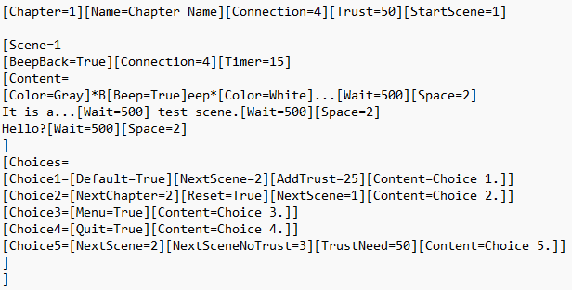

**GitHub Push Informations:**

Feat => Features

Fix => Fix Bugs / Organize Project / Patchs / Improvements