using System;

using System.Collections.Generic;

using System.Linq;

using System.Text;

using System.Threading.Tasks;

namespace Task_2_using_Selection_Statements

{

internal class Program

{

static void Main(string[] args)

{

//Task 1 (Find the Largest number amoung three Numbers?)

Console.WriteLine("***********Select Largest number amoung three numbers.*********");

int num1;

int num2;

int num3;

Console.WriteLine("Enter the Value of num1: ");

num1 = Convert.ToInt32(Console.ReadLine());

Console.WriteLine("Enter the Value of num2: ");

num2 = Convert.ToInt32(Console.ReadLine());

Console.WriteLine("Enter the Value of num3: ");

num3 = Convert.ToInt32(Console.ReadLine());

if (num1 > num2 && num1 > num3)

{

Console.WriteLine("The Value of num1 {0} is Greator than All! ", num1);

}

else if (num2 > num1 && num2 > num3)

{

Console.WriteLine("The Value of num2 {0} is Greator than All! ", num2);

}

else

{

Console.WriteLine("The Value of num3 {0} is Greator than all of above! ", num3);

}

Console.WriteLine();

//Task 2 (To Check a number is Positive, Negative, or Zero.)

Console.WriteLine("*************Positive, Negative or Zero Number************");

int Num1;

Console.WriteLine("Enter the value of Num1: ");

Num1 = Convert.ToInt32(Console.ReadLine());

if (Num1 > 0)

{

Console.WriteLine("The Value of Num1 {0} is Positive! ", Num1);

}

else if (Num1 < 0)

{

Console.WriteLine("The Value of Num1 {0} is Negative! ", Num1);

}

else

{

Console.WriteLine("The Value of Num1 {0} is Zero! ", Num1);

}

Console.WriteLine();

//Task 3 To Check UpperCase or LowerCase Alphabets.

Console.WriteLine("****************LowerCase or UpperCase Character**************");

char Ch;

Console.WriteLine("Enter any Character: ");

Ch = Convert.ToChar(Console.ReadLine());

if (Ch >= 'a' && Ch <= 'z')

{

Console.WriteLine("The Character you entered {0} is LowerCase!", Ch);

}

else if(Ch >= 'A' && Ch <= 'Z')

{

Console.WriteLine("The Character you entered {0} is UpperCase!", Ch);

}

else

{

Console.WriteLine("The Character you entered {0} is not a Single Character, it is a string or You Entered a value.", Ch);

}

Console.WriteLine();

// Task 4 (To Check Character is a Vowel or a Consonant)

Console.WriteLine("***************Vowel or Consonant Character****************");

char Character;

Console.WriteLine("Enter the Any Character: ");

Character = Convert.ToChar(Console.ReadLine());

if (Character == 'a' || Character == 'e' || Character == 'i' || Character == 'o' || Character == 'u')

{

Console.WriteLine("The Character you Entered {0} is Vowel.", Character);

}

else if (Character == 'A' || Character == 'E' || Character == 'I' || Character == 'O' || Character == 'U')

{

Console.WriteLine("The Character you Entered {0} is Vowel.", Character);

}

else if (Character >= 'b' && Character <= 'd' || Character >= 'f' && Character <= 'h' || Character >= 'j' && Character <= 'n' || Character >= 'p' && Character <= 't' || Character >= 'v' && Character <= 'z')

{

Console.WriteLine("The Character you Entered {0} is Consonant.", Character);

}

else if (Character >= 'B' && Character <= 'D' || Character >= 'F' && Character <= 'H' || Character >= 'J' && Character <= 'N' || Character >= 'P' && Character <= 'T' || Character >= 'V' && Character <= 'Z')

{

Console.WriteLine("The Character you Entered {0} is Consonant.", Character);

}

else

{

Console.WriteLine("You Entered a value which is not a Character, Please type any Character!", Character);

}

Console.WriteLine();

// Task 5 (To Determine Whether Age or Education of Voter for Casting Vote?)

Console.WriteLine("*************Casting Vote*******************");

int Age;

string Education;

Console.WriteLine("Enter your Age: ");

Age = Convert.ToInt32(Console.ReadLine());

Console.WriteLine("Enter your Education: ");

Education = Console.ReadLine();

if (Age >= 18 && Education == "Matric" || Education == "Inter" || Education == "Graduate" || Education == "Master")

{

Console.WriteLine("You are Eligible for casting Vote!");

}

else if (Age >= 18 && Education == "matric" || Education == "inter" || Education == "graduate" || Education == "master")

{

Console.WriteLine("You are Eligible for casting Vote!");

}

else if (Age >= 18 && Education == "MATRIC" || Education == "INTER" || Education == "GRADUATE" || Education == "MASTER")

{

Console.WriteLine("You are Eligible for casting Vote!");

}

else if (Age >= 18 && Education == "Matriculation" || Education == "Intermediate" || Education == "Graduate" || Education == "Master")

{

Console.WriteLine("You are Eligible for casting Vote!");

}

else if (Age >= 18 && Education == "matriculation" || Education == "intermediate" || Education == "graduation" || Education == "master")

{

Console.WriteLine("You are Eligible for casting Vote!");

}

else if (Age >= 18 && Education == "MATRICULATION" || Education == "INTERMEDIATE" || Education == "GRADUATION" || Education == "MASTER")

{

Console.WriteLine("You are Eligible for casting Vote!");

}

else

{

Console.WriteLine("Sorry, You are not Eligible for Casting Vote because, You typed invalid Education or You are under 18!");

}

Console.Read();

}

}

}

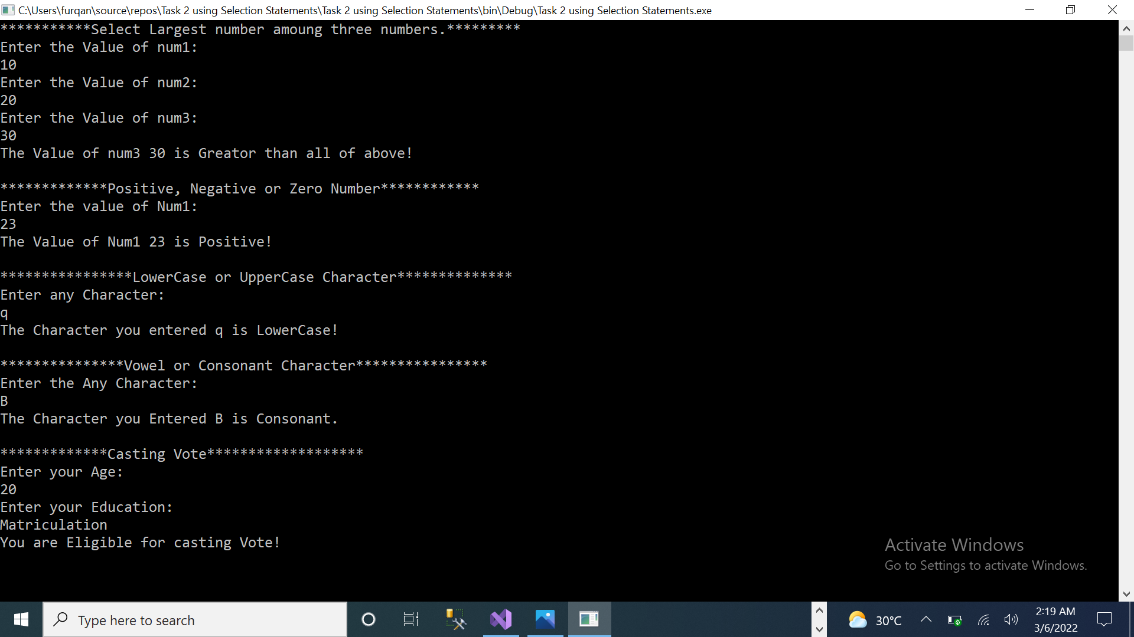 **OUTPUT:**