HW 7 Question 7

Target Corp

3/19/2021

pacman::p_load(pacman, tidyverse, tseries, knitr)  
knitr::opts_chunk$set(message = FALSE)

## Question 1

#a  
x = get.hist.quote(instrument = "TGT",  
 start = "2014-12-01",  
 end = "2019-12-31",  
 quote = "AdjClose",  
 compression = "m")

## time series ends 2019-12-01

## time series ends 2019-12-01  
tgt_m = as.vector(x)  
  
# log prices  
tgt_logPrices = log(tgt_m)  
tgt_logPrices

## [1] 4.139659 4.108892 4.151706 4.224471 4.184192 4.190388 4.225739 4.228430  
## [9] 4.176526 4.195759 4.176765 4.114211 4.123547 4.120927 4.200906 4.256836  
## [17] 4.222465 4.077621 4.100237 4.176195 4.105522 4.091720 4.092448 4.209180  
## [25] 4.150563 4.037062 3.944339 3.890659 3.902547 3.889934 3.847494 3.927933  
## [33] 3.889439 3.979599 3.980107 3.994569 4.090436 4.232627 4.235150 4.160753  
## [41] 4.205399 4.209385 4.261286 4.319466 4.400614 4.416525 4.363207 4.198921  
## [49] 4.136084 4.235526 4.230582 4.339163 4.303136 4.341527 4.424275 4.421848  
## [57] 4.636063 4.642500 4.642500 4.798906 4.830094

#b  
tgt_m_logret = diff(tgt_logPrices)  
# show the data elements  
tgt_m_logret

## [1] -0.0307676109 0.0428142660 0.0727649491 -0.0402790823 0.0061966257  
## [6] 0.0353503547 0.0026914411 -0.0519041656 0.0192330905 -0.0189945375  
## [11] -0.0625539288 0.0093365977 -0.0026204463 0.0799791486 0.0559298540  
## [16] -0.0343710356 -0.1448441091 0.0226164231 0.0759577668 -0.0706724110  
## [21] -0.0138019506 0.0007277764 0.1167316293 -0.0586170317 -0.1135005635  
## [26] -0.0927235578 -0.0536794030 0.0118875296 -0.0126126539 -0.0424405355  
## [31] 0.0804396829 -0.0384939365 0.0901595149 0.0005082306 0.0144615118  
## [36] 0.0958672843 0.1421909944 0.0025230131 -0.0743970622 0.0446460248  
## [41] 0.0039864600 0.0519008756 0.0581795639 0.0811480425 0.0159113273  
## [46] -0.0533182181 -0.1642859477 -0.0628374165 0.0994419311 -0.0049438497  
## [51] 0.1085810206 -0.0360263749 0.0383908410 0.0827481267 -0.0024276466  
## [56] 0.2142149795 0.0064370080 0.0000000000 0.1564063251 0.0311882701

#c  
plot(tgt_m_logret, type="l", ylim=c(-0.3, 0.3), xlab="Time",ylab="Log Return")

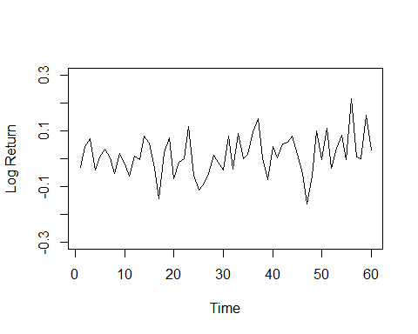

#d  
#Display summary statistics  
  
summary(tgt_m_logret)

## Min. 1st Qu. Median Mean 3rd Qu. Max.   
## -0.164286 -0.036643 0.005092 0.011507 0.056492 0.214215

#e  
# print output and plot  
print(acf(tgt_m_logret, lag.max = 12))

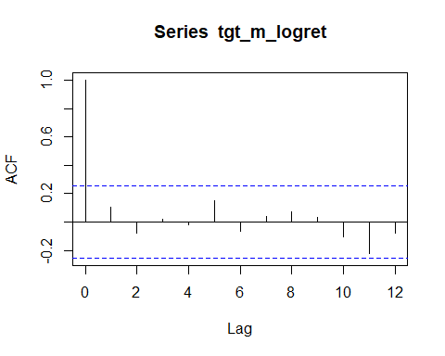

##   
## Autocorrelations of series 'tgt_m_logret', by lag  
##   
## 0 1 2 3 4 5 6 7 8 9 10   
## 1.000 0.107 -0.074 0.020 -0.022 0.151 -0.067 0.042 0.071 0.031 -0.105   
## 11 12   
## -0.220 -0.080

#f  
Box.test(tgt_m_logret, lag = 12, type = "L")

##   
## Box-Ljung test  
##   
## data: tgt_m_logret  
## X-squared = 8.5581, df = 12, p-value = 0.7401

#g  
#Based on this test, there’s no evidence to reject the hypothesis that the data do not exhibit autocorrelation (at least up to lag 12).