HW7 Question 4

Tesla

3/19/2021

pacman::p_load(pacman, tidyverse, tseries, knitr)  
knitr::opts_chunk$set(message = FALSE)

## Question 4

x = get.hist.quote(instrument = "TSLA",  
 start = "2014-12-01",  
 end = "2019-12-31",  
 quote = "AdjClose",  
 compression = "m")

## time series ends 2019-12-01

## time series ends 2019-12-01  
tsla_m = as.vector(x)  
tsla_m

## [1] 44.482 40.720 40.668 37.754 45.210 50.160 53.652 53.230 49.812 49.680  
## [11] 41.386 46.052 48.002 38.240 38.386 45.954 48.152 44.646 42.456 46.958  
## [21] 42.402 40.806 39.546 37.880 42.738 50.386 49.998 55.660 62.814 68.202  
## [31] 72.322 64.694 71.180 68.220 66.306 61.770 62.270 70.862 68.612 53.226  
## [41] 58.780 56.946 68.590 59.628 60.332 52.954 67.464 70.096 66.560 61.404  
## [51] 63.976 55.972 47.738 37.032 44.692 48.322 45.122 48.174 62.984 65.988  
## [61] 83.666

tsla.m.ret = (tsla_m[-1]-tsla_m[-61])/tsla_m[-61]  
length(tsla.m.ret)

## [1] 60

#a  
#Display summary statistics  
  
summary(tsla.m.ret)

## Min. 1st Qu. Median Mean 3rd Qu. Max.   
## -0.22427 -0.06677 0.00127 0.01780 0.10477 0.30743

#b  
plot(tsla.m.ret, type="l", ylab="Return", xlab="Time")

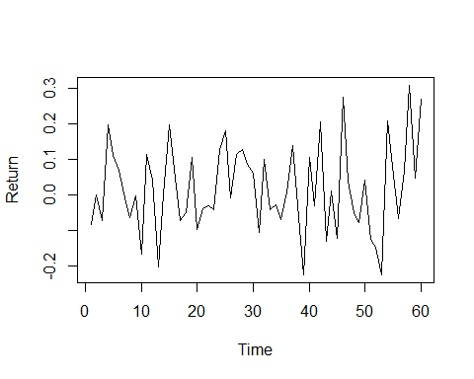

#c  
install.packages("gtools",repos = "http://cran.us.r-project.org")

## package 'gtools' successfully unpacked and MD5 sums checked

## Warning: cannot remove prior installation of package 'gtools'

## Warning in file.copy(savedcopy, lib, recursive = TRUE):  
## problem copying C:\Users\ahmad\OneDrive\Documents\R\win-  
## library\3.6\00LOCK\gtools\libs\x64\gtools.dll to C:  
## \Users\ahmad\OneDrive\Documents\R\win-library\3.6\gtools\libs\x64\gtools.dll:  
## Permission denied

## Warning: restored 'gtools'

##   
## The downloaded binary packages are in  
## C:\Users\ahmad\AppData\Local\Temp\RtmpiyDexl\downloaded_packages

library(gtools)

## Warning: package 'gtools' was built under R version 3.6.3

tsla.rmean = running(tsla.m.ret, fun=mean, width=12)  
  
plot(tsla.rmean, type="l", ylim=c(-0.1, 0.15), xlab="Time", ylab="Return")  
lines(1:49, rep(mean(tsla.m.ret) + 2*sd(tsla.m.ret)/(12^.5), 49), lty=2)  
lines(1:49, rep(mean(tsla.m.ret) - 2*sd(tsla.m.ret)/(12^.5), 49), lty=2)  
abline(a=mean(tsla.m.ret) + 2*sd(tsla.m.ret)/(12^.5), b=0, lty=2)

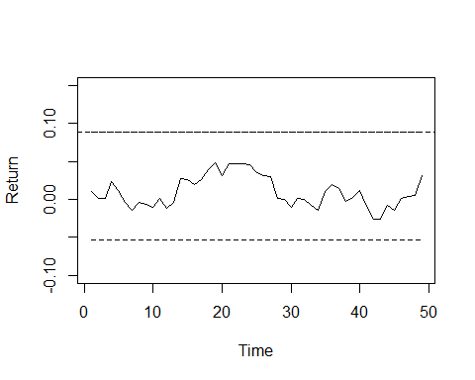

#d  
qqnorm(tsla.m.ret)  
abline(a=mean(tsla.m.ret), b=sd(tsla.m.ret))

