H-Bridge DC Motor Driver with Direction Control & Motion Indication with Speed Control

Furqan Shahid
Dept. of Mechatronics and Control Engineering
University of Engineering and Technology
Lahore, Pakistan
engr.furqanshahid64@gmail.com

Abstract— This project presents the design and implementation of a compact H-Bridge motor driver circuit using MOSFETs for bidirectional control of a DC motor. Two tactile push buttons are used to control the motor’s direction: pressing the first button rotates the motor in one direction, while the second button reverses its rotation. A buzzer is integrated as a motion indicator to provide audible feedback whenever the motor is active. The entire circuit is developed using discrete components, simulated and tested in Proteus, and implemented on a custom-fabricated PCB. This project is ideal for learning motor control fundamentals and embedded switching design using MOSFETs.
Keywords— H-Bridge, DC Motor Control, MOSFET Driver, Bidirectional Motor, Push Button Control, Motor Driver Circuit, Motion Indication, Embedded Hardware, Buzzer Integration, PCB Design, Proteus.

- Project Overview
The aim of this project is to control the direction of a DC motor using an H-Bridge configuration constructed with MOSFETs. Two buttons are employed as directional control inputs. Pressing Button 1 activates the motor in the forward direction, while pressing Button 2 reverses the polarity of current and runs the motor in reverse. A buzzer is connected to provide an audible beep signal every time the motor is in motion, enhancing usability and feedback.
The system is powered by a DC supply and controlled entirely using hardware logic — no microcontroller is required. This approach makes it highly reliable for basic automation tasks. The entire design was simulated in Proteus, and then a PCB layout was generated and fabricated for real-world implementation.
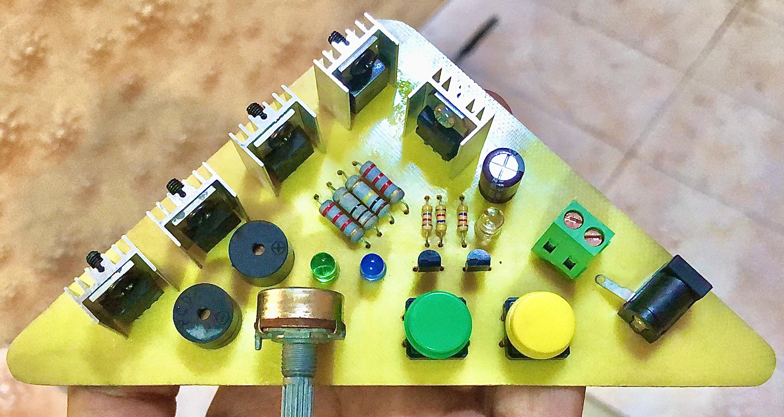
Fig. 1: Final Assembled H-Bridge Motor Driver on PCB
- Process
The development process began with conceptualizing the H-Bridge configuration using MOSFETs. Four MOSFETs were arranged in a standard H-Bridge layout, with each pair responsible for switching the motor’s terminals either high or low. Special attention was given to prevent simultaneous conduction of the high-side and low-side MOSFETs on the same side of the bridge, as this would result in a short circuit.
The push buttons were connected to the gate terminals of the MOSFETs through pull-down or pull-up resistors to ensure proper logic levels and to avoid floating states. Button debouncing was handled passively using RC filters to maintain circuit stability. The buzzer was wired in parallel with the motor, triggered when current flows through the circuit—thus indicating motor operation without requiring a separate control signal.
Once the circuit design was finalized, it was simulated in Proteus. The simulation verified the directional switching of the motor, correct operation of the MOSFETs, and the buzzer’s response. After simulation success, a PCB layout was created in Proteus, following best practices in track width, heat dissipation, and component placement. The PCB was fabricated using the toner transfer method, and components were soldered after hole drilling.
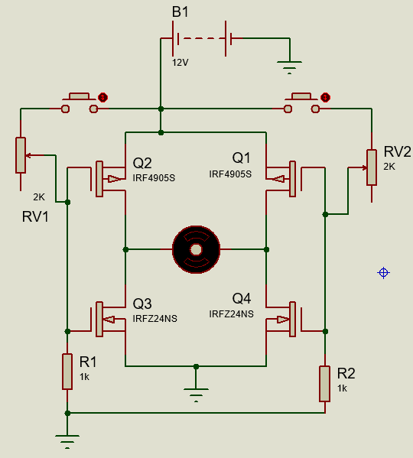
Fig. 2: Circuit Schematic of H-Bridge Motor Driver Designed in Proteus
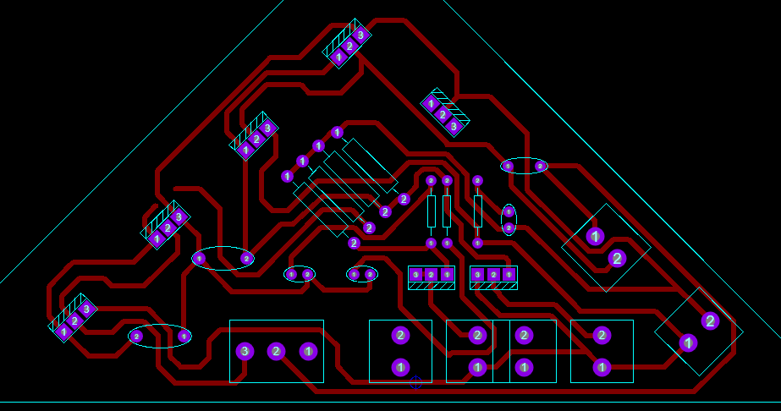
Fig. 3: PCB Design Layout of the Motor Driver Circuit
Once the schematic design was completed and verified through simulation in Proteus, the next step was to convert the circuit into a practical layout suitable for PCB fabrication. The schematic was carefully reviewed to ensure that all MOSFETs, buttons, the DC motor, and the buzzer were correctly placed and connected. Special care was taken to define the gate, source, and drain connections of the MOSFETs properly, with correct biasing and pull-down resistors to avoid false triggering. Following successful simulation results, the same schematic was transferred to the PCB layout editor within Proteus. During the PCB design process, component placement was optimized for minimal trace length, proper current flow, and thermal stability.
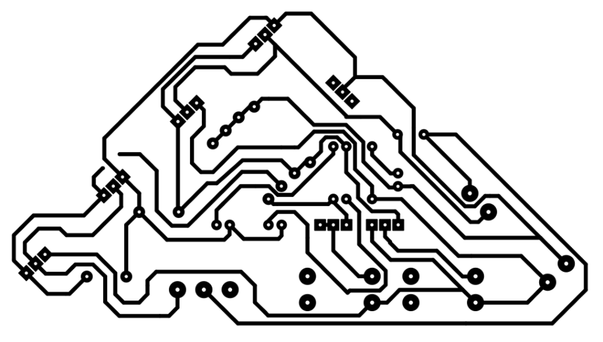
Fig. 4: PCB Design pdf of the Motor Driver Circuit
- working principle
The H-Bridge circuit uses four MOSFETs to control the direction of current flow through a DC motor. Pressing Button 1 turns on one diagonal pair of MOSFETs (Q1 and Q4), causing the motor to rotate in one direction. Pressing Button 2 activates the opposite pair (Q2 and Q3), reversing the polarity and thus the motor's direction.
A buzzer is connected alongside the motor to provide an audible indication whenever the motor is running. Basic speed control is achieved by adjusting the input voltage to the motor driver. Although no PWM control is used in this version, the design supports future expansion for precise speed regulation.
- components used
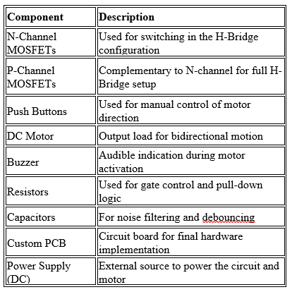
The components listed above form the core of the motor driver circuit. MOSFETs act as electronic switches to handle motor current, while the buttons serve as user input. Passive components like resistors and capacitors support signal stability and filtering. The buzzer adds an additional level of feedback for practical use.
- application
This hardware-based H-Bridge motor driver circuit is suitable for robotic movement control, conveyor systems, miniature vehicles, and directional fan systems. Its simple button-controlled interface makes it ideal for educational demonstrations of motor control logic, prototyping embedded systems, and small-scale automation projects.
- conclusion
This project successfully demonstrates the use of an H-Bridge circuit with MOSFETs to control the direction of a DC motor using simple push-button inputs. The addition of a buzzer provides clear motion feedback. The hardware-only approach ensures reliability, simplicity, and low cost, making it ideal for basic automation and educational applications.
- references
[1] IRF, “MOSFET Basics: Understanding Switching,” Infineon Technologies, [Online]. Available: https://www.infineon.com/dgdl/Infineon-MOSFET_Basics-ApplicationNotes-v01_00-EN.pdf
[2] All About Circuits, “H-Bridge Motor Control,” [Online]. Available: https://www.allaboutcircuits.com/textbook/digital/chpt-9/h-bridge-circuits
[3] STMicroelectronics, “Understanding and Using Power MOSFETs,” [Online]. Available: https://www.st.com/resource/en/application_note/cd00004096-mosfet-basics-and-application-stmicroelectronics.pdf

