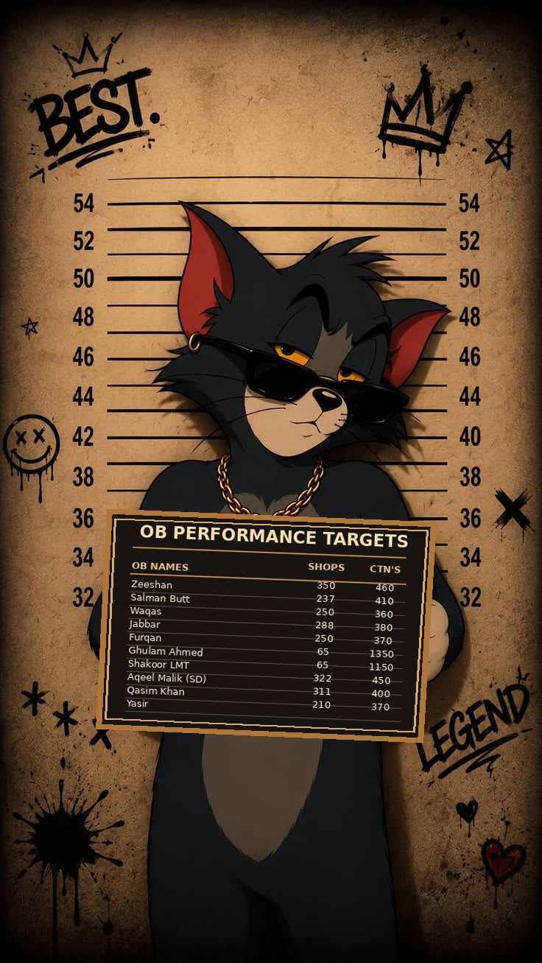

OB NAMES & TARGETS
Editable table — click any cell to change the text or numbers
OB Names | Shops Target | Ctn's Target
Zeeshan | 350 | 460
Salman Butt | 237 | 410
Waqas | 250 | 360
Jabbar | 288 | 380
Furqan | 250 | 370
Ghulam Ahmed | 65 | 1350
Shakoor LMT | 65 | 1150
Aqeel Malik (SD) | 322 | 450
Qasim Khan | 311 | 400
Yasir | 210 | 370

