USER MANUAL FOR THE INVENTORY & BILLING SYSTEM

* How to start the software?

1. In order to start the system you need to start with running the homepage on the solution explorer tab.

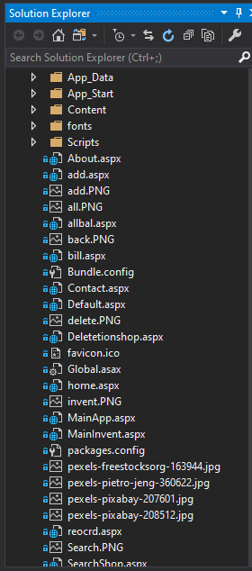

HOME PAGE

1. Once the program starts working you can enter the id and password for the respective inventory system and start with the working.
2. This particular software is designed to be used by the shops as well as the warehouse. Down below are the views you will get when you log in as a shop admin.

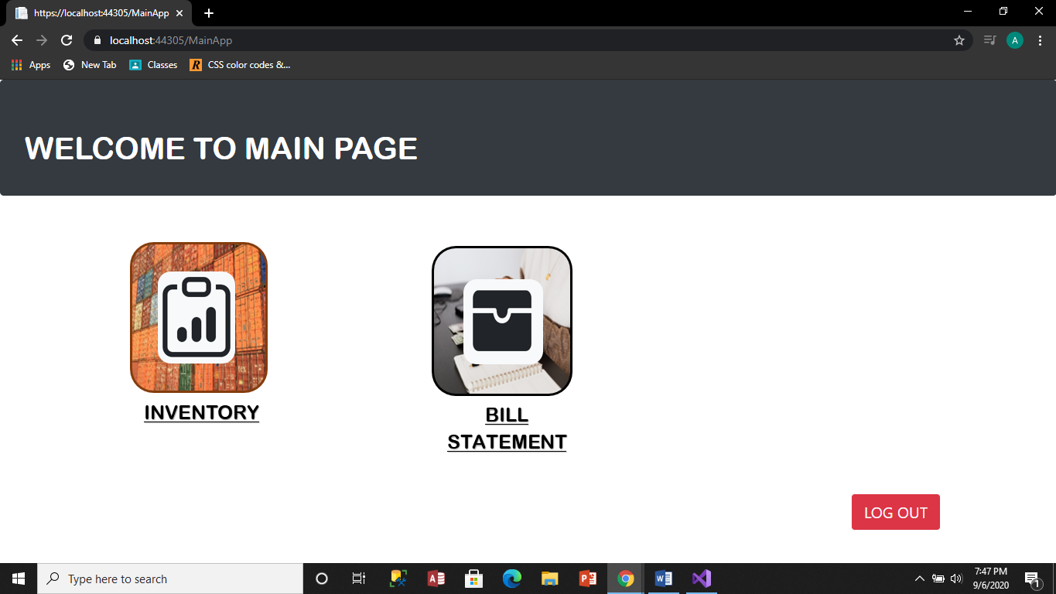

1. Below is the view that you will get when you log in as a warehouse admin.

* **While logged in as a warehouse admin:**

1. Once you are logged in as a ware house admin, you will find 2 options on the page to continue with and one option to log out.
2. You could either use the inventory or the billing statement.

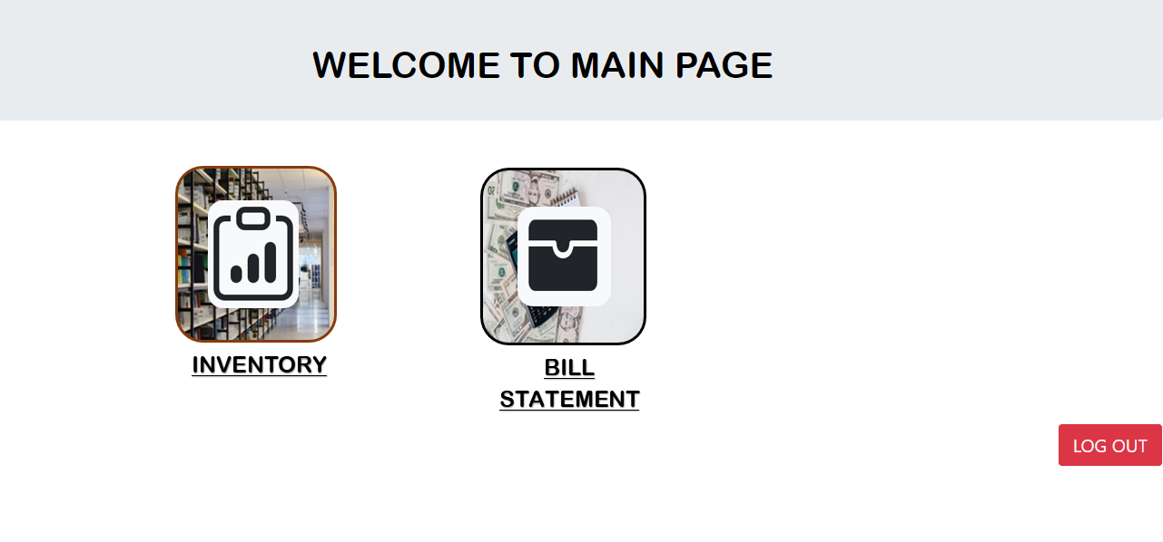

1. If you go for the inventory, then you can access the inventories of shops registered under your warehouse and also your own inventory. You can see all the details of the medicines present at that particular store.

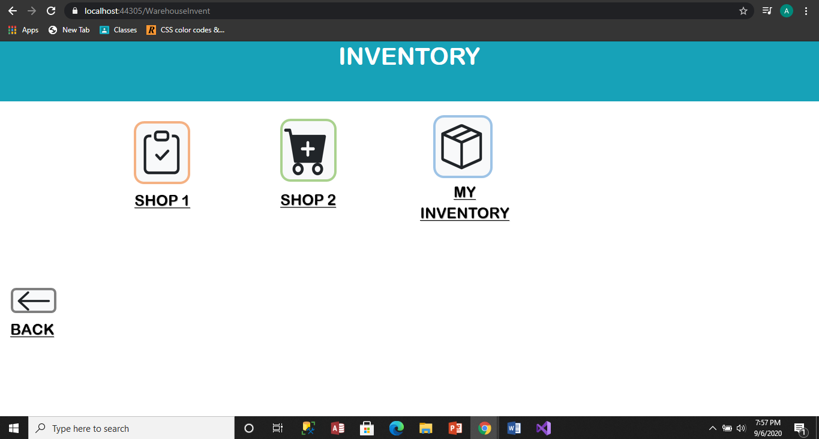

1. You can go back to the main page by clicking on the back button.
2. If you choose to click the bill statement button, there you can find all the sales of the individual sales by clicking on the shops button and as well of the ware house by clicking on the My sales button.

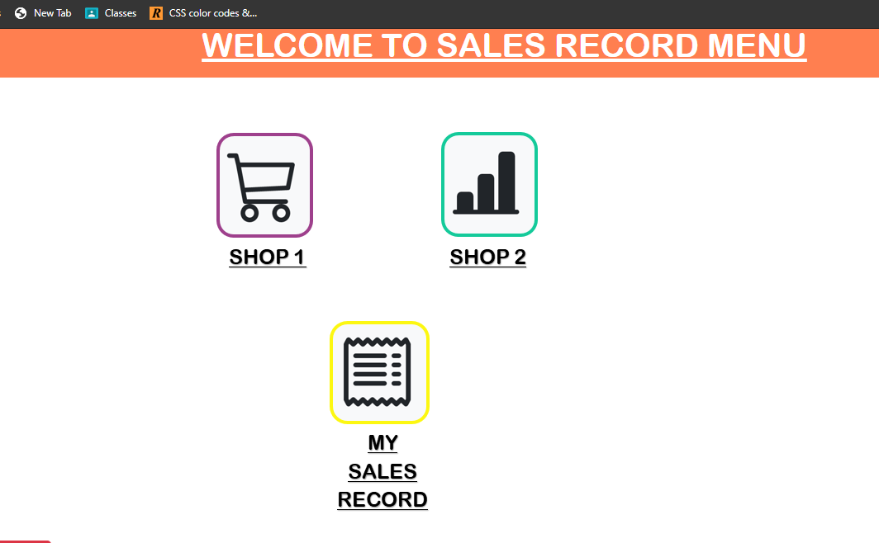

1. If you click on the my inventory button, there you can see 5 button:

Add, Update, Delete, Search and view All Record.

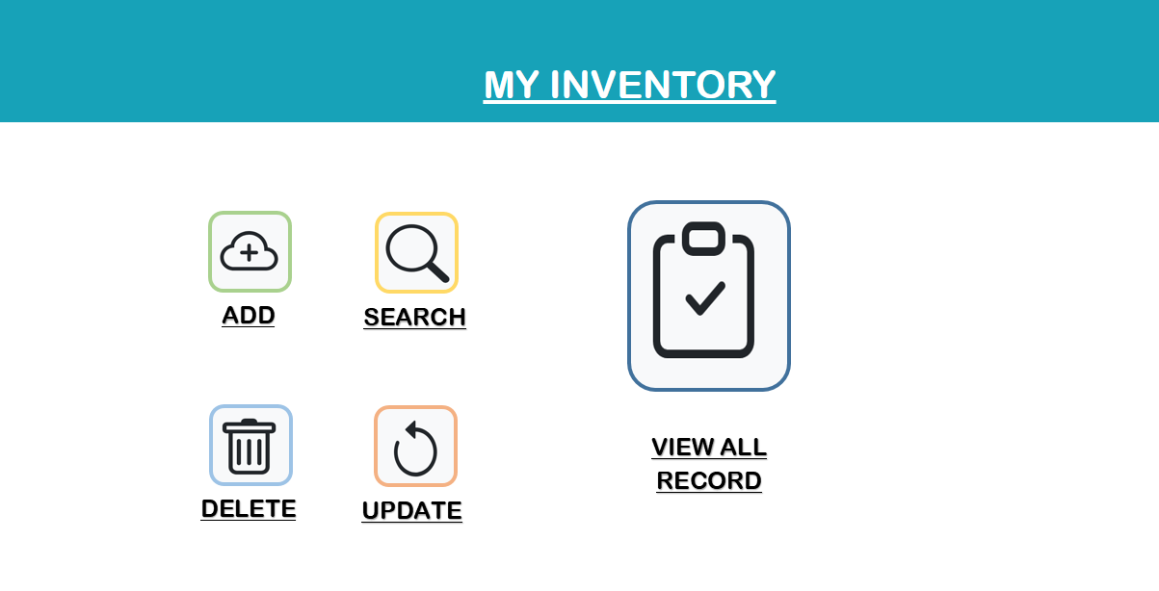

1. you can add new information related to the warehouse by clicking on the button form. A form like struture will appear in front of you, you fill it up and save the information by clicking the save button.

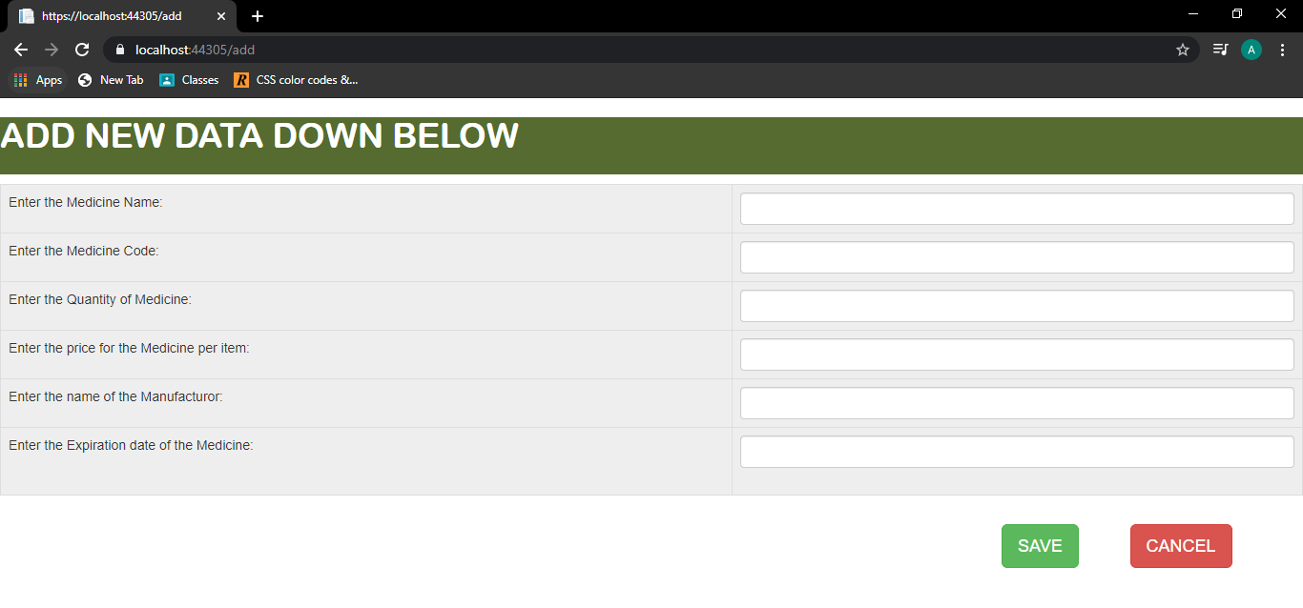

1. You can search through the data quickly by using the search option on the tab. Just type in the name of the medicine and all the data will be shown to you.

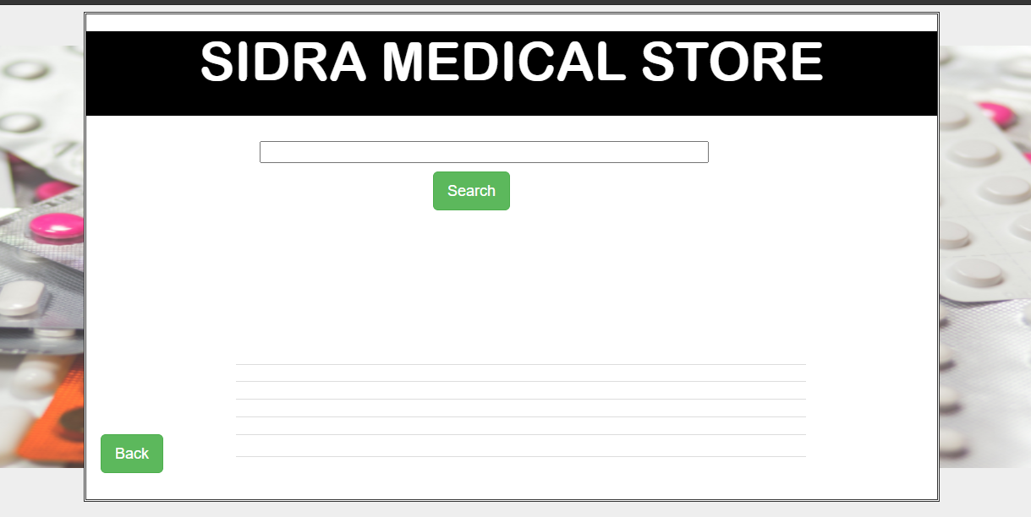

1. You can also update the already saved information by clicking on the update button, and saving the changed information, by clicking of the save button.

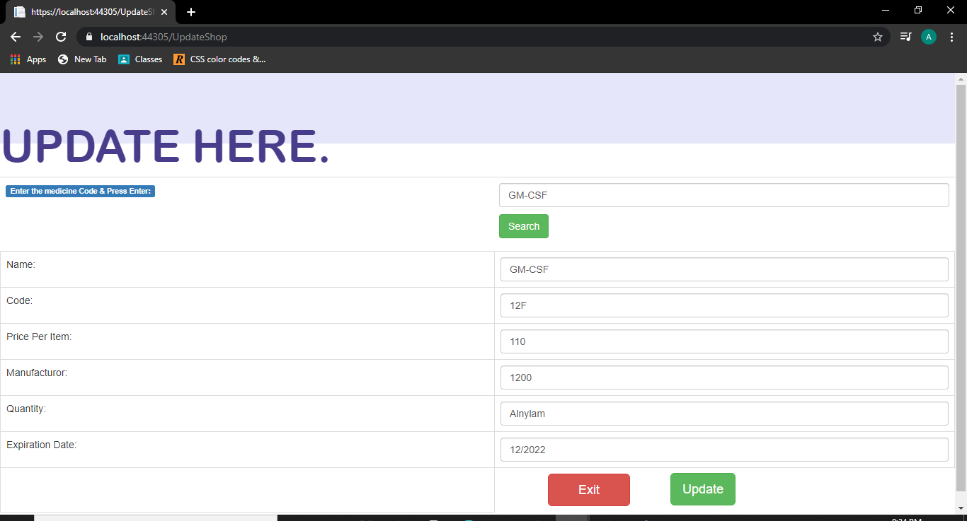

1. And you can also delete the undesired information by clicking on the delete button. You can search the information on the mdicine by inputting the name on the search bar and then delete it by clciking on the delete button.

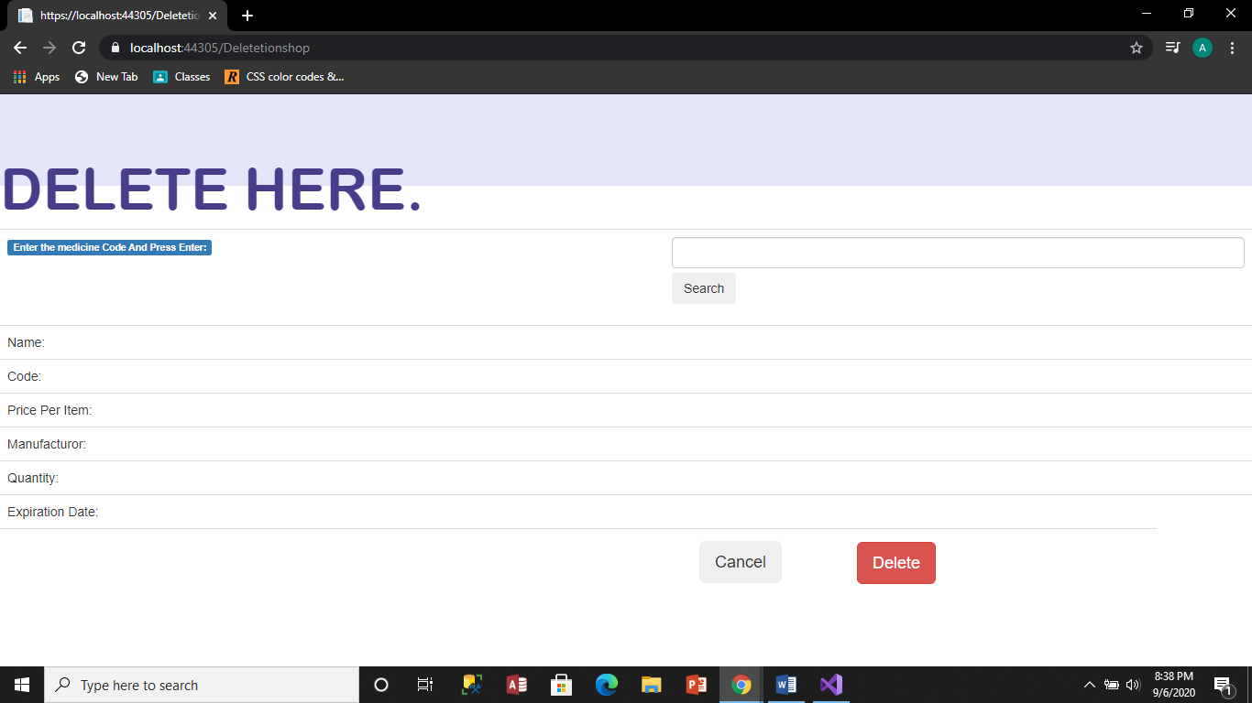

1. You can view all the data of the warehouse, by clicking on the view all record button. 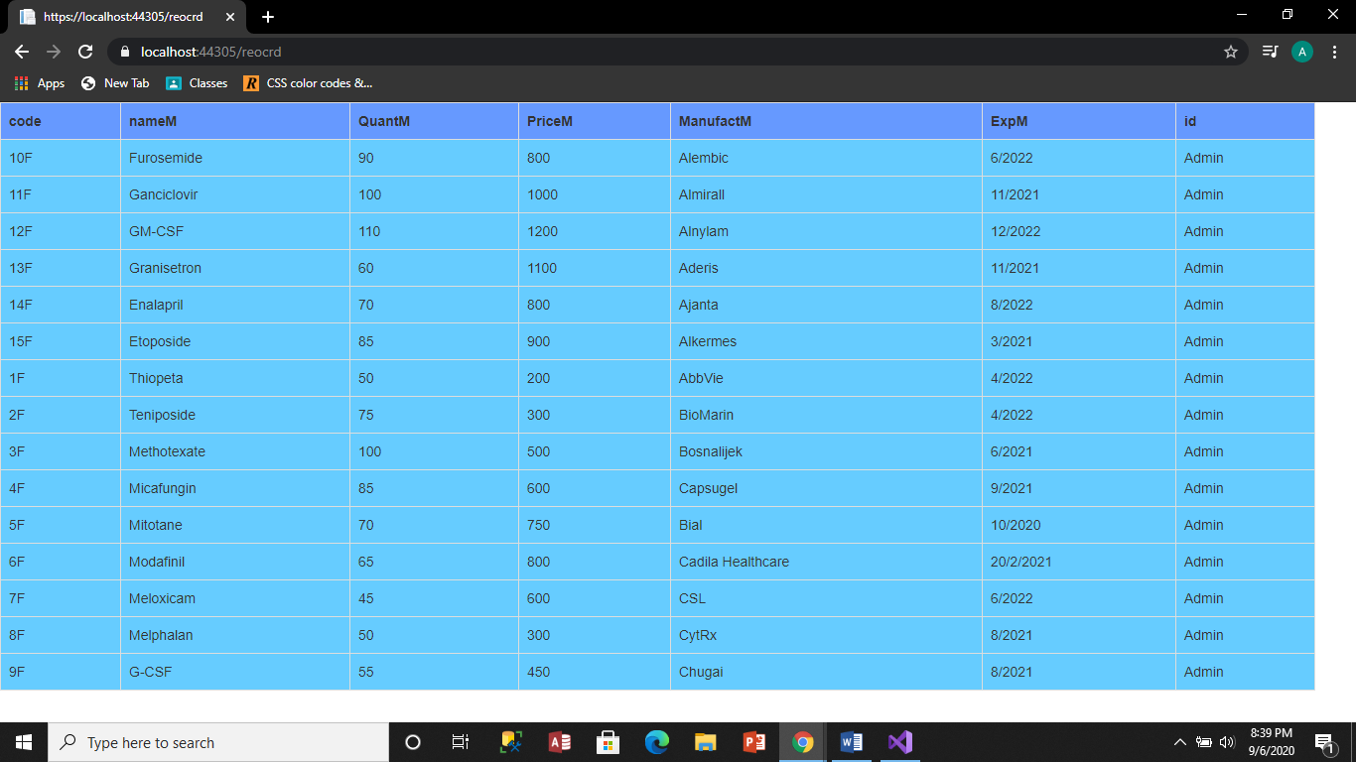

* **While logged in as a shop admin:**

1. When you are logged in as a shop admin you can access the respective shops inventory and sales data. 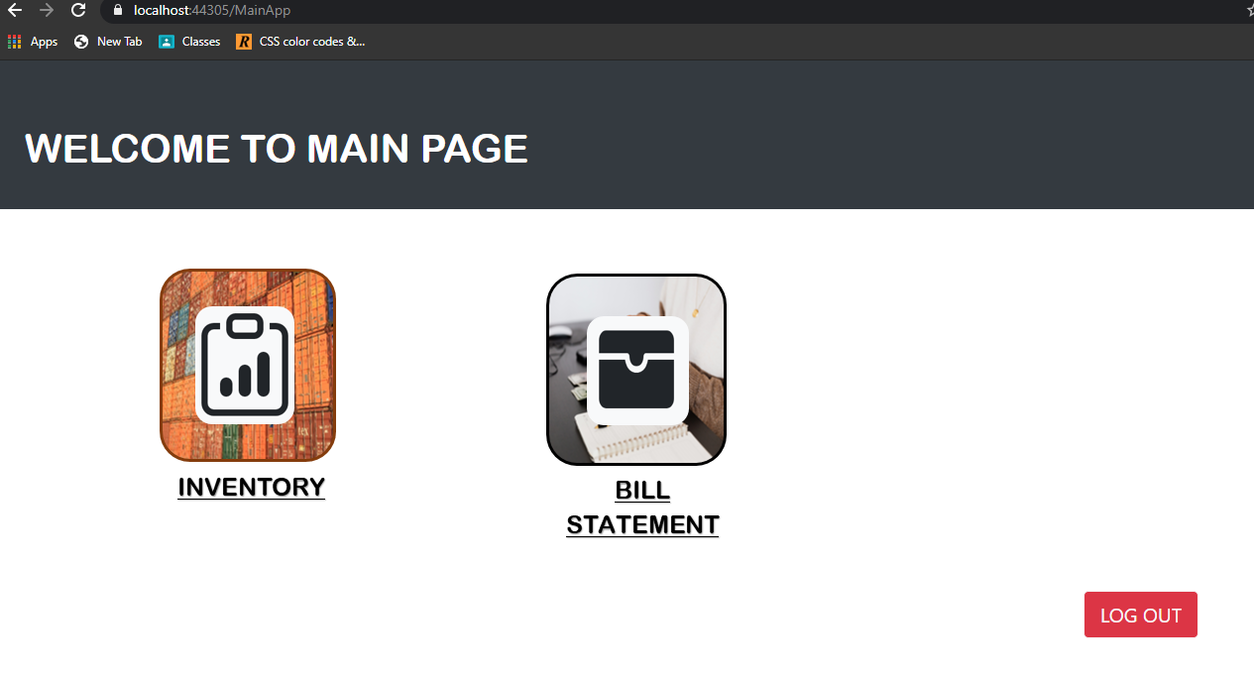
2. You can access the inventory by clicking on the inventory button. Where you can add, search, update, delete and view all the current record present in the shop. 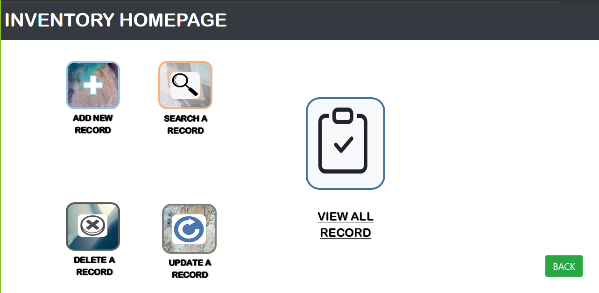
3. Upon clicking on the bill statement, you have to first enter the name of the customer and press submit. 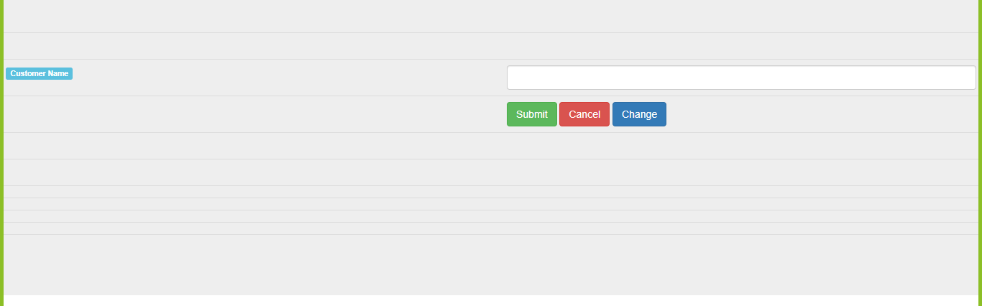
4. Then you can add the name of the medicines you want and the quantities according to sale requirement and add them to the cart. 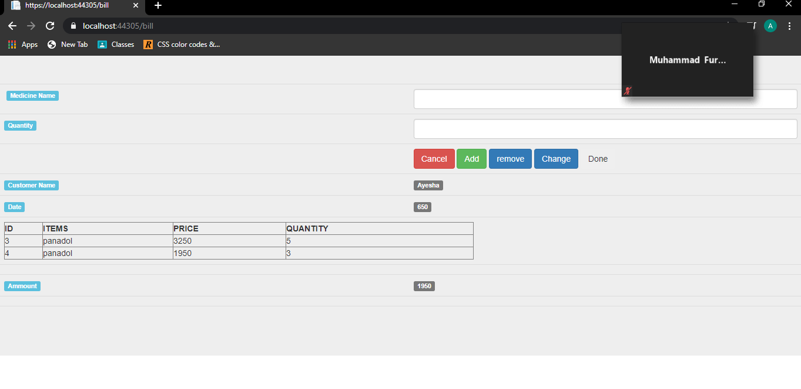
5. Once you are done with adding medicines into the cart and want to check out, you can click on done and check out. Then you can enter the amount that is being paid and the system will provide you with the amount you have to pay back. 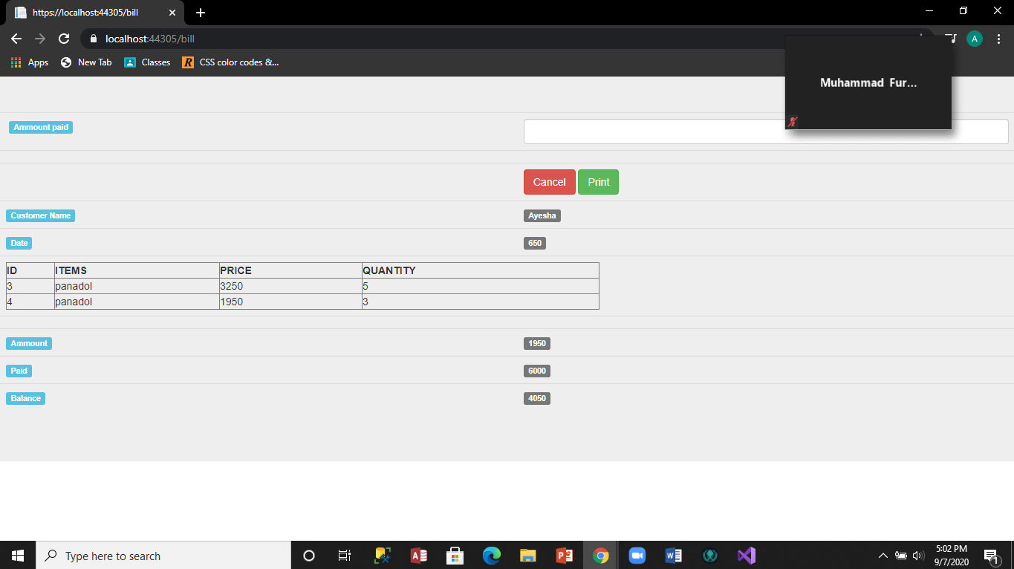
6. You can print the reciept by clicking on the print button.