Encryption Tool Report
Cyber Security Self-Learning Internship Program
Organization: InternCareerPath
Name: Furqan Ansari
Portal ID: ICP-OPN8SS-2026
Duration: 6 Weeks

1. Introduction
Encryption is a core concept in cybersecurity used to protect sensitive data from unauthorized access. This project implements a command-line based file encryption and decryption tool using AES encryption techniques in Python.

2. Objective
• Secure sensitive files using encryption
• Understand symmetric encryption mechanisms
• Implement encryption and decryption practically

3. Tools & Technologies
• Linux (Parrot OS)
• Python 3
• Cryptography Library
• AES (Advanced Encryption Standard)

4. Methodology
1. Generate a secure encryption key
2. Read target file in binary format
3. Encrypt file data using AES-based encryption
4. Save encrypted file with .enc extension
5. Decrypt file using the same secret key

5. Testing Environment
Testing was conducted on a local Linux environment using user-created files. All operations were performed in an authorized and ethical manner.

6. Results
The encryption tool successfully encrypted and decrypted files without data loss. The encrypted file was unreadable until decrypted using the correct secret key.

7. Scan Evidence / Screenshots
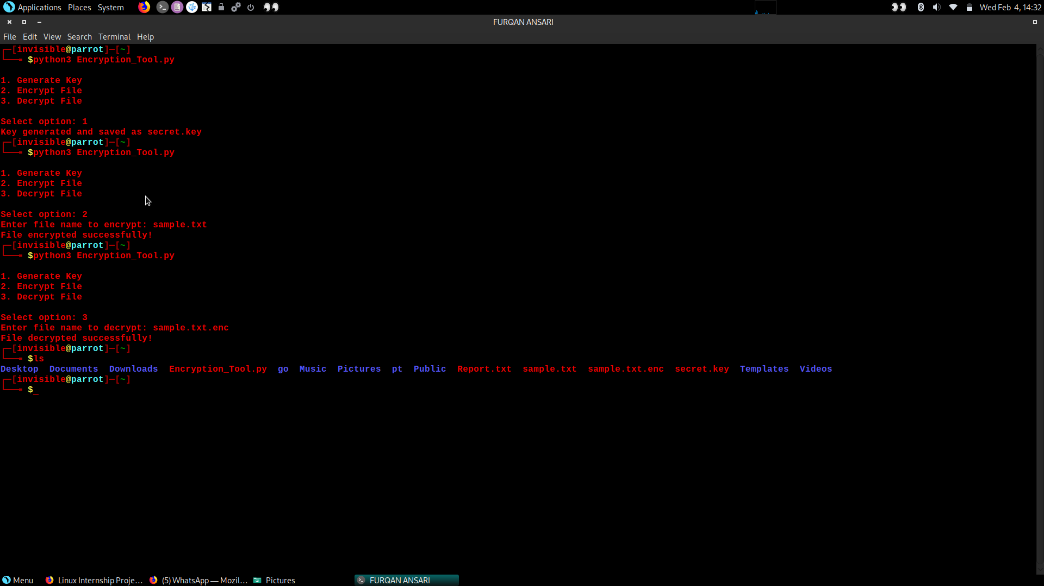

8. Ethical Considerations
This tool was developed and tested strictly for educational purposes. No unauthorized data or systems were accessed.

9. Conclusion
This project improved understanding of cryptography, secure file handling, and practical data protection techniques.

10. Future Improvements
• Password-based key protection
• RSA-based key exchange
• GUI-based interface
• Secure key storage mechanisms

