Week 1 – Web Application Security Testing Report

Objective
The objective of this week was to identify basic web application vulnerabilities in the OWASP Juice Shop lab environment. Testing focused on common injection flaws, authentication weaknesses, and missing security protections.

Vulnerabilities Identified

1. Cross‑Site Scripting (XSS)
Description: The application input fields are vulnerable to Cross‑Site Scripting (XSS). Malicious JavaScript code can be injected into search fields and executed in the browser.
Risk: An attacker can execute scripts in the victim’s browser, steal session cookies, perform actions on behalf of the user, or redirect users to malicious websites.
Evidence: JavaScript alert payload executed successfully during testing.
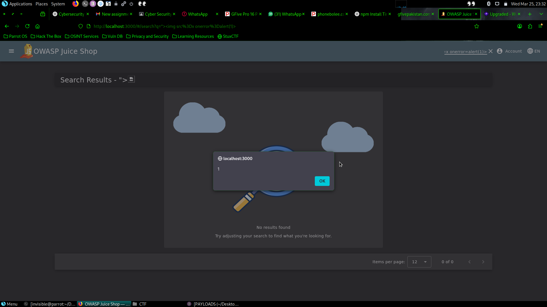

2. SQL Injection
Description: The login form is vulnerable to SQL Injection. Authentication can be bypassed using crafted SQL payloads.
Risk: An attacker may gain unauthorized access to user accounts and potentially access or modify database information.
Evidence: Login bypass was achieved using a SQL injection payload.
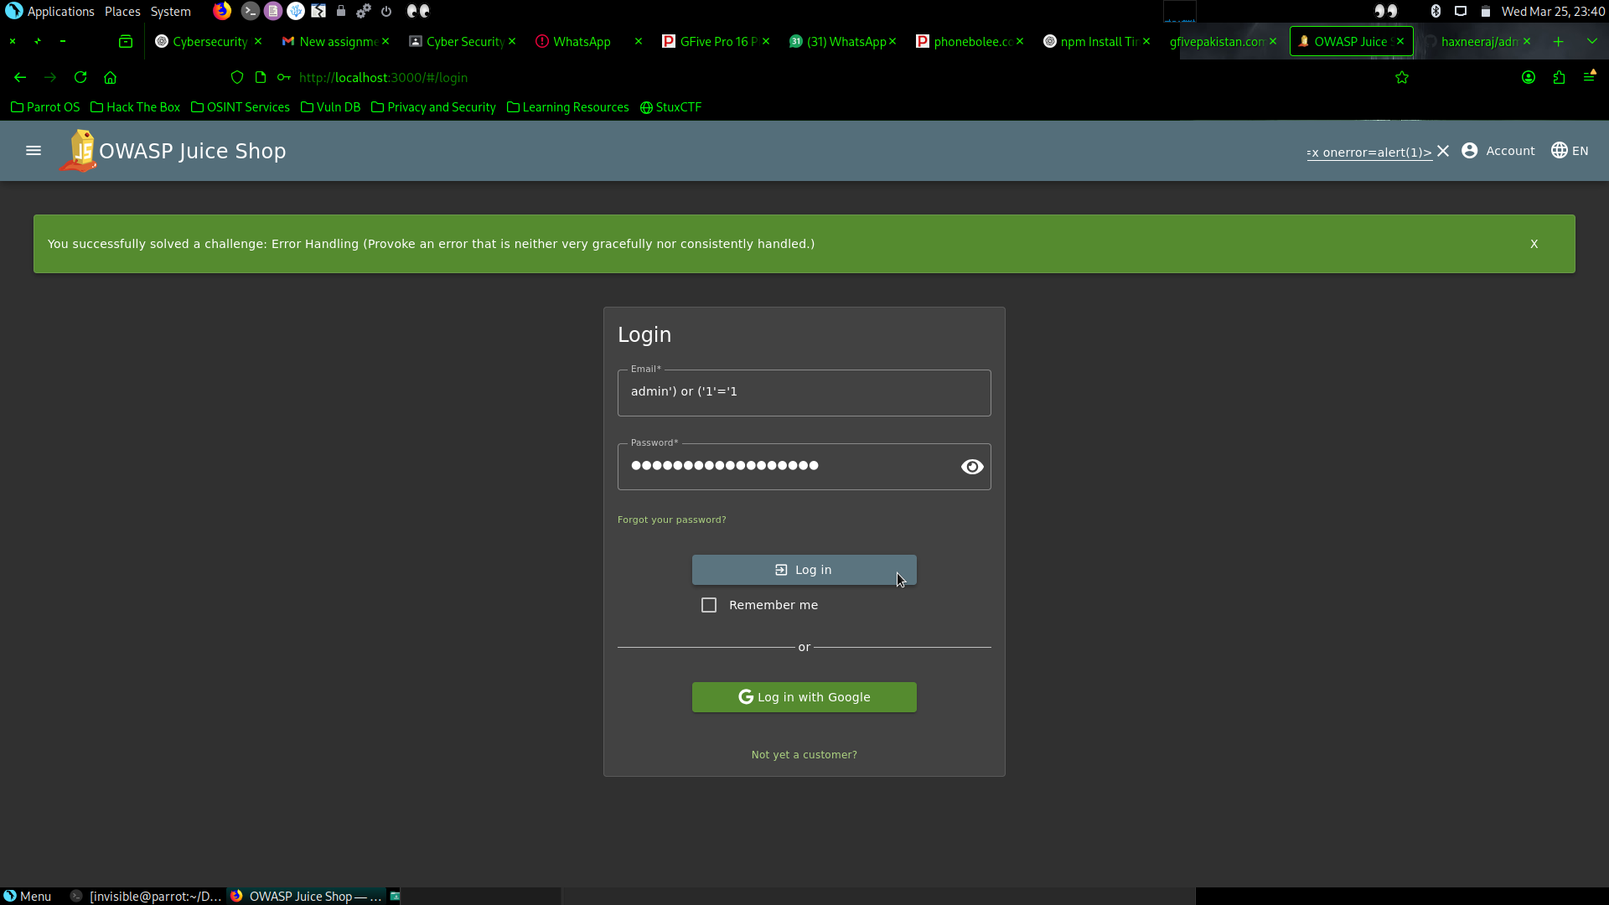

3. Weak Password Policy
Description: The application allows weak or simple passwords without enforcing strong password requirements.
Risk: Weak passwords can be easily guessed or cracked using brute force or dictionary attacks, leading to account compromise.

4. Missing Security Headers
Description: Important HTTP security headers were not properly configured.
Risk: Missing headers such as Content-Security-Policy, X-Frame-Options, and X-Content-Type-Options can expose the application to attacks like clickjacking, MIME sniffing, and XSS.

Conclusion
The testing identified several common web vulnerabilities including XSS and SQL Injection which are considered high-risk issues. Proper input validation, parameterized queries, strong password policies, and implementation of security headers are recommended to improve the security posture of the application.

