Week 2 Security Implementation Report

Introduction
This week focused on implementing basic security mechanisms in the OWASP Juice Shop testing environment. The main objective was to understand how modern web applications protect user data using input validation, password hashing, authentication tokens, and secure HTTP headers.

1. Input Validation (Validator)
Input validation ensures that user supplied data follows expected formats and prevents malicious input. For example, email fields should only accept valid email formats and passwords should meet minimum length requirements. Proper validation helps prevent attacks like SQL Injection, XSS, and malformed requests.

2. Bcrypt (Password Hashing)
Bcrypt is used to securely hash passwords before storing them in the database. Instead of saving plain text passwords, bcrypt converts them into irreversible hashes. This protects user credentials even if a database breach occurs. Bcrypt also uses salting which makes rainbow table attacks very difficult.

3. JWT (JSON Web Token)
JWT is used for authentication after successful login. When a user logs in, the server generates a token which is sent back to the client. This token is then used to verify the identity of the user in future requests. This method supports stateless authentication and improves scalability.

4. Helmet (Security Headers)
Helmet is a middleware used in Node.js applications to secure HTTP headers. It helps protect applications from common attacks such as clickjacking, MIME sniffing, and cross-site scripting. Helmet automatically sets headers like X-Frame-Options, X-Content-Type-Options, and Content-Security-Policy.

Practical Testing Using Burp Suite
Burp Suite Community Edition was used to intercept HTTP requests and responses. The proxy and repeater tools were used to analyze the signup request and the user information endpoints. This helped in understanding how data flows between client and server and how security headers are applied.

Screenshots
Figure 1: Burp Suite Repeater showing signup request testing.
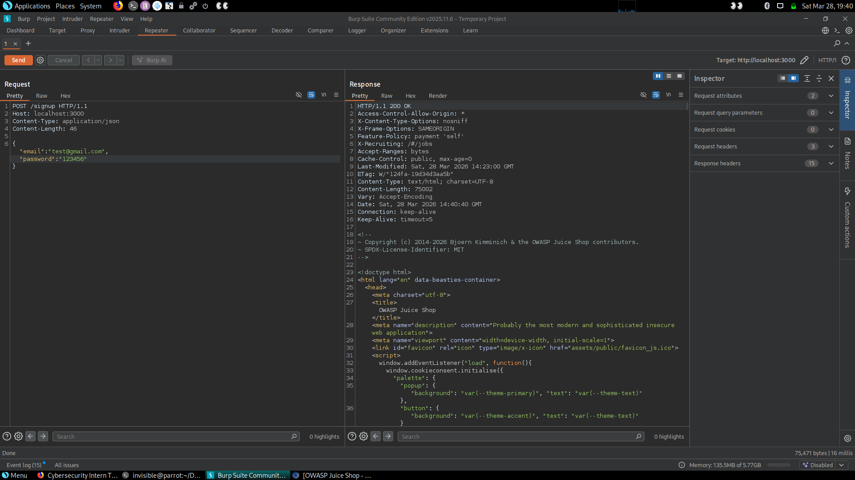
Figure 2: Burp Suite Proxy showing intercepted HTTP traffic.
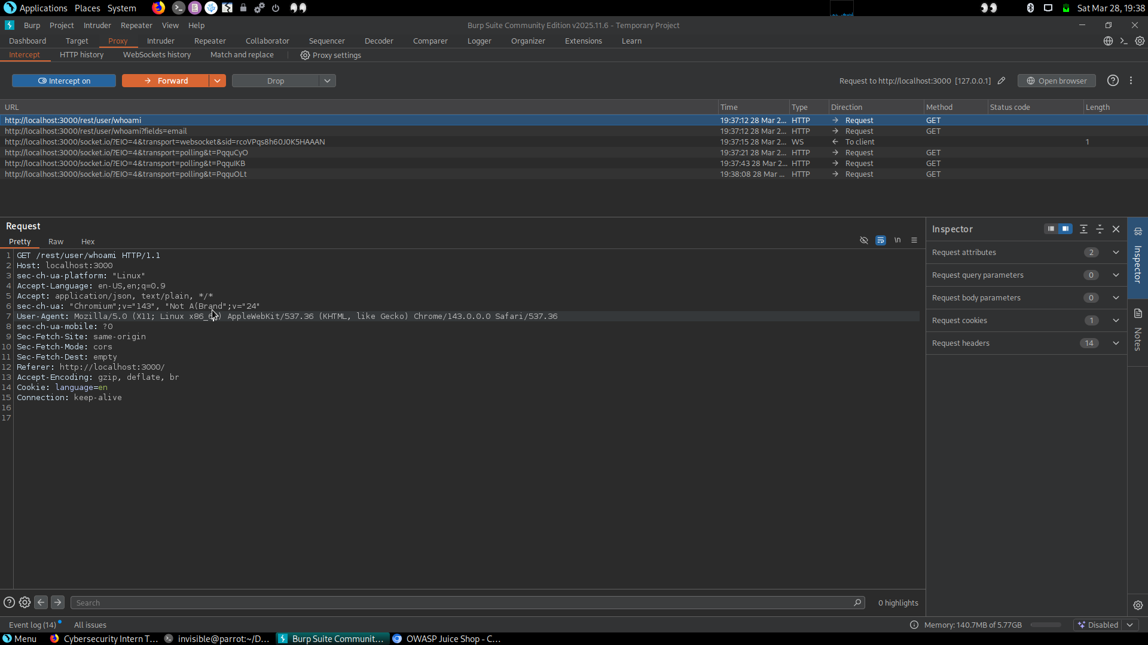

Conclusion
This week provided practical understanding of basic web security controls. Input validation prevents bad data, bcrypt protects passwords, JWT manages authentication, and Helmet improves HTTP security. Together these technologies form a strong foundation for building secure web applications.

