Network Port Scanner Report
Cyber Security Self-Learning Internship Program
Organization: InternCareerPath
Name: Furqan Ansari
Duration: 6 Weeks

1. Introduction
Port scanning is a fundamental network reconnaissance technique used to identify open ports and running services on a target system. This project focuses on developing an advanced multi-threaded port scanner using Python on Linux.

2. Objective
• Identify open TCP ports on a target system
• Understand network services and port behavior
• Practice ethical and authorized security testing

3. Tools & Technologies
• Linux (Parrot OS)
• Python 3
• Socket Programming
• Multithreading
• TryHackMe Authorized Lab Environment

4. Testing Environment
Testing was conducted on an authorized TryHackMe virtual machine. TryHackMe provides legal environments for ethical cybersecurity testing.

5. Methodology
1. Target IP address was provided as input
2. Port range 1–1000 was selected
3. Multi-threading was used for faster scanning
4. Open ports were identified using TCP connection attempts
5. Results were saved to a report file

6. Results
The scanner successfully identified open ports on the target system, including SSH, FTP, and Microsoft-DS services.

7. Scan Evidence
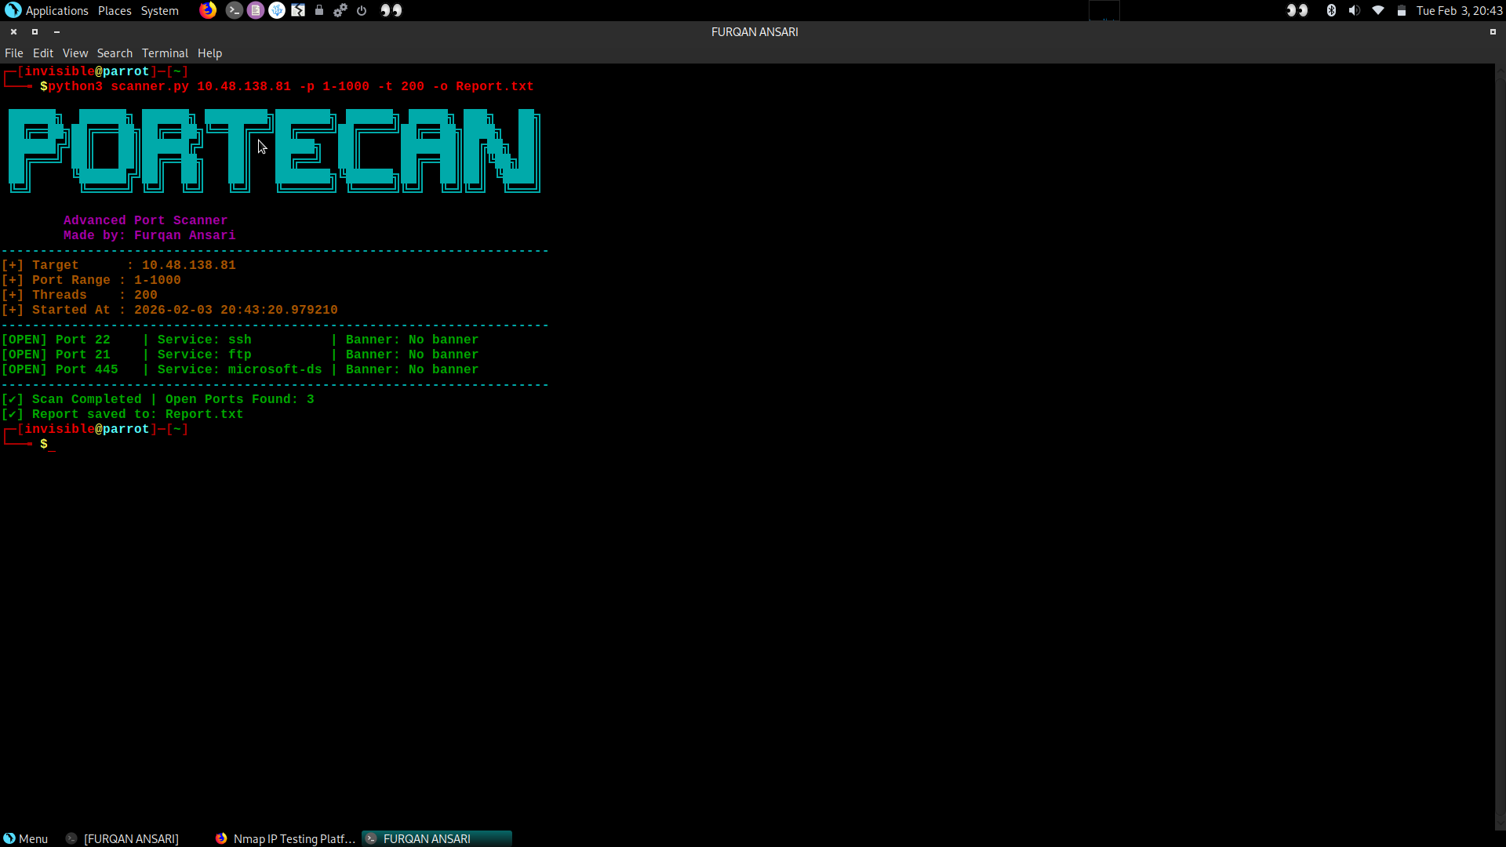

8. Ethical Considerations
All testing was performed strictly on authorized systems. No unauthorized scanning or malicious activity was conducted.

9. Conclusion
This project enhanced understanding of network reconnaissance, port scanning techniques, and ethical security practices.

10. Future Improvements
• Service version detection
• UDP port scanning
• Banner grabbing enhancement
• GUI-based interface

