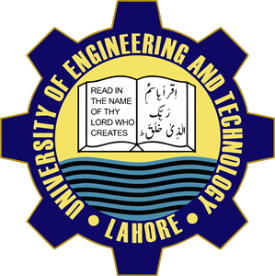 Student’s Information Form

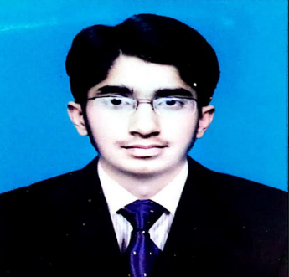Session 2022/1st Semester

Department of Computer Science

University of Engineering and Technology ,Lahore

1. Name: Muhammad Furqan

Tick one of the following

2. Gender: Male ✓ Female

3. Date of Birth: 2-12-2022 Age:19 Years 2 Months 12

4. Residence: Home # 39 ,Street # 47 ,Saleem Park ,Chah Miran ,Lahore

5. City: Lahore

6. Mobile: 0322-8553562

7. E-mail: [muhammadfurqanishaq0@gmail.com](mailto:muhammadfurqanishaq0@gmail.com)

8. Hobbies: Watching Islamic Historic Series

9. Favorite Movie: A Beautiful Mind

10. Favorite Book: Khaaq aur Khoon

Father/Guardian’s Info

Father/Guardian’s Name: Muhammad Ishaq

Father/Guardian’s Profession: Lawyer