## Final Year Project Management System



Session: 2021– 2025

**Submitted by:**

Muhammad Furqan Ishaq

2022R2021-CS-199

**Supervised by:**

Prof. Nazeef-ul-Haq

Department of Computer Science

**University of Engineering and Technology**

**Lahore Pakistan**

## Summary

The main purpose of this project was to understand the working of a database management system and the configuration of the database with a front-end by making a desktop-based Management System. A database schema was used provided by the supervisor, Mr.Nazeef-ul-Haq.

This system supports the management of students, advisors, projects, groups, and evaluations. And all of tese tasks are now automated and the only thing users need to do is enter data in the system and the rest will be managed by a database configured in our system.

## 1.Introduction

### Description:

The manangement of Final year project is done in every University. Where the Data of Student Evaluations are managed by hand on registers. Inserting ,Deleting and Managing data is so inefficient. Due to which there is a large chance of errors in that case there is need of a such a system which can automate the process. Computer Science Department of UET Lahore has a manual system and there is need to make a software application so that this process is done by desktop based application integrated with Database. In final year project management system the Application needs to maintain the students, groups and project, evaluations of those groups. The evaluations of each group is done by advisors. Student make a group of at least two students and a Advisor Board is Assigned to them which supervise there project. The board consists of Main Advisor , Co advisor and industry advisors.

The Main Advisor is the one who maintains manages , supervise, evaluates and leads the group. Where Co advisor and industry advisor Guides the group to make a life solving project. There are multiple evaluations of each group and this record help us in Final Evaluation.

Records are maintained according to the date a student is assigned to a group or the project is assigned to a group. Multiple group may work on same project similarly Same advisor can be assigned to multiple groups. The faculty added to the Advisor Data are according to there designation for example Assistant professor, Lecturer etc.

### Target Audience:

The target audience of this project is all the Universities where final year projects managed on paper. This desktop application will help them add students ,Advisors, Create groups and manage their evalations on anytime. An advisor can supervise multiple projects and evaluate them. Students are evaluted on group based and hence assigned equal marks.

## 2. Working

The management system is made for the single user which is most probably admin . Following are the details that the admin can : The Application is made for a single User who is Admin and manages all the System. Following are listed all the functionalities a user can perform.

1. The Admin can Add and Update all details of each Student.
2. Also just like Students user can add Advisors.
3. All listed projects will be added by admin and he will be able to update there title or discription.
4. Group will be created by admin and Assigned one of the projects.
5. Admin can Delete or remove a member from the group.
6. Evalutions of Each group will be taken by Admin and marks are added for each evalution.
7. Pdf Reports are Generated by Admin to have a look at the results of each group.

## 3. Database Design

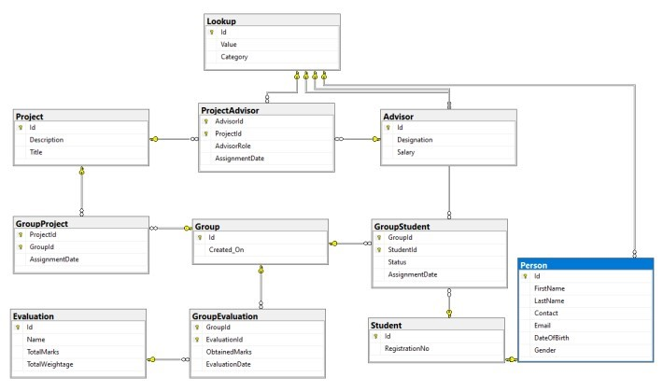

Figure : Database Design of System

### 3.1 Lookup

Lookup Table provided details about different table like gender of advisor, Student and Designation of Advisors and status of students in each group.

### 3.2 Person

Person consist of details that a student or advisor need. The person Id act as Key to Student and Advisor Table. The data of student is stored in the person table if student is deleted than its related information in person table is also deleted.

### 3.3 Student

Student table consist of student registration number and id through which it is linked to person table.

### 3.4 Group

Group contains information of its id and the date it is created on.

### 3.5 GroupStudent

Group student table has the information of the student which group it has joined and if he is still active in that group.

**3.6 Project**

This table has project id as primary key ,title and its description.

**3.7 GroupProject**

The Group Project consist of project id and id of group it i

**3.8 Evalaution**

Evaluations consists of id and total marks and its weightage.

**3.9 GroupEvaluation**

GroupEvaluations consists of obtained marks of each evaluation of a group.

### 3.10 Advisor

The advisor relation consists of the advisor’s designation and the salray. Id acts as the primary key of the relation. The designation is a foriegn key for the parent Lookup table.

### 3.11 ProjectAdvisor

Project Advisor table consists of advisor of that is assigned to each group. Along with there roles. The project and Advisor id act as primary key.

## 4. Graphic User Interface

### Student

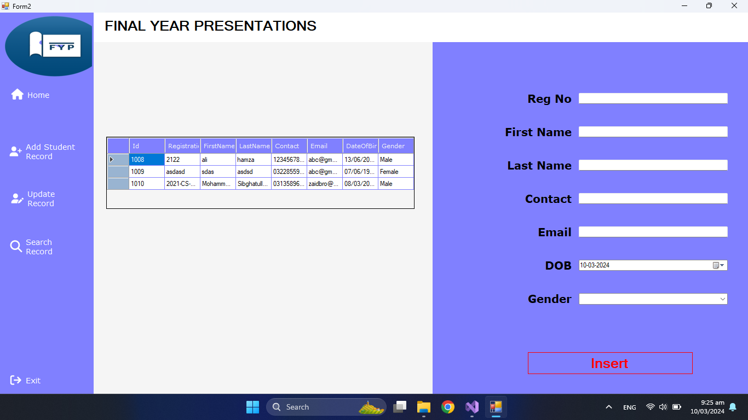

### Advisor

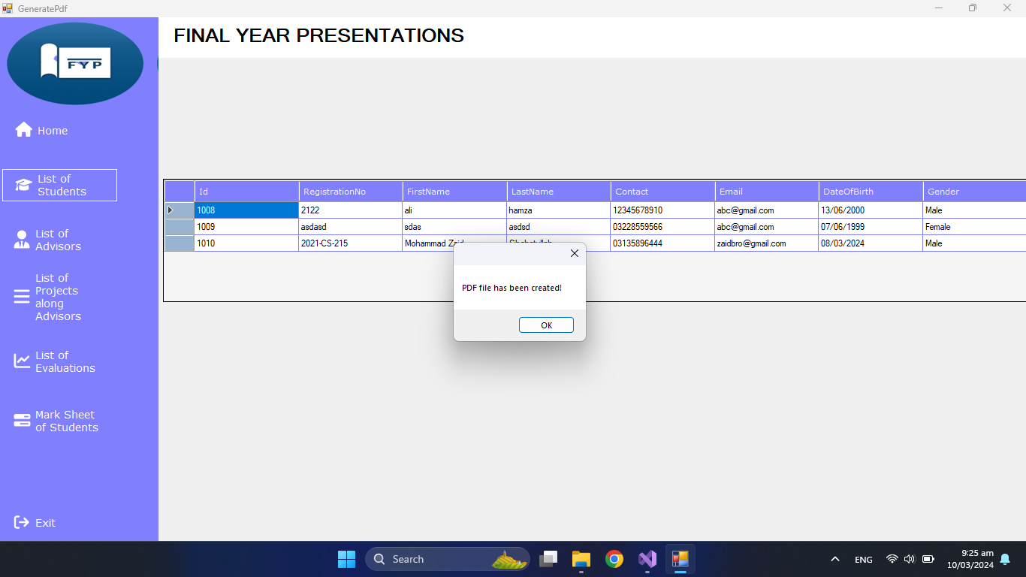

### Assign Project

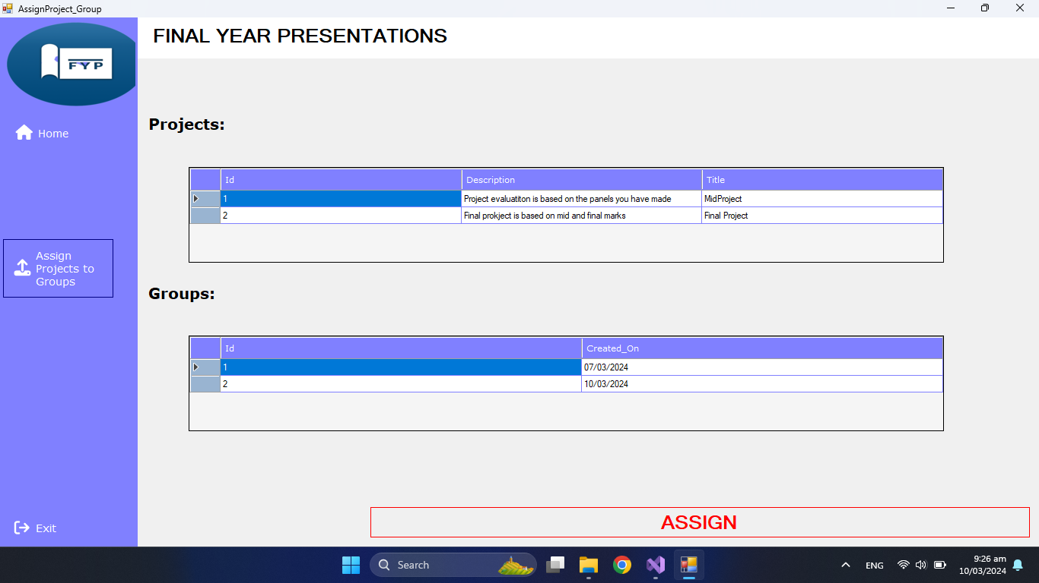

### Multiple Advisor

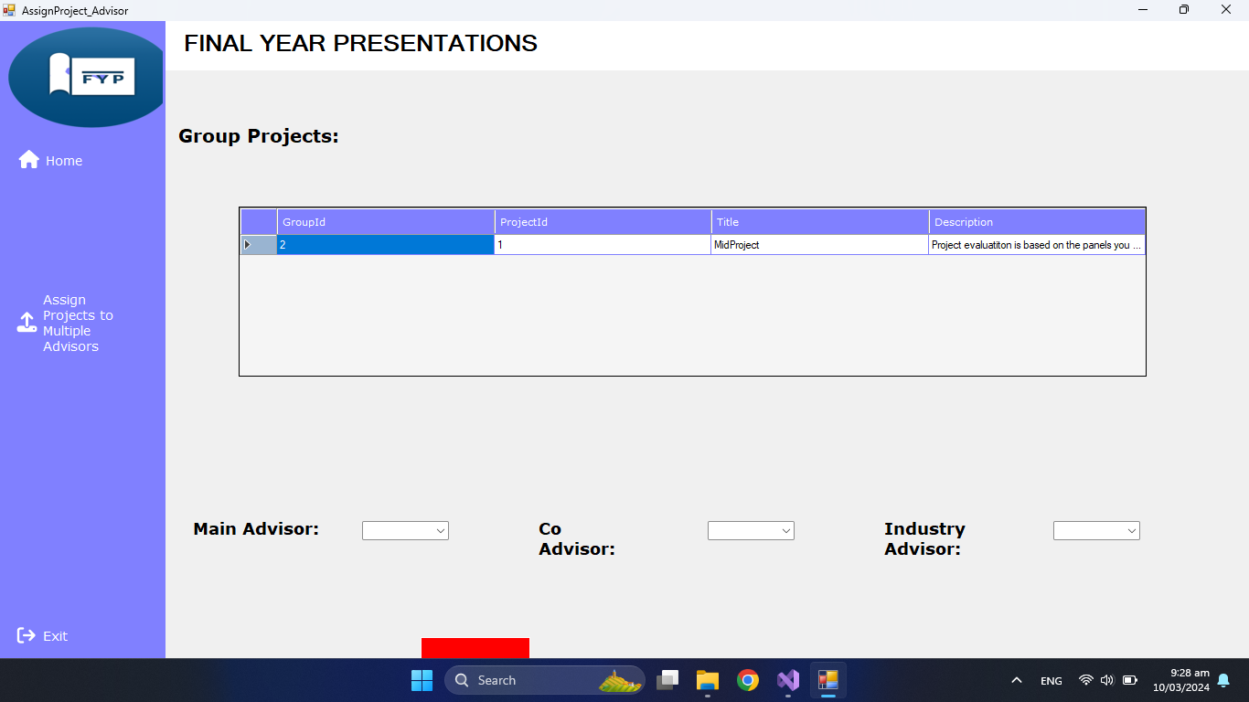

### Project

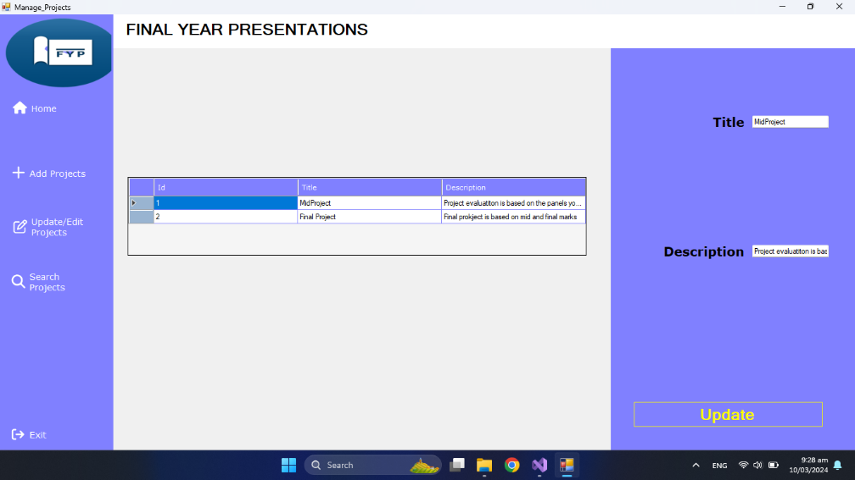

## 6. Limitations

The following are the limitations of the project:

1. The application is made for Single User who is admin and manages all the records.
2. The Data Entered by the admin is unable to delete in any way.

## 7. Conclusion

The Final Year Projects Management System made for DataBase Mangement system Lab for learning purpose provided great experience to learn and understand basics of DataBase and learn how database is used in real life. The poject help me understand storing and retrieving large amounts of data to change it using Graphic User Interface.