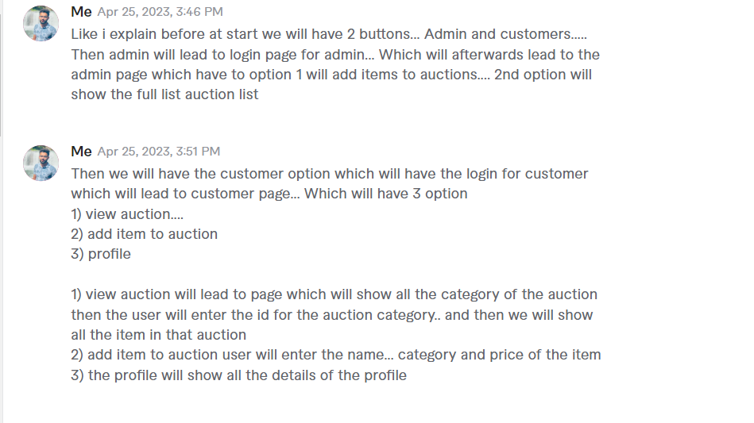

Admin bid option:

Will finalize biding……. after the button is clicked all the rows in order table which include the item name customer username and biding price will be called and then transfer into a dictionary where key is item name and value is list of [(customer username, bidding price)].

Highest value=0

Highest customer

Final_dict={}

For key in dict.keys():

Val=dict[key]

For j in range(0,len(val)-1):

X=val[j]

Y=val[j+1]

If float(x[1])>float(y[1]) and float(x[1])> highest value:

Highest customer=x[0]

Highest value=x[1]

Else if float(x[1])<float(y[1]) and float(y[1])> highest value:

Highest customer=x[0]

Highest value=x[1]

Finaldict[key]=(highest customer, highest value)

Check for all and calculate highest bider and then add that bider to the auction final table and remove all entries from order table

