Experiment

Ansari Mohammed Danish

*211208*

*Cloud Computing CSL605*

***Aim***: To study and Implement Infrastructure as a Service using AWS/Microsoft Azure.

# Theory:

To delve into studying and implementing Infrastructure as a Service (IaaS) using AWS or Microsoft Azure involves comprehending the core concepts and functionalities of these cloud computing platforms. AWS offers a wide array of services under its IaaS umbrella, including Amazon EC2 for virtual servers, Amazon VPC for networking, and Amazon S3 for storage, providing organizations with the building blocks to create flexible, scalable, and cost-effective IT infrastructure in the cloud. Similarly, Microsoft Azure's IaaS offerings encompass virtual machines, virtual networks, and storage solutions, empowering businesses to provision and manage computing resources on-demand and at scale. By leveraging AWS or Azure's IaaS capabilities, organizations can optimize resource utilization, enhance scalability, and improve agility by rapidly deploying and scaling infrastructure to meet evolving business needs.

Through hands-on exploration and implementation of IaaS on AWS or Azure, individuals and teams gain valuable insights into designing, deploying, and managing cloud-based infrastructure solutions. From setting up virtual machines and networks to configuring security policies and implementing high availability and disaster recovery strategies, practical experience with AWS or Azure IaaS services equips professionals with the skills needed to architect robust and resilient IT environments in the cloud. Moreover, understanding the automation and orchestration capabilities provided by tools like AWS CloudFormation and Azure Resource Manager enables organizations to streamline infrastructure deployment and management processes, driving operational efficiency and accelerating time to market for new projects and initiatives.

# OUPUT:

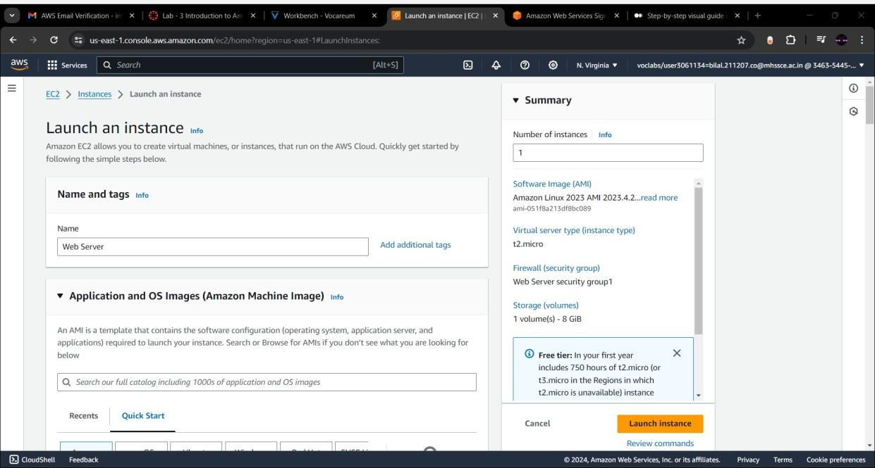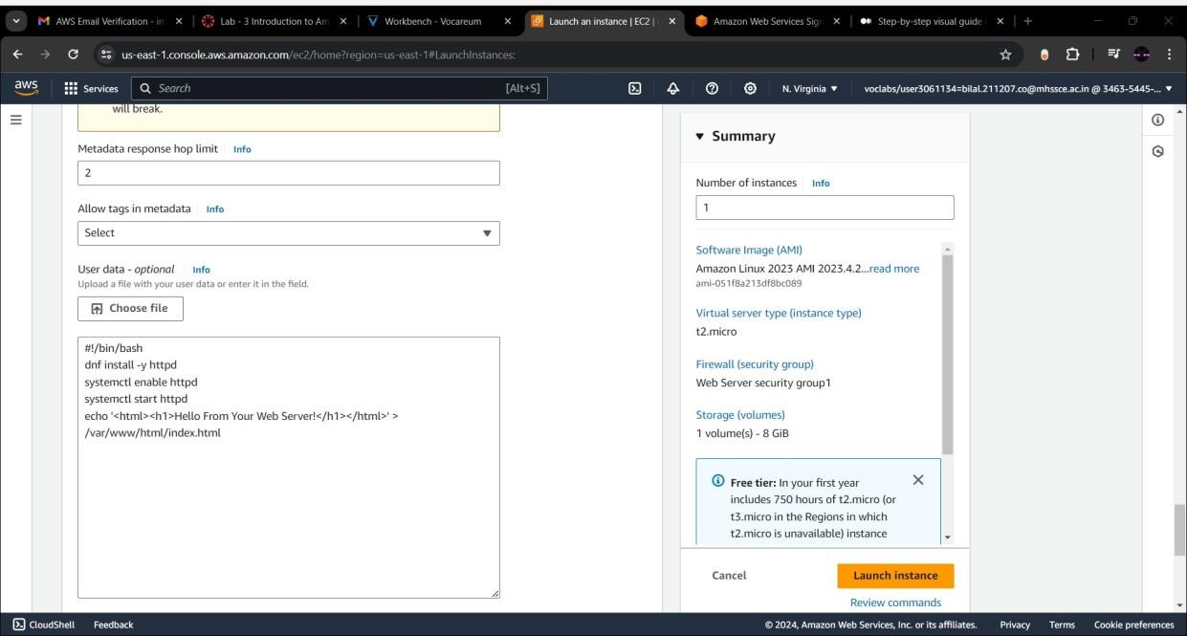

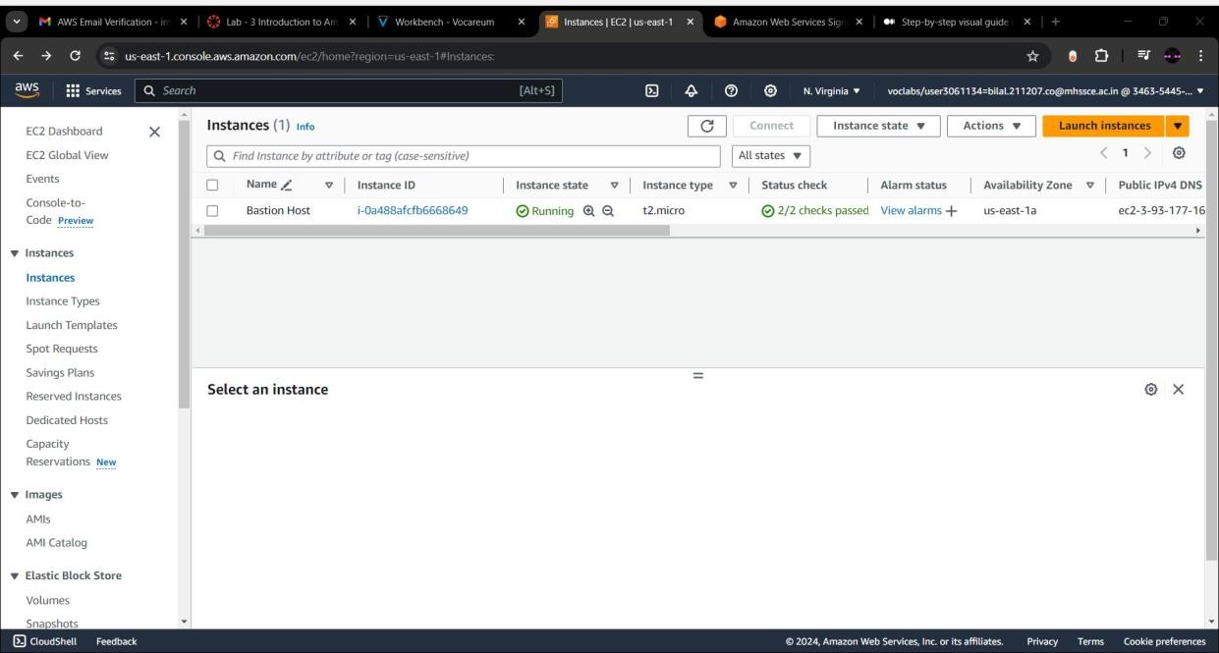

***Conclusion:*** We have successfully implemented IaaS (Infrastructure as a Service ) using EC2.