Experiment No 4

Ansari Mohammed Danish

*211208*

*Cloud Computing CSL605*

***Aim***: To study and Implement Storage as a Service using AWS S3, Glaciers/ Azure Storage.

# Theory:

To delve into studying and implementing Storage as a Service (STaaS) via AWS S3, Glacier, or Azure Storage requires a comprehensive grasp of their respective functionalities and advantages. Amazon S3 stands out as a cornerstone of cloud storage solutions, offering unparalleled scalability and durability for storing a vast array of data types. With features like versioning, encryption, and flexible storage classes, S3 caters to diverse needs, from serving as a repository for website assets to housing critical backups. Glacier, as an extension of S3, specializes in long-term archival with cost-efficient storage options, ensuring data retention compliance and facilitating seamless retrieval through its tiered storage model. Meanwhile, Azure Storage provides a robust ecosystem encompassing Blob, Queue, and File storage services, empowering businesses with scalable and resilient storage solutions tailored to their specific requirements.

By embarking on the journey of studying and implementing STaaS using AWS S3, Glacier, or Azure Storage, organizations unlock a realm of possibilities in managing their data assets effectively in the cloud. Through meticulous examination and hands-on experience with features like data lifecycle management, cross-region replication, and integration with other cloud services, businesses can optimize their storage strategies to align with scalability, reliability, and cost-effectiveness. Moreover, harnessing the power of these cloud storage platforms facilitates seamless collaboration, data sharing, and disaster recovery, enabling organizations to stay agile and competitive in today's dynamic digital landscape.

# OUPUT:

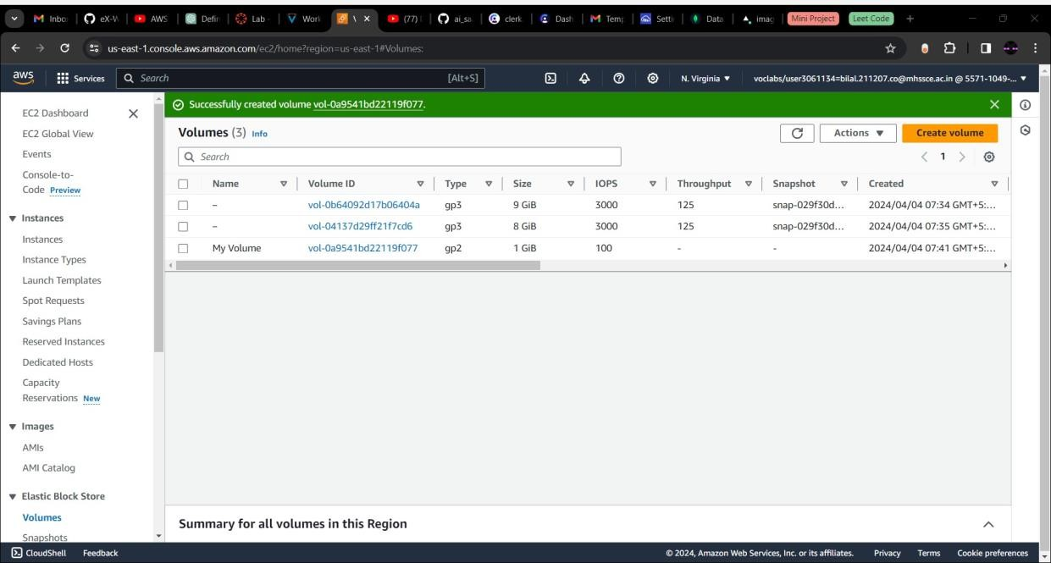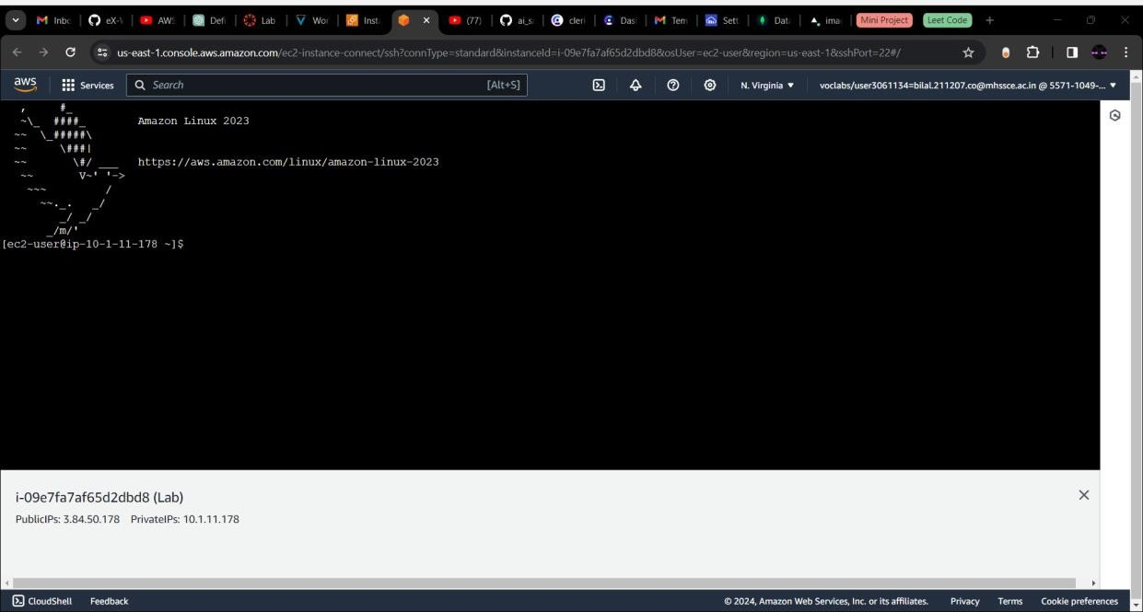

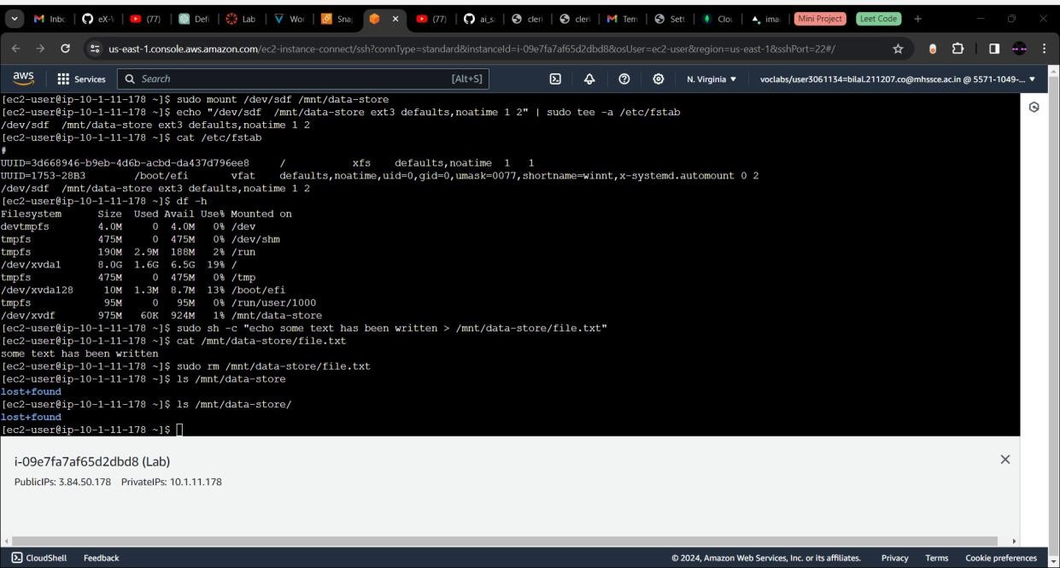

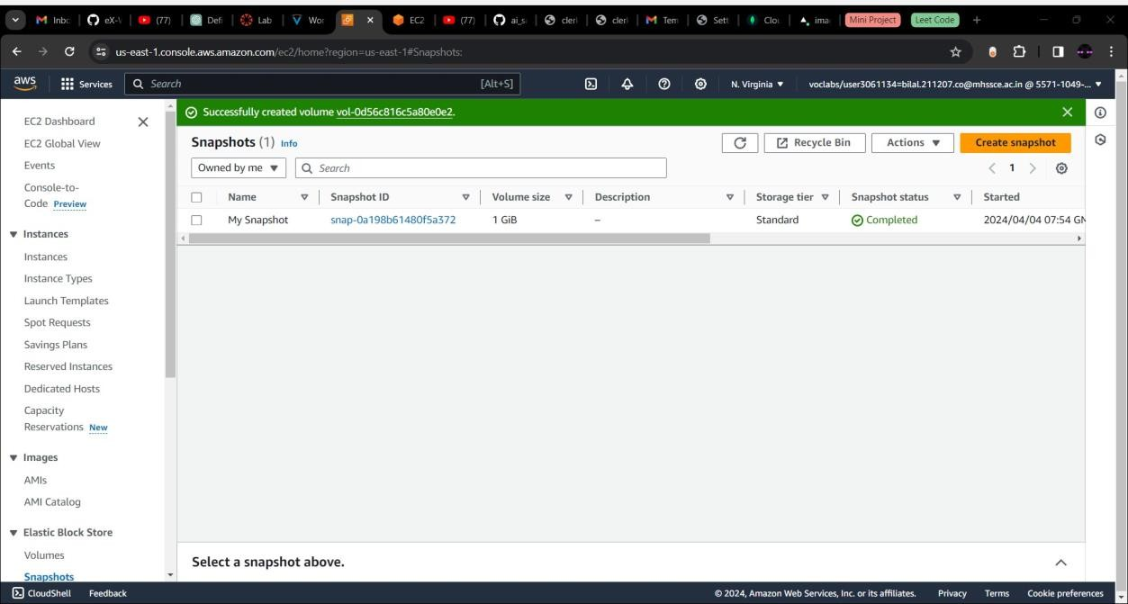

***Conclusion:*** We have successfully implemented S3.