The break statement is used to exit the loop **immediately.**

**Example-**

for i in range(1, 6): # Loops from 1 to 5

if i == 3:

break # Exit the loop when i equals 3

print(i)

# Output:

# 1

# 2

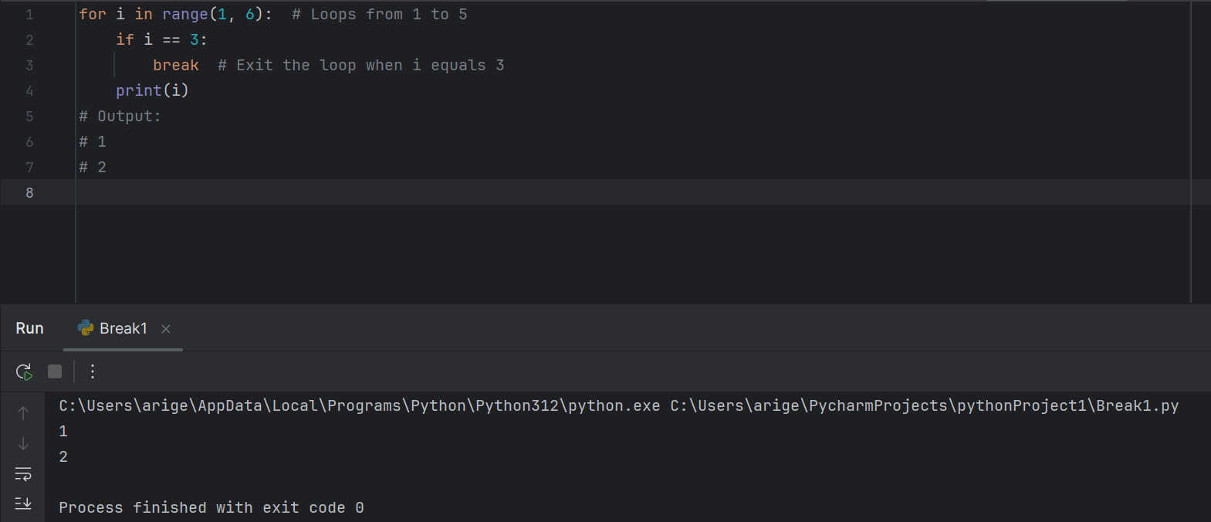

The continue statement skips the **current iteration** of the loop and moves to the next iteration.

**Example** –

