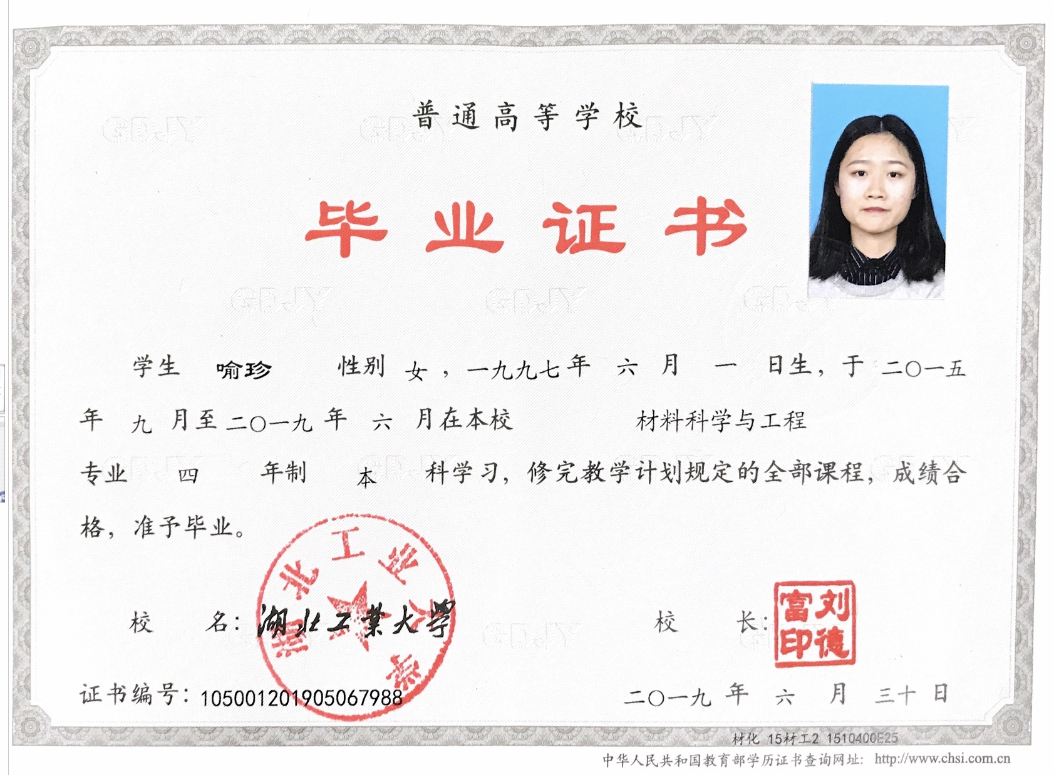

CERTIFICATE FOR GRADUATION
HUBEI UNIVERSITY OF TECHNOLOGY
Certificate No:105001201905067988
This is to certify that Yu Zhen, female, born on June 1,1997, majoring in Materials Science and Engineering of this university from September 2015 to June 2019, has successfully fulfilled all curriculums of the Four-year undergraduate program of study, and passed the examinations. Hereby she is allowed to graduate.

President:Liu Defu

Hubei University of Technology
Issued Date: June 30,2019

注：上传利用人证书，内容仅修改红色部分
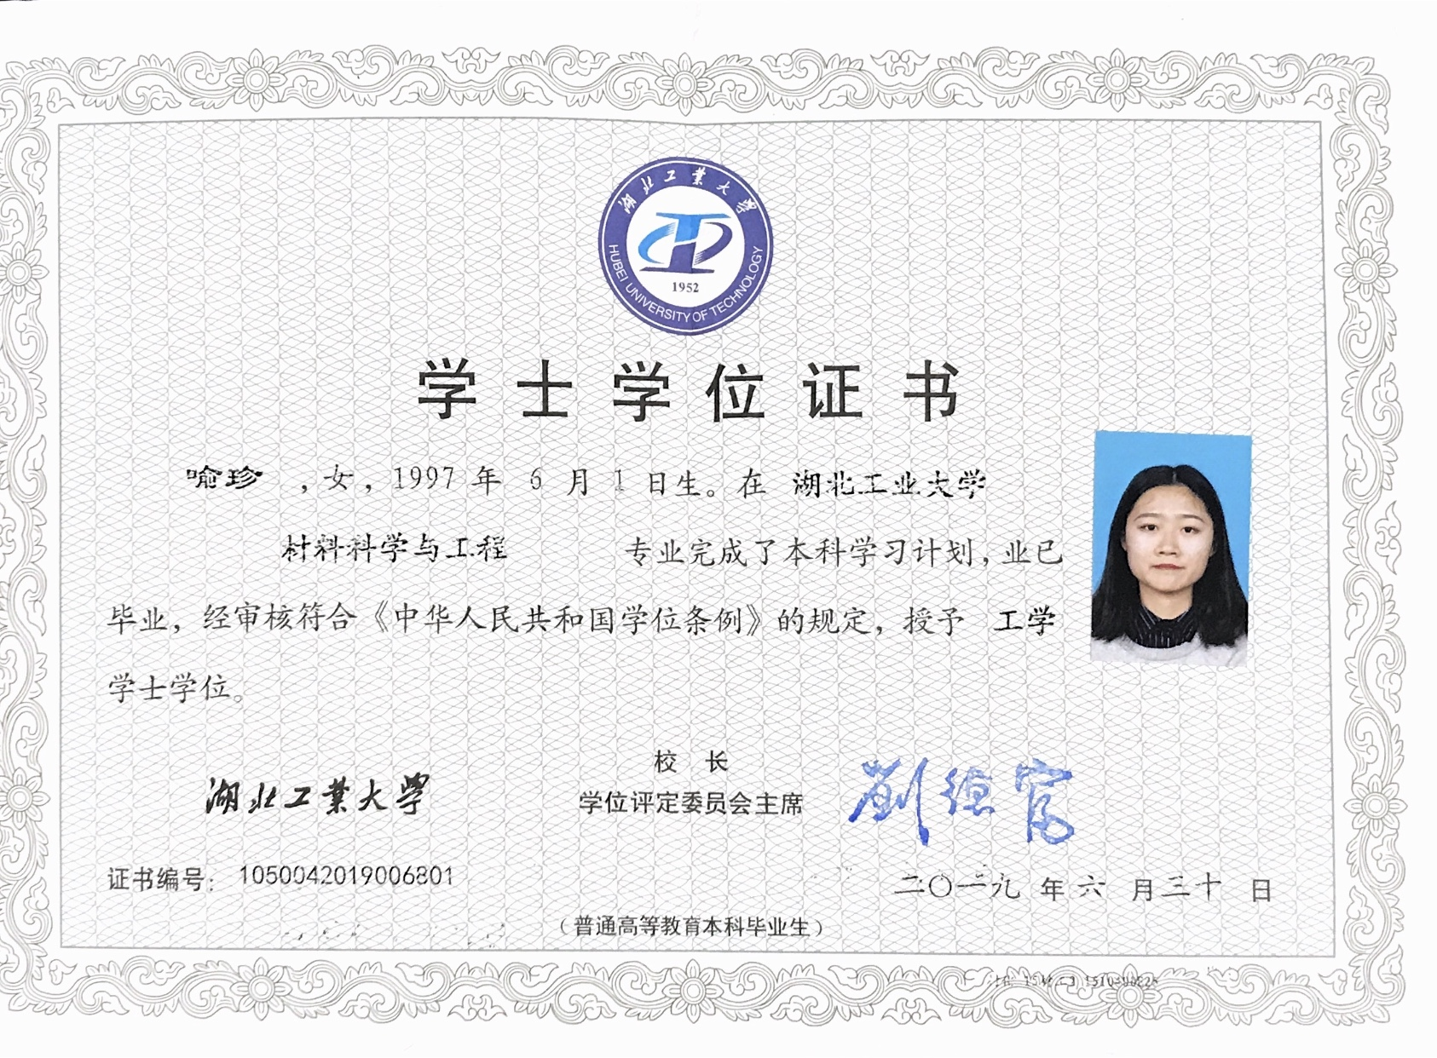

CERTIFICATE FOR THE BACHELOR'S DEGREE
Certificate No: 1050042019006801
This is to certify that Yu Zhen, female, born on June 1,1997, majoring in Materials Science and Engineering of this university, has successfully fulfilled all curriculums of the Four-year undergraduate program of study, and has graduated.
Upon the examination and verification in conformity with the Regulations of Academic Degrees of the People's Republic of China, she is thereby granted the Bachelor’s Degree of Engineering.

President of Hubei University of Technology:Liu Defu
Chairman of Degree Evaluation Committee: Liu Defu
Issued Date: June 30, 2019

