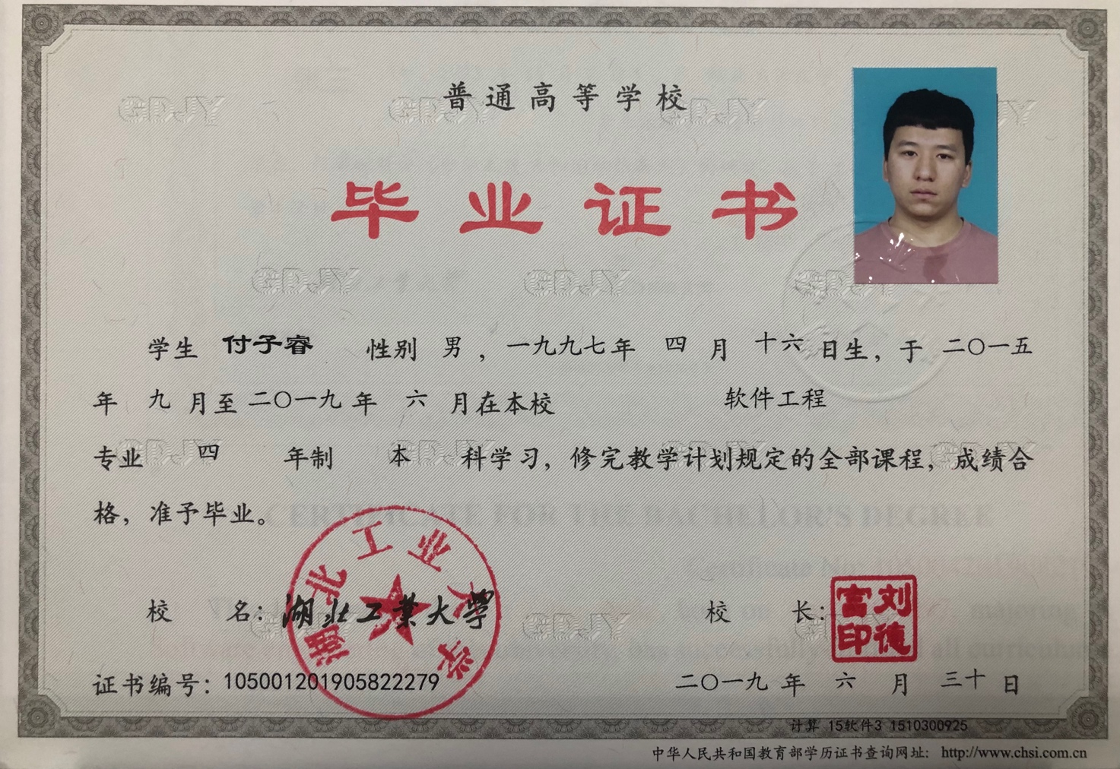

## CERTIFICATE FOR GRADUATION

**HUBEI UNIVERSITY OF TECHNOLOGY**

Certificate No: 105001201905822279

This is to certify that Fu Zirui, male, born on April 16,1997, majoring in Software engineering of this university from September 2015 to June 2019, has successfully fulfilled all curriculums of the Four-year undergraduate program of study, and passed the examinations. Hereby he is allowed to graduate.

President:Liu Defu

# **Hubei University of Technology**

Issued Date: June 30,2019

注：上传利用人证书，内容仅修改红色部分

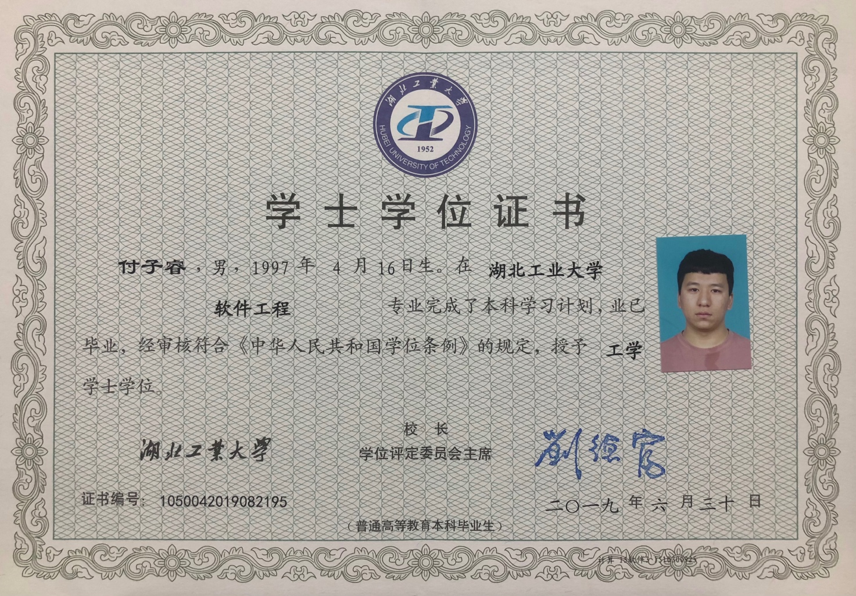

**CERTIFICATE FOR THE BACHELOR'S DEGREE**

Certificate No: 1050042019082195

This is to certify that Fu Zirui, male, born on April 16,1997, majoring in Software engineering of this university, has successfully fulfilled all curriculums of the Four-year undergraduate program of study, and has graduated.

Upon the examination and verification in conformity with *the Regulations of Academic Degrees of the People's Republic of China,* he is thereby granted the Bachelor’s Degree of Engineering.

# President of Hubei University of Technology: Liu Defu

# Chairman of Degree Evaluation Committee: Liu Defu

Issued Date: June 30, 2016