PDFexample

Matthew Rada

2024-08-21

This is a tutorial on how to use a R markdown for reproducible research.

Here we can type long passages or descriptions of our data without the need of “hashing” out our comments with the # symbol.

In our first example, we will be using the tooth growth dataset.

In this experiment, guinea Pigs (literal) were given different amounts of vitamin C to see the effects on the animal’s tooth growth.

To run R code in a markdown file, we need to denote the section that is considered code.

We call these sections “code chunks”.

Below is a code chunk:

Toothdata <- ToothGrowth  
  
head(Toothdata)

## len supp dose  
## 1 4.2 VC 0.5  
## 2 11.5 VC 0.5  
## 3 7.3 VC 0.5  
## 4 5.8 VC 0.5  
## 5 6.4 VC 0.5  
## 6 10.0 VC 0.5

As you can see, from running the play button on the code chunk, the results are printed inline of the r markdown file.

fit <- lm(len ~ dose, data = Toothdata)  
  
b <- fit$coefficients  
  
plot(len ~ dose, data = Toothdata)  
  
abline(lm(len ~ dose, data = Toothdata))

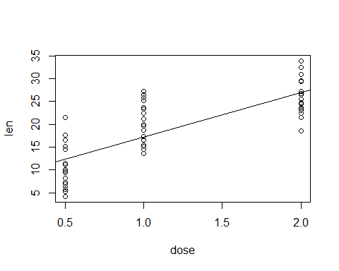

Figure 1: The tooth growth of Guinea Pigs when given variable amounts of vitamin C.

The slope of the regression line is 9.7635714.

# Section Headers

We can also put sections and subsections in our r markdown file. Similar to numbers or bullet points in a word document. This is done with the “#” that we previously used to denote text in an R script.

# First level header

## Second level header

### Third level header

#Make sure that you put a space after the hashtag, or header will not appear.

We can also add bullet point-type marks in our r markdown file.

* one item
* one item
* one item
  + one more item
  + one more item
    - one last item

Its important to note here that in R markdown indentation matters!

1. First Item
2. Second Item
3. Third Item
4. subitem 1
5. subitem 2
6. subitem 3

## Block Quotes

We can put really nice qoutes into the markdown document. We do this by using the “>” symbol.

“Genes are like the story and DNA is the language that the story is written in.”

— Sam Kean

## Hyperlinks

Hyperlinks can also be incorporated into these files. This is especially useful in HTML files, since they are in a web browser and will redirect the reader to the material that you are interested in showing them. Here we will use the link to our r markdown’s homepage for this example. [RMarkdown](https://rmarkdown.rstudio.com)

## Formulas

We can also put nice formated formulas into Markdown using two dollar signs.

Hard-Weinberg Formula

$$p^{2}+2pQ+q^{2}=1$$

And you can get really complex as well!

$$Θ=\left(\begin{matrix}α & β \\ γ & δ\end{matrix}\right)$$

Google: LaTex - cheatsheets for formulas

# Code Chunks

## Code chunk options

There are also options for your r markdown file on how knitr interpret the code chunk. There are the following options:

Eval (T or F): whether or not to evaluate the code chunk.

Echo (T or F): Whether or not to show the code for the chunk, but results will still print.

Cache: If enable, the same code chunk will not be evaluated the next time knitr is run. This is great for code that has long run times.

fig.width or fig.height: the (graphical device) size of the R plots in inches. The figures are first written to the knitr document then to files that are saved separately.

out.width or out.height: the output size of the R plots in the R document.

fig.cap: the words for the figure caption

## Table of Contents

We can also add a table of contents to our HTML Document. We do this by altering the YAML code (the weird code chunk at the VERY top of the document.) We can add this:

title: “HTMLtutorial” author: “Matthew Rada” date: “2024-08-19” output: html_document: toc: true toc_float: true

This will give us a very nice floating table of contents on the left hand side of the document.

## Tabs

You can also add TABS in our report. To do this, you need to specify each section that you want to become a tab by placing “{.tabset}” after the line. Every subsequent header will be a new tab.

## Themes

You can also add themes to your HTML document that change the highlighting color and hyperlink color of you html output. This can be nice aesthetically. To do this, you change your theme in the YAML to onf the following:

* cerulean
* journal
* flatly
* readable
* spacelab
* united
* cosmo
* lumen
* paper
* sandstone
* simplex
* yeti
* null

You can also change the color by specifying highlight:

* default
* tango
* payments
* kate
* monochrome
* espresso
* zenburn
* haddock
* textmate

## Code folding

You can also use the code folding to allow the reader to toggle between displaying the code and hiding the code. This is done with:

code_folding: hide

## Summary

There are a TON of options and ways for you to customize your R code using the HTML format. This is also a great wayt to display a “portfolio” of your work if you are trying to market yourself to interested parties.

# SHARE YOUR WORK IN RPUBS!!!

[Rpubs](https://rpubs.com) - Press publish after knitting on the top right.