Plans

This is an informal document for shorthand planning with regards to implementations of features

Slope verification

Ran into an issue with the current implementation; some walls will be resolved by the slope check as slopes rather than walls due to the resultant angle

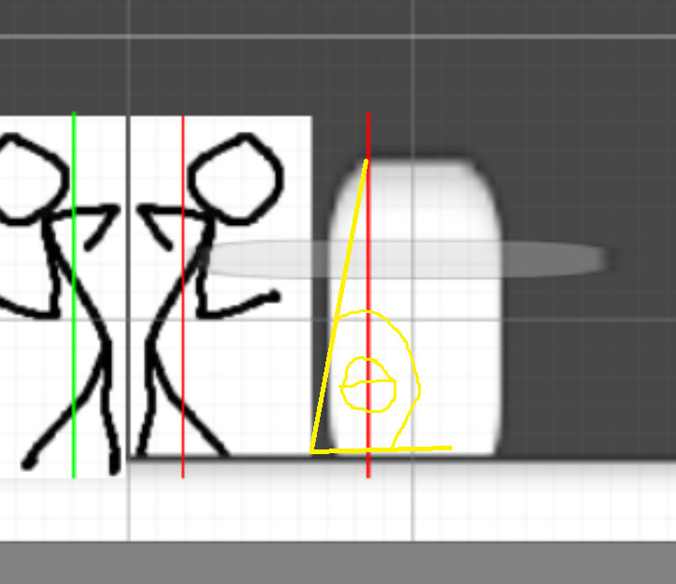

Possible solutions:

1. As shown below, implementation of “min check”. This is a point check on the perimeter point where a ray cast from the origin of either side of the player’s foot collides with the box. For example, a ray cast at 75 degrees from the origin point will result in a point closer to the player’s body, but a ray cast at 15 degrees from the origin point will result in a point closer to the ground. This is to ensure the check is not too far in front of the player such that what is right in front of the player is missed and not too far from the ground that a small piece of geometry is not checked. This also ensures a different piece of geometry in the distance is not checked.

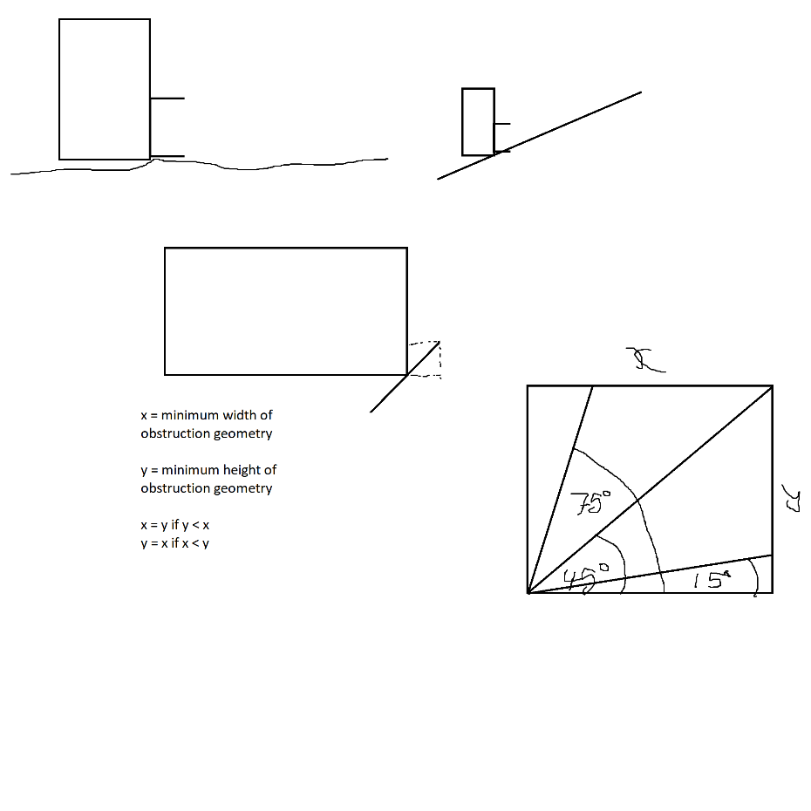

Modularise slope verification

At the moment, the code for slope verification is contained within the movement code in ActorControls. This makes it so that replicating the necessary checking behaviour requires imitation or code copying.

Solutions:

1. Separate out the slope check algorithm to a non-virtual function that can be called by all its descendants.