**Methods. S1 A new method to segment plant organ**

The new method combines the region growing method with the skeleton extraction method which is used as a reference to obtain point clouds belonging to leaves. Firstly, the denoised point clouds of each plant was processed with a Laplacian based method (Cao *et al.*, 2010) to generate plant skeleton points, a connectivity matrix of skeleton points and an incidence matrix between point clouds and skeleton points (Fig. 2A). Secondly, a region growing algorithm (Rabbani *et al.*, 2006) was used to divide point clouds into clusters (Fig. 2D) according to the curvatures and angles of the normal vectors changing along the organ surface.

The plant organ segmentation includes three parts, i.e., leaf skeleton extraction, classification of point cloud clusters and unclassified cluster merging. The following paragraphs show the three parts respectively.

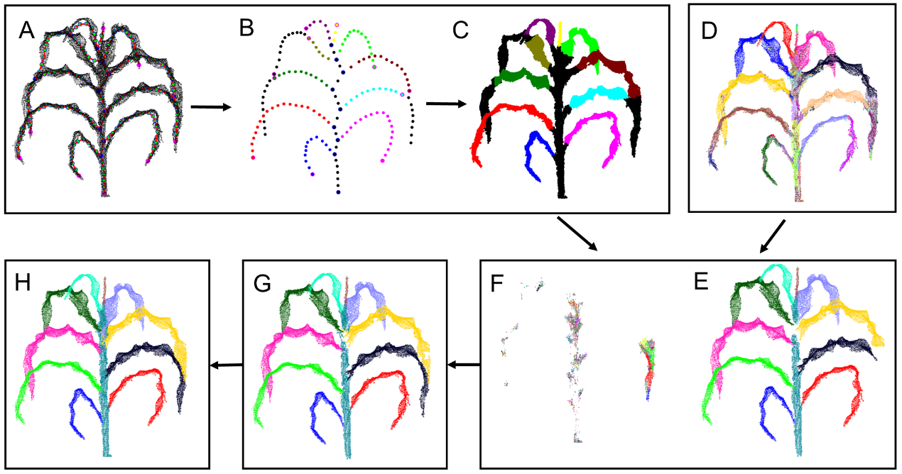

Fig. 2 A pipeline of *Zea mays* plant organ segmentation. The plant point clouds of A619 at 37 DAS were transferred to a skeleton by a Laplacian based method (a) and clusters based on the region growing method (d). Leaf skeletons (b) were extracted from the plant skeleton. Reference leaf point clouds (c) were obtained from the plant point clouds according to the leaf skeletons. According to reference leaf point clouds and angles between clusters and stem direction, small clusters (d) were classified to organ point clouds (e) and unclassified point clouds. The unclassified point clouds were classified into clusters by the region growing method (f). The larger clusters from unclassified point clouds were merged into organ point clouds (g) according to the similarity of normal and curvature of points between the larger cluster and neighbouring organ point clouds. Finally, the remaining clusters were merged into organ point clouds by a Euclidean distance-based method (h).

**Part 1. Leaf skeleton extraction**

The details of the leaf skeleton extraction (Fig. 2B) include five main steps:

1) Plant skeleton rotation. The plant skeleton was rotated to a vertical plane. The rotated angle was determined by the main direction of plant point clouds in the horizontal plane. The main direction was estimated by the PCA (Principal Component Analysis) algorithm.

2) Skeleton points classification. Skeleton points were classified into three different types: root points which are connected with only one other skeleton point, normal points which are connected with two other skeleton points, or junction points which are connected with more than three other skeleton points.

3) Extraction of junction points between a stem and a leaf. First, the lowest root point was regarded as the base of a stem, and points within 5 cm horizontal distance from the base of the stem were used to fit a line. Then, the distance between each junction point and the line was calculated, and a distance 3.5 times the median distance was used as a threshold to remove the outlier junction points. Finally, the shortest path between the base of the stem and the top junction point was calculated with the Dijkstra method (Dijkstra, 1959), and those junction points in the path were the junction points between the stem and each of the leaves.

4) Correction of root points in leaves. The outlier junction point was resulted from the overlap between two leaves and was obtained by the previous steps. The nearest root point of the outlier junction point and the path from the nearest root point to the outlier junction point were found by comparing the path length from the outlier junction point to root points based on the Dijkstra method. Then, the normal points that were connected with the outlier junction point and not in the path from the outlier junction point to the nearest root points were transferred to new root points, and the nearest root point was changed to a normal point. These new root points were only connected with the points that were not in the path. For each outlier junction point, the above process was applied.

5) Extraction of leaf skeleton. For each root point that is not in the stem, the shortest path from the root point to a junction point in the stem was calculated using the Dijkstra method (Dijkstra, 1959). All these paths were leaf skeletons, and they were separated for each leaf.

**Part 2. Classification of point cloud clusters**

After leaf skeletons were obtained, the point clouds of a leaf (Fig. 2C) was obtained based on the skeleton of the leaf and the incidence matrix between the point clouds and skeleton points. The point clouds of all leaves in a plant were used as a reference to classify the clusters of points, which was generated from the region growing method, into different leaves. The process of classification includes two main steps:

1. Classification of point clouds in leaves. First, the overlap relationship between the reference leaf point clouds and the clusters was calculated. Second, if the cluster intersects with two reference leaf point clouds, the region growing method with a smaller threshold is conducted for the cluster to generate several sub-clusters until each of the sub-clusters only intersects with one reference leaf point cloud data. Third, leaf point clouds were generated by merging the intersected clusters into reference leaf point clouds.
2. Classification of point clouds in the stem. Angles between the stem direction and the main directions of the remaining clusters estimated by PCA were calculated. Clusters with an angle of fewer than 10 degrees were regarded as possible stem point clouds. Outliers in these clusters were removed with *pcsegdist* function according to a Euclidean distance threshold (5 cm). The remaining point clouds were stem point clouds.

**Part 3. Unclassified clusters merging**

Unclassified clusters (Fig. 2F) were merged into organ point clouds (Fig. 2F) in 3 main steps.

1. The unclassified clusters were categorized into two classes, i.e., small clusters with 20 or fewer points and big clusters with more than 20 points.
2. Classification of the big clusters (Fig, 2G). The first and second nearest organ point clouds of a big cluster were found according to Euclidean distance. The 20 points closest to the big cluster from the two organ point clouds and 20 closest points to the selected organ point clouds from the big cluster were used to compare the similarity of mean curvatures and mean normal directions of the points. The big cluster was merged into the high-similarity organ.
3. Classification of the small clusters (Fig, 2H). Small clusters (cluster points) were merged into organ point clouds through a Euclidean distance-based method (Zhu *et al.*, 2020). The mean Euclidean distance between the cluster points and the first and second nearest organ point clouds was calculated. The distances between the cluster points and the planes fitted by the K-nearest neighbours' points in the first and second nearest organ point clouds were also calculated. Both these two distances were used to classify the cluster points.

**Reference**

**Cao J, Tagliasacchi A, Olson M, Zhang H, Su Z**. 2010. Point cloud skeletons via laplacian based contraction. *2010 Shape Modeling International Conference*: IEEE, 187-197.

**Dijkstra EW**. 1959. A note on two problems in connexion with graphs. Numerische mathematik **1**, 269-271.

**Rabbani T, Van Den Heuvel F, Vosselmann G**. 2006. Segmentation of point clouds using smoothness constraint. International archives of photogrammetry, remote sensing and spatial information sciences **36**, 248-253.

**Zhu C, Miao T, Xu T, Yang T, Li N**. 2020. Stem-leaf segmentation and phenotypic trait extraction of maize shoots from three-dimensional point cloud. arXiv preprint arXiv:2009.03108.