**Assignment**

**1.Jenkins Introduction & steps of Jenkins Installation**

**Step 1: Setup wizard:**

On opening the Windows Installer, an **Installation Setup Wizard** appears, Click **Next** on the Setup Wizard to start your installation.

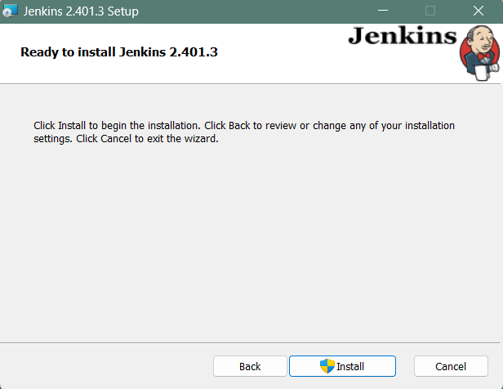

**Step 2: Select destination folder:**

Select the destination folder to store your Jenkins Installation and click **Next** to continue.

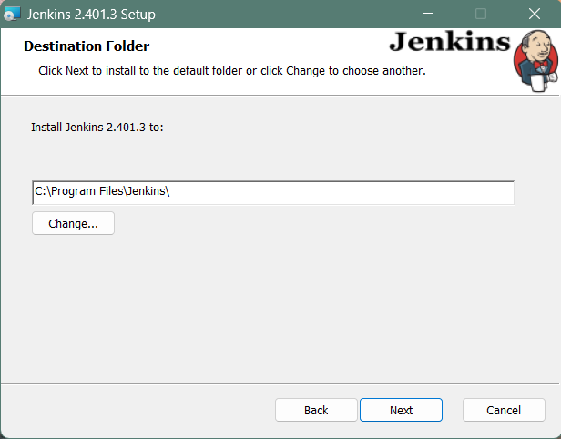

**Step 3: Service logon credentials**

When Installing Jenkins, it is recommended to install and run Jenkins as an independent windows service using a **local or domain user** as it is much safer than running Jenkins using **LocalSystem(Windows equivalent of root)** which will grant Jenkins full access to your machine and services.

To run Jenkins service using a **local or domain user**, specify the domain user name and password with which you want to run Jenkins, click on **Test Credentials** to test your domain credentials and click on **Next**.

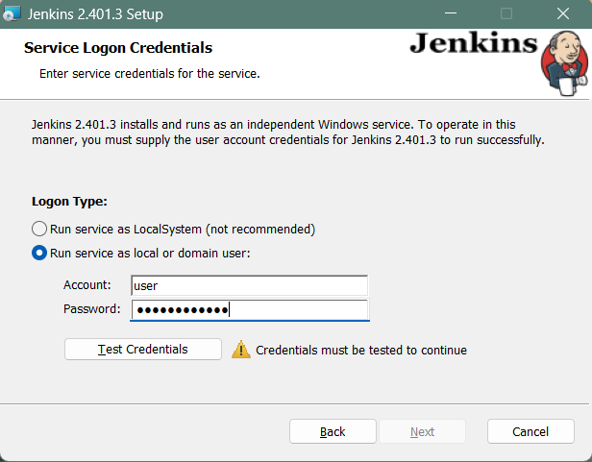

**Step 4: Port selection**

Specify the port on which Jenkins will be running, **Test Port** button to validate whether the specified port if free on your machine or not. Consequently, if the port is free, it will show a green tick mark as shown below, then click on **Next**.

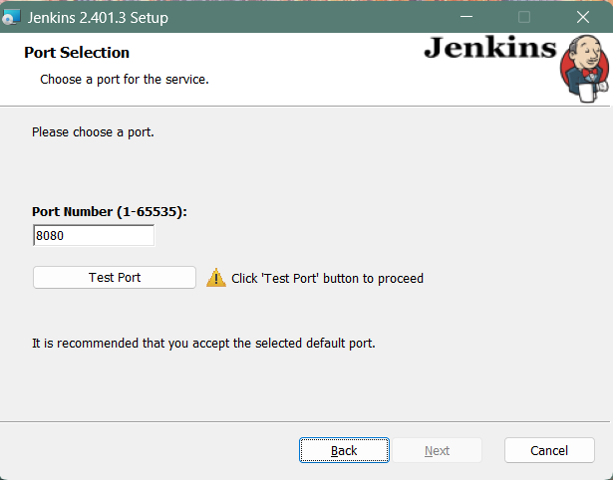

**Step 5: Select Java home directory**

The installation process checks for Java on your machine and prefills the dialog with the Java home directory. If the needed Java version is not installed on your machine, you will be prompted to install it.

Once your Java home directory has been selected, click on **Next** to continue.

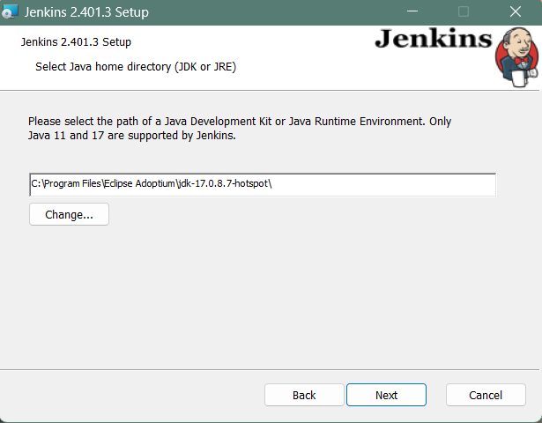

**Step 6: Custom setup**

Select other services that need to be installed with Jenkins and click on **Next**.

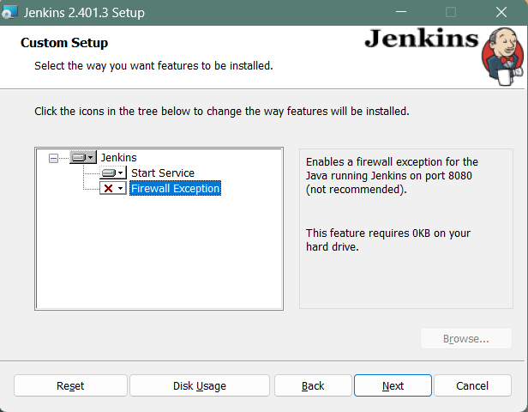

**Step 7: Install Jenkins**

Click on the **Install** button to start the installation of Jenkins.

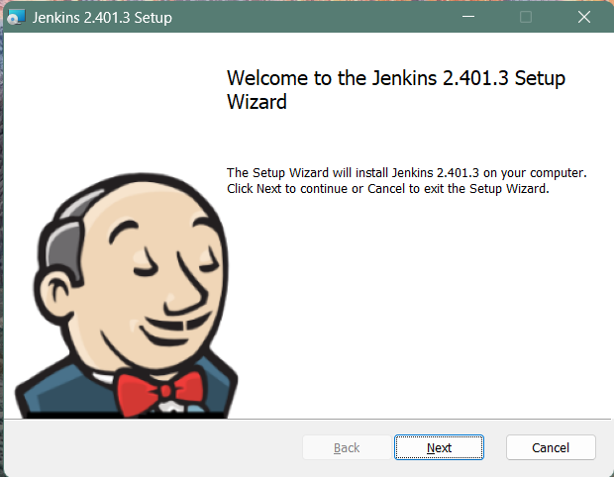

Additionally, clicking on the **Install** button will show the progress bar of installation, as shown below:

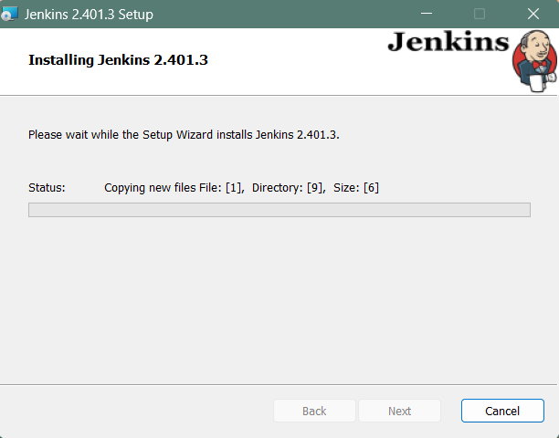

**Step 8: Finish Jenkins installation**

Once the installation completes, click on **Finish** to complete the installation.

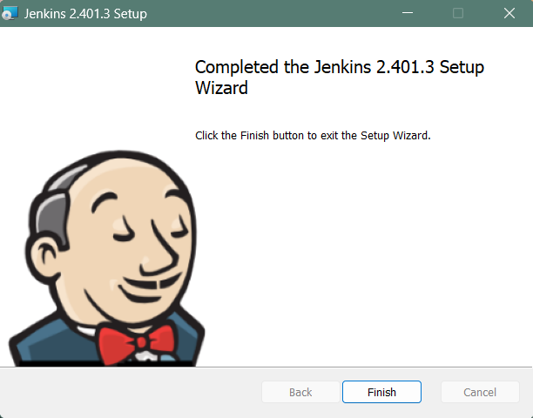

Jenkins will be installed as a **Windows Service**. You can validate this by browsing the **services** section, as shown below:

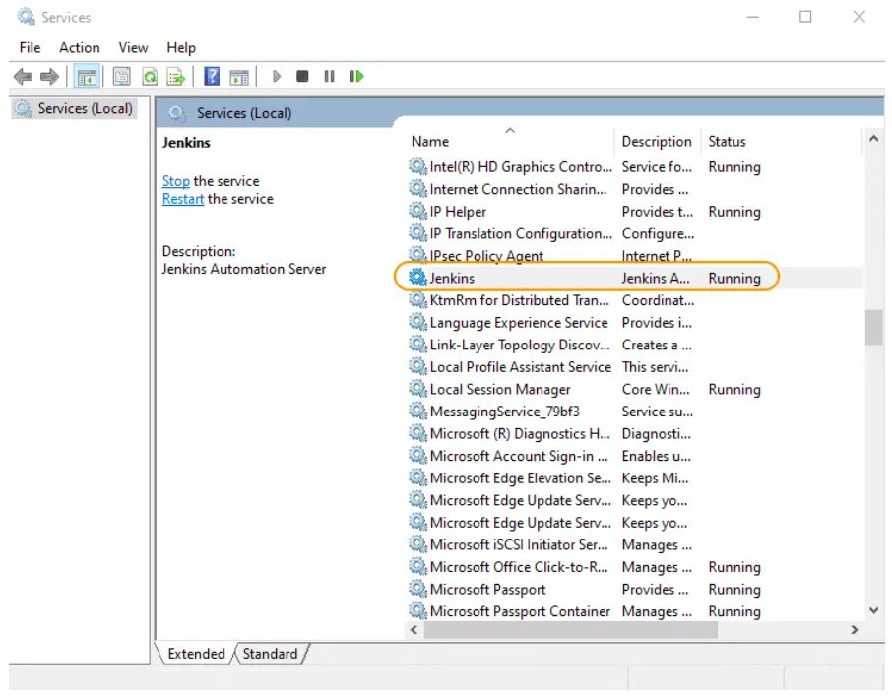

**2.Jenkins – build and deploy a web application to a local HTTP server**

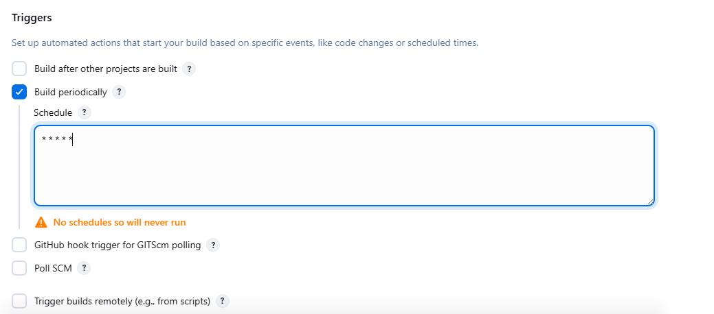

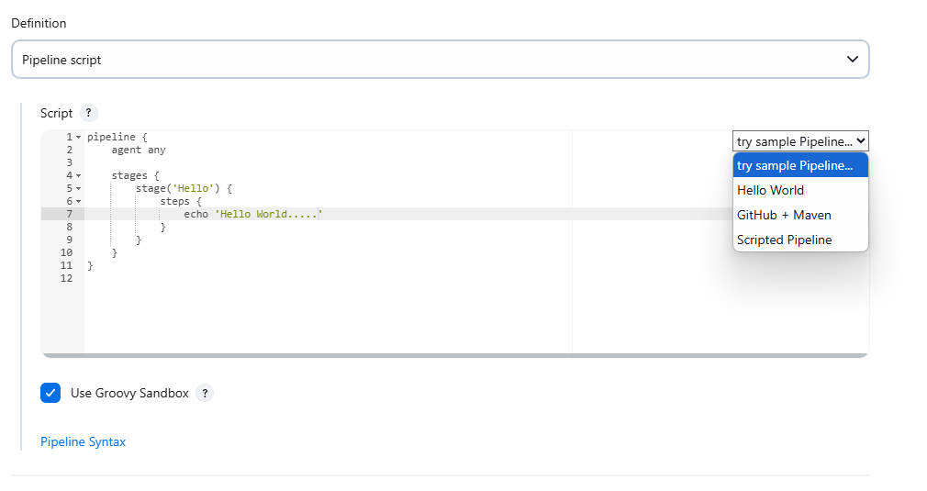

**Pipeline Script**

pipeline {

agent any

stages {

stage('Hello') {

steps {

echo 'Hello World.....'

}

}

stage('Build'){

steps{

echo 'Building the project....'

}

}

stage('Deploy'){

steps{

echo 'Deploying the application....'

}

}

}

post{

success{

echo 'Pipeline completed successfully!'

}

failure{

echo "Pipeline failed!"

}

}

}

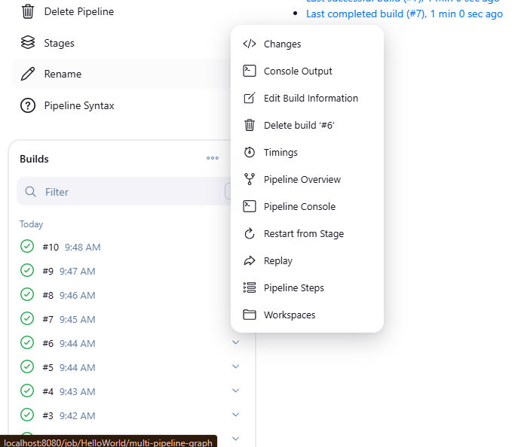

**Output:**

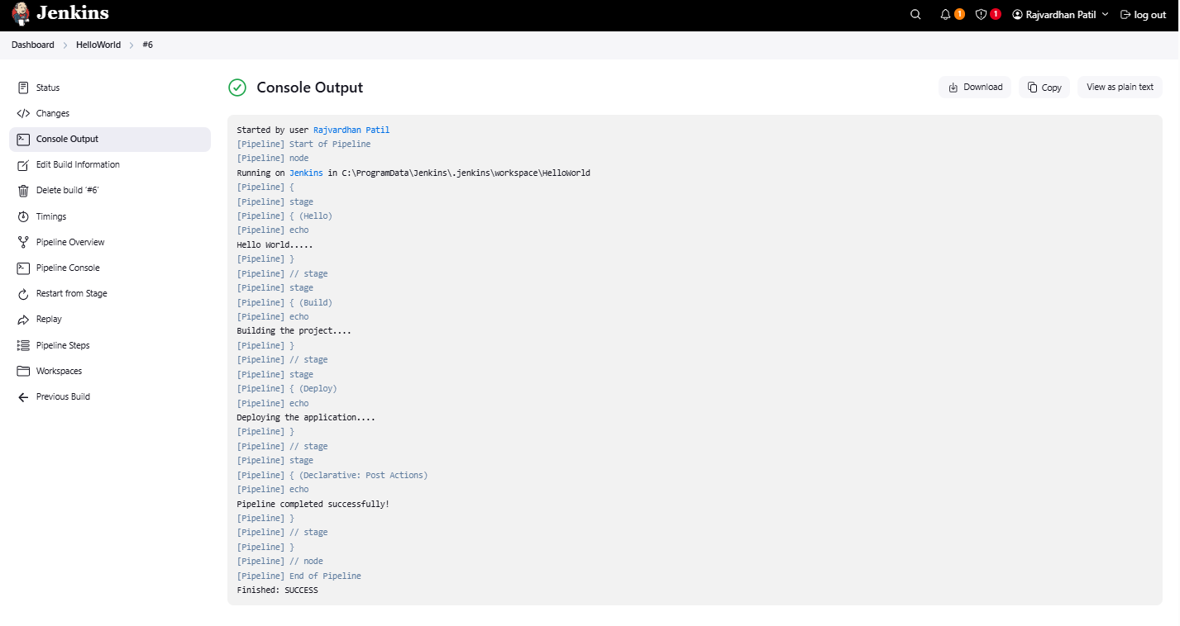

**3. Jenkins – Integrating Jenkins with Github**

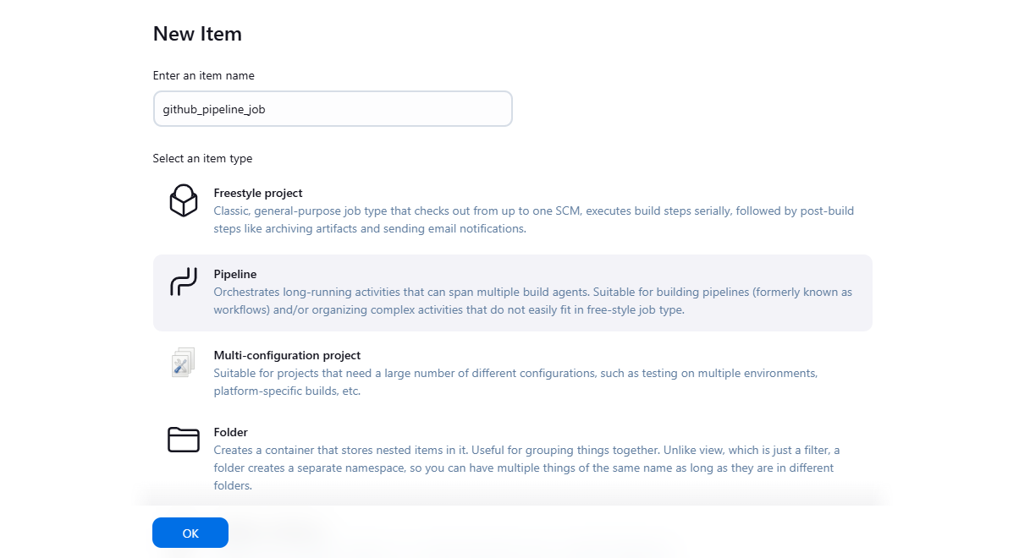

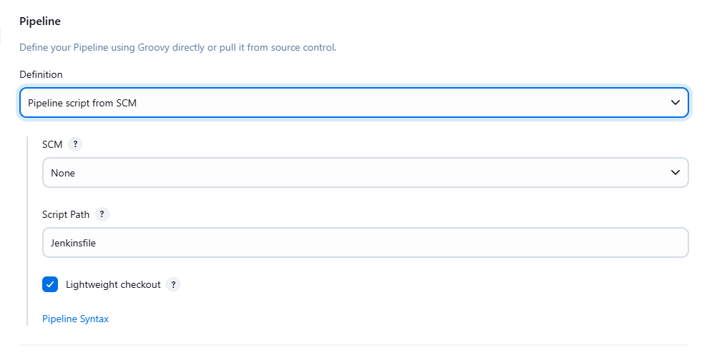

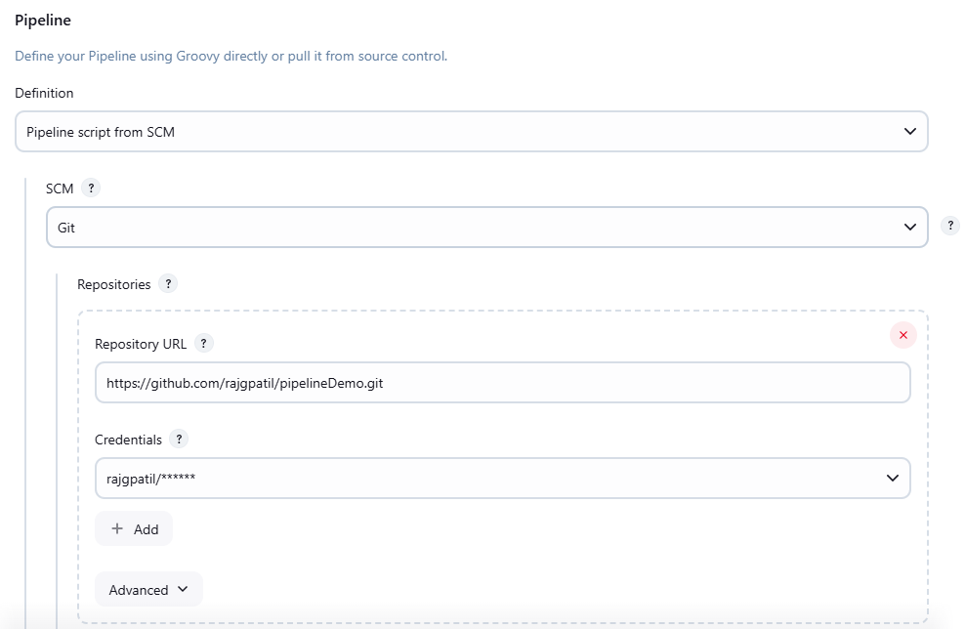

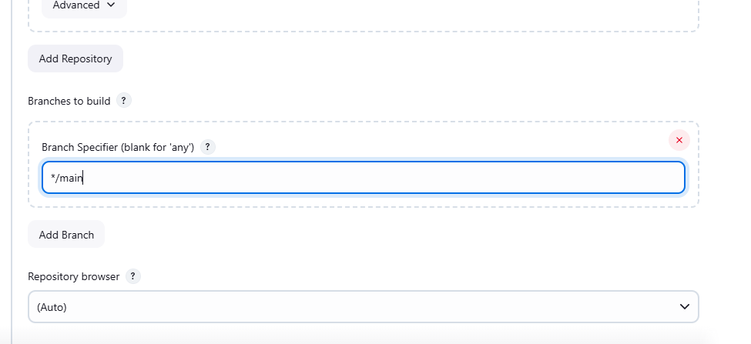

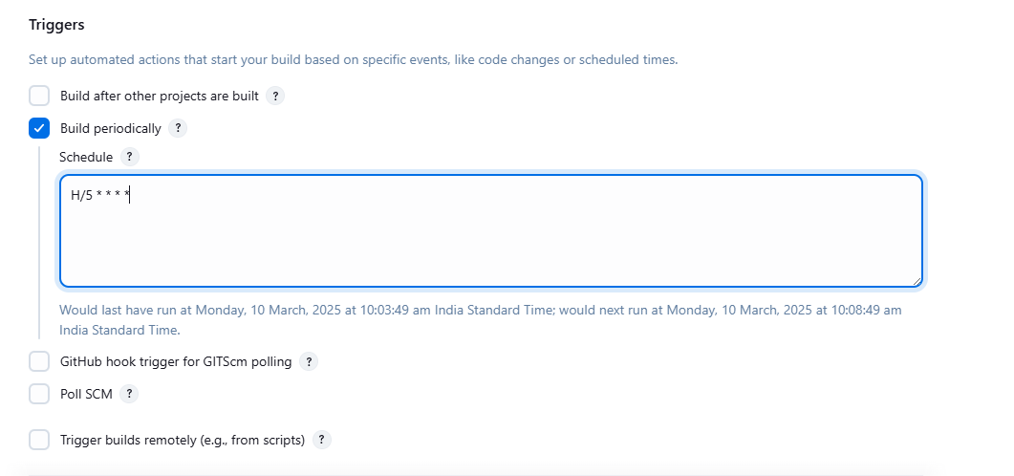

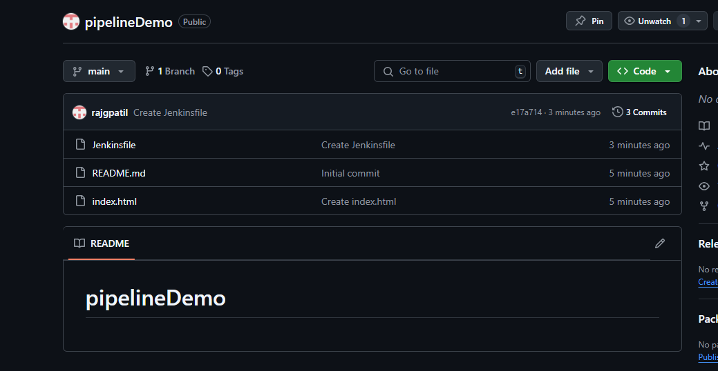

**Jenkensfile:**

pipeline {

agent any

stages {

stage('Checkout') {

steps {

checkout scm

}

}

stage('Build') {

steps {

echo 'Building the project...'

// Add build commands here based on your project type

// For example, if it's a Java project:

// sh 'mvn clean compile'

}

}

stage('Test') {

steps {

echo 'Running tests...'

// Add test commands here

// Example: sh 'mvn test'

}

}

stage('Deploy') {

steps {

echo 'Deploying...'

// Add deployment commands

}

}

}

post {

success {

echo 'Pipeline executed successfully!'

}

failure {

echo 'Pipeline execution failed!'

}

}

}

**Output**

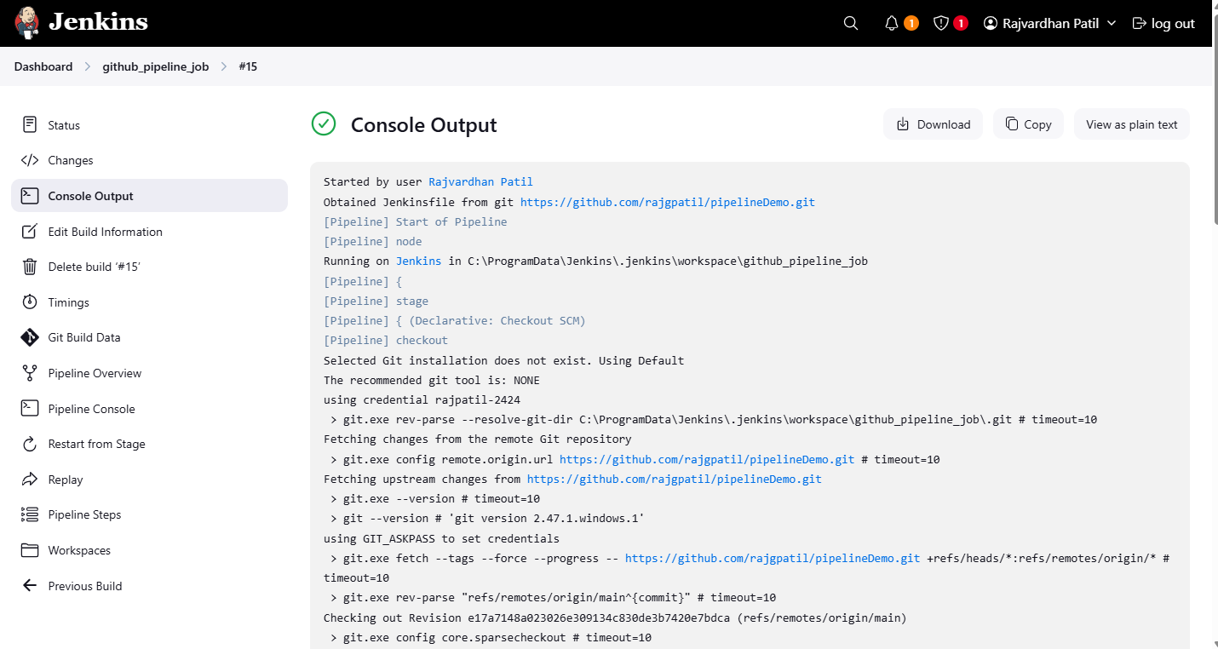

**4.Demonstrate Continuous Integration and development using Jenkins(login Page html)**

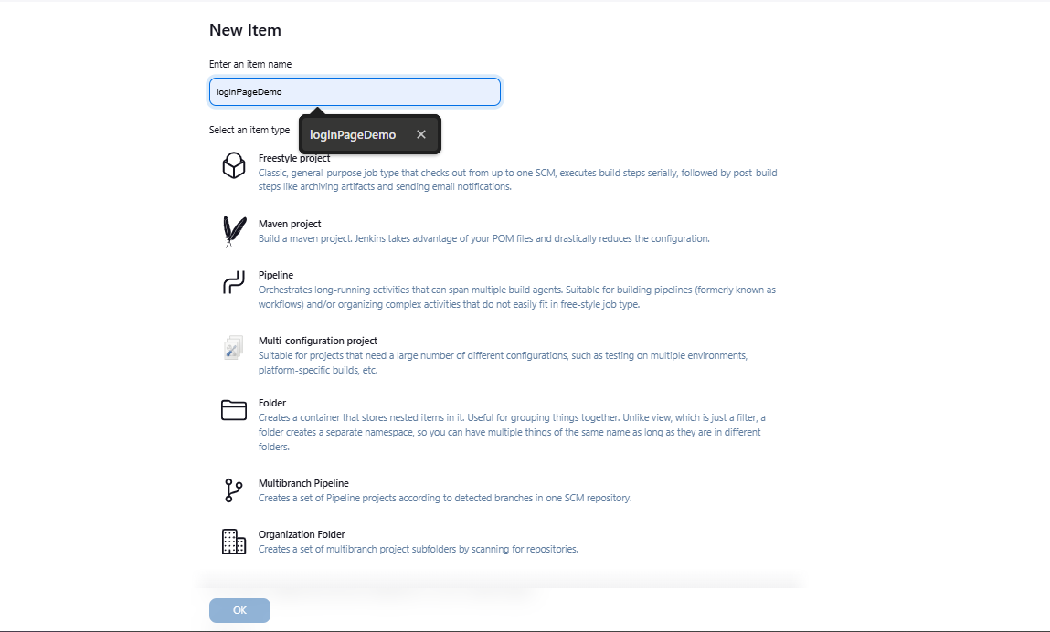

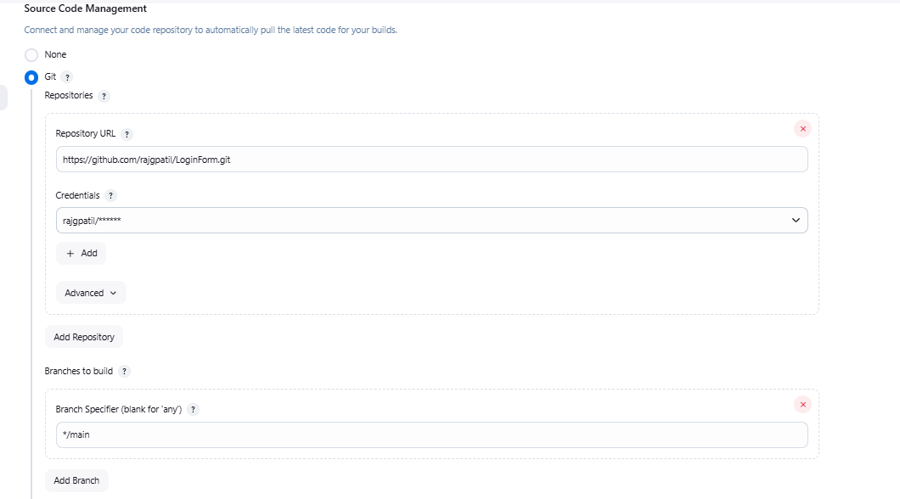

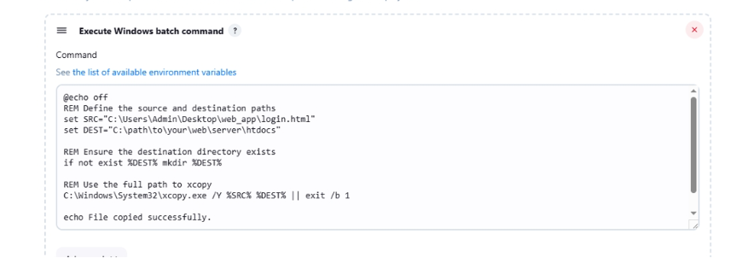

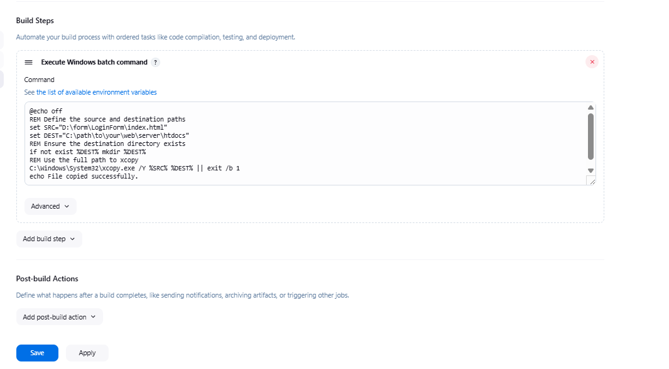

**Output:**

