1. To demonstrate we will first fork the repository (<https://github.com/jenkins-docs/simple-node-js-react-npm-app>)
2. 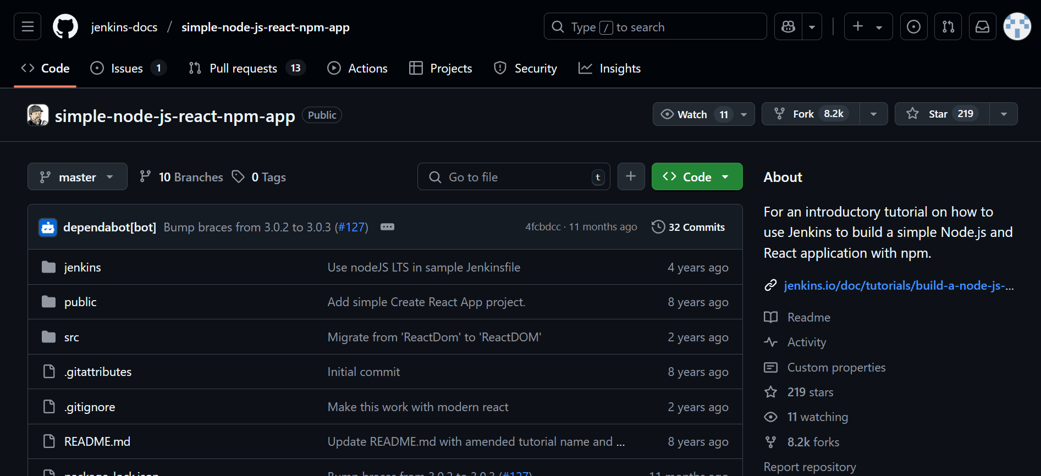
3. This is repo after forking

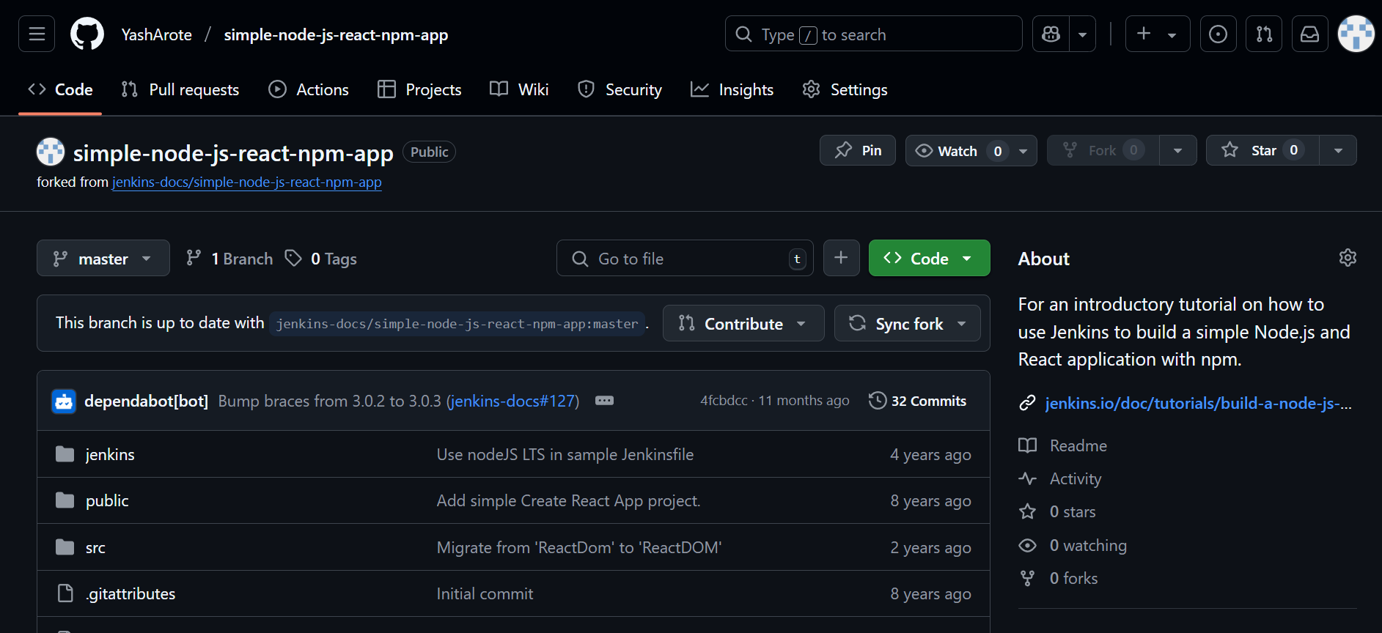

1. Clone the above repo and create a Jenkinsfile including the code below and push it

pipeline {

    agent any

    stages {

        stage('Checkout') {

            steps {

                git 'https://github.com/YashArote/simple-node-js-react-npm-app'

            }

        }

        stage('Install') {

            steps {

                // Install dependencies (for Node.js)

                bat 'npm install'

            }

        }

        stage('Build') {

            steps {

                // Build the project (for Node.js)

                bat 'npm run build'

            }

        }

    }

}

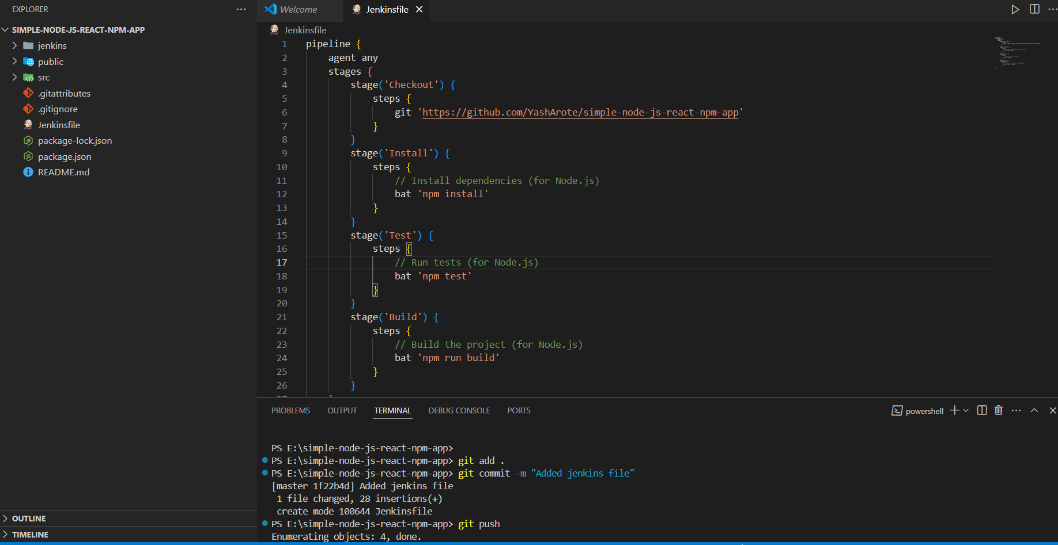

(Note:- don’t add stage(‘test’) as in image)

1. Make sure “Github Plugin” is installed on Jenkins if not install it in manage Jenkins tab

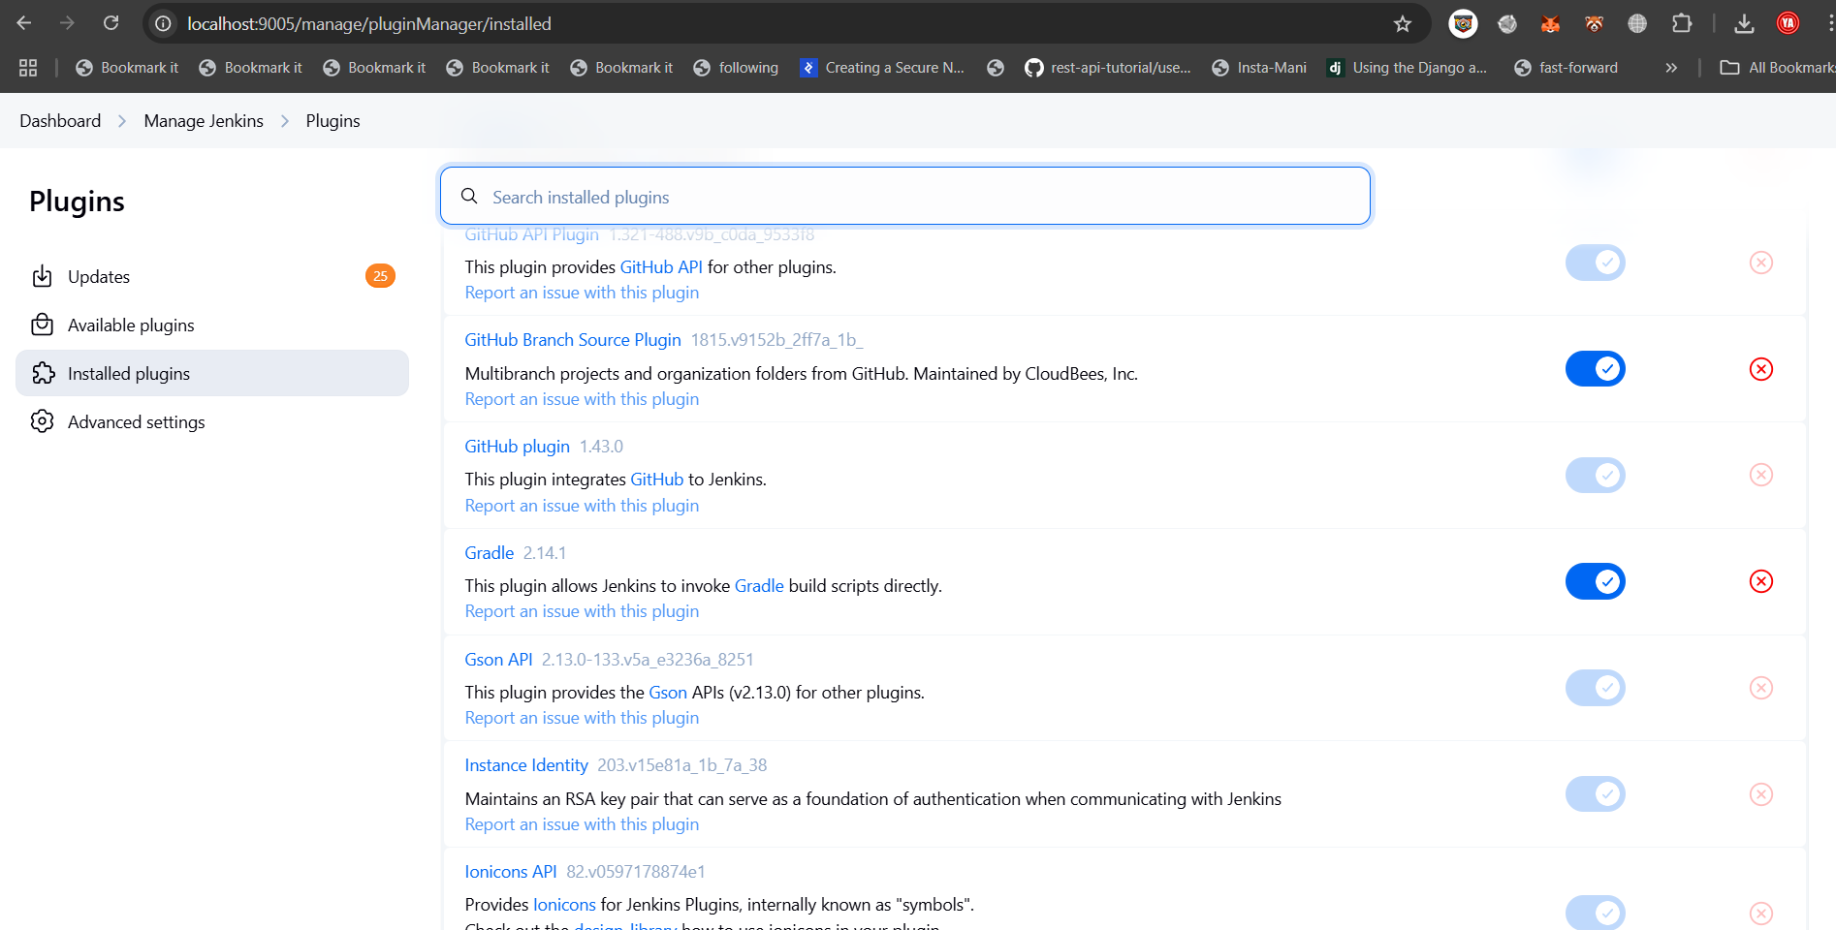

1. Create a Jenkins pipeline

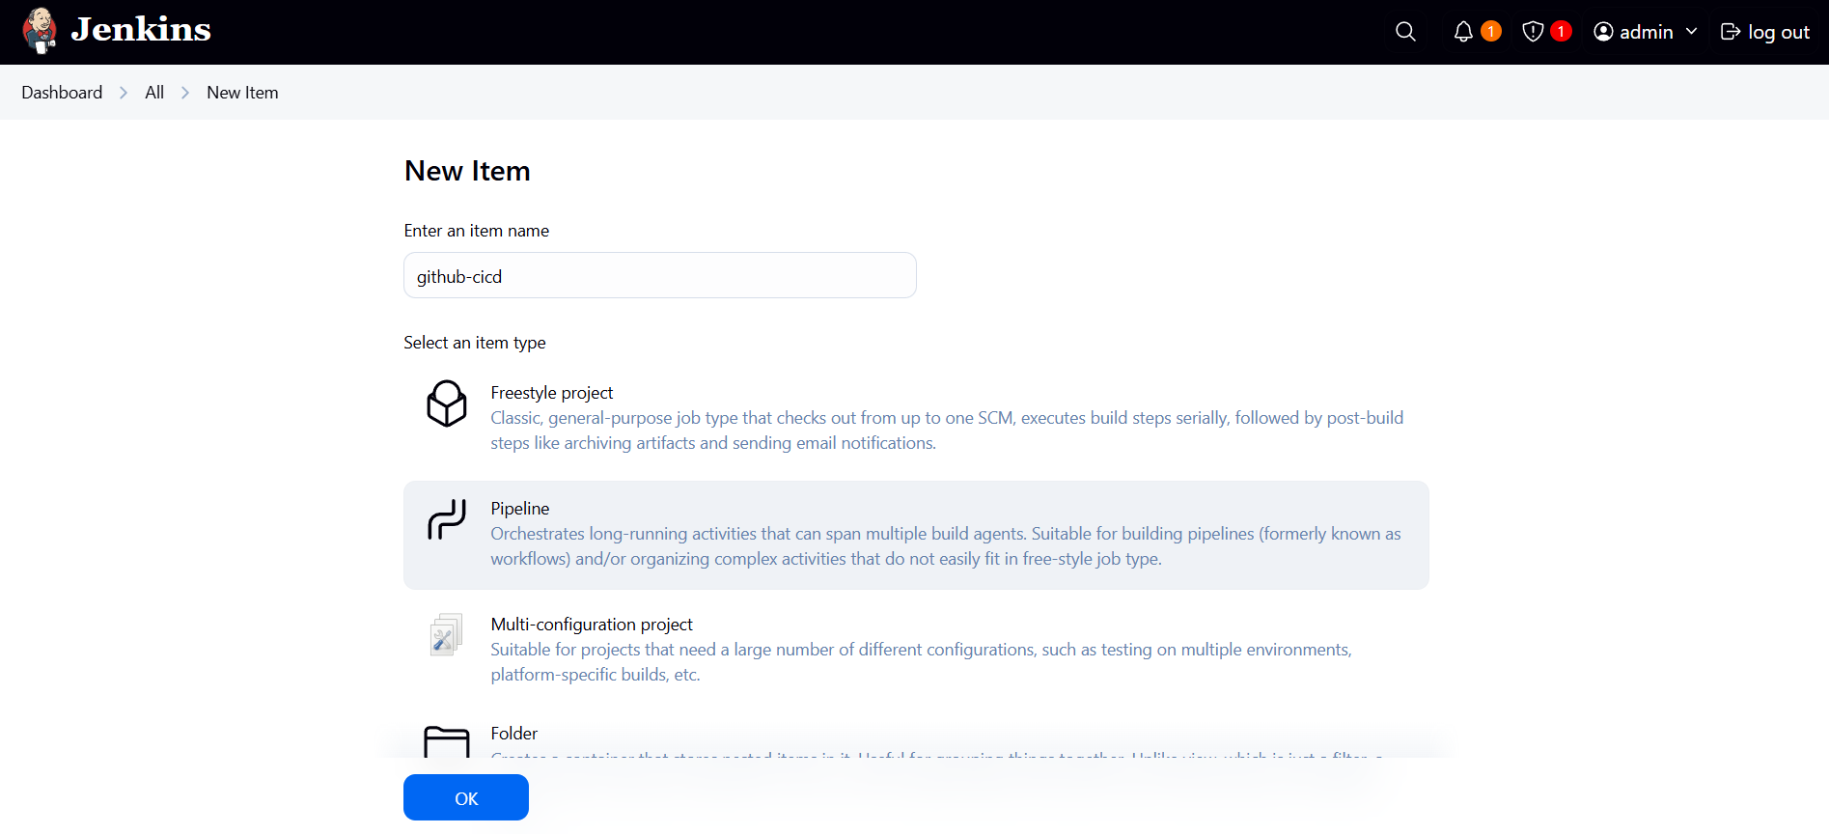

1. Do the following configurations in the pipeline:-

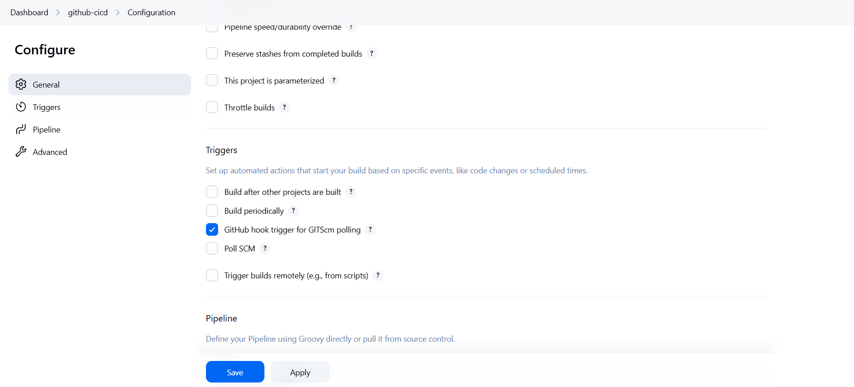

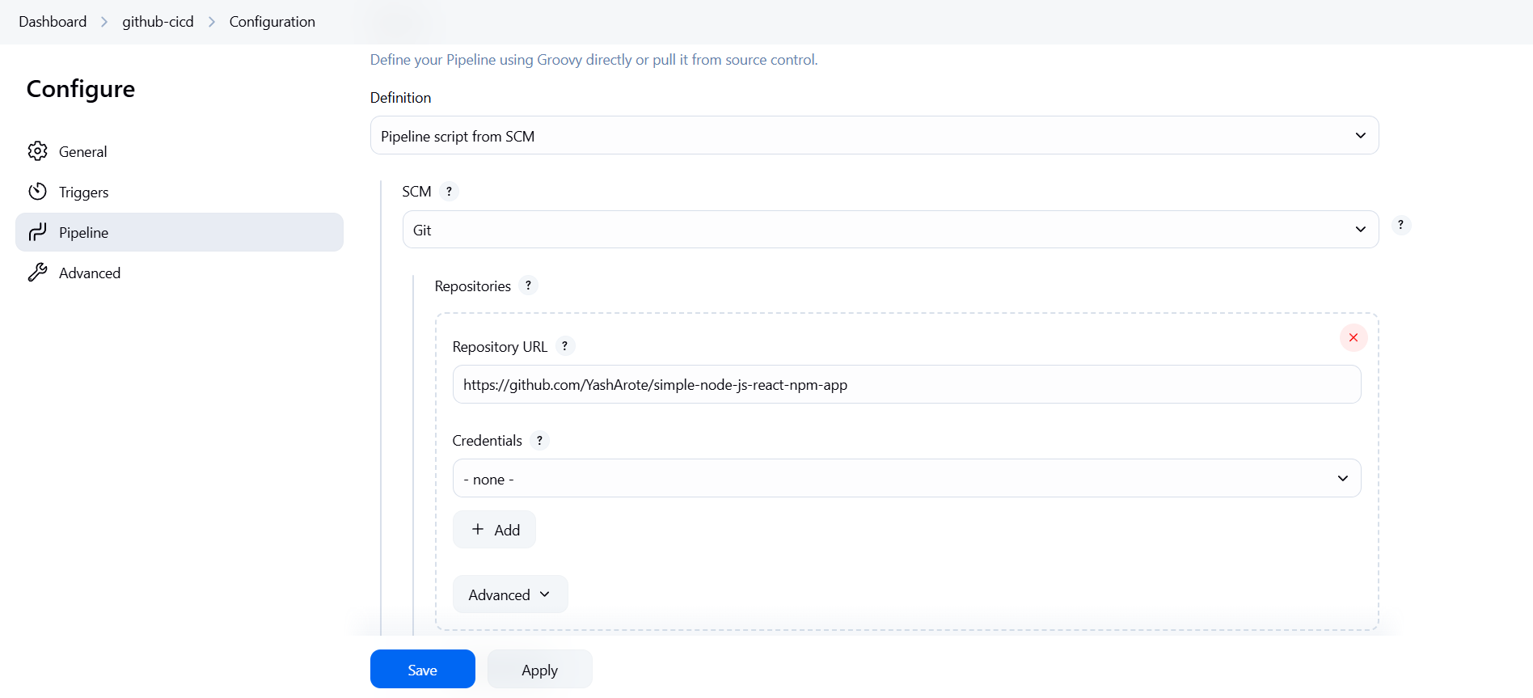

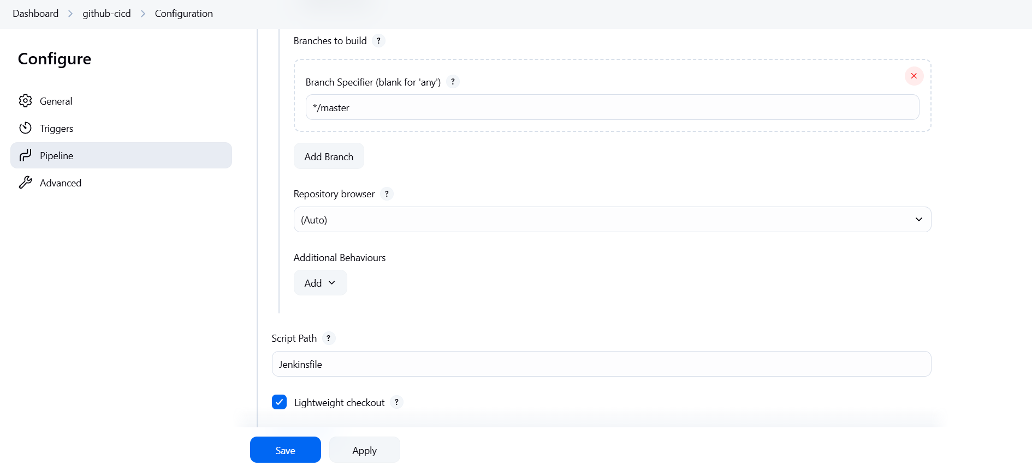

1. Expose the Jenkins port using ngrok to make it accessible to github webhooks(make sure ngrok is installed for windows)

Run the command :-

ngrok http <port-of-jenkins>

This starts the service:-

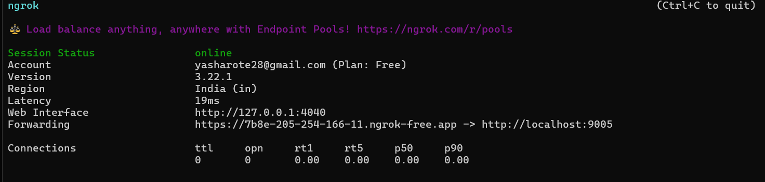

Copy the url forwarding url from here.

1. Add the url to github webhook with “/github-webhook/” appended at end with following additional configurations:-

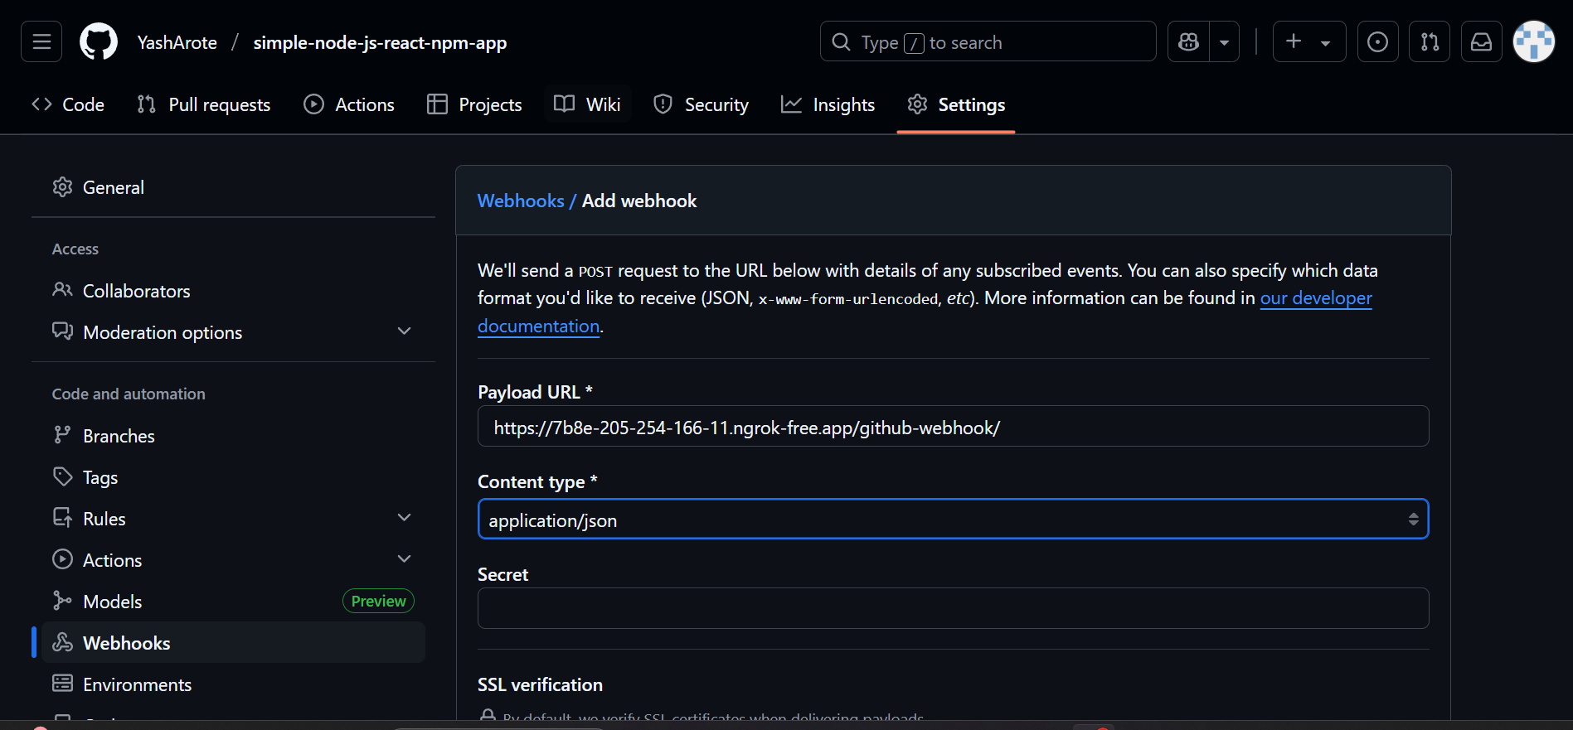

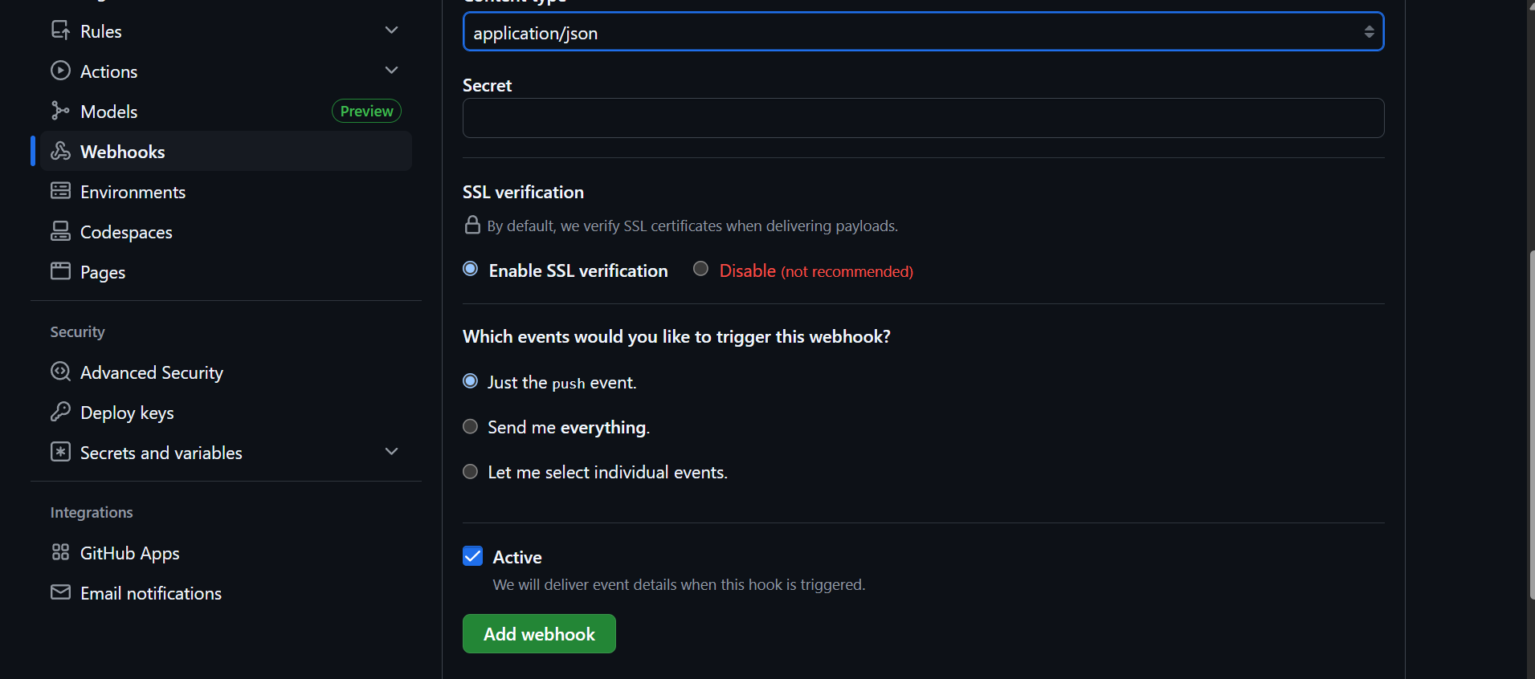

Finally add the webhook.

1. Finally make some changes in our repo and push it on github to see the pipeline triggered on Jenkins

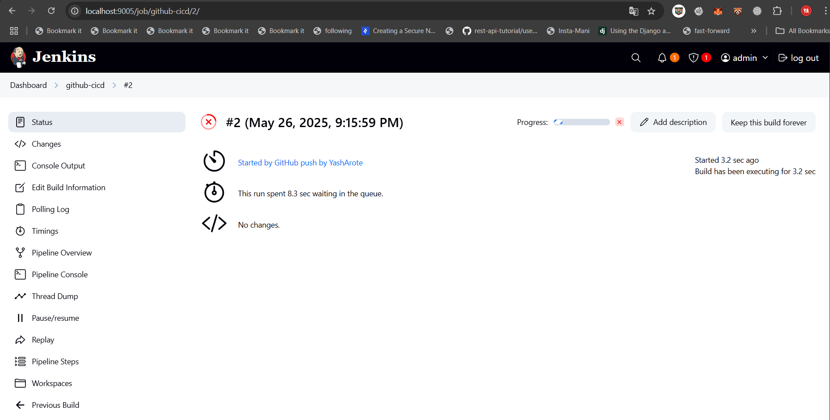

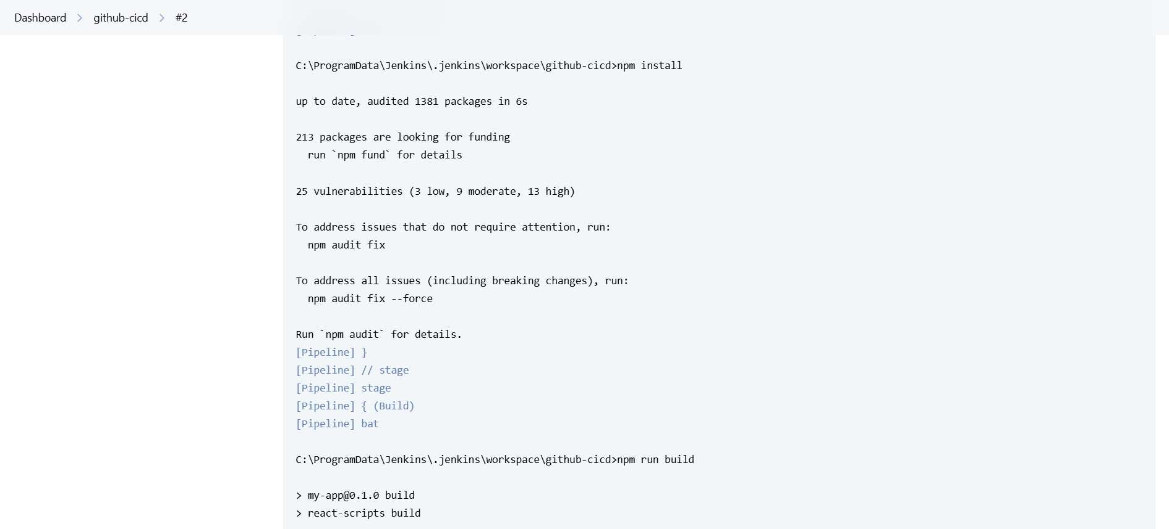

It can be seen the “npm install” and “npm build” as mentioned in our Jenkinsfile are automatically triggered in pipeline when code is pushed

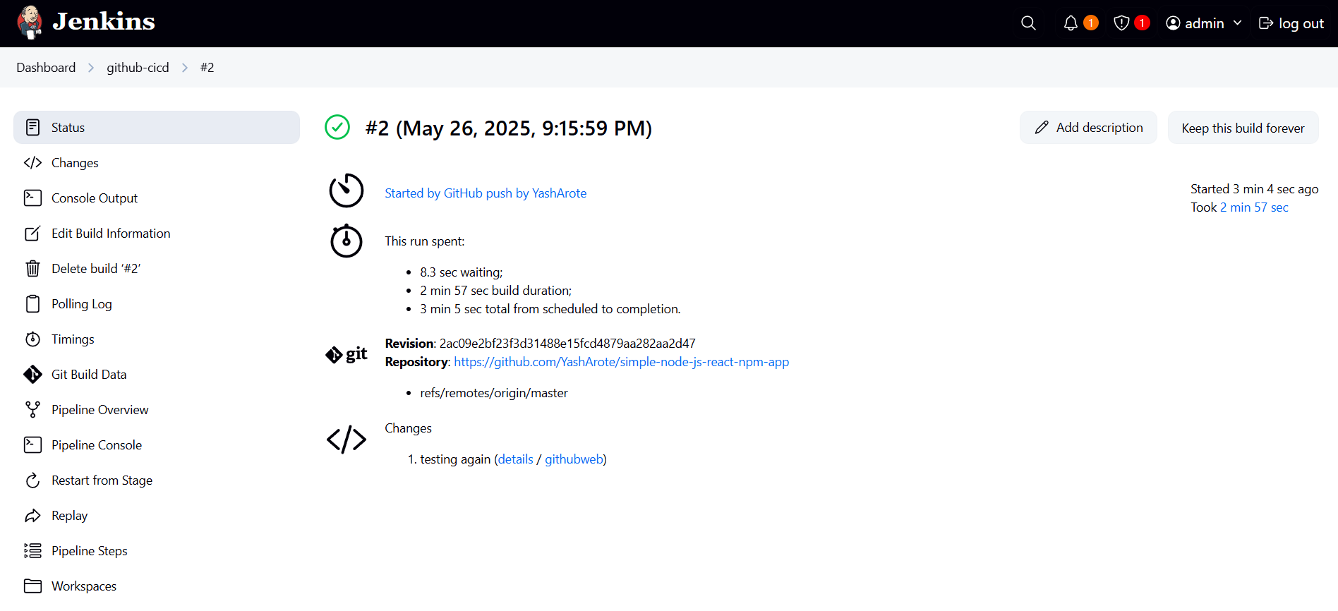

The build was successful !!